**MINISTRY OF EDUCATION AND TRAINING VIET NAM**

**FPT UNIVERSITY**  
Capstone Project Document

[eHospital]

|  |  |  |
| --- | --- | --- |
| **eHopital Group** | | |
| **Group Members** | Phạm Đức Khoa | SE03752 |
| Phạm Tuấn Anh | SE03615 |
| Lương Tiến Dũng | SE02166 |
| Chu Văn Thắng | SE03256 |
| Nguyễn Văn Long | SE03428 |
| **Supervisor** | **Mr. Trần Đình Trí** | |
| **Capstone Project code** | eHPT | |

Hanoi, 5/2017

CHAPTER 1: INTRODUCTION 11

1.1. Purpose 11

1.2. Project information 11

1.2.1. Project members 12

1.2.2. Problems 12

1.2.3. Solution 13

1.2.4. Compare other systems 13

1.2.5. Basic functions 14

1.3. Benefit 17

1.4. Limitation 17

CHAPTER 2: SOFTWARE PROJECT MANAGEMENT PLAN 18

2.1. Purpose 18

2.2. Problem Definition 18

2.2.1. Name of this Capstone Project 18

2.2.2. Problem Abstraction 18

2.2.3. Project Overview 19

2.3. Project organization 20

2.3.1. Software Process Model 20

2.3.2. Roles and Responsibilities 21

2.3.3. Tools and Techniques 23

2.4. Project management plan 23

2.4.1. Task 23

2.4.2. Meeting Minutes 24

2.4.3. Risk Management Plan 24

CHAPTER 3: SOFTWARE REQUIREMENT SPECIFICATION 27

3.1. Purpose 27

3.2. User Requirement Specification 27

3.2.1. User Description: 27

3.2.2. User Requirement 29

3.3. System Requirement Specification 35

3.3.1. External Interface Requirement 35

3.3.2. System Use Case 35

3.3.3. List of Use Cases 40

3.3.4. Business Rules 43

3.3.5. Use Case Specification 44

3.3.6. Non-functional Requirements 132

3.4. Entity Relationship Diagram (ERD) 133

CHAPTER 4: SOFTWARE DESIGN DESCRIPTION 136

4.1. Purpose 136

4.2. Architecture Overview 137

4.2.1. Choice of System Architecture 137

4.2.2. System Architecture 139

4.3. Component Diagram 140

4.4. Sequence Diagram 142

4.5. CRC Cards and Class Diagram 175

4.5.1. CRC Cards 175

4.5.2. Class Diagram 204

4.6. Use Interface Design 250

4.6.1. Register 250

4.6.2. View Profile 251

4.6.3. Change Password 252

4.6.4. Create Appointment 253

4.6.5. View Examination Record 254

4.6.6. Doctor Schedule Management 255

4.6.7. View Appointment 256

4.6.8. Patient Account Management (Reception) 257

4.6.9. Medicine Management 258

4.6.10. Service Management 259

4.6.11. Bill Management 260

4.6.12. Department Management 261

4.6.13. Appointment Management 262

4.6.14. Accept Doctor Schedule 263

4.6.15. Room Management 264

4.6.16. Bed Management 265

4.6.17. Staff Account Management 266

4.6.18. Patient Account Management (Admin) 267

4.6.19. Action History Management 268

4.7. Database Design 269

4.7.1. Appointment table 271

4.7.2. Bed table 271

4.7.3. Bed Patient table 271

4.7.4. Bill table 272

4.7.5. Bill Detail table 272

4.7.6. Department table 273

4.7.7. Examination Record table 273

4.7.8. Log System table 273

4.7.9. Medicine table 274

4.7.10. Patient table 274

4.7.11. Role table 275

4.7.12. Room table 275

4.7.13. Schedule table 275

4.7.14. Service table 276

4.7.15. Service Bill table 276

4.7.16. Staff table 277

CHAPTER 5: SOFTWARE TESTING DOCUMENT 278

5.1. Introduction 278

5.1.1. Purpose 278

5.1.2. Test Approach 278

5.2. Test Plan 280

5.2.1. Test Process 280

5.2.2. Features to be tested 280

5.2.3. Features not to be tested 284

5.2.4. Testing Tools and Environment 284

5.2.5. Test phases 285

5.2.6. Test schedule 286

5.2.7. Deliverables 286

5.2.8. Resources and responsibilities 287

5.3. Test Case Sample 287

5.3.1. Unit Test 287

5.3.2. System Test 288

5.3.3. Acceptance Test 288

5.4. Test Report Detail 289

5.4.1. Unit Test 289

5.4.2. System Test 289

5.4.3. Final Report 290

5.5. Checklist 290

CHAPTER 6: SOFTWARE USER’S MANUAL 291

6.1. Deployment Guidelines 291

6.1.1. Environment 291

6.1.2. Register “Mắt Bão” hosting 291

6.1.3. Update source code to host 292

6.2. Guest’s Guide 295

6.2.1. Register 295

6.3. Patient’s Guide 296

6.3.1. Login 296

6.3.2. Logout 296

6.3.3. View Profile 297

6.3.4. Change Password 297

6.3.5. Edit Profile 298

6.3.6. View Doctor Schedule 298

6.3.7. Create Appointment 299

6.3.8. View Appointment 299

6.3.9. Edit Appointment 300

6.3.10. Delete Appointment 300

6.3.11. View Examination Record 301

6.4. Doctor’s Guide 301

6.4.1. Login 301

6.4.2. Create schedule 302

6.4.3. View schedule 302

6.4.4. Edit schedule 303

6.5. Reception’s Guide 304

6.5.1. Login 304

6.5.2. Create Direct Appointment 305

6.5.3. Accept Appointment 305

6.5.4. Delete Appointment 306

6.5.5. View Doctor Schedule 307

6.5.6. Accept Doctor Schedule 307

6.5.7. View Examination Record 308

6.5.8. Create Bill 308

6.5.9. Finish bill 309

6.5.10. Delete bill 309

6.5.11. View bill 310

6.5.12. Check-in to exam 310

6.5.13. Check-in bed 311

6.5.14. Check-out bed 312

6.5.15. Create patient account 313

6.5.16. Ban patient account 313

6.5.17. View patient account 314

6.5.18. Create medicine 314

6.5.19. Edit medicine 315

6.5.20. Delete medicine 316

6.5.21. View medicine 316

6.5.22. Create service 317

6.5.23. Edit service 317

6.5.24. Delete service 318

6.5.25. View service 319

6.5.26. Create room 320

6.5.27. Edit room 321

6.5.28. Delete room 321

6.5.29. View room 322

6.5.30. Create bed 323

6.5.31. Delete bed 324

6.5.32. View bed 324

6.5.33. Create department 325

6.5.34. Edit department 325

6.5.35. Delete department 326

6.5.36. View department 327

6.6. Admin’s Guide 328

6.6.1. Login 328

6.6.2. Create Staff Account 328

6.6.3. Delete Staff Account 329

6.6.4. Delete Patient Account 329

6.6.5. View Staff Account 330

6.6.6. View Patient Account 330

6.6.7. View Action History 331

6.6.8. Analyze Doctor Working Detail 331

6.6.9. Analyze Bed 332

6.6.10. Analyze Patient Examined 332

# CHAPTER 1: INTRODUCTION

## Purpose

The purpose of this chapter is to provide an overview of Hospital web service and why we chose it. And we also show Idea, solution, some basic functions in this project. Besides, we have some benefit and limitation in the project. Thereby, we will research orientation of future.

## Project information

|  |  |
| --- | --- |
| **Project name** | eHospital |
| **Project code** | eHPT |
| **Project type** | Website |
| **Project manager** | Phạm Đức Khoa |
| **Start** | 8ᵗʰ May, 2016 |



### Project members

* **Supervisor:**

|  |  |  |
| --- | --- | --- |
| Full name | E-mail | Title |
| Tran Dinh Tri | **Tritd@fpt.edu.vn** | **Lecturer** |

* **Team members :**

|  |  |  |  |
| --- | --- | --- | --- |
| Full name | Roll Number | E-mail | Phone |
| **Pham Duc Khoa** | SE03752 | Khoapdse03752@fpt.edu.vn | 01668957703 |
| **Pham Tuan Anh** | SE03615 | Anhptse03615@fpt.edu.vn | 01657010064 |
| **Luong Tien Dung** | SE02166 | Dungltse02166@fpt.edu.vn | 0981736889 |
| **Nguyen Van Long** | SE03428 | Longnvse03428@fpt.edu.vn | 0981904794 |
| **Chu Van Thang** | SE03256 | Thangcvse03256@fpt.edu.vn | 01628778826 |

### Problems

The developing internet service, customer request working on internet regularly. In the medical field, online booking for health check-up is not popular. Customer often order directly and wait so long for check-up. Besides, they have to spend one day or more for health check-up. So if they can order online, can chose the time they free, it is really convenient, save more time. The target customer using our product is manager of private hospital.

### Solution

Create a connection between doctor and patient under control of reception. Website provides basic information and schedule of each doctor to help patients book right doctor instead of going to the hospital.

The reception censors order list and make an appointment between doctor and patient.

### Compare other systems

In Vietnam, this project is being used in some hospitals, but it is still being developed. In <https://vinmec.com/>, this website is too much information, the design of website is complicated. It is hard for customer visit website first time. Or like <http://datlichkham.hoibacsi.com/> is good enough for customer. But it is used for management of maternity hospital, so our project will be developed widely.

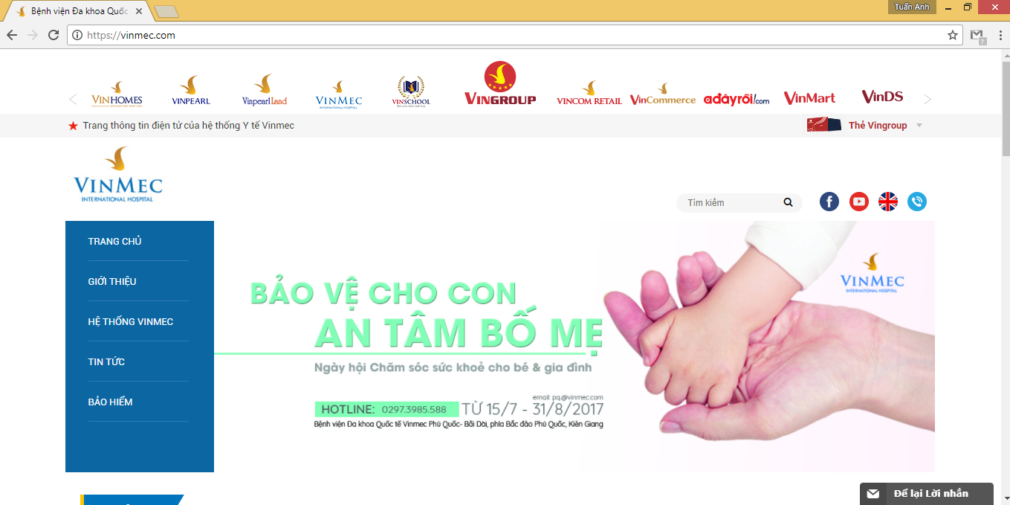

Figure 1: Homepage of Vinmec.com

### Basic functions

* **Guest**
  + Register
* **Patient**
* Login
* Logout
* View profile
* Edit profile
* Change password
* View schedule doctor
* Create appointment
* View appointment
* Edit appointment
* Delete appointment
* View examination record
* **Doctor**
* Login
* Logout
* View profile
* Edit profile
* Change password
* Create schedule
* View schedule
* Edit schedule
* View appointment
* Create examination record
* Create daily record
* View record
* **Reception**
* Login
* Logout
* View profile
* Edit profile
* Change password
* Create patient account
* Ban patient account
* View patient account
* Accept appointment
* Create direct appointment
* Delete appointment
* Accept doctor schedule
* View doctor schedule
* View patient’s examination record
* Create medicine
* Edit medicine
* Delete medicine
* View medicine
* Create service
* Edit service
* Delete service
* View service
* Create bill
* Delete bill
* Finish bill
* View bill
* Create room
* Edit room
* Delete room
* View room
* Create bed
* Edit bed
* Delete bed
* View bed
* Create department
* Edit department
* Delete department
* View department
* Check-in bed
* Check-out bed
* Check-in to exam
* **Admin**
* Login
* Logout
* View profile
* Edit profile
* Change password
* Create Staff account
* Delete Staff account
* View Staff account
* Delete Patient account
* View Patient account
* View action history
* Clean action history
* Analyze doctor details
* Analyze bed
* Analyze patient examined

## Benefit

* For our group
* Have change and experiment to develop a project, how to manage plan, how to promote effective teamwork.
* Training skill about HTML5, Javascript, ASP.NET, SQL Sever.
* For user
* Save time booking for health check-up.
* Improve service of hospital.
* Get closer to the customer.

## Limitation

* We do not know professional knowledge clearly.
* And we are not invested.
* We do not have experiment to develop a project.
* We do not know about how a hospital works.

# CHAPTER 2: SOFTWARE PROJECT MANAGEMENT PLAN

## Purpose

In this chapter, we will talk about the specific roles of the project team members. Plan and organize the project, the responsibilities of the members in each task. Project team members use this document to know their responsibilities and actions in the project.

## Problem Definition

### Name of this Capstone Project

* **Capstone Project Name**: eHospital
* **Abbreviation**: EHPT



### Problem Abstraction

Every time the patients go to the clinic, they must lose so much waiting time and effort for examination. In fact, the time to see a doctor for examination and consultation just in a few minutes, but they still have to wait all day for treatment and examination results. In addition, patients cannot select desire doctor.

And on the hospital side, they must use document for manage everything and it will lose so much time. Example, when a patient want to billing, the staff must statistic so many involved document to create a bill.

### Project Overview

#### The Current System

There are not current available systems; the product will be built from the scratch. The Proposed System eHPT includes one separated application:

• A website for patients, doctor, hospital staff and service administration.

#### Boundaries of System

In the scope of the project, the EHPT contains all the functions described in chapter

#### Development Environment

|  |  |  |
| --- | --- | --- |
|  | Minimum Requirements | Recommended |
| Internet Connection | Cable, Wi-Fi (4 Mbps) | Cable, Wi-Fi (8 Mbps) |
| Computer Processor | Intel® Core™ i3 | Intel® Core™ i7 |
| Computer Memory | 4 GB | 8 GB or more |
| Web Browser | Google Chrome 60.0.3112.101 | Google Chrome 60.0.3112.101 or higher |
| Operation System | Window 7 | Window 10 |

## Project organization

### Software Process Model

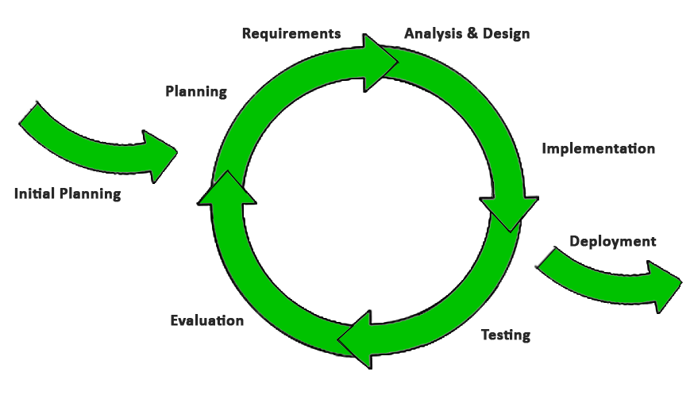

Figure 2: Iterative and Incremental process model

The reason why the project team chooses Iterative & Incremental software process model:

* This model is more flexible – less costly to change scope and requirements.
* Reduce the risk of delay due to the important work done first.
* Establish a good relationship between users and developers. Project team will always communicate with users to obtain information to meet the needs of users.
* Repetition of the phases can be built so that the system really met the demand of users
* Through every iterative, we can control scope and requirements, flexibly update or even change things if we think it will help us to have a better product.
* It is easy to manage risk by dividing it into pieces and solve it as quick as possible in each iterative.

### Roles and Responsibilities

#### Team organization structure

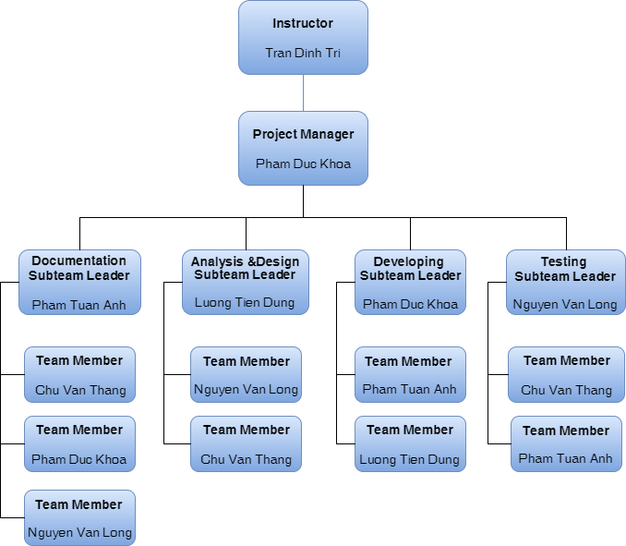

Figure 3: Human Resource

#### Roles and responsibilities

|  |  |  |
| --- | --- | --- |
| Name | Role | Quality Responsibility |
| Pham Duc Khoa | Project Management | - Define scope and planning, allocate resources to the project. Take responsibility for communication and keep focus on the team, leading the team to the right target. |
| Pham Tuan Anh | Designer | - Code product.  - Design product.( fix bug, build system, review code) |
| Pham Duc Khoa | Designer | - Code project.  - Design project.  (Investigate solution. Build system architecture, coding. Review codes. Fix bug) |
| Luong Tien Dung | Developer | - Code project.  - Design project.  (Collecting database. To be in charge of data issues. Review code. Fix bug) |
| Chu Van Thang | BA | - Analyze requirements  - Design workflow  - Write a solution document |
| Nguyen Van Long | QA and Tester | - Responsible for test execution, including test set-up and test run, evaluation of test run and error recovery, defect logging and test results recording.  - Create test cases, Execute test cases  - Manage the Quality Assurance function  - Audits and approve project deliverables from QA perspective. Review plans and deliverables for compliance with applicable standards. Provides guidance and assistance on process matters |

### Tools and Techniques

|  |  |
| --- | --- |
| Programming Language | C#, JavaScript, HTML, XML |
| Framework | Entity Framework v6.1.3, Bootstrap v3.3.7,.NET Framework 4.5, ASP.NET MVC 5 |
| Version Control | Github |
| IDEs | Visual studio 2015 |
| DBMS | SQL Server 2014 |
| UML Tools | Astah Professional 7.1.0/f2c212, Draw.io |
| Other | Office 2016 |

## Project management plan

### Task

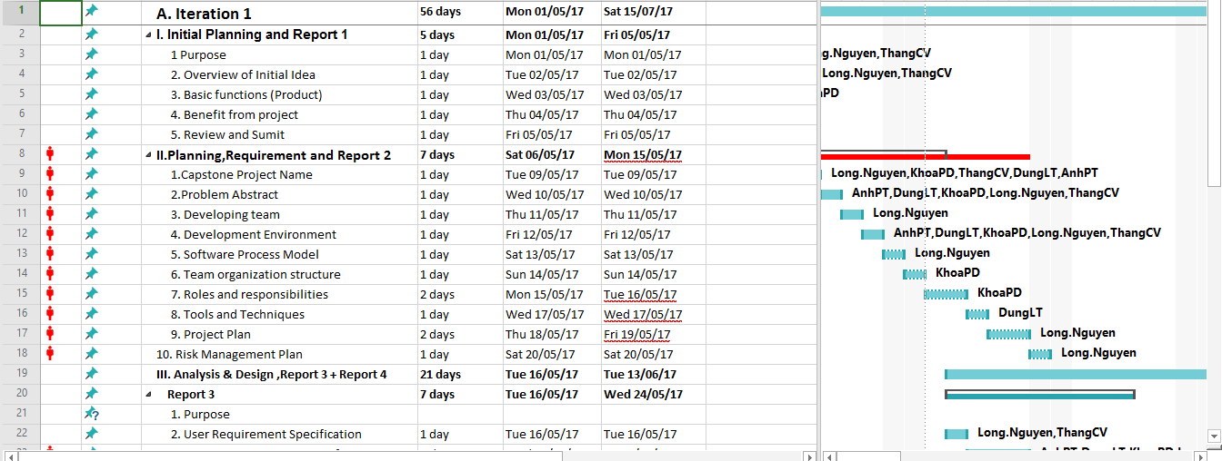

Figure 4 - Work Breakdown Structure

Refer file EHPT_Schedule.mpp for details



### Meeting Minutes

Weekly meeting is hold on Tuesday from 13h30-14h30 at room P202 Hoa Lac campus. The meeting minutes is sent to all members after each meeting. It is written using the following template.

Meeting Minute template:

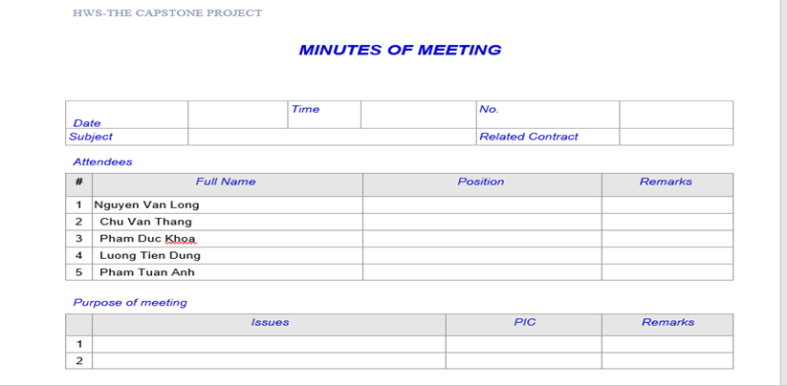

Figure 5 – Meeting Minute template

### Risk Management Plan

|  |  |  |  |  |  |
| --- | --- | --- | --- | --- | --- |
| No | Description | Probability | Avoidance Plan | Contingency Plan | Impact |
| 1 | Team members refuse to cooperate with each other | High | Hold teambuilding activities to build team’s spirit.  Create a friendly environment. | Talk to involved team members personally and in group to work out a solution. | Very High |
| 2 | Absences of team members | Medium | Provide meeting schedules and deadlines in advance so that all team members know the time and place where they will be needed  PM should be warned immediately when team member plan to be absent for a period of time. | Assign important tasks to other suitable team members | High |
| 3 | Team members lack technical skills and knowledge | High | Person in charge of Development Team provides workshops and training sessions for developers to acquire needed knowledge and techniques.  Encourage team members to study on themselves for their technical personal needs  Develop project plan with regards to training and self-study period | Person in charge of Development Team assists team member personally or in group to develop required skills and knowledge | Very High |
| 4 | Change of requirement | High | Take time to brainstorm features carefully with all team members.  Meticulously design system, take care of all possible situations to avoid changes. | Hold meeting with supervisor to decide which features suitable for implementation | Very High |
| 5 | Miscommunication | Medium | Participate fully in the meetings  Take note all content that meeting mention  Set communication channel since initiate | We will hold a meeting between all of our members if necessary to clear things up when miscommunication is detected. | Normal |
| 6 | Time shortage | Medium | PM planning to divide of work logical  Perform work on schedule | Accelerate some phases if possible  Members support each other | High |
| 7 | Lost data | Low | Backup database automatically daily by using some Version Control Tools or Clouding Service | Restore data from backed up data  Restore source code from history versions | Normal |
| 8 | Wrong choose in using tools and techniques | Medium | Research and ask some review from similar project in the part to choose right tools and techniques | Hold a meeting to analyze which part not suitable and figure out new things to replace it | High |

# CHAPTER 3: SOFTWARE REQUIREMENT SPECIFICATION

## Purpose

The main purpose of this chapter is providing specific information the system. It covers details specification about user requirements, software requirements and entity relationship diagram. This chapter provides the overview description about features of Hospital web service.

This chapter includes:

* User requirements
* System requirements
* Software system attributes
* Entity relationship diagram

## User Requirement Specification

### User Description:

In Hospital Web Service, there are 4 types of end-user: Guest, Patient, Doctor, and Admin.

1. **Guest** is people who use eHPT application without registering. They have to register to become a Customer user with full functions of eHPT.
2. **Patient** is people who have previously register an account or have seen a hospital. They will use the system to register for the exam and choose a doctor.
3. **Doctor** is people who will use the system to register the appointment, view patient information, edit patient information, record medical records and write prescriptions.
4. **Reception** is people who will use the system to manage appointment, bill and check in, check out for patient.
5. **Admin is** theadministrator. The administrator has the responsibility to manage the system such as user accounts.

In the system there are 5 user groups as shown in the following:

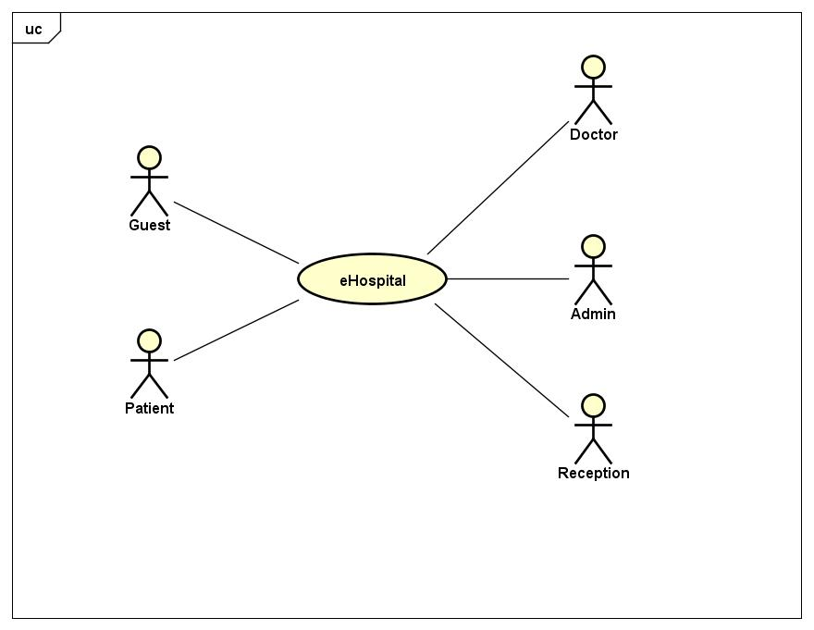

Figure 6: Use case level 0

### User Requirement

Here is the total use case diagram:

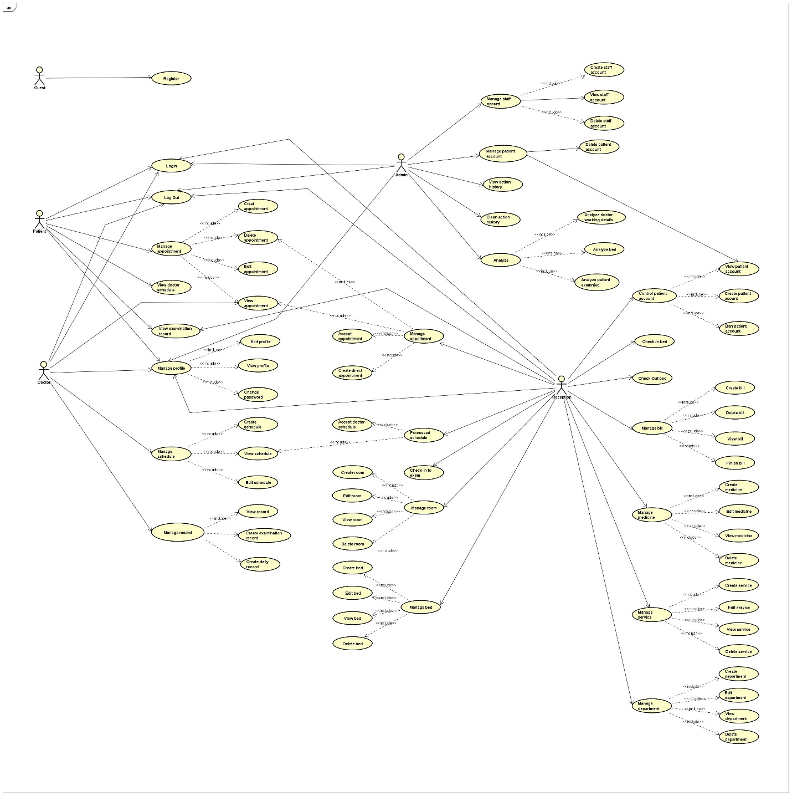

Figure 7: Use case total

#### Guest

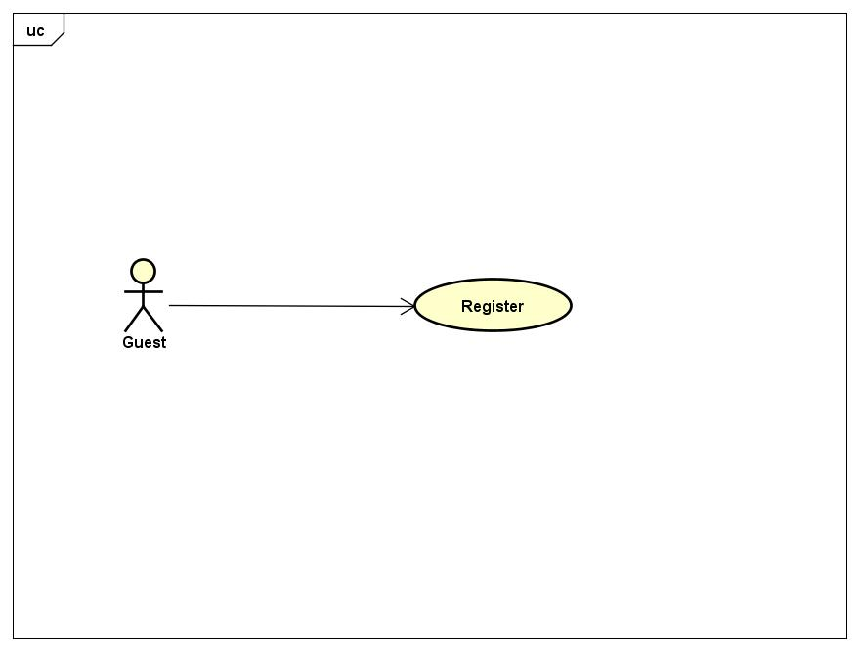

Figure 8: Use case level 1 - Guest

#### Patient

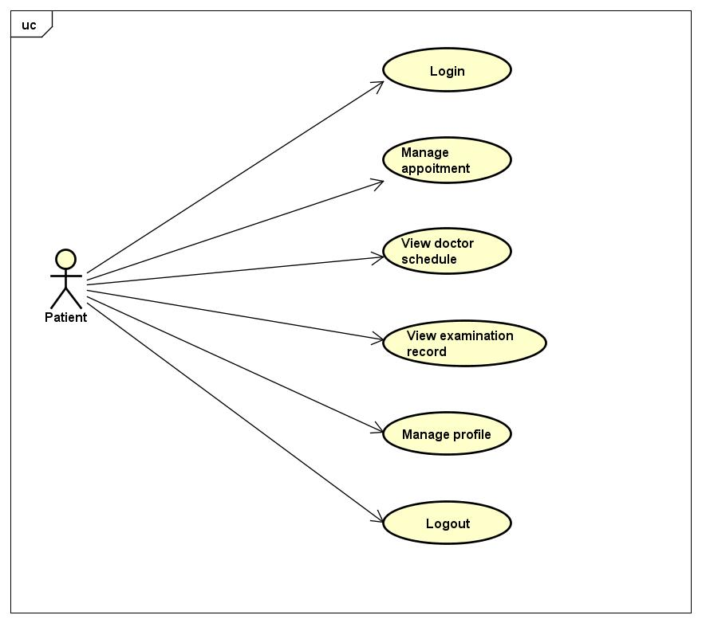

Figure 9: Use case level 1 - Patient

#### Doctor

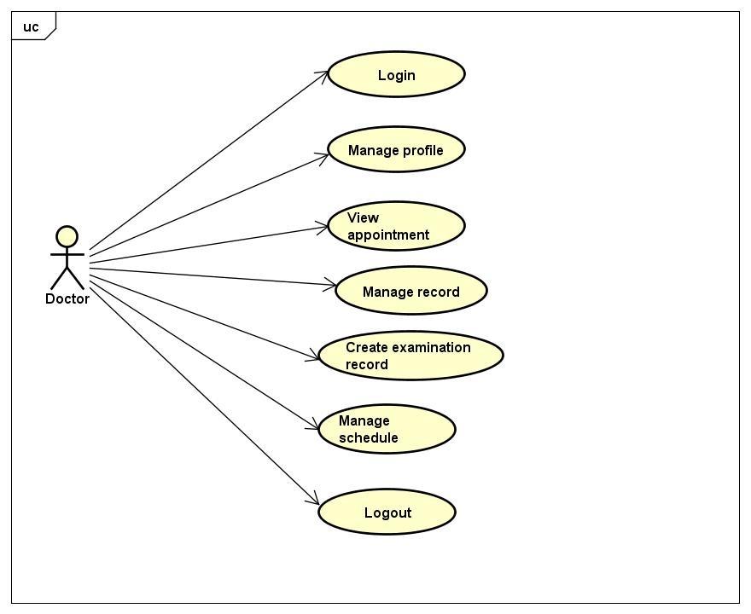

Figure 10: Use case level 1 - Doctor

#### Reception

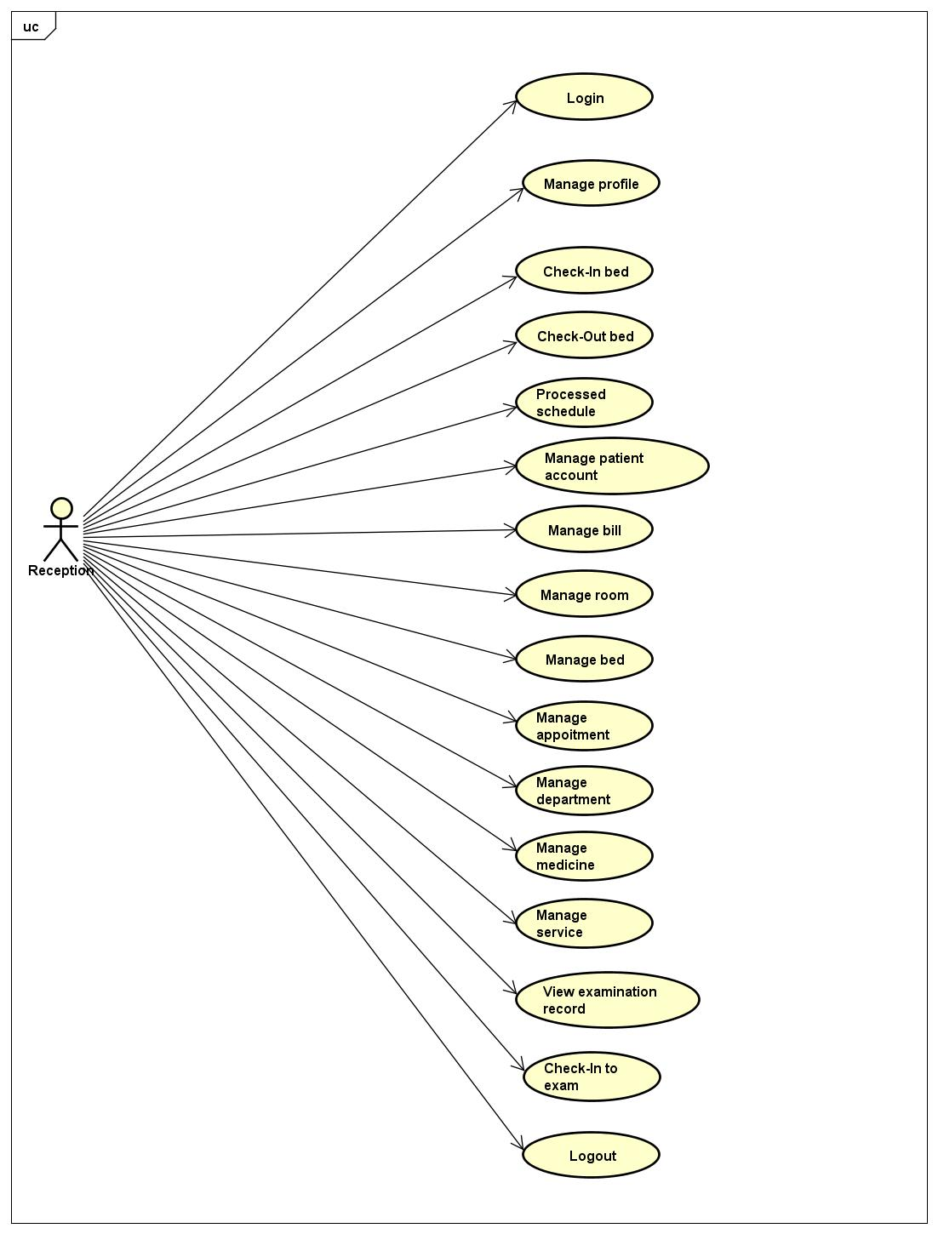

Figure 11: Use case level 1 – Reception

#### Admin

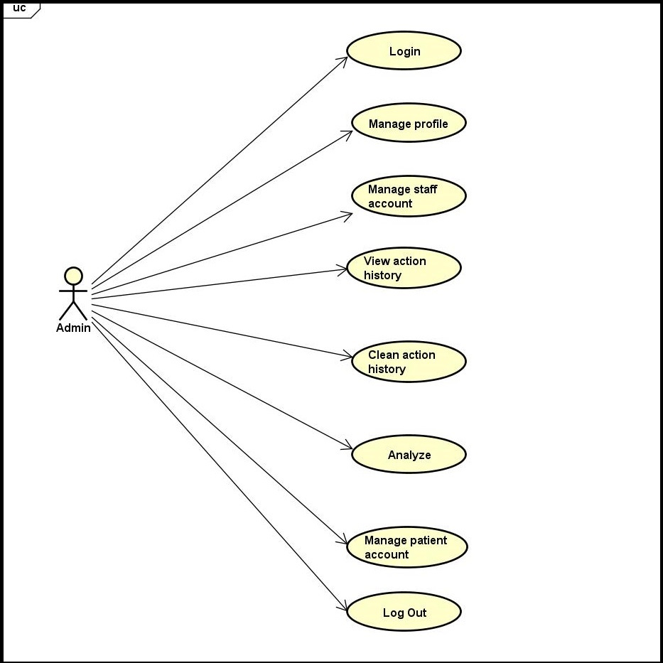

Figure 12: Use case level 1 – Admin

## System Requirement Specification

### External Interface Requirement

#### User Interface

* Vietnamese is the official language of eHospital website.
* The main screen is familiar with the user.
* Each user interface element must be arranged logically, not overlapped over other, allowing user access easily.
* If any error occurs, the system displays a friendly error message.
* The interface is friendly with the user.

#### Hardware Interfaces

* All web browsers : Google Chrome, Firefox, IE,..

#### Software Interface

* eHPT run on Visual Studio and SQL Sever.

#### User Characteristic

#### Constraints (Communications Protocol)

* The scope of the project is not changed in the process of the project so time and funding of the project is unchanged.
* Must finish of the project work within 90 days.
* Must work within the available resources.
* The customer is not acceptable if the product delay of delivery 10 days, the product does quality, not conforming to the requirements will not be accepted.
* Risks relating to the project must be notified in advance.

### System Use Case

Below are the detail use cases for every user groups:

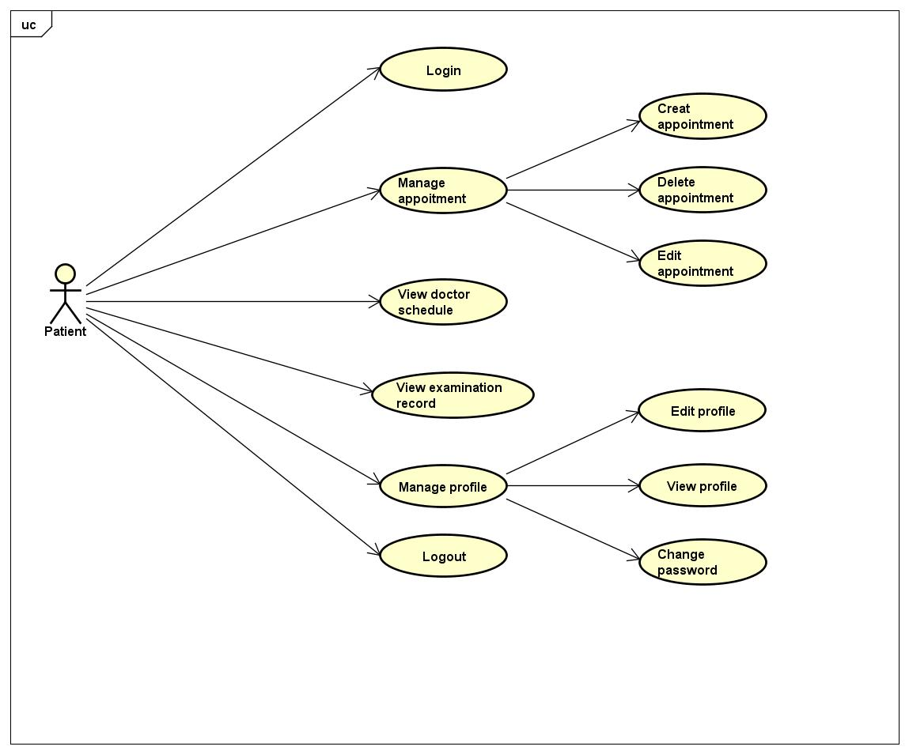

Figure 13: Use case level 2 – Patient

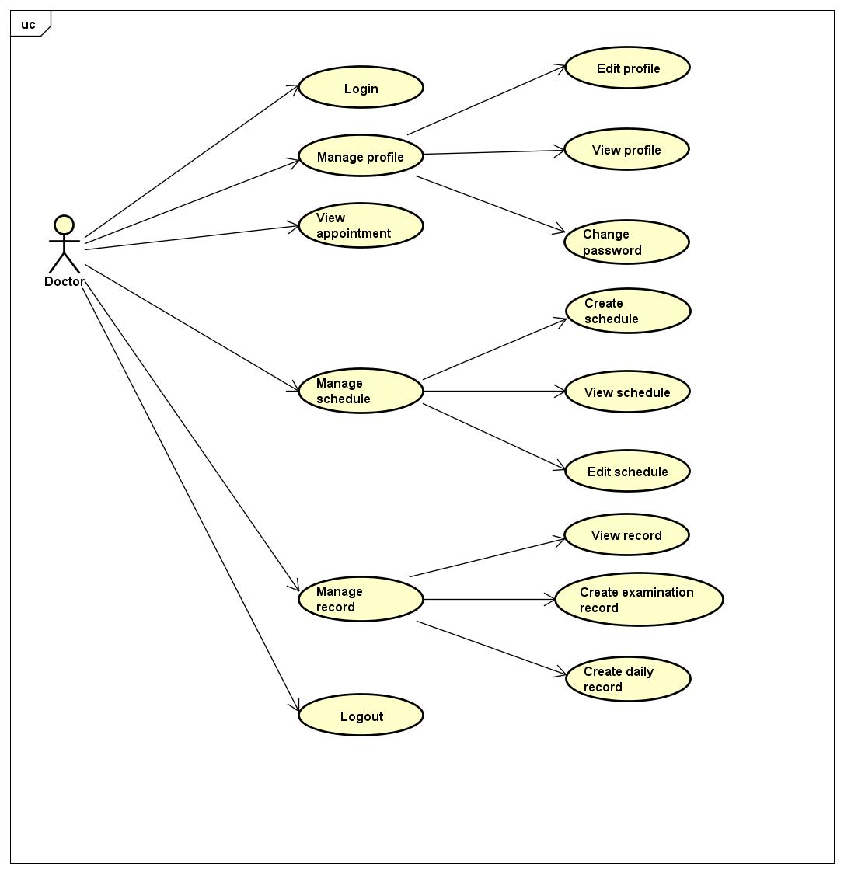

Figure 14: Use case level 2 - Doctor

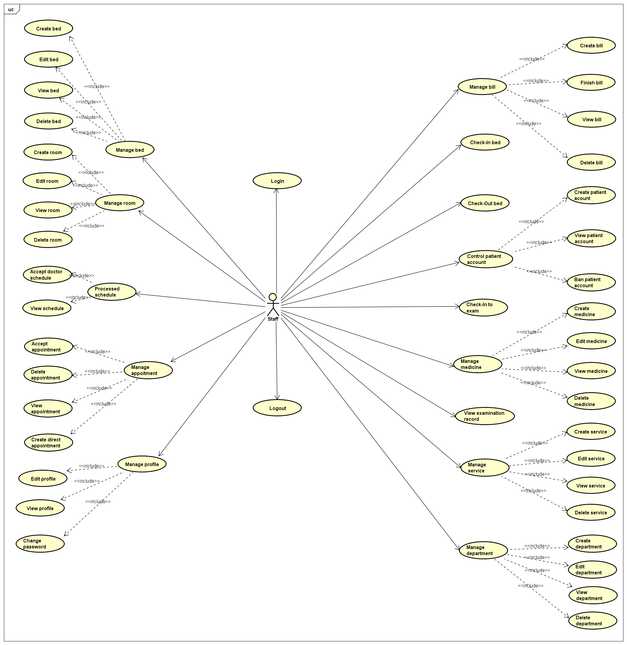

Figure 15: Use case level 2 – Reception

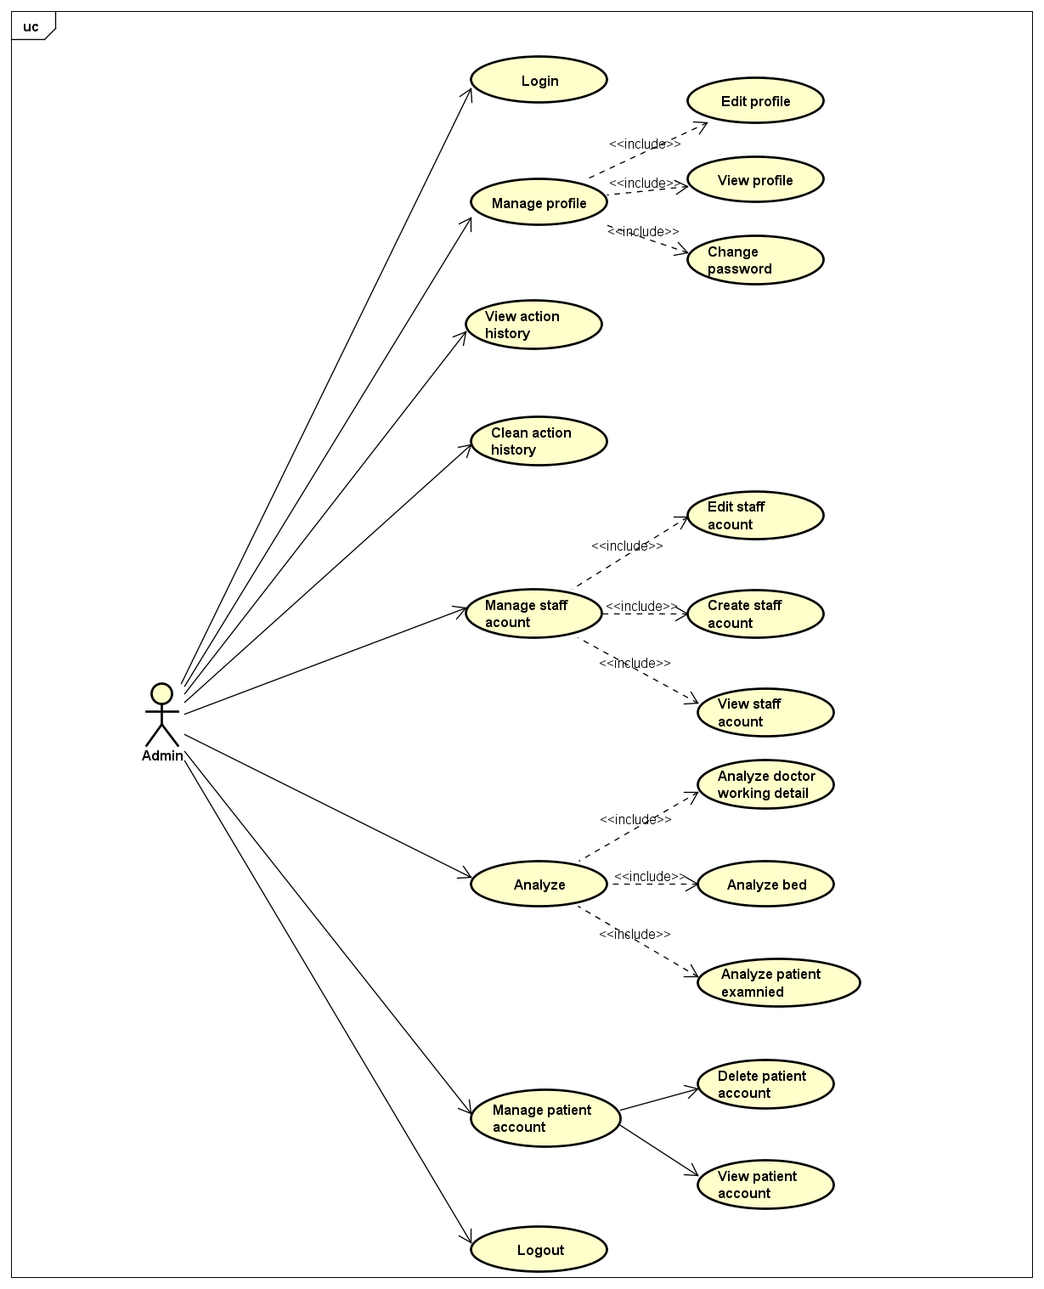

Figure 16: Use case level 2 – Admin

### List of Use Cases

|  |  |  |  |
| --- | --- | --- | --- |
| **No** | **Use case ID** | **Name** | **Primary Actor** |
|  | UC1.01 | Register | Guest |
|  | UC2.01 | Login | Patient, Reception, Doctor, Admin |
|  | UC2.02 | Logout | Patient, Reception, Doctor, Admin |
|  | UC2.03 | Change password | Patient, Reception, Doctor, Admin |
|  | UC2.04 | View profile | Patient, Reception, Doctor, Admin |
|  | UC2.05 | Edit profile | Patient, Reception, Doctor, Admin |
|  | UC2.06 | View doctor schedule | Patient |
|  | UC2.07 | Create appointment | Patient |
|  | UC2.08 | View appointment | Patient |
|  | UC2.09 | Edit appointment | Patient |
|  | UC2.10 | Delete appointment | Patient |
|  | UC2.11 | View examination record | Patient |
|  | UC3.01 | Create schedule | Doctor |
|  | UC3.02 | View schedule | Doctor |
|  | UC3.03 | Edit schedule | Doctor |
|  | UC3.04 | View appointment | Doctor |
|  | UC3.05 | Create examination record | Doctor |
|  | UC3.06 | Create daily record | Doctor |
|  | UC3.07 | View record | Doctor |
|  | UC5.01 | Create direct appointment | Reception |
|  | UC5.02 | Accept appointment | Reception |
|  | UC5.03 | Delete appointment | Reception |
|  | UC5.04 | View doctor schedule | Reception |
|  | UC5.05 | Accept doctor schedule | Reception |
|  | UC5.06 | View examination record | Reception |
|  | UC5.07 | Create bill | Reception |
|  | UC5.08 | Finish bill | Reception |
|  | UC5.09 | Delete bill | Reception |
|  | UC5.10 | View bill | Reception |
|  | UC5.11 | Check-in to exam | Reception |
|  | UC5.12 | Check-in bed | Reception |
|  | UC5.13 | Check-out bed | Reception |
|  | UC5.14 | Create patient account | Reception |
|  | UC5.15 | Ban patient account | Reception |
|  | UC5.16 | View patient account | Reception |
|  | UC5.17 | Create medicine | Reception |
|  | UC5.18 | Edit medicine | Reception |
|  | UC5.19 | Delete medicine | Reception |
|  | UC5.20 | View medicine | Reception |
|  | UC5.21 | Create service | Reception |
|  | UC5.22 | Edit service | Reception |
|  | UC5.23 | Delete service | Reception |
|  | UC5.24 | View service | Reception |
|  | UC5.25 | Create room | Reception |
|  | UC5.26 | Edit room | Reception |
|  | UC5.27 | Delete room | Reception |
|  | UC5.28 | View room | Reception |
|  | UC5.29 | Create bed | Reception |
|  | UC5.30 | Edit bed | Reception |
|  | UC5.31 | Delete bed | Reception |
|  | UC5.32 | View bed | Reception |
|  | UC5.33 | Create department | Reception |
|  | UC5.34 | Edit department | Reception |
|  | UC5.35 | Delete department | Reception |
|  | UC5.36 | View department | Reception |
|  | UC6.01 | Create staff account | Admin |
|  | UC6.02 | Delete staff account | Admin |
|  | UC6.03 | Delete patient account | Admin |
|  | UC6.04 | View staff account | Admin |
|  | UC6.05 | View patient account | Admin |
|  | UC6.06 | View action history | Admin |
|  | UC6.07 | Clean action history | Admin |
|  | UC6.08 | Analyze doctor working details | Admin |
|  | UC6.09 | Analyze bed | Admin |
|  | UC6.10 | Analyze patient examined | Admin |

### Business Rules

|  |  |
| --- | --- |
| **No** | **Description** |
| **B01** | All of register textbox must not be empty. |
| **B02** | Personal identification number use for account must contains 9 or 12 numbers. |
| **B03** | Password must contains more than 6 characters and has an upper case, a lower case, a number and do not has special characters. |
| **B04** | Date of birth use for account must be invalid. |
| **B05** | Phone number use for account must contains 10 or 11 numbers. And it must begin with “09” if contains 10 numbers and “01” if contains 11 numbers. |
| **B06** | Email use for account must be standard email form and exist. |
| **B07** | If user tick “Ghi nhớ đăng nhập” checkbox, eHospital will not require actor to login next time they use the website. |
| **B08** | Doctor must has a working schedule. |
| **B09** | A patient cannot booking more than attribution appointments in one day. |
| **B10** | A medical examination day must have attribution booking appointment quantity. |
| **B11** | Action involve with booking appointment must perform before attribution days. |
| **B12** | Action involve with doctor schedule must perform before attribution days. |
| **B13** | Action must wait permission of admin. |
| **B14** | Ban account cannot login system. |
| **B15** | After reception clicks the ban button, eHospital replaces it with the unban button |
| **B16** | Reception cannot add exist thing. |
| **B17** | After reception clicks the “Duyệt” button, eHospital replaces it with the ”Bỏ duyệt” button |
| **B18** | Reception cannot add a patient into a bed being used. |
| **B19** | If reception add a patient into an empty bed, eHospital change status of this bed. |
| **B20** | Reception cannot delete it because it contains data. |
| **B21** | After reception clicks the “Xác nhận thanh toán” button, eHospital change status of this bill become “Đã thanh toán”. |

### Use Case Specification

|  |  |  |  |  |
| --- | --- | --- | --- | --- |
| **USE CASE-1 SPECIFICATION** : Register | | | | |
| **Use-case No.** | <UC1.01> | **Use-case Version** | | <1.0> |
| **Use-case Name** | Register | | | |
| **Author** | AnhPT | | | |
| **Date** | 02/06/2017 | **Priority** | High | |
| **User:** Guest  **Summary:** The user uses this feature to register patient account.  **Goal:** Register account successfully.  **Triggers:** The user clicks on link “Đăng ký” in the homepage.  **Preconditions:** Users must register with accurate personal information.  **Post Conditions:** The user has an account to login system.  **Main Success Scenario:**   |  |  | | --- | --- | | User | System | | 1. User clicks on link “Đăng ký” in the homepage. |  | |  | 2. Display a register form. | | 3. User fill information in corresponding textbox and click on button “Đăng ký”. |  | |  | 4. Check input information and display successfully notification. |   **Alternative Scenario:** N/A  **Exceptions:**   |  |  | | --- | --- | | User | System | | 1. User clicks on link “Đăng ký” in the homepage. |  | |  | 2. Display a register form. | | 3. User fill information in corresponding textbox and click on button “Đăng ký”. |  | |  | 4. Check input information and display successfully notification. |   **Relationships:** N/A  **Business Rules:** B01, B02, B03, B04, B05, B06 | | | | |

|  |  |  |  |  |
| --- | --- | --- | --- | --- |
| **USE CASE-2 SPECIFICATION** : Login | | | | |
| **Use-case No.** | <UC2.01> | **Use-case Version** | | <1.0> |
| **Use-case Name** | Login | | | |
| **Author** | AnhPT | | | |
| **Date** | 22/05/2017 | **Priority** | High | |
| **User:** Patient, Doctor, Reception, Admin  **Summary:** The user uses this feature to login account.  **Goal:** Login account successfully.  **Triggers:** The user clicks on “Đăng nhập” in the homepage.  **Preconditions:** Users must have account in system.  **Post Conditions:** Display page matching each role account.  **Main Success Scenario:**   |  |  | | --- | --- | | User | System | | 1. User clicks on button “Đăng nhập” in the menu. |  | |  | 2. Display a login page. | | 3. User fill email or personal ID and password in login form and clicks on button “Đăng nhập” in this form. |  | |  | 4. Accept the user to login system. |   **Alternative Scenario:** N/A  **Exceptions:**   |  |  | | --- | --- | | User | System | | 3. User use invalid username or invalid password to login. |  | |  | 4. Display error message “Sai tên tài khoản hoặc mật khẩu”. | | 3. User does not fill the username to login |  | |  | 4. Display error message “Bạn chưa điền tên tài khoản” | | 3. User does not fill the password to login |  | |  | 4. Display error message “Bạn chưa điền mật khẩu” |   **Relationships:** N/A  **Business Rules:** B07,B13 | | | | |

|  |  |  |  |  |
| --- | --- | --- | --- | --- |
| **USE CASE-3 SPECIFICATION** : Logout | | | | |
| **Use-case No.** | <UC2.02> | **Use-case Version** | | <1.0> |
| **Use-case Name** | Logout | | | |
| **Author** | AnhPT | | | |
| **Date** | 22/05/2017 | **Priority** | High | |
| **User:** Patient, Reception, Doctor, Nurse, Admin  **Summary:** The user uses this feature to logout account.  **Goal:** Logout account successfully.  **Triggers:** The user clicks on button “Đăng xuất” in the page.  **Preconditions:** Users must login in system.  **Post Conditions:** Display login page.  **Main Success Scenario:**   |  |  | | --- | --- | | User | System | | 1. User clicks on button “Đăng xuất” in the page. |  | |  | 2. Display login page. |   **Alternative Scenario:** N/A  **Exceptions:** N/A  **Relationships:** N/A  **Business Rules:** N/A | | | | |

|  |  |  |  |  |
| --- | --- | --- | --- | --- |
| **USE CASE-4 SPECIFICATION** : Change Password | | | | |
| **Use-case No.** | <UC2.03> | **Use-case Version** | | <1.0> |
| **Use-case Name** | Change password | | | |
| **Author** | AnhPT | | | |
| **Date** | 2/07/2017 | **Priority** | Normal | |
| **User:** Patient, Reception, Doctor, Admin  **Summary:** The user uses this feature to change password.  **Goal:** Get a new password.  **Triggers:** The user clicks on button “Đổi mật khẩu” in the menu of profile page.  **Preconditions:** Users must have account and login successfully in the system.  **Post Conditions:** Display change password screen.  **Main Success Scenario:**   |  |  | | --- | --- | | User | System | | 1. User clicks on button “Đổi mật khẩu” in the homepage. |  | |  | 2. Display change password screen. | | 3. User fill old password in old password textbox and new password in new password |  | |  | 4. Check information and display successful change password notification. |   **Alternative Scenario:** N/A  **Exceptions:**  1)   |  |  | | --- | --- | | User | System | | User fill incorrect old password |  | |  | Display incorrect password notification. |   2)   |  |  | | --- | --- | | User | System | | User fill new password is not satisfy with requirement |  | |  | Display unsatisfy password notification. |   **Relationships:** N/A  **Business Rules:** B03 | | | | |

|  |  |  |  |  |
| --- | --- | --- | --- | --- |
| **USE CASE-5 SPECIFICATION** : View Profile | | | | |
| **Use-case No.** | <UC2.04> | **Use-case Version** | | <1.0> |
| **Use-case Name** | View profile | | | |
| **Author** | AnhPT | | | |
| **Date** | 02/07/2017 | **Priority** | Low | |
| **User:** Patient, Reception, Doctor, Admin  **Summary:** The user uses this feature to view personal information.  **Goal:** View personal information.  **Triggers:** The user clicks on account name link in the page.  **Preconditions:** Users must login in system.  **Post Conditions:** Display personal information screen.  **Main Success Scenario:**   |  |  | | --- | --- | | User | System | | 1. User clicks on account name link in the page. |  | |  | 2. Display personal information page. |   **Alternative Scenario:** N/A  **Exceptions:** N/A  **Relationships:** N/A  **Business Rules:** N/A | | | | |

|  |  |  |  |  |
| --- | --- | --- | --- | --- |
| **USE CASE-6 SPECIFICATION** : Edit Profile | | | | |
| **Use-case No.** | <UC2.05> | **Use-case Version** | | <1.0> |
| **Use-case Name** | Edit profile | | | |
| **Author** | AnhPT | | | |
| **Date** | 02/07/2017 | **Priority** | Low | |
| **User:** Patient, Reception, Doctor, Admin  **Summary:** The user uses this feature to change personal information.  **Goal:** Change personal information.  **Triggers:** The user clicks on button “profile” in the page.  **Preconditions:** Users must login in system.  **Post Conditions:** Display change personal information page.  **Main Success Scenario:**   |  |  | | --- | --- | | User | System | | 1. User clicks on button “profile” in the page. |  | |  | 2. Display change personal information page. | | 3. User fill information want to change in corresponding textbox and click button “Cập nhật” |  | |  | 4. Check information and display notification. |   **Alternative Scenario:** N/A  **Exceptions:**   |  |  | | --- | --- | | User | System | | 3. User fill incorrect information. |  | |  | 4. Display incorrect information notification. |   **Relationships:** N/A  **Business Rules:** B01, B02, B04, B05, B06 | | | | |

|  |  |  |  |  |
| --- | --- | --- | --- | --- |
| **USE CASE-7 SPECIFICATION** : View Doctor Schedule | | | | |
| **Use-case No.** | <UC2.06> | **Use-case Version** | | <1.0> |
| **Use-case Name** | View doctor schedule | | | |
| **Author** | AnhPT | | | |
| **Date** | 03/07/2017 | **Priority** | High | |
| **User:** Patient  **Summary:** The user uses this feature to view working schedule of doctor.  **Goal:** View working schedule of doctor.  **Triggers:** The user click on “ĐẶT HẸN ONLINE” in the menu of patient page and choose department and doctor name.  **Preconditions:** Users must login in system.  **Post Conditions:** Display working schedule of doctor include : working date and working time.  **Main Success Scenario:**   |  |  | | --- | --- | | User | System | | 1. User click on “ĐẶT HẸN ONLINE” in the menu of patient page. |  | |  | 2. Display appointment page. | | 3. User choose department name in “Chuyên khoa” box and doctor name in “Bác sĩ” box |  | |  | 4. Display working schedule of this doctor. |   **Alternative Scenario:** N/A  **Exceptions:** N/A  **Relationships:** N/A  **Business Rules:** B08 | | | | |

|  |  |  |  |  |
| --- | --- | --- | --- | --- |
| **USE CASE-8 SPECIFICATION** : Create Appointment | | | | |
| **Use-case No.** | <UC2.07> | **Use-case Version** | | <1.0> |
| **Use-case Name** | Create appointment | | | |
| **Author** | AnhPT | | | |
| **Date** | 03/07/2017 | **Priority** | High | |
| **User:** Patient  **Summary:** The user uses this feature to create appointment with doctor.  **Goal:** Create a successful appointment.  **Triggers:** The user click on “ĐẶT HẸN ONLINE” in the menu of patient page.  **Preconditions:** Users must login in system.  **Post Conditions:** Create an appointment in appointment list.  **Main Success Scenario:**   |  |  | | --- | --- | | User | System | | 1. User click on “ĐẶT HẸN ONLINE” in the menu of patient page. |  | |  | 2. Display appointment page. | | 3. User set appointment information and click on button “Đặt lịch”. |  | |  | 4. Display successfully notification and appointment in appointment list. |   **Alternative Scenario:** N/A  **Exceptions:** N/A  **Relationships:** N/A  **Business Rules:** B08,B09,B10,B11,B13 | | | | |

|  |  |  |  |  |
| --- | --- | --- | --- | --- |
| **USE CASE-9 SPECIFICATION** : View Appointment | | | | |
| **Use-case No.** | <UC2.08> | **Use-case Version** | | <1.0> |
| **Use-case Name** | View appointment | | | |
| **Author** | AnhPT | | | |
| **Date** | 03/07/2017 | **Priority** | Normal | |
| **User:** Patient  **Summary:** The user uses this feature to view appointment with doctor.  **Goal:** View appointment.  **Triggers:** The user click on “ĐẶT HẸN ONLINE” in the menu of patient page.  **Preconditions:** Users must login in system.  **Post Conditions:** Display appointments of this user.  **Main Success Scenario:**     |  |  | | --- | --- | | User | System | | 1. User click on “ĐẶT HẸN ONLINE” in the menu of patient page. |  | |  | 2. Display a list of appointment. |   **Alternative Scenario:** N/A  **Exceptions:** N/A  **Relationships:** N/A  **Business Rules:** N/A | | | | |

|  |  |  |  |  |
| --- | --- | --- | --- | --- |
| **USE CASE-10 SPECIFICATION** : Edit Appointment | | | | |
| **Use-case No.** | <UC2.09> | **Use-case Version** | | <1.0> |
| **Use-case Name** | Edit appointment | | | |
| **Author** | AnhPT | | | |
| **Date** | 03/07/2017 | **Priority** | Normal | |
| **User:** Patient  **Summary:** The user uses this feature to edit appointment with doctor.  **Goal:** Edit appointment.  **Triggers:** The user click on edit button in the appointment list of appointment page.  **Preconditions:** Users must login in system and have an appointment.  **Post Conditions:** Change appointment information in doctor’s schedule.  **Main Success Scenario:**     |  |  | | --- | --- | | User | System | | 1. User click on “ĐẶT HẸN ONLINE” in the menu of patient page. |  | |  | 2. Display a list of appointment. | | 3. User click on edit button mathching appointment user want to edit. |  | |  | 4. Display appointment information. | | 5. User insert new appointment information. |  | |  | 6. Check information and display notification. |   **Alternative Scenario:** N/A  **Exceptions:** N/A  **Relationships:** N/A  **Business Rules:** B08,B09,B10,B11,B13 | | | | |

|  |  |  |  |  |
| --- | --- | --- | --- | --- |
| **USE CASE-11 SPECIFICATION** : Delete Appointment | | | | |
| **Use-case No.** | <UC2.10> | **Use-case Version** | | <1.0> |
| **Use-case Name** | Delete appointment | | | |
| **Author** | AnhPT | | | |
| **Date** | 03/07/2017 | **Priority** | Normal | |
| **User:** Patient  **Summary:** The user uses this feature to delete appointment with doctor.  **Goal:** Delete appointment.  **Triggers:** The user click on delete button in appointment list of appointment page.  **Preconditions:** Users must login in system and have an appointment.  **Post Conditions:** Delete appointment information in appointment list.  **Main Success Scenario:**     |  |  | | --- | --- | | User | System | | 1. User click on “ĐẶT HẸN ONLINE” in the menu of patient page. |  | |  | 2. Display a list of appointment. | | 3. User click on delete button mathching appointment user want to delete. |  | |  | 4. Display successfully and new appointment list. |   **Alternative Scenario:** N/A  **Exceptions:** N/A  **Relationships:** N/A  **Business Rules:** B11,B13 | | | | |

|  |  |  |  |  |
| --- | --- | --- | --- | --- |
| **USE CASE-12 SPECIFICATION** : View Examination Record | | | | |
| **Use-case No.** | <UC2.11> | **Use-case Version** | | <1.0> |
| **Use-case Name** | View examination record. | | | |
| **Author** | AnhPT | | | |
| **Date** | 03/07/2017 | **Priority** | Normal | |
| **User:** Patient  **Summary:** The user uses this feature to view examination record.  **Goal:** View examination record.  **Triggers:** The user click on “HỒ SƠ BỆNH ÁN” in the menu of homepage.  **Preconditions:** Users must login in system.  **Post Conditions:** Display examination record screen.  **Main Success Scenario:**     |  |  | | --- | --- | | User | System | | 1. User click on “HỒ SƠ BỆNH ÁN” in the menu. |  | |  | 2. Display examination record screen. |   **Alternative Scenario:** N/A  **Exceptions:** N/A  **Relationships:** N/A  **Business Rules:** N/A | | | | |

|  |  |  |  |  |
| --- | --- | --- | --- | --- |
| **USE CASE-13 SPECIFICATION :** Create Schedule | | | | |
| **Use-case No.** | <UC3.01> | **Use-case Version** | | <1.0> |
| **Use-case Name** | Create Schedule | | | |
| **Author** | AnhPT | | | |
| **Date** | 22/05/2017 | **Priority** | High | |
| **User:** Doctor  **Summary:** The user uses this feature to create a working schedule in hospital.  **Goal:** Create a doctor’s working schedule.  **Triggers:** The user clicks on button “Thêm” in “LỊCH LÀM VIỆC” drop down list in doctor page.  **Preconditions:** N/A  **Post Conditions:** Display create schedule page.  **Main Success Scenario:**     |  |  | | --- | --- | | User | System | | 1. User clicks on button “Thêm” in “LỊCH LÀM VIỆC” drop down list in doctor page. |  | |  | 2. Display create schedule page. | | 3. User set information of schedule in register form and clicks on button “Thêm” |  | |  | 4. Check input information and display notification. |   **Alternative Scenario:** N/A  **Exceptions:** N/A  **Relationships:** N/A  **Business Rules:** B12,B13 | | | | |

|  |  |  |  |  |
| --- | --- | --- | --- | --- |
| **USE CASE-14 SPECIFICATION :** View Schedule | | | | |
| **Use-case No.** | <UC3.02> | **Use-case Version** | | <1.0> |
| **Use-case Name** | View Schedule | | | |
| **Author** | AnhPT | | | |
| **Date** | 22/05/2017 | **Priority** | Normal | |
| **User:** Doctor  **Summary:** The user uses this feature to view working schedule in hospital.  **Goal:** View doctor’s working schedule.  **Triggers:** The user clicks on button “Danh sách” in “LỊCH LÀM VIỆC” drop down list in doctor page.  **Preconditions:** N/A  **Post Conditions:** Display working schedule of this doctor.  **Main Success Scenario:**   |  |  | | --- | --- | | User | System | | 1. User clicks on button “Danh sách” in “LỊCH LÀM VIỆC” drop down list in doctor page. |  | |  | 2. Display working schedule had created by this doctor. |   **Alternative Scenario:** N/A  **Exceptions:** N/A  **Relationships:** N/A  **Business Rules:** N/A | | | | |

|  |  |  |  |  |
| --- | --- | --- | --- | --- |
| **USE CASE-15 SPECIFICATION :** Edit Schedule | | | | |
| **Use-case No.** | <UC3.03> | **Use-case Version** | | <1.0> |
| **Use-case Name** | Edit Schedule | | | |
| **Author** | AnhPT | | | |
| **Date** | 22/05/2017 | **Priority** | Normal | |
| **User:** Doctor  **Summary:** The doctor uses this feature to edit working schedule in hospital.  **Goal:** Edit doctor’s working schedule information.  **Triggers:** The user clicks on edit button in schedule list in schedule page.  **Preconditions:** N/A.  **Post Conditions:** Display working schedule information of this doctor to edit.  **Main Success Scenario:**   |  |  | | --- | --- | | User | System | | 1. User clicks on edit button in schedule list in schedule page. |  | |  | 2. Display information of working schedule had created by this doctor. | | 3. User changes the desired information and clicks on button “Cập nhật” or “ Hủy”. |  | |  | 4. Check new schedule information and display nitification. |   **Alternative Scenario:** N/A  **Exceptions:** N/A  **Relationships:** N/A  **Business Rules:** B12,B13 | | | | |

|  |  |  |  |  |
| --- | --- | --- | --- | --- |
| **USE CASE-16 SPECIFICATION :** View Appointment | | | | |
| **Use-case No.** | <UC3.04> | **Use-case Version** | | <1.0> |
| **Use-case Name** | View appointment | | | |
| **Author** | AnhPT | | | |
| **Date** | 22/05/2017 | **Priority** | Normal | |
| **User:** Doctor  **Summary:** The user uses this feature to view appointment with the patient.  **Goal:** View appointment between the doctor and the patient.  **Triggers:** The user clicks on button “DANH SÁCH KHÁM” in the menu.  **Preconditions:** N/A  **Post Conditions:** Display appointment between the doctor and the patient.  **Main Success Scenario:**     |  |  | | --- | --- | | User | System | | 1. User clicks on button “DANH SÁCH KHÁM” in the menu. |  | |  | 2. Display appointment between the doctor and the patient had created. |   **Alternative Scenario:** N/A  **Exceptions:** N/A  **Relationships:** N/A  **Business Rules:** N/A | | | | |

|  |  |  |  |  |
| --- | --- | --- | --- | --- |
| **USE CASE-17 SPECIFICATION :** Create Examination Record | | | | |
| **Use-case No.** | <UC3.05> | **Use-case Version** | | <1.0> |
| **Use-case Name** | Create examination record | | | |
| **Author** | AnhPT | | | |
| **Date** | 22/05/2017 | **Priority** | High | |
| **User:** Doctor  **Summary:** The user uses this feature to create examination record of patient.  **Goal:** Create examination record of patient.  **Triggers:** The user clicks on button “Kê đơn” in the appointment list in appointment page.  **Preconditions:** The patient must has appointment with doctor.  **Post Conditions:** Create an examination record match with this patient.  **Main Success Scenario:**   |  |  | | --- | --- | | User | System | | 1. User clicks on button “Kê đơn” in the appointment list in appointment page |  | |  | 2. Display a record of patient form. | | 3. User fill information of record in register form and clicks on button “Kê đơn” or “Hủy bỏ” in this form. |  | |  | 4. Check record information and display notification |   **Alternative Scenario:** N/A  **Exceptions:** N/A  **Relationships:** N/A  **Business Rules:** N/A | | | | |

|  |  |  |  |  |
| --- | --- | --- | --- | --- |
| **USE CASE-18 SPECIFICATION :** Create Daily Record | | | | |
| **Use-case No.** | <UC3.06> | **Use-case Version** | | <1.0> |
| **Use-case Name** | Create daily record | | | |
| **Author** | AnhPT | | | |
| **Date** | 22/05/2017 | **Priority** | High | |
| **User:** Doctor  **Summary:** The user uses this feature to create daily record of patient be hospitalized.  **Goal:** Create daily record of patient.  **Triggers:** The user clicks on button “Kê đơn” in the list of the treatment page.  **Preconditions:** The patient must be hospitalized.  **Post Conditions:** Create a daily record match with examination record of patient.  **Main Success Scenario:**   |  |  | | --- | --- | | User | System | | 1. User clicks on button “Kê đơn” in the list of the treatment page |  | |  | 2. Display a record of patient form. | | 3. User fill information of record in register form and clicks on button “Kê đơn” or “Hủy bỏ” in this form. |  | |  | 4. Check record information and display notification |   **Alternative Scenario:** N/A  **Exceptions:** N/A  **Relationships:** N/A  **Business Rules:** N/A | | | | |

|  |  |  |  |  |
| --- | --- | --- | --- | --- |
| **USE CASE-19 SPECIFICATION :** View Record | | | | |
| **Use-case No.** | <UC3.07> | **Use-case Version** | | <1.0> |
| **Use-case Name** | View record | | | |
| **Author** | AnhPT | | | |
| **Date** | 22/05/2017 | **Priority** | High | |
| **User:** Doctor  **Summary:** The user uses this feature to view record of each patient be examined.  **Goal:** View record of patient.  **Triggers:** The user clicks on button “Xem” in the list of the treatment or examination page.  **Preconditions:** The patient must be examined  **Post Conditions:** View record match with patient.  **Main Success Scenario:**   |  |  | | --- | --- | | User | System | | 1. User clicks on button “Xem” in the list of the treatment or examination page |  | |  | 2. Display a record of patient. |   **Alternative Scenario:** N/A  **Exceptions:** N/A  **Relationships:** N/A  **Business Rules:** N/A | | | | |

|  |  |  |  |  |
| --- | --- | --- | --- | --- |
| **USE CASE-20 SPECIFICATION** : Create Direct Appointment | | | | |
| **Use-case No.** | <UC5.01> | **Use-case Version** | | <1.0> |
| **Use-case Name** | Create direct appointment | | | |
| **Author** | ThangCV | | | |
| **Date** | 03/07/2017 | **Priority** | High | |
| **Actor:** Reception  **Summary:** The actor uses this feature to create appointment between patient and doctor.  **Goal:** Create a successful appointment.  **Triggers:** The actor click on “Thêm” in the menu of homepage.  **Preconditions:** Users must login in system.  **Post Conditions:** Have an appointment in doctor’s schedule.  **Main Success Scenario:**   |  |  | | --- | --- | | Actor | System | | 1. Actor click on “Thêm” in the menu |  | |  | 2. Display a list of doctors. | | 3. Actor click on doctor they wanted |  | |  | 4. Display schedule of this doctor and an appointment time textbox. | | 5. Actor insert appointment time. |  | |  | 6. Check information and display notification. |   **Alternative Scenario:** N/A  **Exceptions:**   |  |  | | --- | --- | | Actor | System | | Actor insert appointment time out of schedule of doctor |  | |  | Display incorrect time notification. |   **Relationships:** N/A  **Business Rules:** N/A | | | | |

|  |  |  |  |  |
| --- | --- | --- | --- | --- |
| **USE CASE-21 SPECIFICATION** : Accept Appointment | | | | |
| **Use-case No.** | <UC5.02> | **Use-case Version** | | <1.0> |
| **Use-case Name** | Accept appointment | | | |
| **Author** | ThangCV | | | |
| **Date** | 03/07/2017 | **Priority** | High | |
| **Actor:** Reception  **Summary:** The actor uses this feature to accept appointment between patient and doctor.  **Goal:** Accept appointment successful.  **Triggers:** The actor click on “Duyệt” in the menu of homepage.  **Preconditions:** Users must login in system.  **Post Conditions:** Accept appointments of this actor.  **Main Success Scenario:**   |  |  | | --- | --- | | Actor | System | | 1. Actor click on “Quản lý lịch hẹn” in the menu |  | |  | 2. Display a list of appointment. | | 3. Actor click on “Duyệt” in the menu |  | |  | 4. Accept appointment successful. |   **Alternative Scenario:** N/A  **Exceptions:** N/A  **Relationships:** N/A  **Business Rules:** N/A | | | | |

|  |  |  |  |  |
| --- | --- | --- | --- | --- |
| **USE CASE-22 SPECIFICATION** : Delete Appointment | | | | |
| **Use-case No.** | <UC5.03> | **Use-case Version** | | <1.0> |
| **Use-case Name** | Delete appointment | | | |
| **Author** | ThangCV | | | |
| **Date** | 03/07/2017 | **Priority** | Normal | |
| **Actor:** Reception  **Summary:** The actor uses this feature to delete appointment with doctor.  **Goal:** Delete appointment successfully.  **Triggers:** The actor click on delete icon button in the menu of appointment page.  **Preconditions:** Users must login in system and have an appointment.  **Post Conditions:** Delete appointment information in doctor’s schedule.  **Main Success Scenario:**   |  |  | | --- | --- | | Actor | System | | 1. Actor click on “Delete” in the menu |  | |  | 2. Display a list of appointment. | | 3. Actor click on appointment they want to delete |  | |  | 4. Check information and display notification. |   **Alternative Scenario:** N/A  **Exceptions:**   |  |  | | --- | --- | | Actor | System | | Actor does not have appointment |  | |  | Display appointment notification and redirect to create appointment screen. |   **Relationships:** N/A  **Business Rules:** N/A | | | | |

|  |  |  |  |  |
| --- | --- | --- | --- | --- |
| **USE CASE-23 SPECIFICATION** : View Doctor Schedule | | | | |
| **Use-case No.** | <UC5.04> | **Use-case Version** | | <1.0> |
| **Use-case Name** | View doctor schedule | | | |
| **Author** | ThangCV | | | |
| **Date** | 03/07/2017 | **Priority** | Normal | |
| **Actor:** Reception  **Summary:** The actor uses this feature to view doctor schedule.  **Goal:** View doctor schedule.  **Triggers:** The actor click on “DUYỆT LỊCH LÀM VIỆC” in the menu of homepage.  **Preconditions:** Users must login in system and have doctor schedule.  **Post Conditions:** Display doctor schedule.  **Main Success Scenario:**   |  |  | | --- | --- | | Actor | System | | 1. Actor click on “Duyệt lịch làm việc” in the menu. |  | |  | 2. Display doctor schedule. |   **Alternative Scenario:** N/A  **Exceptions:**   |  |  | | --- | --- | | Actor | System | | Actor does not have doctor schedule. |  | |  | Display no doctor schedule notification. |   **Relationships:** N/A  **Business Rules:** N/A | | | | |

|  |  |  |  |  |
| --- | --- | --- | --- | --- |
| **USE CASE-24 SPECIFICATION :** Accept Doctor Schedule | | | | |
| **Use-case No.** | <UC5.05> | **Use-case Version** | | <1.0> |
| **Use-case Name** | Accept doctor schedule | | | |
| **Author** | ThangCV | | | |
| **Date** | 22/05/2017 | **Priority** | High | |
| **Actor:** Reception  **Summary:** The doctor uses this feature to accept doctor schedule.  **Goal:** Accept doctor schedule successful.  **Triggers:** The actor clicks on button “Duyệt” in the menu.  **Preconditions:** Users must login in system and have doctor schedule don’t accept.  **Post Conditions:** Accept doctor schedule successful.  **Main Success Scenario:**   |  |  | | --- | --- | | Actor | System | | 1. Actor clicks on button “Duyệt” in the menu. |  | |  | 2. Accept doctor schedule successfully. |   **Alternative Scenario:** N/A  **Exceptions:**   |  |  | | --- | --- | | Actor | System | | Actor click on button “Bỏ duyệt” in the menu. |  | |  | Doctor schedule will not accept. |   **Relationships:** N/A  **Business Rules:** B17 | | | | |

|  |  |  |  |  |
| --- | --- | --- | --- | --- |
| **USE CASE-25 SPECIFICATION :** View Examination Record | | | | |
| **Use-case No.** | <UC5.06> | **Use-case Version** | | <1.0> |
| **Use-case Name** | View examination record | | | |
| **Author** | ThangCV | | | |
| **Date** | 22/05/2017 | **Priority** | Normal | |
| **Actor:** Reception  **Summary:** The actor uses this feature to view examination record.  **Goal:** View examination record.  **Triggers:** The actor clicks on button “QUẢN LÝ BỆNH ÁN” in the menu.  **Preconditions:** N/A  **Post Conditions:** Display examination record.  **Main Success Scenario:**   |  |  | | --- | --- | | Actor | System | | 1. Actor clicks on button “QUẢN LÝ BỆNH ÁN” in the menu. |  | |  | 2. Display list examination record. | | 3. Actor clicks on button “Xem” in the menu |  | |  | 4. Display information of examination record. |   **Alternative Scenario:** N/A  **Exceptions:** N/A  **Relationships:** N/A  **Business Rules:** N/A | | | | |

|  |  |  |  |  |
| --- | --- | --- | --- | --- |
| **USE CASE-26 SPECIFICATION :** Create Bill | | | | |
| **Use-case No.** | <UC5.07> | **Use-case Version** | | <1.0> |
| **Use-case Name** | Create bill | | | |
| **Author** | ThangCV | | | |
| **Date** | 22/05/2017 | **Priority** | High | |
| **Actor:** Reception  **Summary:** The actor uses this feature to create bill.  **Goal:** Create bill successfully.  **Triggers:** The actor clicks on button “Thêm” in the bill page.  **Preconditions:** N/A.  **Post Conditions:** Create bill successfully.  **Main Success Scenario:**   |  |  | | --- | --- | | Actor | System | | 1. Actor clicks on button “QUẢN LÝ HÓA ĐƠN – DANH SÁCH” in the menu. |  | |  | 2. Display list bill. | | 3. Actor clicks on button “Thêm” in the menu. |  | |  | 4. Create bill successfully. |   **Alternative Scenario:** N/A  **Exceptions:** N/A  **Relationships:** N/A  **Business Rules:** N/A | | | | |

|  |  |  |  |  |
| --- | --- | --- | --- | --- |
| **USE CASE-27 SPECIFICATION :** Finish Bill | | | | |
| **Use-case No.** | <UC5.08> | **Use-case Version** | | <1.0> |
| **Use-case Name** | Finish bill | | | |
| **Author** | ThangCV | | | |
| **Date** | 22/05/2017 | **Priority** | Normal | |
| **Actor:** Reception  **Summary:** The actor uses this feature to update status of bill.  **Goal:** Finish bill successfully.  **Triggers:** The actor clicks on button “Xác nhận thanh toán” in the bill list.  **Preconditions:** N/A  **Post Conditions:** Update bill status.  **Main Success Scenario:**   |  |  | | --- | --- | | Actor | System | | 1. Actor clicks on button “Xác nhận thanh toán” in the bills list. |  | |  | 2 Display status “Xác nhận thanh toán” |   **Alternative Scenario:** N/A  **Exceptions:** N/A  **Relationships:** N/A  **Business Rules:** B21 | | | | |

|  |  |  |  |  |
| --- | --- | --- | --- | --- |
| **USE CASE-28 SPECIFICATION** : Delete Bill | | | | |
| **Use-case No.** | <UC5.09> | **Use-case Version** | | <1.0> |
| **Use-case Name** | Delete bill | | | |
| **Author** | ThangCV | | | |
| **Date** | 02/07/2017 | **Priority** | Normal | |
| **Actor:** Reception  **Summary:** The actor uses this feature delete bill.  **Goal:** Delete bill successfully.  **Triggers:** The actor clicks on icon“” in the bills list.  **Preconditions:** Have a bill in the system.  **Post Conditions:** Delete bill successfully.  **Main Success Scenario:**     |  |  | | --- | --- | | Actor | System | | 1. The actor clicks on icon “” and click button “Xóa” in the menu. |  | |  | 2. Delete bill successful. |   **Alternative Scenario:** N/A  **Exceptions:** N/A  **Relationships:** N/A  **Business Rules:** N/A | | | | |

|  |  |  |  |  |
| --- | --- | --- | --- | --- |
| **USE CASE-29 SPECIFICATION** : View Bill | | | | |
| **Use-case No.** | <UC5.10> | **Use-case Version** | | <1.0> |
| **Use-case Name** | View bill | | | |
| **Author** | ThangCV | | | |
| **Date** | 02/07/2017 | **Priority** | Low | |
| **Actor:** Reception  **Summary:** The actor uses this feature to view bill.  **Goal:** Display bill information.  **Triggers:** The actor clicks on icon “” in the menu.  **Preconditions:** Have bill in the system.  **Post Conditions:** Display bill information page.  **Main Success Scenario:**   |  |  | | --- | --- | | Actor | System | | 1. The actor clicks on icon “” in the bills list. |  | |  | 2. Display bill information. |   **Alternative Scenario:** N/A  **Exceptions:** N/A  **Relationships:** N/A  **Business Rules:** N/A | | | | |

|  |  |  |  |  |
| --- | --- | --- | --- | --- |
| **USE CASE-30 SPECIFICATION** : Check-in To Exam | | | | |
| **Use-case No.** | <UC5.11> | **Use-case Version** | | <1.0> |
| **Use-case Name** | Check-in to exam | | | |
| **Author** | ThangCV | | | |
| **Date** | 02/07/2017 | **Priority** | Normal | |
| **Actor:** Reception  **Summary:** The actor uses this feature to confirm booking patient for examination.  **Goal:** Check-in to exam successful.  **Triggers:** The actor clicks on button “CheckIn” in the menu.  **Preconditions:** N/A.  **Post Conditions:** Take patient to the doctor’s examination list.  **Main Success Scenario:**   |  |  | | --- | --- | | Actor | System | | 1. Actor clicks on button “CheckIn” in the menu. |  | |  | 2. Check-in to exam successful. |   **Alternative Scenario:** N/A  **Exceptions:**   |  |  | | --- | --- | | Actor | System | | Actor clicks on button “Vắng” in the menu. |  | |  | Display status “Vắng mặt”. |   **Relationships:** N/A  **Business Rules:** N/A | | | | |

|  |  |  |  |  |
| --- | --- | --- | --- | --- |
| **USE CASE-31 SPECIFICATION :** Check-in Bed | | | | |
| **Use-case No.** | <UC5.12> | **Use-case Version** | | <1.0> |
| **Use-case Name** | Check-in bed | | | |
| **Author** | ThangCV | | | |
| **Date** | 22/05/2017 | **Priority** | High | |
| **Actor:** Reception  **Summary:** The actor uses this feature to take bed for hospitalized patient.  **Goal:** Take bed for patient successfully  **Triggers:** The actor clicks on button “Thêm” in the menu.  **Preconditions:** The bed is empty.  **Post Conditions:** Display patient information in this bed.  **Main Success Scenario:**   |  |  | | --- | --- | | Actor | System | | 1. Actor clicks on button “Thêm” in the menu. |  | |  | 2. Display check-in bed page | | 1. Actor fill patient information in information box |  | |  | 1. Check input and take patient in this bed. |   **Alternative Scenario:** N/A  **Exceptions:** N/A  **Relationships:** N/A  **Business Rules:** B18,B19 | | | | |

|  |  |  |  |  |
| --- | --- | --- | --- | --- |
| **USE CASE-32 SPECIFICATION :** Check-out Bed | | | | |
| **Use-case No.** | <UC5.13> | **Use-case Version** | | <1.0> |
| **Use-case Name** | Check-out bed | | | |
| **Author** | ThangCV | | | |
| **Date** | 22/05/2017 | **Priority** | Normal | |
| **Actor:** Reception  **Summary:** The actor uses this feature to take hospitalized patientget out of bed.  **Goal:** Patient check-out bed successfully.  **Triggers:** The actor clicks on button “Xuất viện” in the bed management page.  **Preconditions:** The patient is discharged.  **Post Conditions:** Check-out bed successfully.  **Main Success Scenario:**   |  |  | | --- | --- | | Actor | System | | 1. Actor clicks on button “Xuất viện” in the menu. |  | |  | 2. Check-out bed successfully. |   **Alternative Scenario:** N/A  **Exceptions:** N/A  **Relationships:** N/A  **Business Rules:** N/A | | | | |

|  |  |  |  |  |
| --- | --- | --- | --- | --- |
| **USE CASE-33 SPECIFICATION :** Create Patient Account | | | | |
| **Use-case No.** | <UC5.14> | **Use-case Version** | | <1.0> |
| **Use-case Name** | Create patient account | | | |
| **Author** | ThangCV | | | |
| **Date** | 22/05/2017 | **Priority** | Normal | |
| **Actor:** Reception  **Summary:** The actor uses this feature to create a patient account.  **Goal:** Create patient account successfully.  **Triggers:** The actor clicks on button “Thêm” in the patient management page.  **Preconditions:** N/A.  **Post Conditions** Create patient account in system.  **Main Success Scenario:**   |  |  | | --- | --- | | Actor | System | | 1. Actor clicks on button “Thêm” in the patient management page. |  | |  | 2. Display add patient account form. | | 3. Actor fill patient information and clicks on button “Thêm” in the menu. |  | |  | 1. Check input and display notification. |   **Alternative Scenario:** N/A  **Exceptions:** N/A  **Relationships:** N/A  **Business Rules:** B01,B02,B03,B04,B05,B06 | | | | |

|  |  |  |  |  |
| --- | --- | --- | --- | --- |
| **USE CASE-34 SPECIFICATION :** Ban Patient Account | | | | |
| **Use-case No.** | <UC5.15> | **Use-case Version** | | <1.0> |
| **Use-case Name** | Ban patient account | | | |
| **Author** | ThangCV | | | |
| **Date** | 22/05/2017 | **Priority** | Normal | |
| **Actor:** Reception  **Summary:** The actor uses this feature to ban patient account.  **Goal:** Make this account cannot login system.  **Triggers:** The actor clicks on icon “” in the patient accounts list page.  **Preconditions:** Patient account must be active.  **Post Conditions:** Ban patient account.  **Main Success Scenario:**   |  |  | | --- | --- | | Actor | System | | 1. Actor clicks on button “” in the menu. |  | |  | 2. Display notification and update status of patient account |   **Alternative Scenario:** N/A  **Exceptions:** N/A  **Relationships:** N/A  **Business Rules:** B15 | | | | |

|  |  |  |  |  |
| --- | --- | --- | --- | --- |
| **USE CASE-35 SPECIFICATION :** View Patient Account | | | | |
| **Use-case No.** | <UC5.16> | **Use-case Version** | | <1.0> |
| **Use-case Name** | View patient account | | | |
| **Author** | ThangCV | | | |
| **Date** | 03/07/2017 | **Priority** | Normal | |
| **Actor:** Reception  **Summary:** The actor uses this feature to view patient information.  **Goal:** View patient account successfully.  **Triggers:** The actor clicks on button “QUẢN LÝ BỆNH NHÂN – Danh sách” in the menu of homepage.  **Preconditions:** Have patient in the system.  **Post Conditions:** Display patient account information page  .  **Main Success Scenario:**   |  |  | | --- | --- | | Actor | System | | 1. Actor clicks on button “QUẢN LÝ BỆNH NHÂN – Danh sách” in the menu. |  | |  | 2. Display a list of patient account. |   **Alternative Scenario:** N/A  **Exceptions:** N/A  **Relationships:** N/A  **Business Rules:** N/A | | | | |

|  |  |  |  |  |
| --- | --- | --- | --- | --- |
| **USE CASE-36 SPECIFICATION :** Create Medicine | | | | |
| **Use-case No.** | <UC5.18> | **Use-case Version** | | <1.0> |
| **Use-case Name** | Create medicine | | | |
| **Author** | ThangCV | | | |
| **Date** | 03/07/2017 | **Priority** | Normal | |
| **Actor:** Reception  **Summary:** The actor uses this feature to create a kind of medicine.  **Goal:** Create medicine successfully.  **Triggers:** The actor clicks on button “QUẢN LÝ THUỐC - Thêm” in the menu.  **Preconditions:** N/A.  **Post Conditions:** Create a new kind of medicine.  **Main Success Scenario:**   |  |  | | --- | --- | | Actor | System | | 1. Actor clicks on button “QUẢN LÝ THUỐC - Thêm” in the menu. |  | |  | 2. Display add medicine page. | | 3. Actor fill information of medicine and click on button “Thêm” in the menu. |  | |  | 4.Check input , display notification. |   **Alternative Scenario:** N/A  **Exceptions:** N/A  **Relationships:** N/A  **Business Rules:** B16 | | | | |

|  |  |  |  |  |
| --- | --- | --- | --- | --- |
| **USE CASE-37 SPECIFICATION :** Edit Medicine | | | | |
| **Use-case No.** | <UC5.18> | **Use-case Version** | | <1.0> |
| **Use-case Name** | Edit medicine | | | |
| **Author** | ThangCV | | | |
| **Date** | 03/07/2017 | **Priority** | Normal | |
| **Actor:** Reception  **Summary:** The actor uses this feature to edit medicine information.  **Goal:** Edit medicine information successfully.  **Triggers:** The actor clicks on icon “” in the medicines list page.  **Preconditions:** N/A  **Post Conditions:** Change medicine information in system.  **Main Success Scenario:**   |  |  | | --- | --- | | Actor | System | | 1. Actor clicks on button “” in the menu. |  | |  | 2. Display medicine information. | | 3. Actor update medicine information and clicks on button “Cập nhật”. |  | |  | 4. Check input and display notification. |   **Alternative Scenario:** N/A  **Exceptions:** N/A  **Relationships:** N/A  **Business Rules:** B16 | | | | |

|  |  |  |  |  |
| --- | --- | --- | --- | --- |
| **USE CASE-38 SPECIFICATION :** Delete Medicine | | | | |
| **Use-case No.** | <UC5.19> | **Use-case Version** | | <1.0> |
| **Use-case Name** | Delete medicine | | | |
| **Author** | ThangCV | | | |
| **Date** | 03/07/2017 | **Priority** | Normal | |
| **Actor:** Reception  **Summary:** The actor uses this feature to delete medicine.  **Goal:** Delete medicine successfully.  **Triggers:** The actor clicks on icon “” in the medicines list page.  **Preconditions:** N/A.  **Post Conditions:** Delete medicine information in system.  **Main Success Scenario:**   |  |  | | --- | --- | | Actor | System | | 1. The actor clicks on icon “” and click button “Xóa” in the medicines list page. |  | |  | 2.Display a confirm notification. | | 3. Click button “Đồng ý” in this notification. |  | |  | 4.Delete medicine in system |   **Alternative Scenario:** N/A  **Exceptions:** N/A  **Relationships:** N/A  **Business Rules:** N/A | | | | |

|  |  |  |  |  |
| --- | --- | --- | --- | --- |
| **USE CASE-39 SPECIFICATION :** View Medicine | | | | |
| **Use-case No.** | <UC5.20> | **Use-case Version** | | <1.0> |
| **Use-case Name** | View medicine | | | |
| **Author** | ThangCV | | | |
| **Date** | 03/07/2017 | **Priority** | Normal | |
| **Actor:** Reception  **Summary:** The actor uses this feature to view medicine information.  **Goal:** View medicine information successfully.  **Triggers:** The actor clicks on button “QUẢN LÝ THUỐC – Danh sách” in the menu.  **Preconditions:** N/A.  **Post Conditions:** Display list all medicine.  **Main Success Scenario:**   |  |  | | --- | --- | | Actor | System | | 1. Actor clicks on button “QUẢN LÝ THUỐC – Danh sách” in the menu. |  | |  | 2. Display list all medicine in system. |   **Alternative Scenario:** N/A  **Exceptions:** N/A  **Relationships:** N/A  **Business Rules:** N/A | | | | |

|  |  |  |  |  |
| --- | --- | --- | --- | --- |
| **USE CASE-40 SPECIFICATION :** Create Service | | | | |
| **Use-case No.** | <UC5.21> | **Use-case Version** | | <1.0> |
| **Use-case Name** | Create service | | | |
| **Author** | ThangCV | | | |
| **Date** | 03/07/2017 | **Priority** | Normal | |
| **Actor:** Reception  **Summary:** The actor uses this feature to create a new service.  **Goal:** Create service successfully.  **Triggers:** The actor clicks on button “QUẢN LÝ DỊCH VỤ – Thêm” in the menu of homepage.  **Preconditions:** N/A.  **Post Conditions:** Create a new service in system.  **Main Success Scenario:**   |  |  | | --- | --- | | Actor | System | | 1. Actor clicks on button “QUẢN LÝ DỊCH VỤ – Thêm” in the menu. |  | |  | 2. Display service information form. | | 3. Actor fill service information and click on button “Thêm” |  | |  | 4. Check input and display notification. |   **Alternative Scenario:** N/A  **Exceptions:** N/A  **Relationships:** N/A  **Business Rules:** B16 | | | | |

|  |  |  |  |  |
| --- | --- | --- | --- | --- |
| **USE CASE-41 SPECIFICATION :** Edit Service | | | | |
| **Use-case No.** | <UC5.22> | **Use-case Version** | | <1.0> |
| **Use-case Name** | Edit service | | | |
| **Author** | ThangCV | | | |
| **Date** | 03/07/2017 | **Priority** | Normal | |
| **Actor:** Reception  **Summary:** The actor uses this feature to edit service information.  **Goal:** Edit service successfully.  **Triggers:** The actor clicks on icon “” in the services list page.  **Preconditions:** N/A  **Post Conditions:** Edit service information successfully.  **Main Success Scenario:**   |  |  | | --- | --- | | Actor | System | | 1. The actor clicks on icon “” in the menu. |  | |  | 2. Display service information. | | 3. Actor change service information and click button “Cập nhật”. |  | |  | 4. Check input and display notification. |   **Alternative Scenario:** N/A  **Exceptions:** N/A  **Relationships:** N/A  **Business Rules:** B16 | | | | |

|  |  |  |  |  |
| --- | --- | --- | --- | --- |
| **USE CASE-42 SPECIFICATION :** Delete Service | | | | |
| **Use-case No.** | <UC5.23> | **Use-case Version** | | <1.0> |
| **Use-case Name** | Delete service | | | |
| **Author** | ThangCV | | | |
| **Date** | 03/07/2017 | **Priority** | Normal | |
| **Actor:** Reception  **Summary:** The actor uses this feature to delete service.  **Goal:** Delete service successfully in system.  **Triggers:** The actor clicks on icon “” in the services list page.  **Preconditions:** N/A.  **Post Conditions:** Delete service in system.  **Main Success Scenario:**   |  |  | | --- | --- | | Actor | System | | 1. The actor clicks on icon “” in the services list page. |  | |  | 2. Display a confirm notification. | | 3.The actor clicks on button “Đồng ý” in this notification. |  | |  | 4.Delete this service in system and display successful notification. |   **Alternative Scenario:** N/A  **Exceptions:** N/A  **Relationships:** N/A  **Business Rules:** N/A | | | | |

|  |  |  |  |  |
| --- | --- | --- | --- | --- |
| **USE CASE-43 SPECIFICATION :** View Service | | | | |
| **Use-case No.** | <UC5.24> | **Use-case Version** | | <1.0> |
| **Use-case Name** | View service | | | |
| **Author** | ThangCV | | | |
| **Date** | 03/07/2017 | **Priority** | Normal | |
| **Actor:** Reception  **Summary:** The actor uses this feature to view service information.  **Goal:** View service information.  **Triggers:** The actor clicks on button “QUẢN LÝ DỊCH VỤ – Danh sách” in the menu of homepage.  **Preconditions:** N/A.  **Post Conditions:** Display list all service.  **Main Success Scenario:**   |  |  | | --- | --- | | Actor | System | | 1. Actor clicks on button “QUẢN LÝ DỊCH VỤ – Danh sách” in the menu. |  | |  | 2. Display a list all service. |     **Alternative Scenario:** N/A  **Exceptions:** N/A  **Relationships:** N/A  **Business Rules:** N/A | | | | |

|  |  |  |  |  |
| --- | --- | --- | --- | --- |
| **USE CASE-44 SPECIFICATION :** Create room | | | | |
| **Use-case No.** | <UC5.25> | **Use-case Version** | | <1.0> |
| **Use-case Name** | Create room | | | |
| **Author** | ThangCV | | | |
| **Date** | 03/07/2017 | **Priority** | Normal | |
| **Actor:** Reception  **Summary:** The actor uses this feature to create a new room.  **Goal:** Create room successfully.  **Triggers:** The actor clicks on button “Thêm” in the room management page.  **Preconditions:** N/A.  **Post Conditions:** Create a new room in system.  **Main Success Scenario:**   |  |  | | --- | --- | | Actor | System | | 1. Actor clicks on button “Thêm” in the menu. |  | |  | 2. Display room information form. | | 3. The actor fill room information and click button “Ok” |  | |  | 4. Create new room in system. |   **Alternative Scenario:** N/A  **Exceptions:** N/A  **Relationships:** N/A  **Business Rules:** B16 | | | | |

|  |  |  |  |  |
| --- | --- | --- | --- | --- |
| **USE CASE-45 SPECIFICATION :** Edit Room | | | | |
| **Use-case No.** | <UC5.26> | **Use-case Version** | | <1.0> |
| **Use-case Name** | Edit room | | | |
| **Author** | ThangCV | | | |
| **Date** | 03/07/2017 | **Priority** | Normal | |
| **Actor:** Reception  **Summary:** The actor uses this feature to edit room information.  **Goal:** Edit room information successfully.  **Triggers:** The actor clicks on icon “” in the menu.  **Preconditions:** N/A  **Post Conditions:** Edit room information successfully.  **Main Success Scenario:**   |  |  | | --- | --- | | Actor | System | | 1. The actor clicks on icon “” in the menu. |  | |  | 2. Display room information. | | 3. Actor change room information and click button “Ok”. |  | |  | 4. Check input and display notification. |   **Alternative Scenario:** N/A  **Exceptions:** N/A  **Relationships:** N/A  **Business Rules:** B16 | | | | |

|  |  |  |  |  |
| --- | --- | --- | --- | --- |
| **USE CASE-46 SPECIFICATION :** Delete room | | | | |
| **Use-case No.** | <UC5.27> | **Use-case Version** | | <1.0> |
| **Use-case Name** | Delete room | | | |
| **Author** | ThangCV | | | |
| **Date** | 03/07/2017 | **Priority** | Normal | |
| **Actor:** Reception  **Summary:** The actor uses this feature to delete room.  **Goal:** Delete room successfully.  **Triggers:** The actor clicks on icon “” in the room list page.  **Preconditions:** N/A.  **Post Conditions:** Delete room successfully in the system.  **Main Success Scenario:**   |  |  | | --- | --- | | Actor | System | | 1. The actor clicks on icon “” and click button “Xóa” in the menu. |  | |  | 1. Display a confirm notification. | | 3.The actor clicks on button “Đồng ý” in this notification. |  | |  | 4.Display successful notification and delete this room in system. |   **Alternative Scenario:** N/A  **Exceptions:** N/A  **Relationships:** N/A  **Business Rules:** B20 | | | | |

|  |  |  |  |  |
| --- | --- | --- | --- | --- |
| **USE CASE-47 SPECIFICATION :** View room | | | | |
| **Use-case No.** | <UC5.28> | **Use-case Version** | | <1.0> |
| **Use-case Name** | View room | | | |
| **Author** | ThangCV | | | |
| **Date** | 03/07/2017 | **Priority** | Normal | |
| **Actor:** Reception  **Summary:** The actor uses this feature to view room information.  **Goal:** View room information.  **Triggers:** The actor clicks on view icon in the room list page.  **Preconditions:** N/A.  **Post Conditions:** Display room information page.  **Main Success Scenario:**   |  |  | | --- | --- | | Actor | System | | 1. Actor clicks view icon in the room list page. |  | |  | 2. Display room information. |   **Alternative Scenario:** N/A  **Exceptions:** N/A  **Relationships:** N/A  **Business Rules:** N/A | | | | |

|  |  |  |  |  |
| --- | --- | --- | --- | --- |
| **USE CASE-48 SPECIFICATION :** Create Bed | | | | |
| **Use-case No.** | <UC5.29> | **Use-case Version** | | <1.0> |
| **Use-case Name** | Create bed | | | |
| **Author** | ThangCV | | | |
| **Date** | 03/07/2017 | **Priority** | Normal | |
| **Actor:** Reception  **Summary:** The actor uses this feature to create a new bed.  **Goal:** Create bed successfully.  **Triggers:** The actor clicks on button “Thêm” in the menu.  **Preconditions:** N/A.  **Post Conditions:** Add a new bed in system.  **Main Success Scenario:**   |  |  | | --- | --- | | Actor | System | | 1. Actor clicks on button “Thêm” in the menu. |  | |  | 2. Display bed information form. | | 3. The actor fill bed information and click button “Ok” |  | |  | 4. Display new bed on system. |   **Alternative Scenario:** N/A  **Exceptions:** N/A  **Relationships:** N/A  **Business Rules:** B16 | | | | |

|  |  |  |  |  |
| --- | --- | --- | --- | --- |
| **USE CASE-49 SPECIFICATION :** Edit Bed | | | | |
| **Use-case No.** | <UC5.30> | **Use-case Version** | | <1.0> |
| **Use-case Name** | Edit bed | | | |
| **Author** | ThangCV | | | |
| **Date** | 03/07/2017 | **Priority** | Normal | |
| **Actor:** Reception  **Summary:** The actor uses this feature to edit bed information.  **Goal:** Edit bed information successfully.  **Triggers:** The actor clicks on icon “” in the bed list page.  **Preconditions:** N/A.  **Post Conditions:** Edit bed information successfully.  **Main Success Scenario:**   |  |  | | --- | --- | | Actor | System | | 1. The actor clicks on icon “” in the menu. |  | |  | 2. Display bed information. | | 3. Actor change bed information and click button “Ok”. |  | |  | 1. Check input and display notification. |   **Alternative Scenario:** N/A  **Exceptions:** N/A  **Relationships:** N/A  **Business Rules:** B16 | | | | |

|  |  |  |  |  |
| --- | --- | --- | --- | --- |
| **USE CASE-50 SPECIFICATION :** Delete Bed | | | | |
| **Use-case No.** | <UC5.31> | **Use-case Version** | | <1.0> |
| **Use-case Name** | Delete bed | | | |
| **Author** | ThangCV | | | |
| **Date** | 03/07/2017 | **Priority** | Normal | |
| **Actor:** Reception  **Summary:** The actor uses this feature to delete bed.  **Goal:** Delete bed successfully.  **Triggers:** The actor clicks on icon “” in the bed list page.  **Preconditions:** N/A.  **Post Conditions:** Delete bed successfully in system.  **Main Success Scenario:**   |  |  | | --- | --- | | Actor | System | | 1. The actor clicks on icon “” in bed list page. |  | |  | 2.Display a confirm notification. | | 3.The actor clicks on button “Đồng ý” |  | |  | 4. Display success notification and delete this bed in system. |   **Alternative Scenario:** N/A  **Exceptions:** N/A  **Relationships:** N/A  **Business Rules:** B20 | | | | |

|  |  |  |  |  |
| --- | --- | --- | --- | --- |
| **USE CASE-51 SPECIFICATION :** View Bed | | | | |
| **Use-case No.** | <UC5.32> | **Use-case Version** | | <1.0> |
| **Use-case Name** | View bed | | | |
| **Author** | ThangCV | | | |
| **Date** | 03/07/2017 | **Priority** | Normal | |
| **Actor:** Reception  **Summary:** The actor uses this feature to view bed information.  **Goal:** View bed information.  **Triggers:** The actor clicks on view icon in bed list page.  **Preconditions:** N/A.  **Post Conditions:** Display bed information page.  **Main Success Scenario:**   |  |  | | --- | --- | | Actor | System | | 1. Actor clicks on view icon in bed list page. |  | |  | 2. Display bed information |   **Alternative Scenario:** N/A  **Exceptions:** N/A  **Relationships:** N/A  **Business Rules:** N/A | | | | |

|  |  |  |  |  |
| --- | --- | --- | --- | --- |
| **USE CASE-52 SPECIFICATION :** Create Department | | | | |
| **Use-case No.** | <UC5.33> | **Use-case Version** | | <1.0> |
| **Use-case Name** | Create department | | | |
| **Author** | ThangCV | | | |
| **Date** | 03/07/2017 | **Priority** | Normal | |
| **Actor:** Reception  **Summary:** The actor uses this feature to create new department.  **Goal:** Create department successfully.  **Triggers:** The actor clicks on button “QUẢN LÝ KHOA – Thêm” in the menu.  **Preconditions:** N/A.  **Post Conditions:** Add new department in system.  **Main Success Scenario:**   |  |  | | --- | --- | | Actor | System | | 1. Actor clicks on button “QUẢN LÝ KHOA- Thêm” in the menu. |  | |  | 2. Display department information form. | | 3. The actor fill department information and click button “Thêm” |  | |  | 4. Check input and display notification. |   **Alternative Scenario:** N/A  **Exceptions:** N/A  **Relationships:** N/A  **Business Rules:** B16 | | | | |

|  |  |  |  |  |
| --- | --- | --- | --- | --- |
| **USE CASE-53 SPECIFICATION :** Edit Department | | | | |
| **Use-case No.** | <UC5.34> | **Use-case Version** | | <1.0> |
| **Use-case Name** | Edit department | | | |
| **Author** | ThangCV | | | |
| **Date** | 03/07/2017 | **Priority** | Normal | |
| **Actor:** Reception  **Summary:** The actor uses this feature to edit department information.  **Goal:** Edit department information successfully.  **Triggers:** The actor clicks on icon “” in the department list page.  **Preconditions:** N/A.  **Post Conditions:** Edit department information successfully.  **Main Success Scenario:**   |  |  | | --- | --- | | Actor | System | | 1. The actor clicks on icon “” in the menu. |  | |  | 2. Display department information. | | 3. Actor change department information and click button “Cập nhật”. |  | |  | 4. Check input and display notification. |   **Alternative Scenario:** N/A  **Exceptions:** N/A  **Relationships:** N/A  **Business Rules:** B20 | | | | |

|  |  |  |  |  |
| --- | --- | --- | --- | --- |
| **USE CASE-54 SPECIFICATION :** Delete Department | | | | |
| **Use-case No.** | <UC5.35> | **Use-case Version** | | <1.0> |
| **Use-case Name** | Delete department | | | |
| **Author** | ThangCV | | | |
| **Date** | 03/07/2017 | **Priority** | Normal | |
| **Actor:** Reception  **Summary:** The actor uses this feature to delete department.  **Goal:** Delete department successfully in system.  **Triggers:** The actor clicks on icon “” in the department list page.  **Preconditions:** N/A.  **Post Conditions:** Delete department successfully in system.  **Main Success Scenario:**   |  |  | | --- | --- | | Actor | System | | 1. The actor clicks on icon “” and click button “Xóa” in the menu. |  | |  | 2. Display a confirm notification. | | 3.The actor clicks on button “Đồng ý”. |  | |  | 1. Display a successful notification. |   **Alternative Scenario:** N/A  **Exceptions:** N/A  **Relationships:** N/A  **Business Rules:** N/A | | | | |

|  |  |  |  |  |
| --- | --- | --- | --- | --- |
| **USE CASE-55 SPECIFICATION :** View Department | | | | |
| **Use-case No.** | <UC5.36> | **Use-case Version** | | <1.0> |
| **Use-case Name** | View department | | | |
| **Author** | ThangCV | | | |
| **Date** | 03/07/2017 | **Priority** | Normal | |
| **Actor:** Reception  **Summary:** The actor uses this feature to view department information.  **Goal:** View department information.  **Triggers:** The actor clicks on view icon in department list page.  **Preconditions:** N/A.  **Post Conditions:** Display department information page.  **Main Success Scenario:**   |  |  | | --- | --- | | Actor | System | | 1. The actor clicks on view icon in department list page. |  | |  | 2. Display department information page. |   **Alternative Scenario:** N/A  **Exceptions:** N/A  **Relationships:** N/A  **Business Rules:** N/A | | | | |

|  |  |  |  |  |
| --- | --- | --- | --- | --- |
| **USE CASE-56 SPECIFICATION :** Create Staff Account | | | | |
| **Use-case No.** | <UC6.01> | **Use-case Version** | | <1.0> |
| **Use-case Name** | Create staff account | | | |
| **Author** | ThangCV | | | |
| **Date** | 03/07/2017 | **Priority** | High | |
| **Actor:** Admin  **Summary:** The actor uses this feature to create a staff account.  **Goal:** Create staff account successfully.  **Triggers:** The actor clicks on button “QUẢN LÝ NHÂN VIÊN – Thêm” in the menu.  **Preconditions:** N/A.  **Post Conditions:** Create a staff account can login system.  **Main Success Scenario:**   |  |  | | --- | --- | | Actor | System | | 1. Actor clicks on button “QUẢN LÝ NHÂN VIÊN- Thêm” in the menu. |  | |  | 2. Display staff account information form. | | 3. The actor fill staff account t information and click button “Thêm” |  | |  | 4. Check input and display notification. |   **Alternative Scenario:** N/A  **Exceptions:** N/A  **Relationships:** N/A  **Business Rules:** N/A | | | | |

|  |  |  |  |  |
| --- | --- | --- | --- | --- |
| **USE CASE-57 SPECIFICATION :** Delete Staff Account | | | | |
| **Use-case No.** | <UC6.02> | **Use-case Version** | | <1.0> |
| **Use-case Name** | Delete staff account | | | |
| **Author** | ThangCV | | | |
| **Date** | 03/07/2017 | **Priority** | Normal | |
| **Actor:** Admin  **Summary:** The actor uses this feature to delete staff account.  **Goal:** Delete staff account successfully.  **Triggers:** The actor clicks on icon “” in the staff acount list page.  **Preconditions:** N/A.  **Post Conditions:** Delete staff account successfullly in system.  **Main Success Scenario:**   |  |  | | --- | --- | | Actor | System | | 1. The actor clicks on icon “” in staff list. |  | |  | 2. Display a confirm notification. | | 1. The actor clicks on button “Đồng ý”. |  | |  | 1. Display a success notification and delete this staff account in system |   **Alternative Scenario:** N/A  **Exceptions:** N/A  **Relationships:** N/A  **Business Rules:** N/A | | | | |

|  |  |  |  |  |
| --- | --- | --- | --- | --- |
| **USE CASE-58 SPECIFICATION :** Delete Patient Account | | | | |
| **Use-case No.** | <UC6.03> | **Use-case Version** | | <1.0> |
| **Use-case Name** | Delete patient account | | | |
| **Author** | ThangCV | | | |
| **Date** | 03/07/2017 | **Priority** | Normal | |
| **Actor:** Admin  **Summary:** The actor uses this feature to delete patient account.  **Goal:** Delete patient account successfully.  **Triggers:** The actor clicks on icon “” in the patient account list page.  **Preconditions:** N/A.  **Post Conditions:** Delete patient account successfully in system.  **Main Success Scenario:**   |  |  | | --- | --- | | Actor | System | | 1. The actor clicks on icon “” in the patient account list page. |  | |  | 2. Display a confirm notification. | | 1. The actor clicks on button “Đồng ý” in this notification. |  | |  | 1. Display success notification and delete this account in system |   **Alternative Scenario:** N/A  **Exceptions:** N/A  **Relationships:** N/A  **Business Rules:** N/A | | | | |

|  |  |  |  |  |
| --- | --- | --- | --- | --- |
| **USE CASE-59 SPECIFICATION :** View Staff Account | | | | |
| **Use-case No.** | <UC6.04> | **Use-case Version** | | <1.0> |
| **Use-case Name** | View staff account | | | |
| **Author** | ThangCV | | | |
| **Date** | 03/07/2017 | **Priority** | Normal | |
| **Actor:** Admin  **Summary:** The actor uses this feature to view staff account information.  **Goal:** View staff acount infotmation successfully.  **Triggers:** The actor clicks on view icon in staff account list page.  **Preconditions:** N/A.  **Post Conditions:** Display staff acount information page.  **Main Success Scenario:**   |  |  | | --- | --- | | Actor | System | | 1. The actor clicks on view icon in staff account list page. |  | |  | 2. Display staff acount information page. |   **Alternative Scenario:** N/A  **Exceptions:** N/A  **Relationships:** N/A  **Business Rules:** N/A | | | | |

|  |  |  |  |  |
| --- | --- | --- | --- | --- |
| **USE CASE-60 SPECIFICATION :** View Patient Account | | | | |
| **Use-case No.** | <UC6.05> | **Use-case Version** | | <1.0> |
| **Use-case Name** | View patient account | | | |
| **Author** | ThangCV | | | |
| **Date** | 03/07/2017 | **Priority** | Normal | |
| **Actor:** Admin  **Summary:** The actor uses this feature to view patient account information.  **Goal:** View patient account successfully.  **Triggers:** The actor clicks on view icon in patient account list page.  **Preconditions:** N/A.  **Post Conditions:** Display patient account information page.  **Main Success Scenario:**   |  |  | | --- | --- | | Actor | System | | 1. Actor clicks on view icon in patient account list page. |  | |  | 2. Display patient account information page. |   **Alternative Scenario:** N/A  **Exceptions:** N/A  **Relationships:** N/A  **Business Rules:** N/A | | | | |

|  |  |  |  |  |
| --- | --- | --- | --- | --- |
| **USE CASE-61 SPECIFICATION :** View Action History | | | | |
| **Use-case No.** | <UC6.06> | **Use-case Version** | | <1.0> |
| **Use-case Name** | View action history | | | |
| **Author** | ThangCV | | | |
| **Date** | 03/07/2017 | **Priority** | Normal | |
| **Actor:** Admin  **Summary:** The actor uses this feature to view action history.  **Goal:** View action history list.  **Triggers:** The actor clicks on button “LỊCH SỬ HỆ THỐNG” in the menu of admin page.  **Preconditions:** N/A.  **Post Conditions:** Display action history list page.  **Main Success Scenario:**   |  |  | | --- | --- | | Actor | System | | 1. Actor clicks on button “LỊCH SỬ HỆ THỐNG” in the menu of admin page. |  | |  | 2. Display action history list page. |     **Alternative Scenario:** N/A  **Exceptions:** N/A  **Relationships:** N/A  **Business Rules:** N/A | | | | |

|  |  |  |  |  |
| --- | --- | --- | --- | --- |
| **USE CASE-62 SPECIFICATION :** Clean Action History | | | | |
| **Use-case No.** | <UC6.06> | **Use-case Version** | | <1.0> |
| **Use-case Name** | View action history | | | |
| **Author** | ThangCV | | | |
| **Date** | 03/07/2017 | **Priority** | Normal | |
| **Actor:** Admin  **Summary:** The actor uses this feature to clean action history in system.  **Goal:** Clean action history list successfully.  **Triggers:** The actor clicks on clean button in the “LỊCH SỬ HỆ THỐNG” page.  **Preconditions:** N/A.  **Post Conditions:** Clean action history in system.  **Main Success Scenario:**   |  |  | | --- | --- | | Actor | System | | 1. Actor clicks on clean button in the “LỊCH SỬ HỆ THỐNG” page. |  | |  | 2. Display empty action history list page. |   **Alternative Scenario:** N/A  **Exceptions:** N/A  **Relationships:** N/A  **Business Rules:** N/A | | | | |

|  |  |  |  |  |
| --- | --- | --- | --- | --- |
| **USE CASE-63 SPECIFICATION :** Analyze Doctor Working Details | | | | |
| **Use-case No.** | <UC6.08> | **Use-case Version** | | <1.0> |
| **Use-case Name** | Analyze doctor working details | | | |
| **Author** | ThangCV | | | |
| **Date** | 03/07/2017 | **Priority** | Normal | |
| **Actor:** Admin  **Summary:** The actor uses this feature to analyze doctor working details.  **Goal:** List all doctor working details.  **Triggers:** The actor clicks on button “THỐNG KÊ BÁC SĨ” in the menu of admin page.  **Preconditions:** N/A.  **Post Conditions:** Display analyze doctor working details page.  **Main Success Scenario:**   |  |  | | --- | --- | | Actor | System | | 1. Actor clicks on button “THỐNG KÊ BÁC SĨ” in the menu. |  | |  | 1. Display analyze doctor working details page. |   **Alternative Scenario:** N/A  **Exceptions:** N/A  **Relationships:** N/A  **Business Rules:** N/A | | | | |

|  |  |  |  |  |
| --- | --- | --- | --- | --- |
| **USE CASE-64 SPECIFICATION :** Analyze Bed | | | | |
| **Use-case No.** | <UC6.09> | **Use-case Version** | | <1.0> |
| **Use-case Name** | Analyze bed | | | |
| **Author** | ThangCV | | | |
| **Date** | 03/07/2017 | **Priority** | Normal | |
| **Actor:** Admin  **Summary:** The actor uses this feature to analyze bed.  **Goal:** Analyze bed information.  **Triggers:** The actor clicks on button “THỐNG KÊ GIƯỜNG” in the menu of admin page.  **Preconditions:** N/A.  **Post Conditions:** Display analyze bed page.  **Main Success Scenario:**   |  |  | | --- | --- | | Actor | System | | 1. Actor clicks on button “THỐNG KÊ GIƯỜNG” in the menu. |  | |  | 2. Display analyze bed page. |   **Alternative Scenario:** N/A  **Exceptions:** N/A  **Relationships:** N/A  **Business Rules:** N/A | | | | |

|  |  |  |  |  |
| --- | --- | --- | --- | --- |
| **USE CASE-65 SPECIFICATION :** Analyze Patient Examined | | | | |
| **Use-case No.** | <UC6.10> | **Use-case Version** | | <1.0> |
| **Use-case Name** | Analyze patient examined | | | |
| **Author** | ThangCV | | | |
| **Date** | 03/07/2017 | **Priority** | Normal | |
| **Actor:** Admin  **Summary:** The actor uses this feature to analyze patient examined.  **Goal:** List all analyze patient examined.  **Triggers:** The actor clicks on button “THỐNG KÊ BỆNH NHÂN” in the menu of homepage.  **Preconditions:** N/A.  **Post Conditions:** Display list all analyze patient examined.  **Main Success Scenario:**   |  |  | | --- | --- | | Actor | System | | 1. Actor clicks on button “THỐNG KÊ BỆNH NHÂN” in the menu. |  | |  | 2. Display analyze patient examined page. |   **Alternative Scenario:** N/A  **Exceptions:** N/A  **Relationships:** N/A  **Business Rules:** N/A | | | | |

### Non-functional Requirements

#### Usability

* Easy to remember; casual users do not lose much time to learn how to use.
* The application's UI should be simple, friendly, logical and easy to use.

#### Reliability

* All inputs are validated
* Data must be saved to database correctly.
* Data related to patient information and hospital information in eHospial website is controlled by Admin to avoid bad content and bad member in the system.

#### Security

* Using Base64 to encrypt password

#### Maintainability

* Apply c#.Net convention for coding: naming variables, methods…

## Entity Relationship Diagram (ERD)

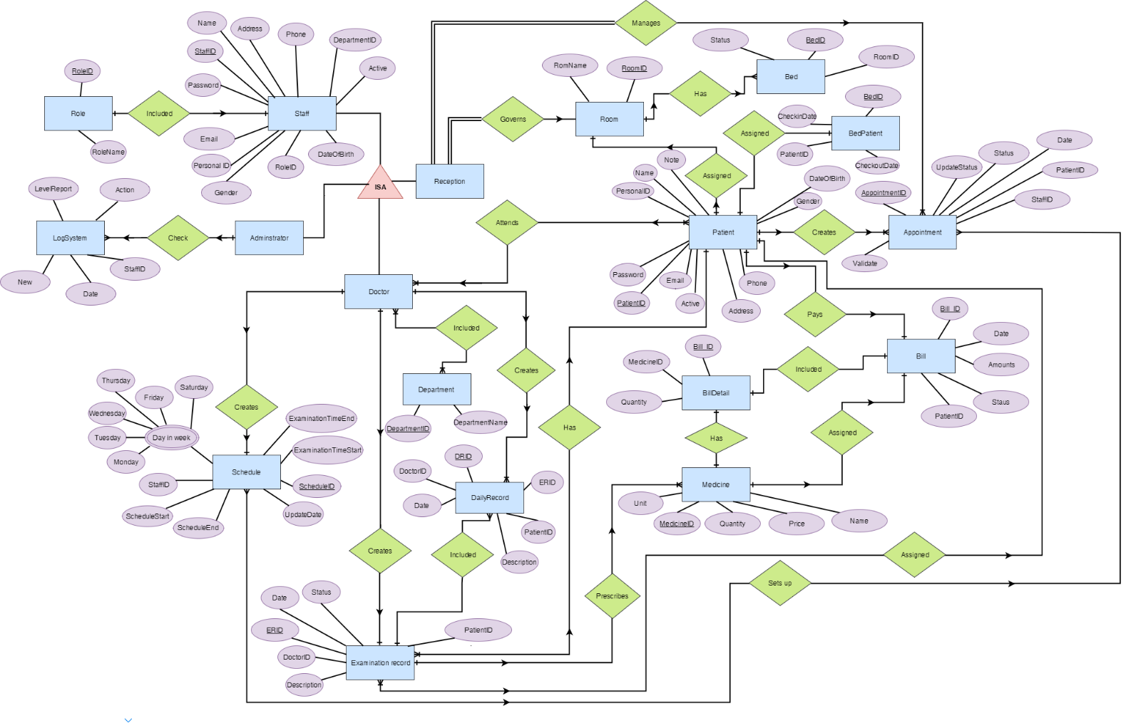

Figure 17: Entity Relationship Diagram

# CHAPTER 4: SOFTWARE DESIGN DESCRIPTION

## Purpose

The purpose of this chapter is to give the developer team a guide of the system’s architecture and how they should be implemented. This chapter includes:

* Architecture Overview
* Component Diagram
* Sequence Diagram
* Class Diagram
* User Interface Design
* Database Design

## Architecture Overview

### Choice of System Architecture

#### MVC model

Model–view–controller (MVC) is a software architectural pattern for implementing user interfaces on computers. It divides a given application into three interconnected parts. This is done to separate internal representations of information from the ways information is presented to, and accepted from, the user

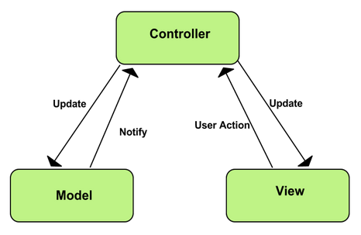

Figure 20: MVC Model

* **Model:** Model represents shape of the data and business logic. It maintains the data of the application. Model objects retrieve and store model state in a database.
* **View:** View is a user interface. View display data using model to the user and also enables them to modify the data.
* **Controller:** Controller handles the user request. Typically, user interact with View, which in-tern raises appropriate URL request, this request will be handled by a controller. The controller renders the appropriate view with the model data as a response.

#### Advantages and disadvantages of MVP model

* **Advantages**
  + **Faster development process:** MVC supports rapid and parallel development. With MVC, one programmer can work on the view while other can work on the controller to create business logic of the web application. The application developed using MVC can be three times faster than application developed using other development patterns.
  + **Ability to provide multiple views:** In the MVC Model, you can create multiple views for a model. Code duplication is very limited in MVC because it separates data and business logic from the display.
  + **Support for asynchronous technique:** MVC also supports asynchronous technique, which helps developers to develop an application that loads very fast.
  + **Modification does not affect the entire model:** Modification does not affect the entire model because model part does not depend on the views part. Therefore, any changes in the Model will not affect the entire architecture.
  + **MVC model returns the data without formatting:** MVC pattern returns data without applying any formatting so the same components can be used and called for use with any interface.
  + **SEO friendly Development platform**: Using this platform, it is very easy to develop SEO-friendly URLs to generate more visits from a specific application.
* **Disadvantages**
  + Increased complexity
  + Inefficiency of data access in view
  + Difficulty of using MVC with modern user interface.
  + Need multiple programmers
  + Knowledge on multiple technologies is required.
  + Developer have knowledge of client side code and html code.

### System Architecture

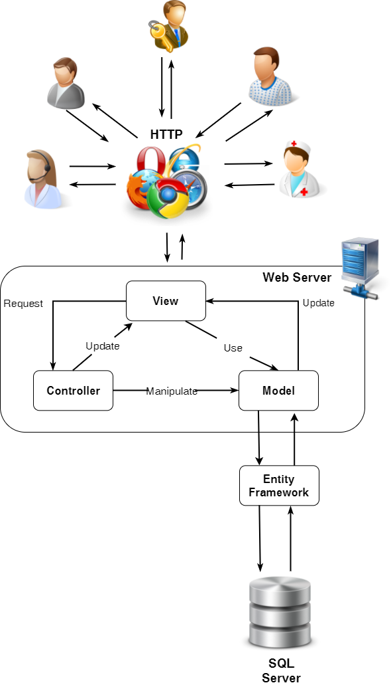

Figure 19: System Architecture Overview

## Component Diagram

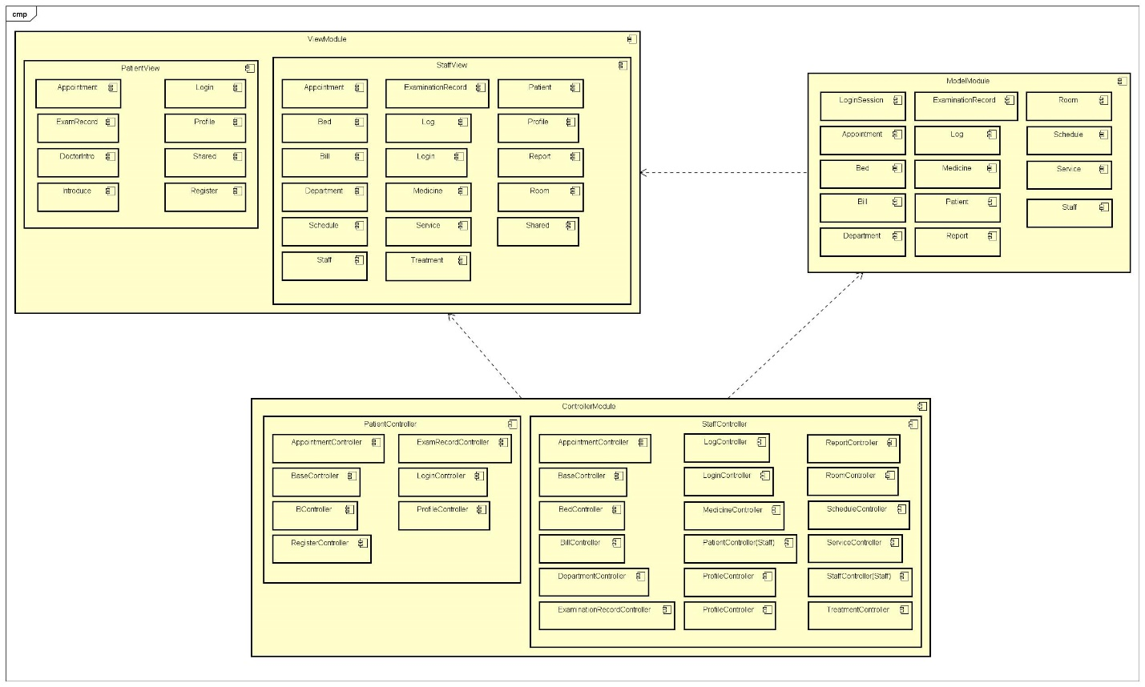

Figure 18: Component Diagram

## Sequence Diagram

Several sequence diagrams are shown in the following:

#### Register

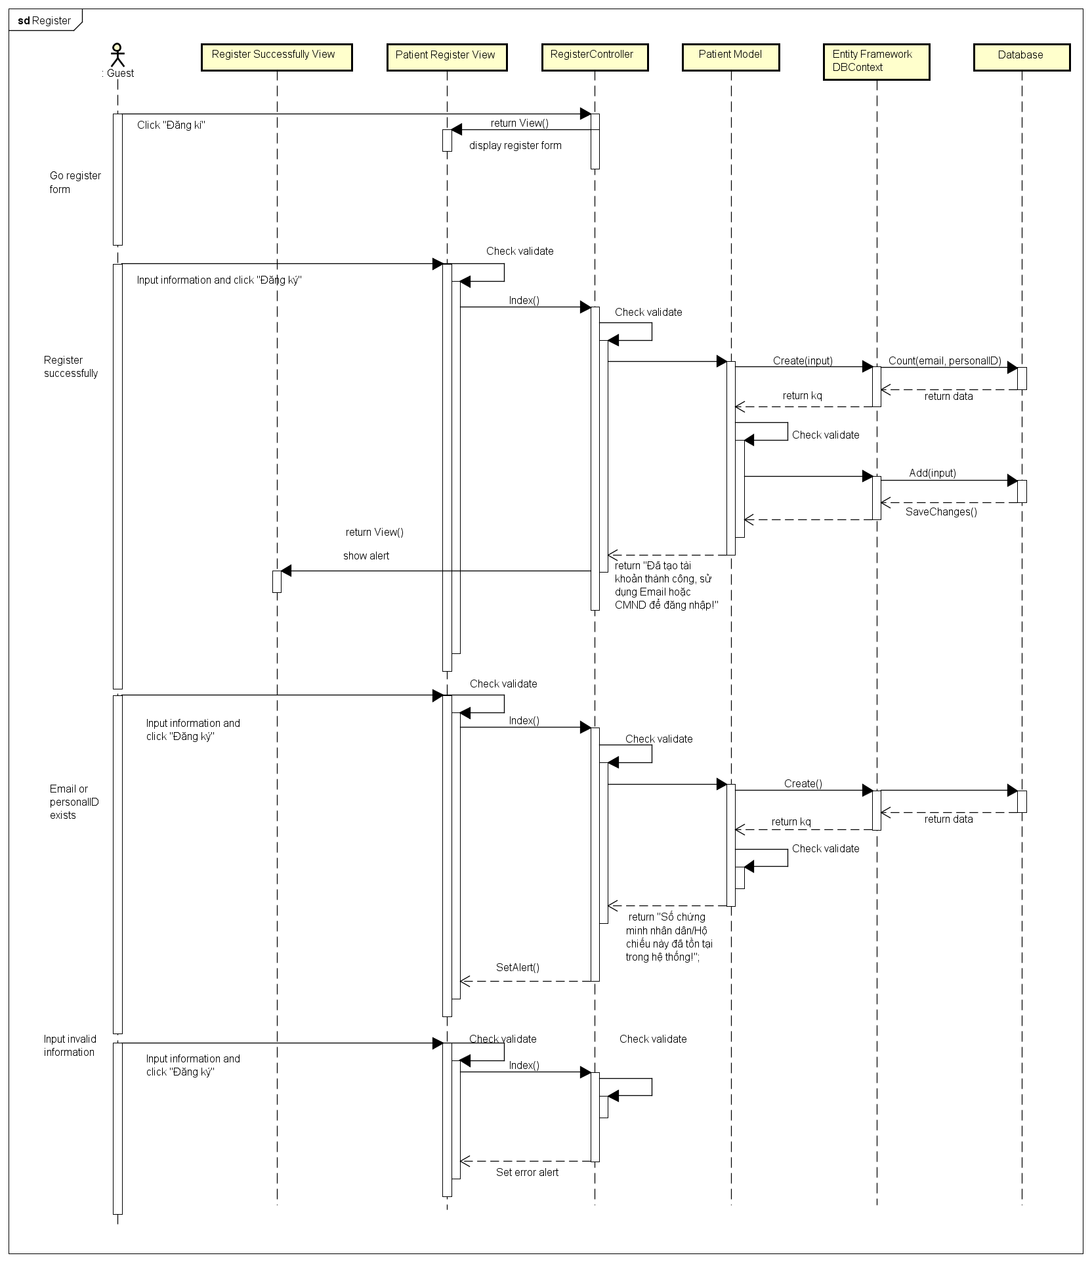

Figure 21: Register Sequence Diagram

#### Login

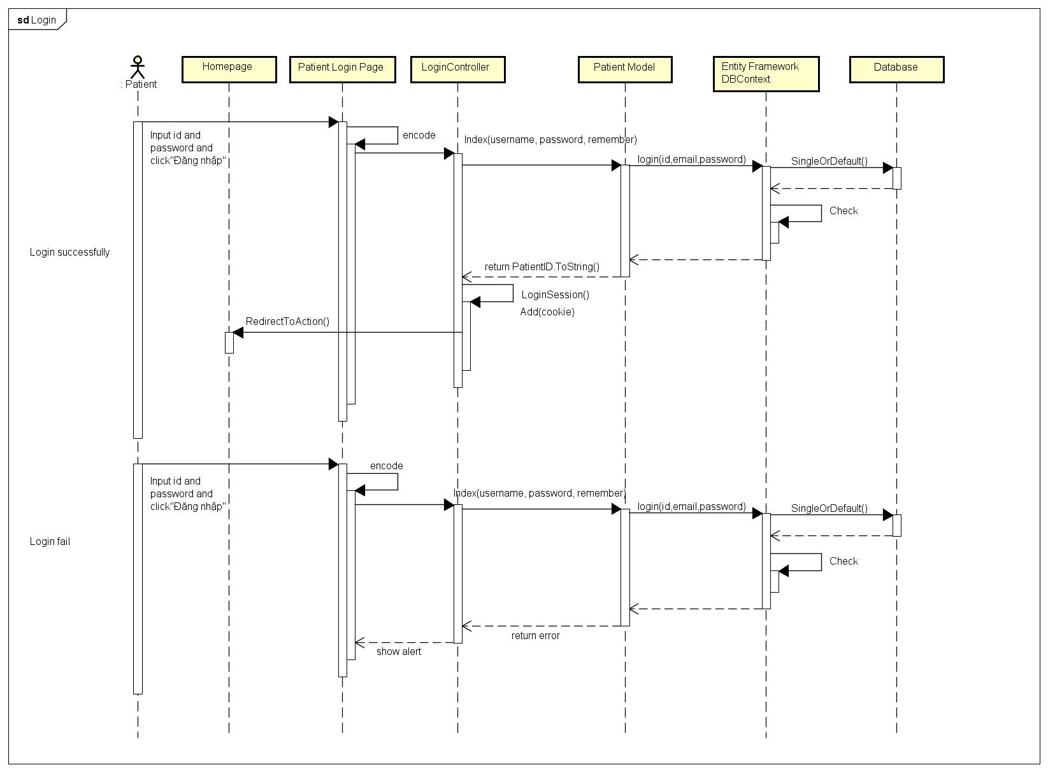

Figure 22: Patient Login Sequence Diagram

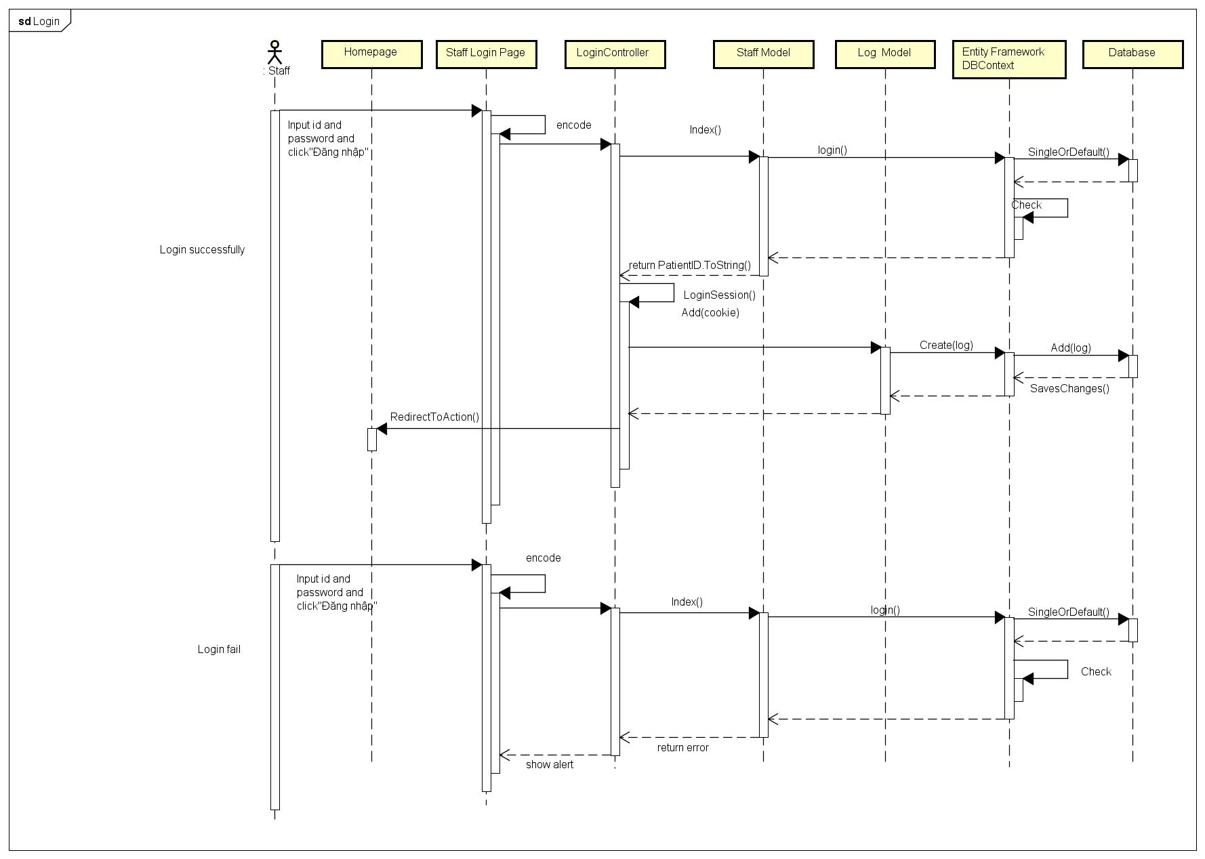

Figure 23: Staff Login Sequence Diagram

#### LogOut

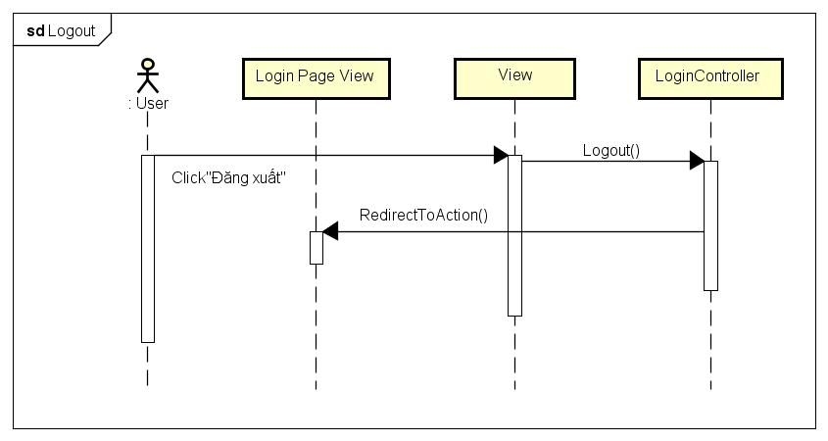

Figure 24: Log Out Sequence Diagram

#### Change password

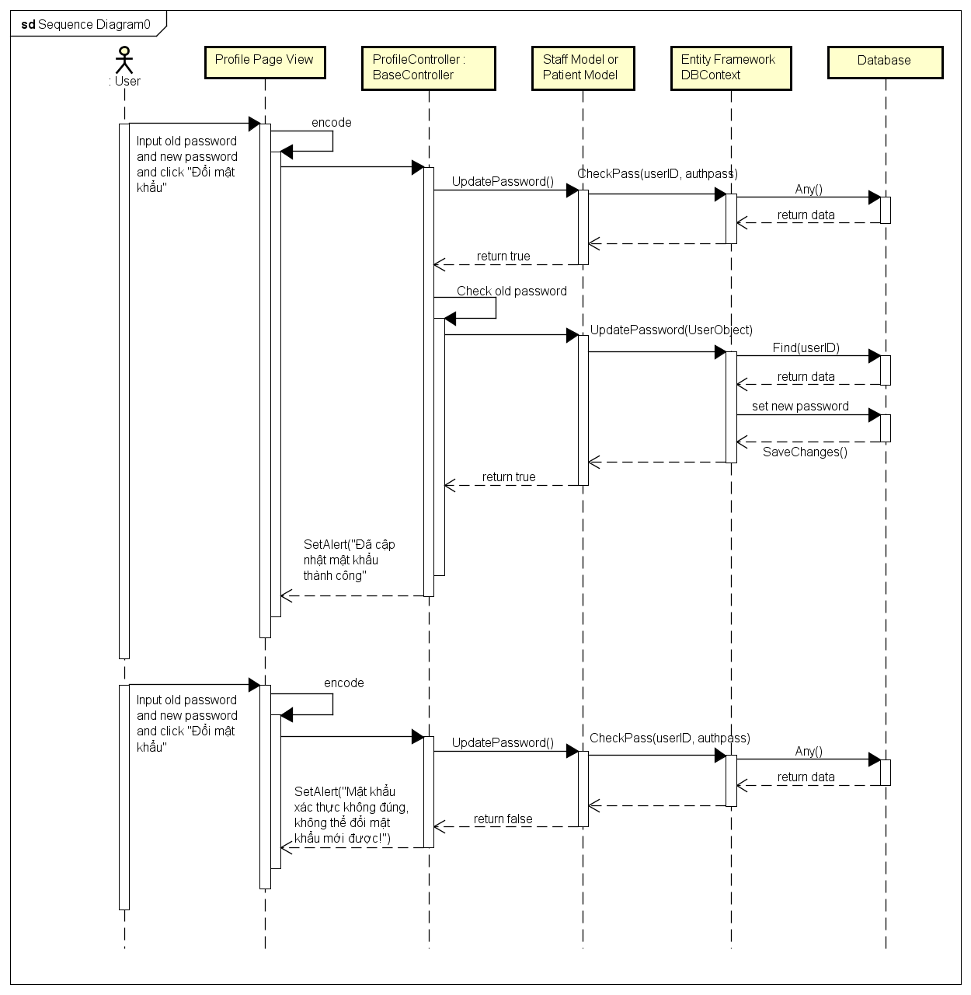

Figure 25: Change Password Sequence Diagram

#### View Profile

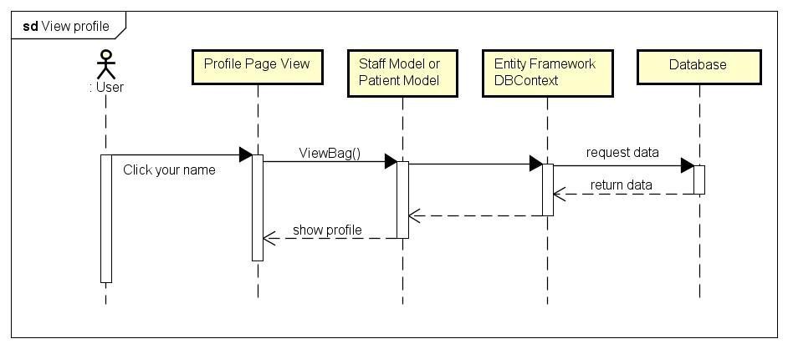

Figure 26: View Profile Sequence Diagram

#### Edit Profile

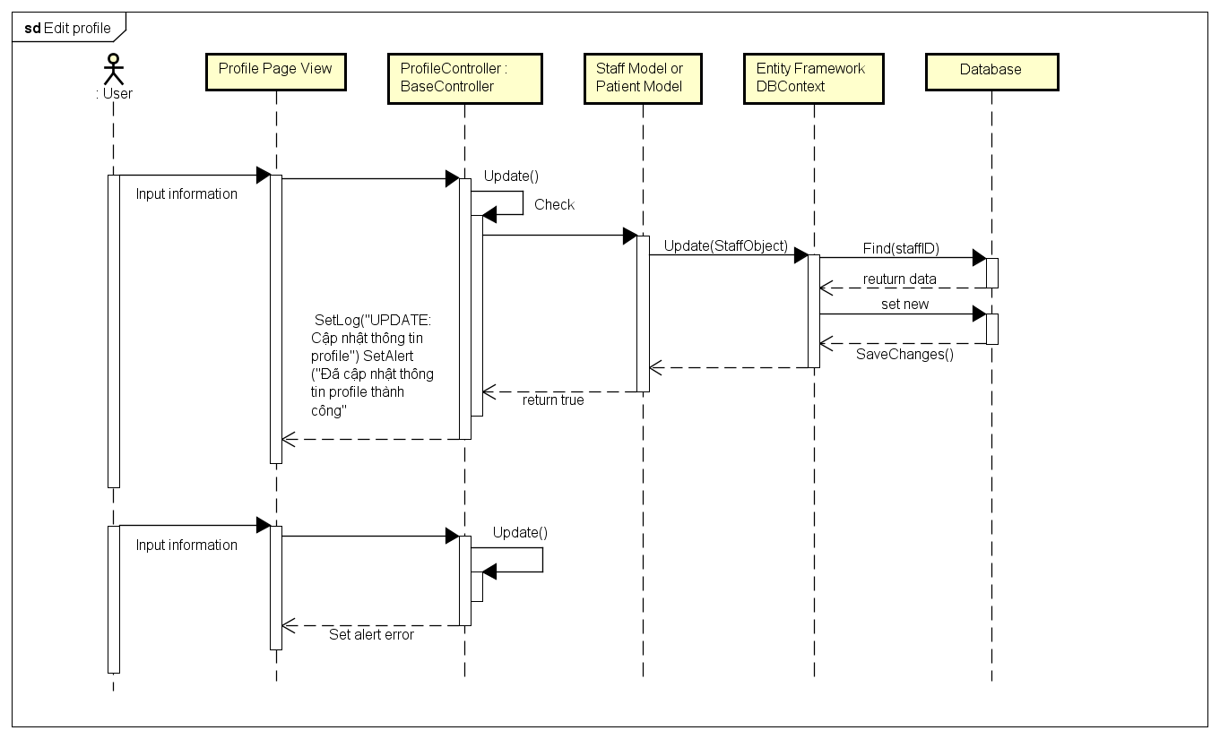

Figure 27: Edit Profile Sequence Diagram

#### Create Appointment

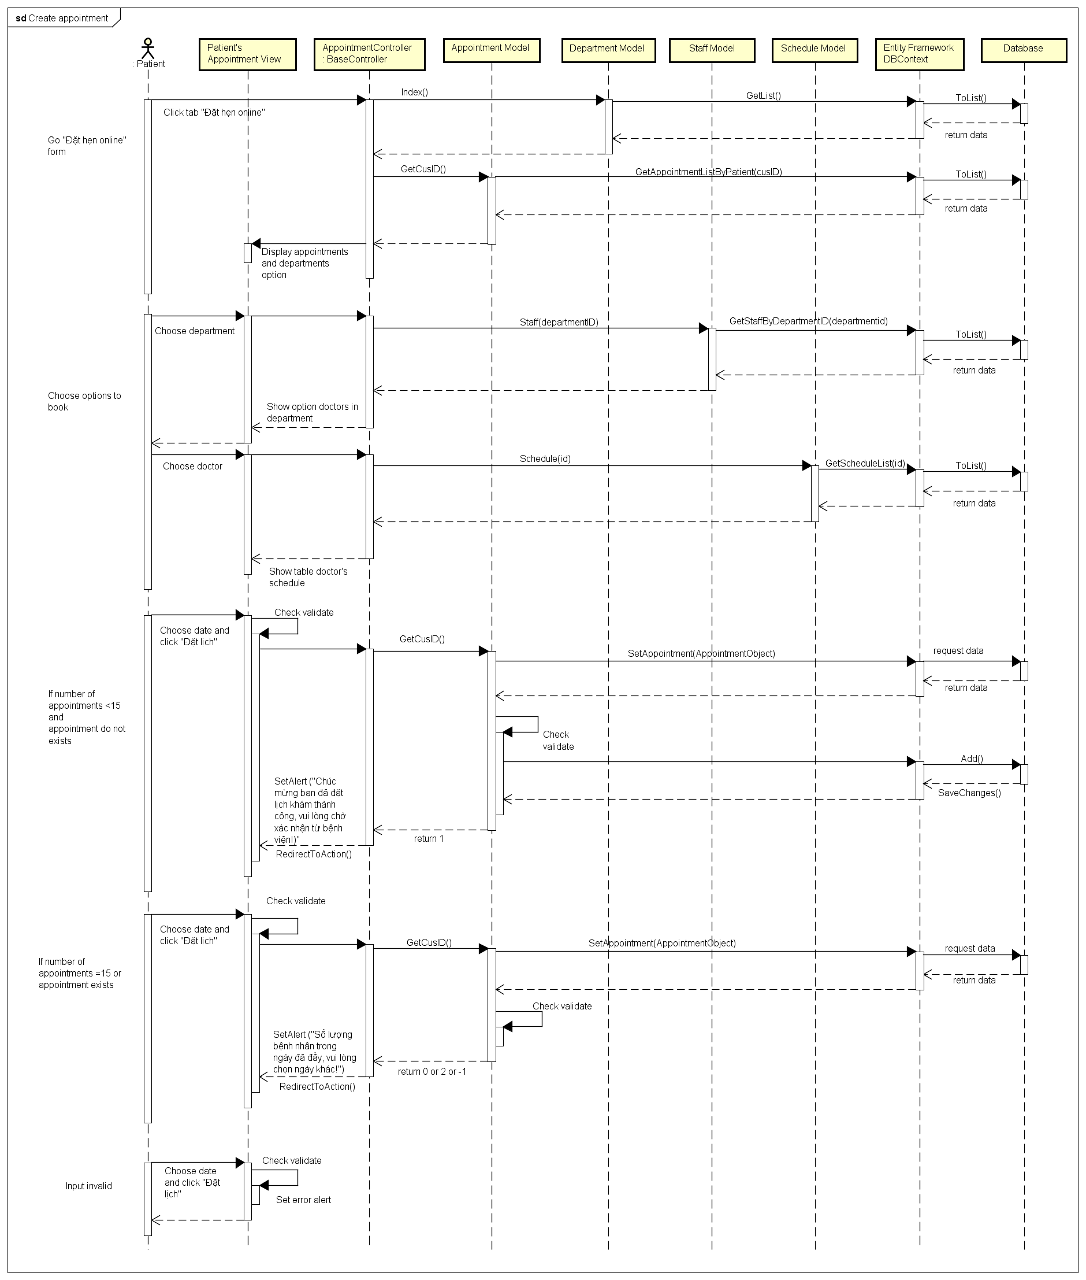

Figure 28: Create Appointment Sequence Diagram

#### View Appointment

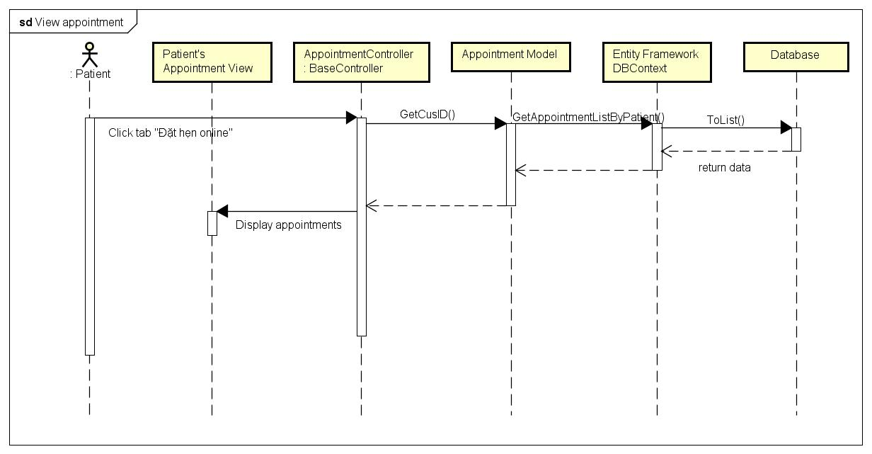

Figure 29: View Appointment Sequence Diagram

#### Edit Appointment

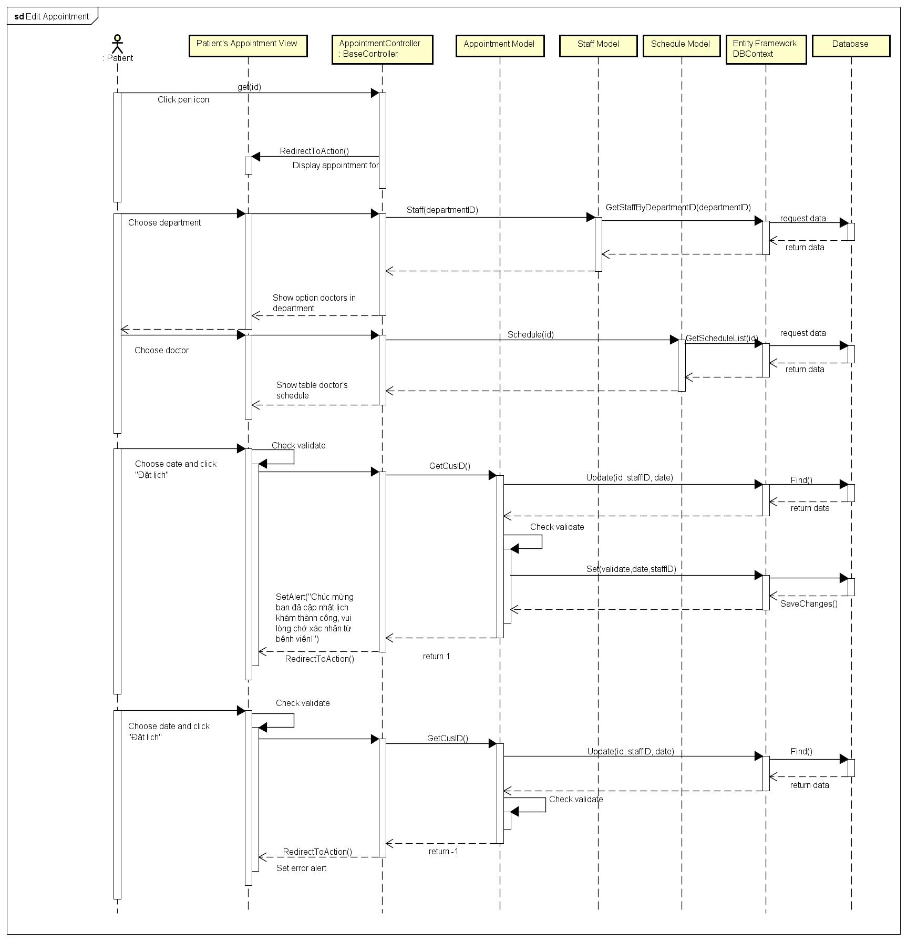

Figure 30: Edit appointment Sequence Diagram

#### Delete Appointment

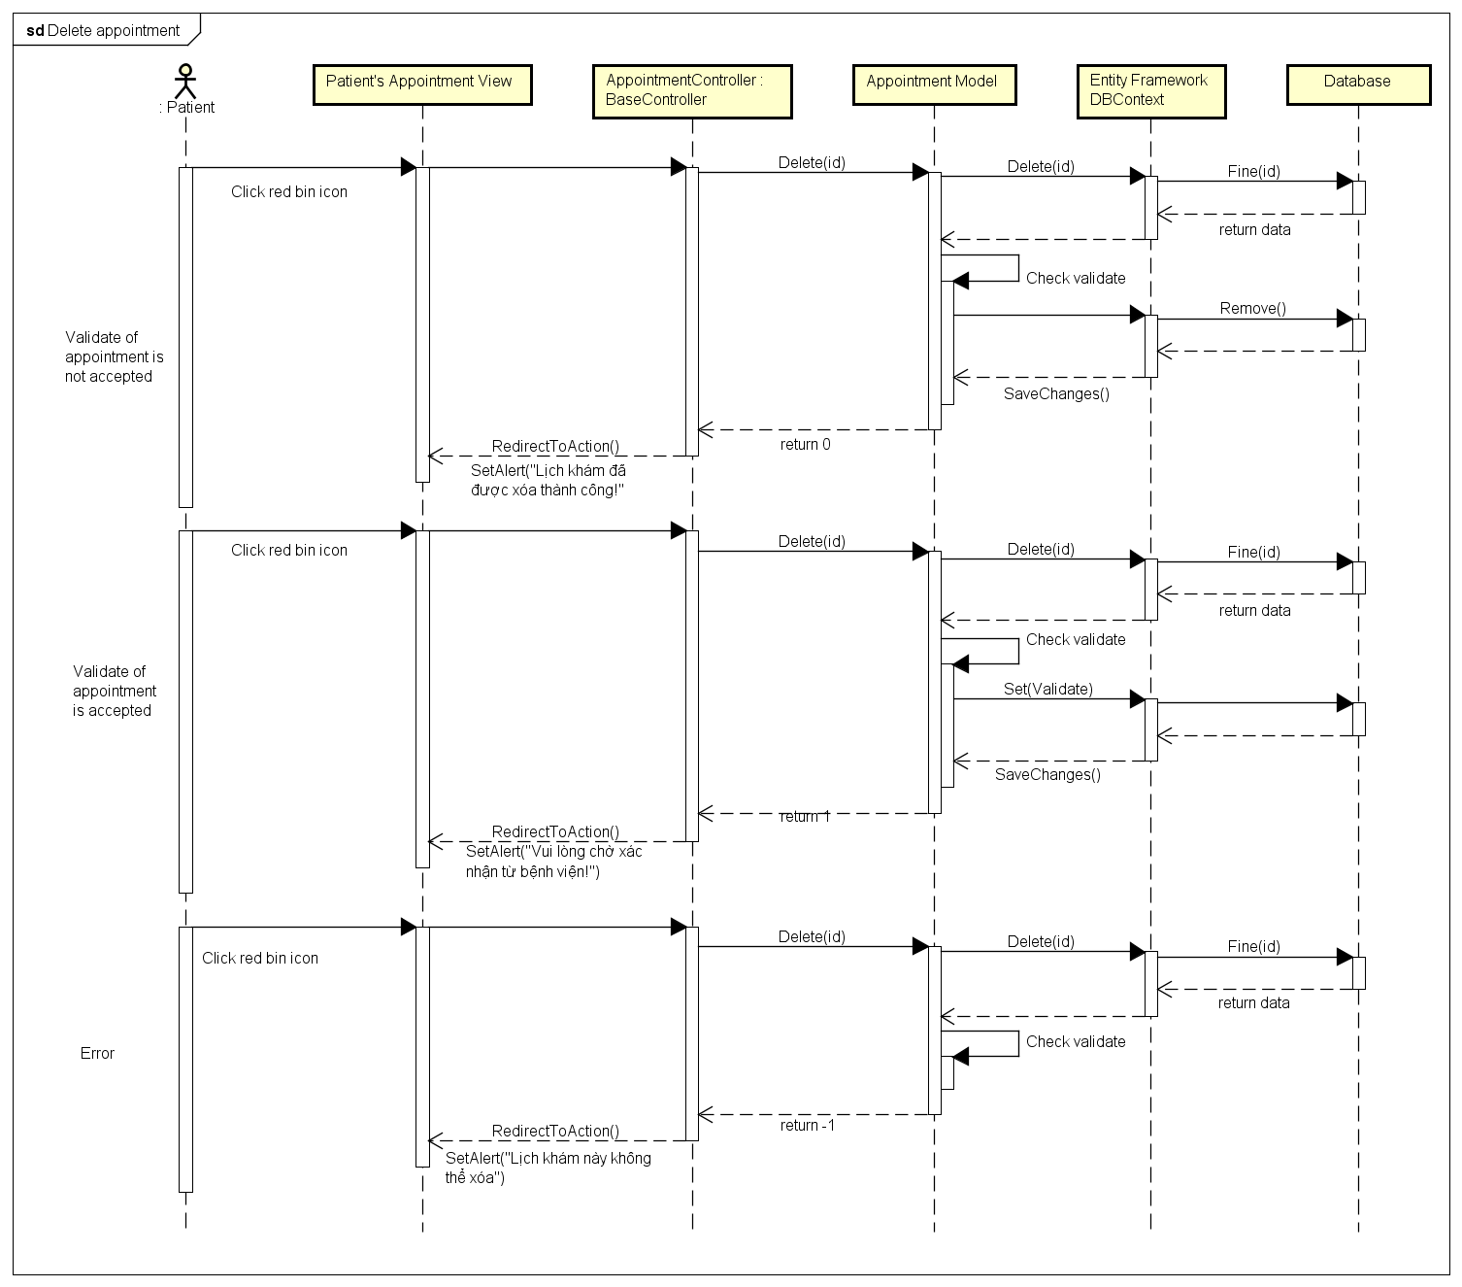

Figure 31: Delete Appointment Sequence Diagram

#### View Examination Record

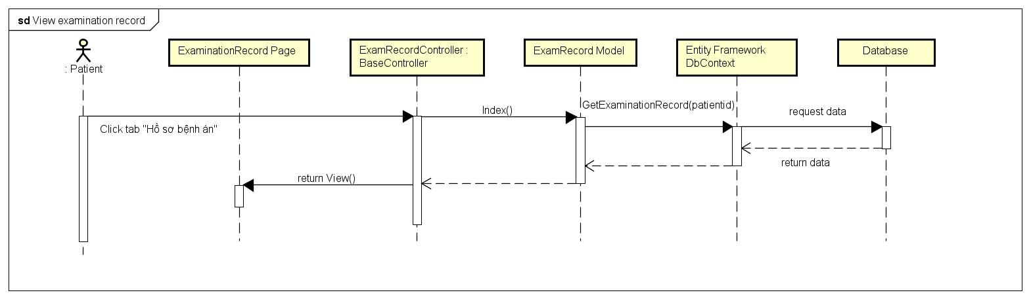

Figure 32: View Examination Sequence Diagram

#### Create Schedule

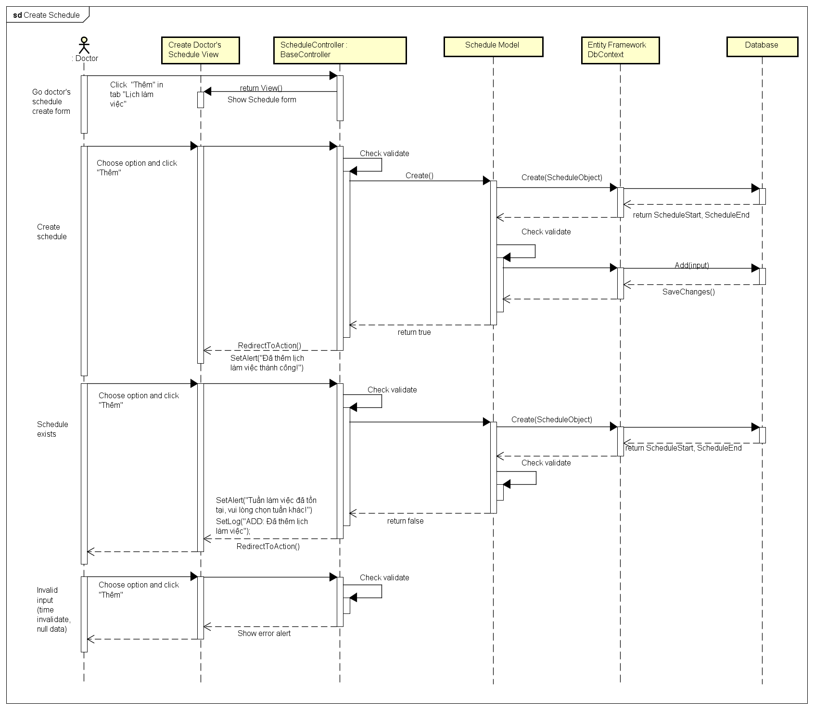

Figure 33: Create Schedule Sequence Diagram

#### View schedule

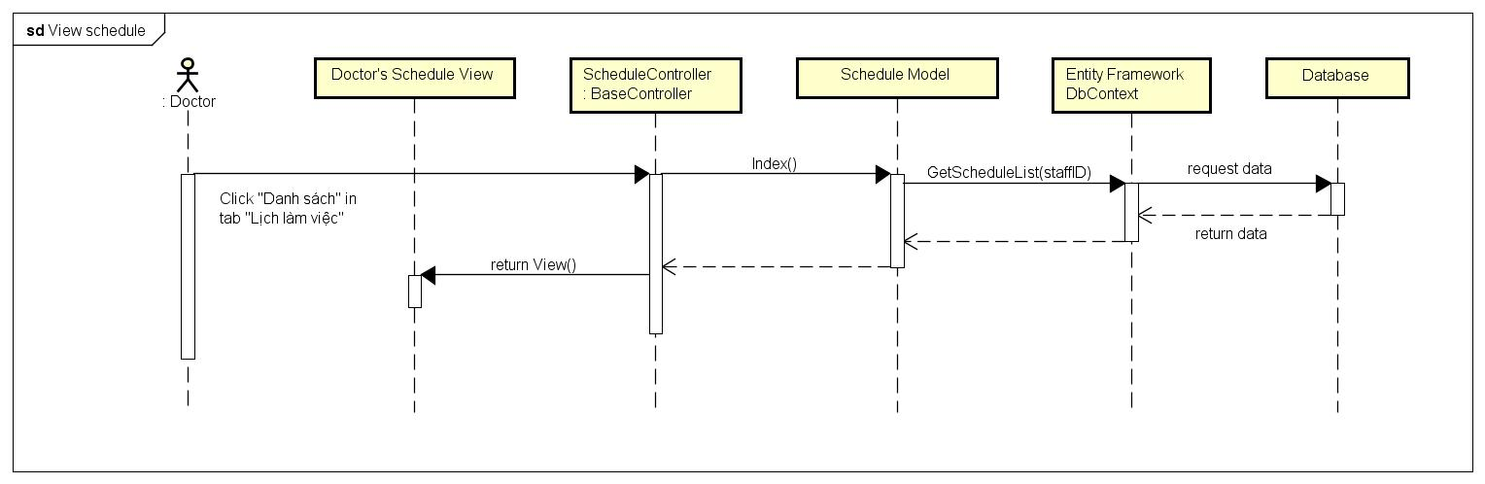

Figure 34: View Schedule Sequence Diagram

#### Edit Schedule

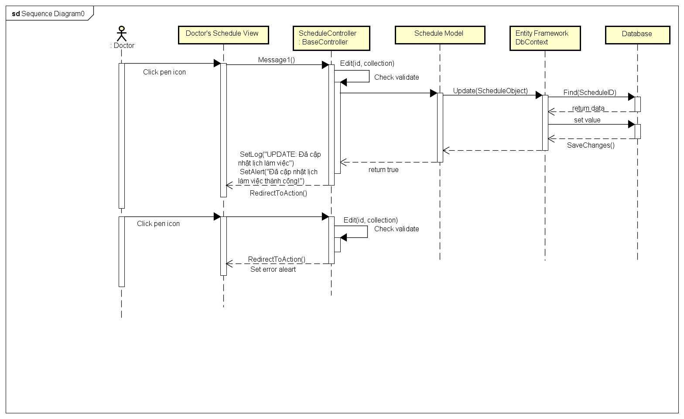

Figure 35: Edit Schedule Sequence Diagram

#### View Appointment

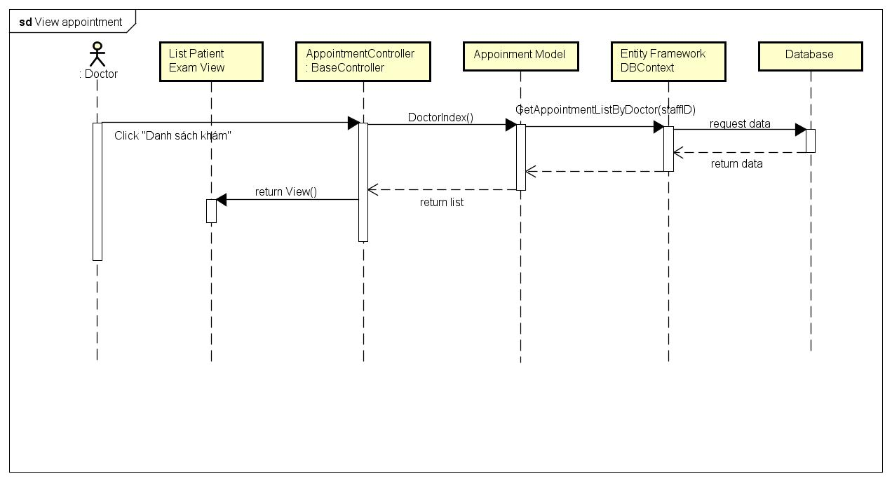

Figure 36: View Appointment Sequence Diagram

#### Create Examination Record

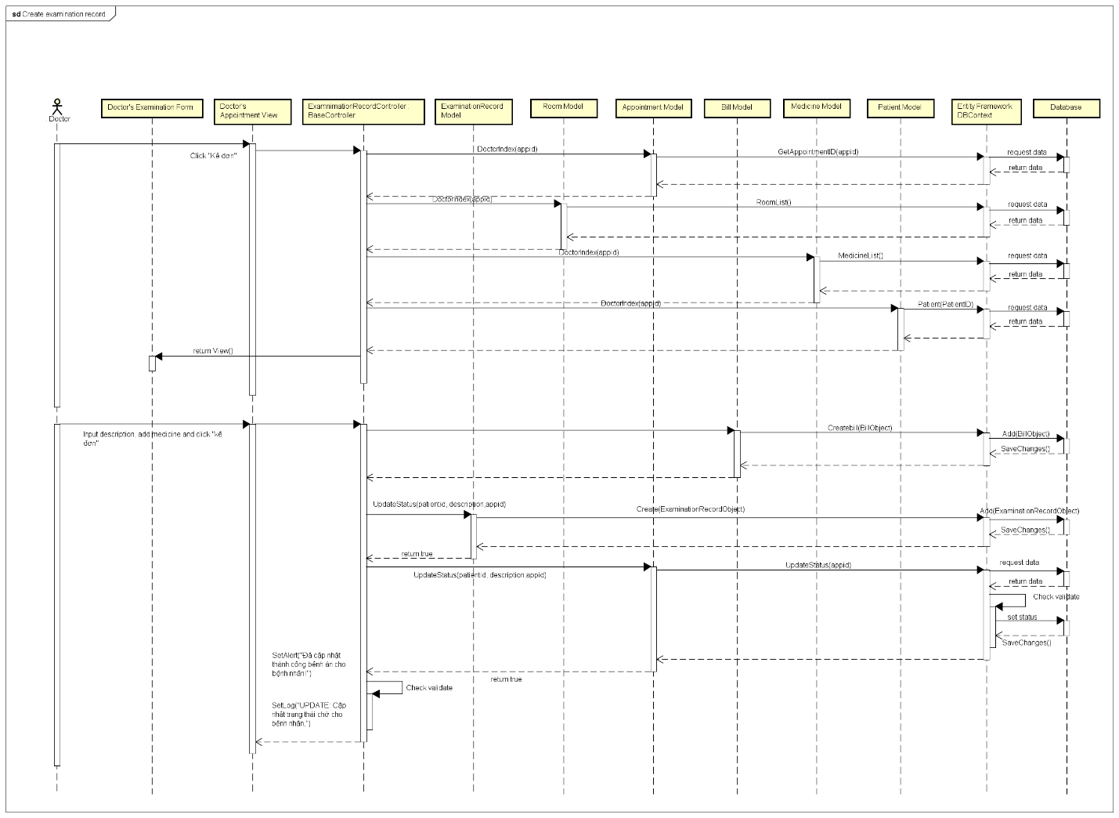

Figure 37: Create Examination Record Sequence Diagram

#### Create Direct Appointment

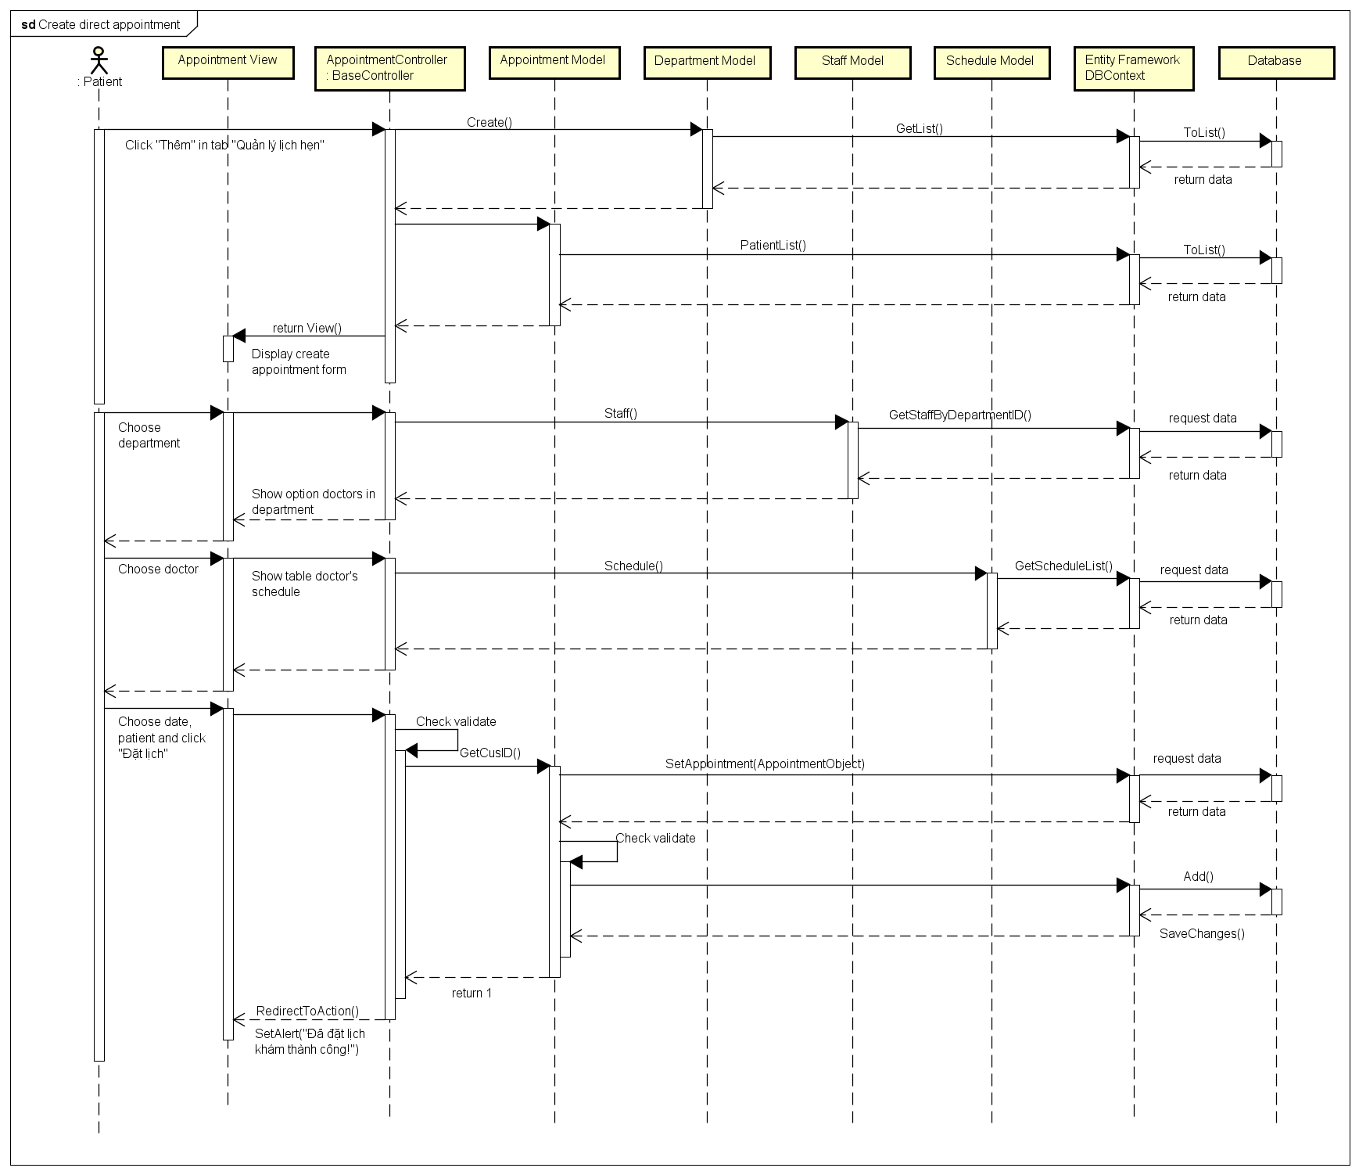

Figure 38: Create Direct Appointment Sequence Diagram

#### Accept Appointment

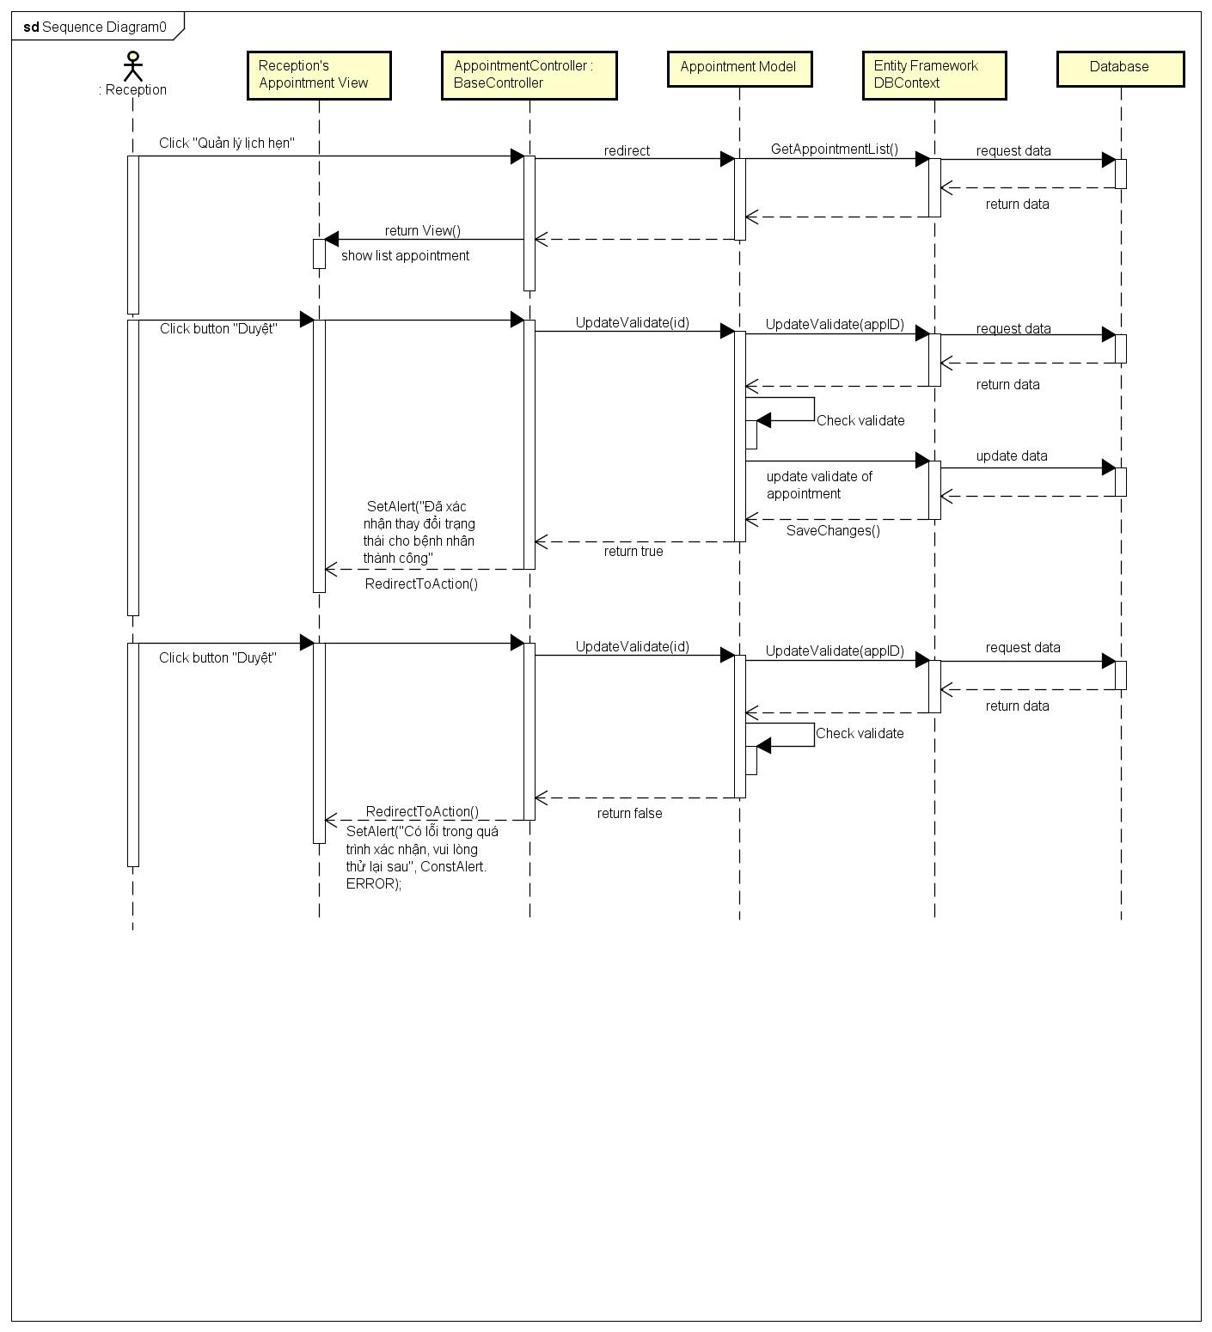

Figure 39: Accept Appointment Sequence Diagram

#### Delete Appointment

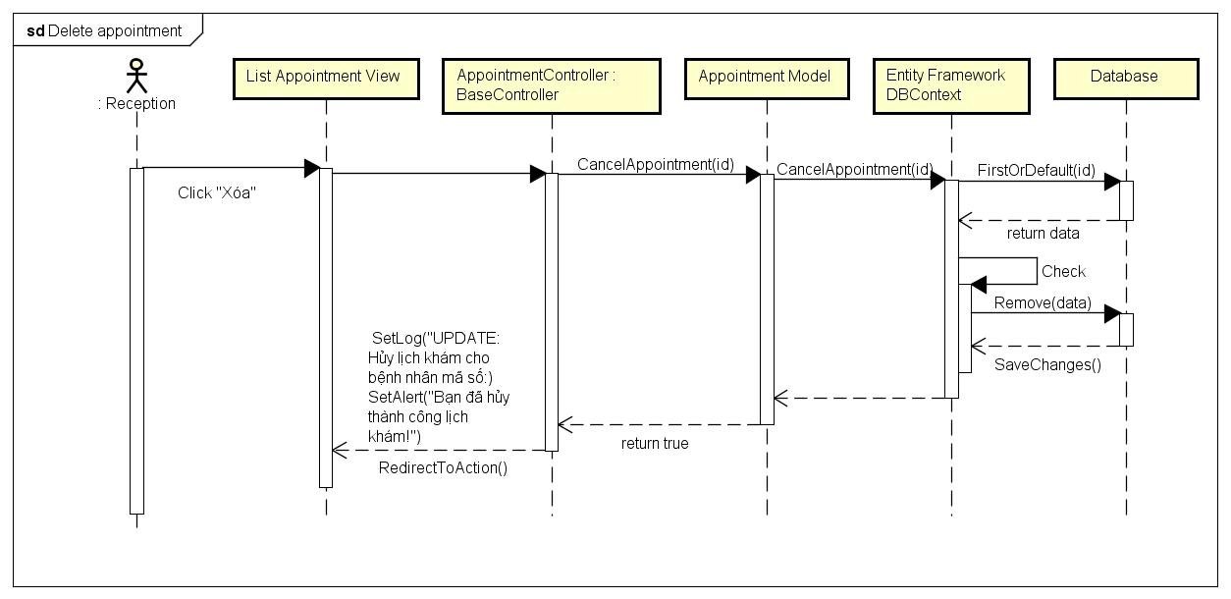

Figure 40: Delete Appointment Sequence Diagram

#### View Doctor Schedule

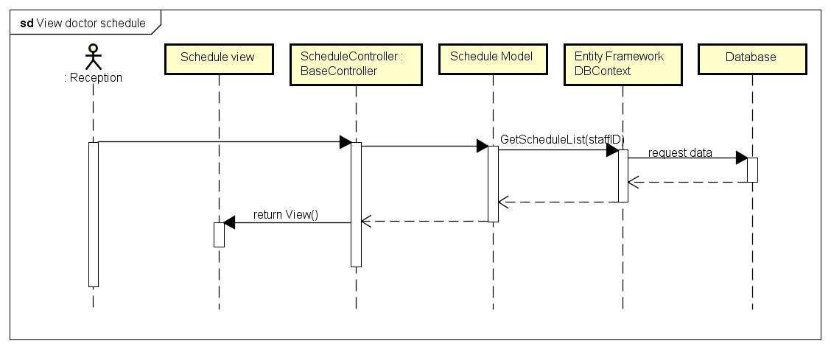

Figure 41: View Doctor Schedule Sequence Diagram

#### Accept Doctor Schedule

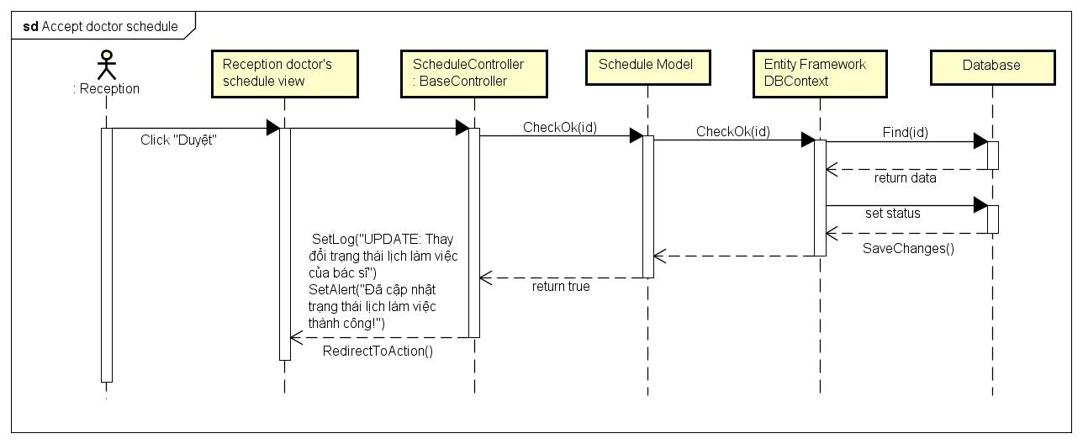

Figure 42: Accept Doctor Scheduler Sequence Diagram

#### View Examination Record

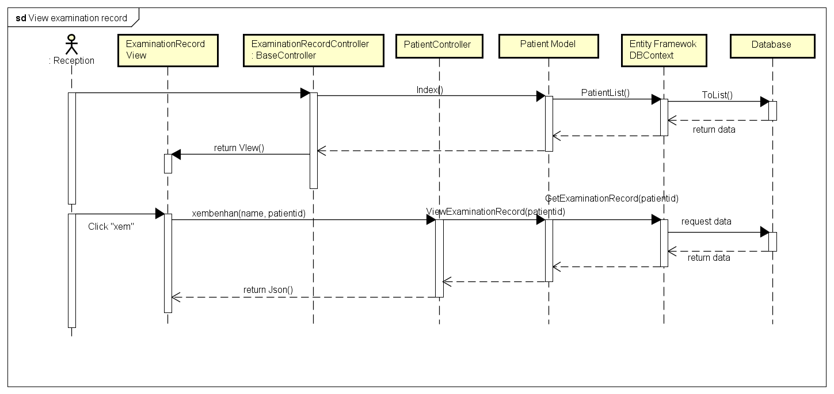

Figure 43: View Examination Record Sequence Diagram

#### Create Bill

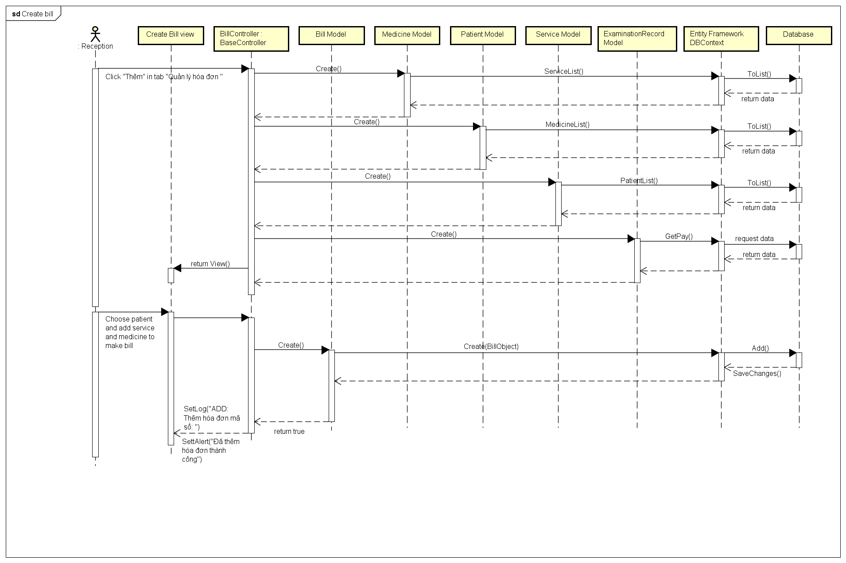

Figure 44: Create Bill Sequence Diagram

#### Finish Bill

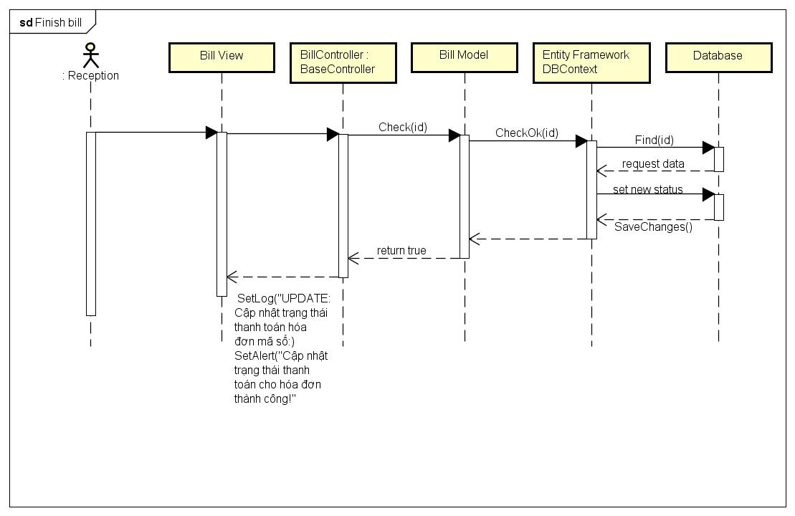

Figure 45: Finish Bill Sequence Diagram

#### Delete Bill

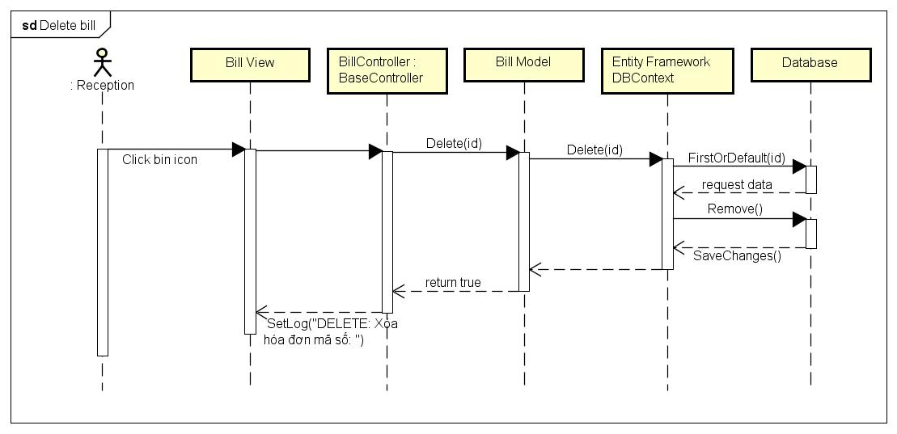

Figure 46: Delete Bill Sequence Diagram

#### View Bill

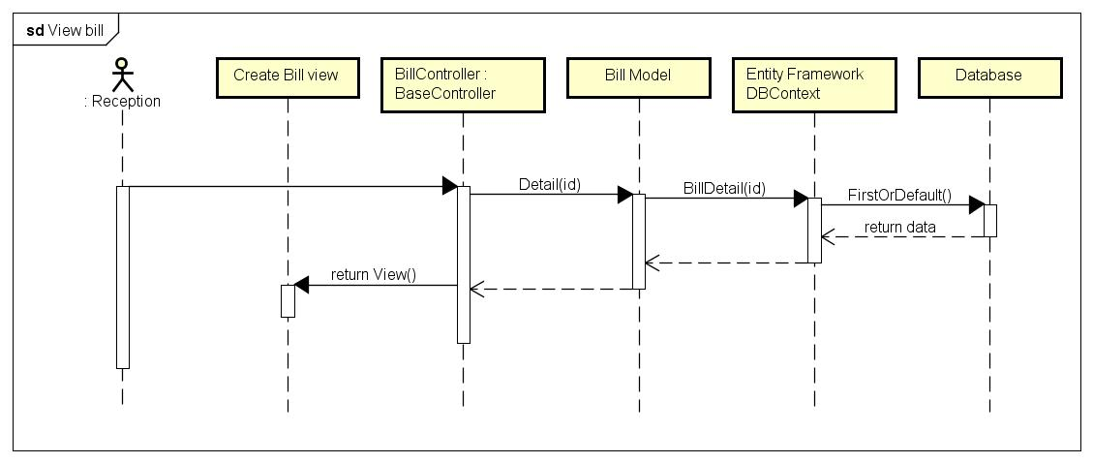

Figure 47: View Bill Sequence Diagram

#### Check-in To Exam

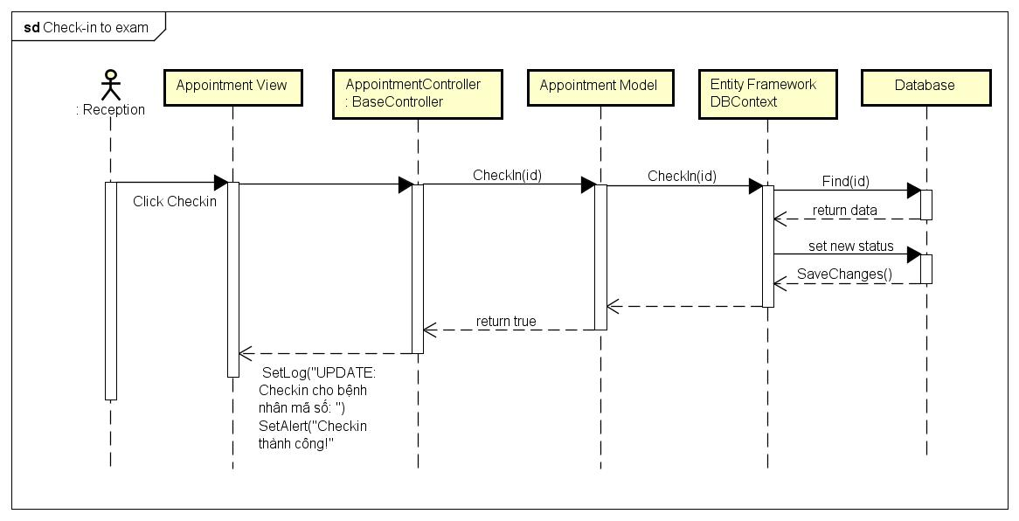

Figure 48: Check-in To Exam Sequence Diagram

#### Check-in bed

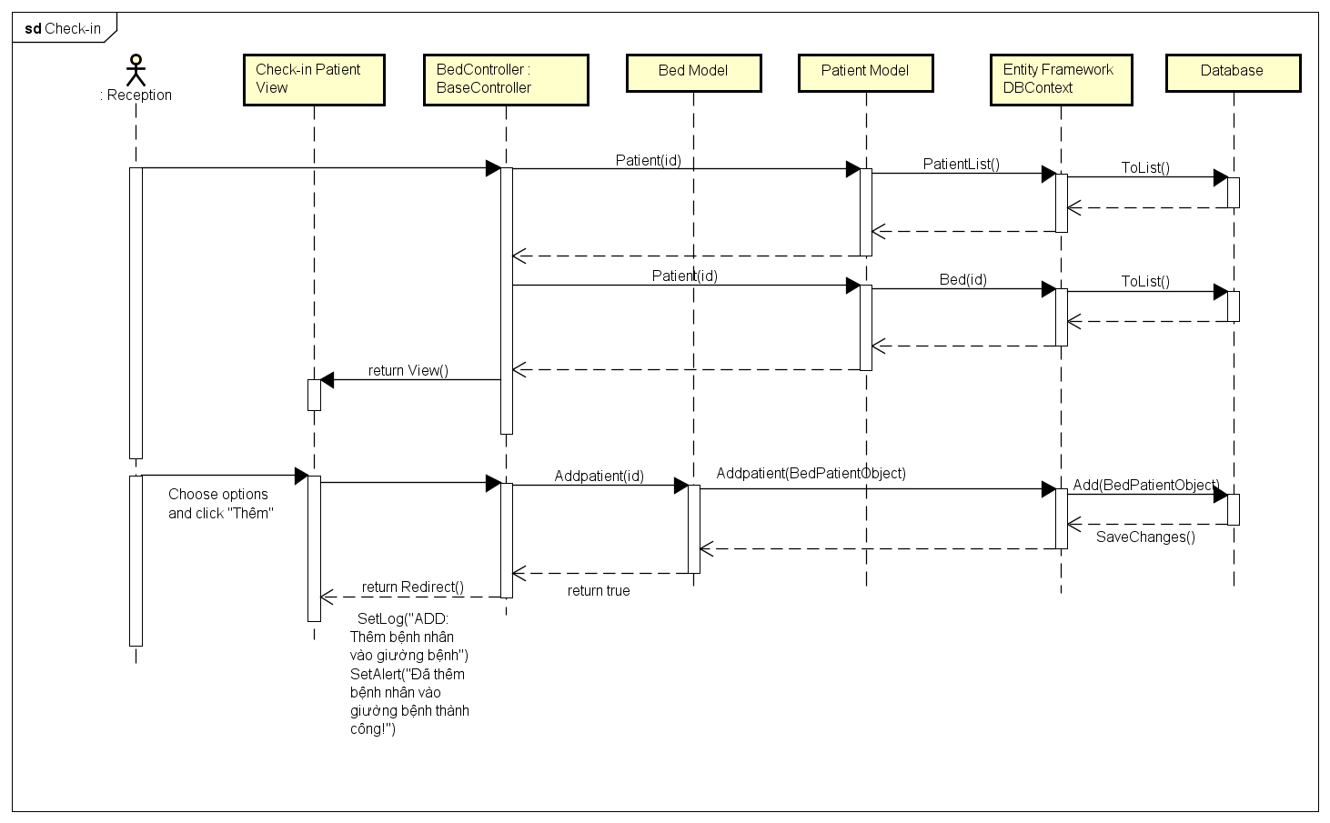

Figure 49: Check-in Bed Sequence Diagram

#### Check-out Bed

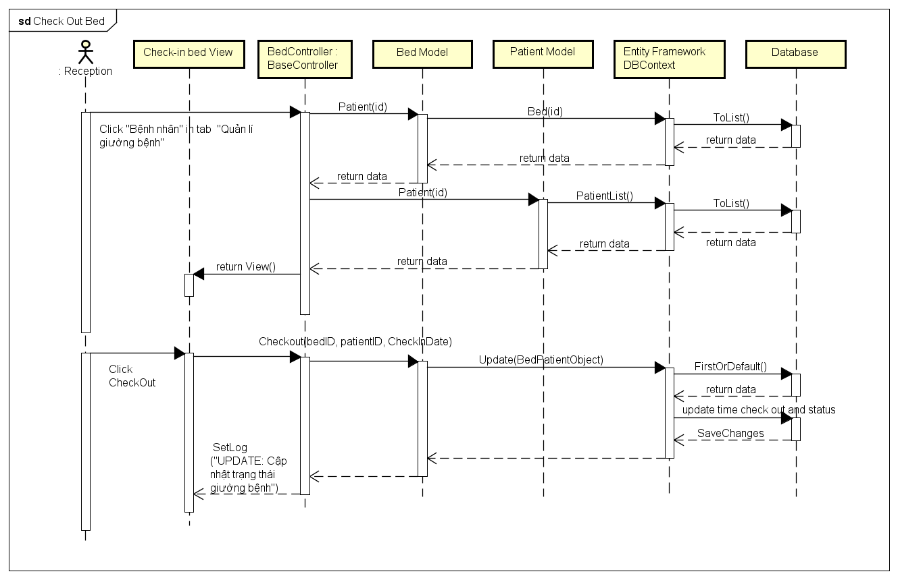

Figure 50: Check-out Bed Sequence Diagram

#### Ban Patient Account

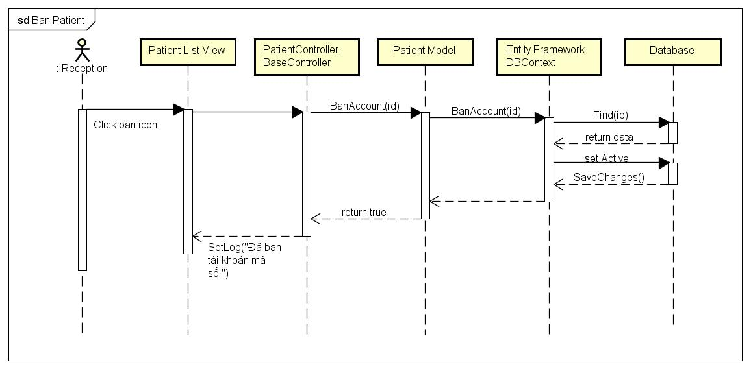

Figure 51: Ban Patient Account Sequence Diagram

#### View Patient Account

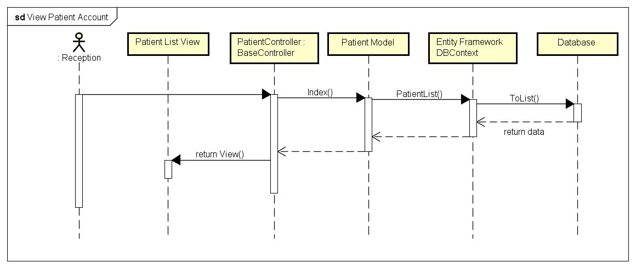

Figure 52: View Patient Account Sequence Diagram

#### Create Medicine

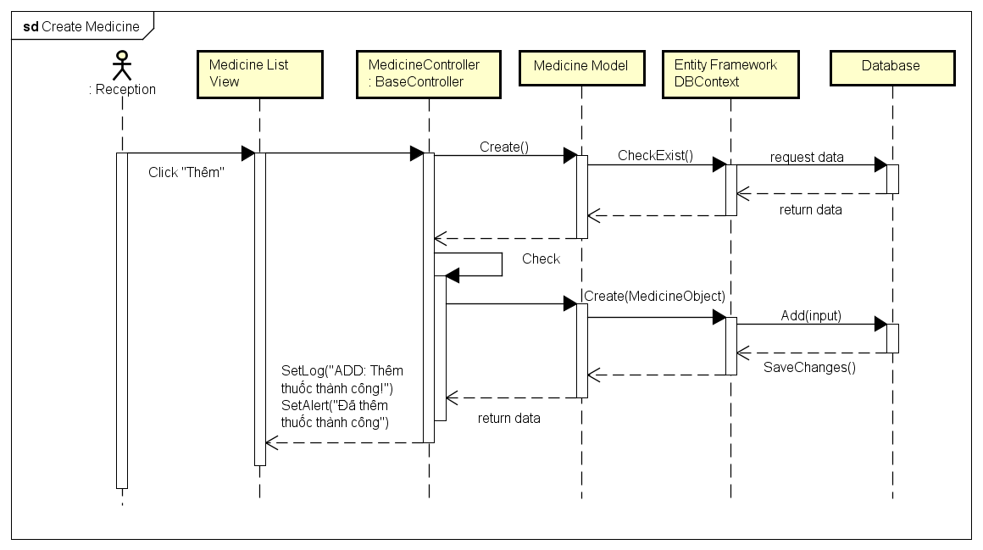

Figure 53: Create Medicine Sequence Diagram

#### Delete Medicine

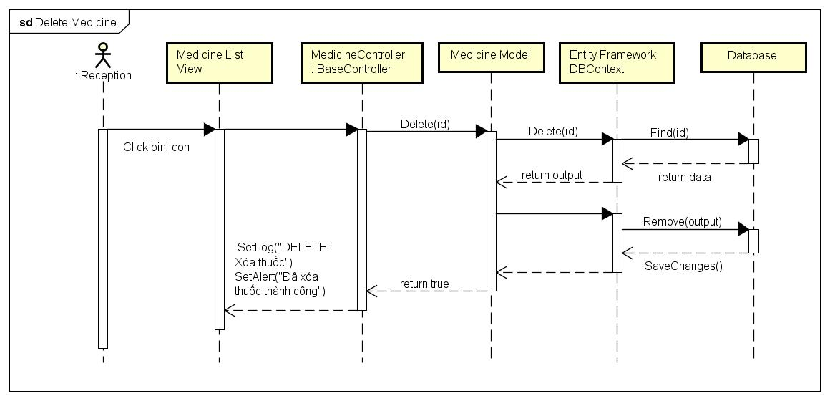

Figure 54: Delete Medicine Sequence Diagram

#### View Medicine

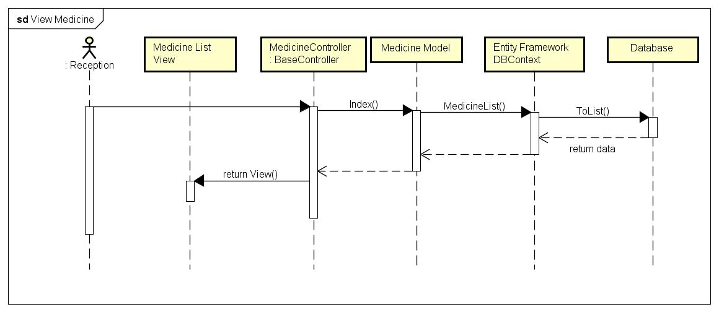

Figure 55: View Medicine Sequence Diagram

#### Create Room

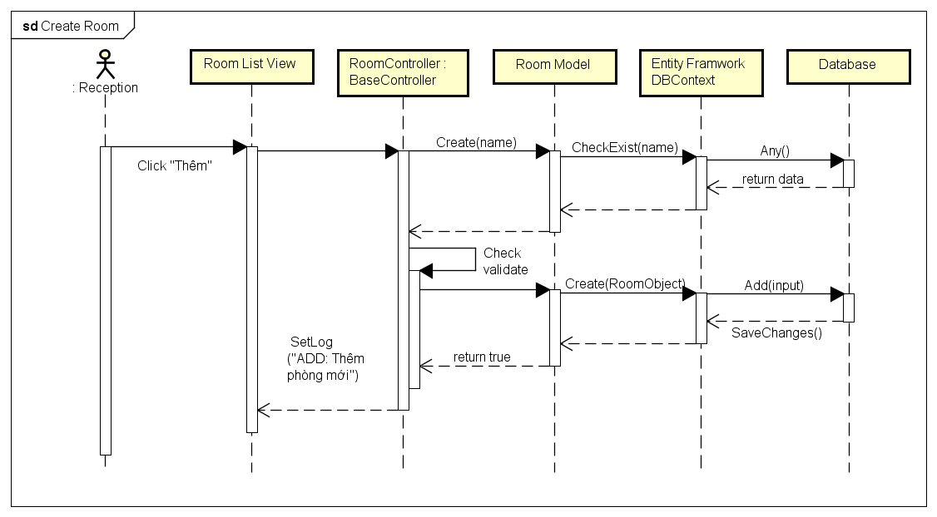

Figure 56: Create Room Sequence Diagram

#### Delete Room

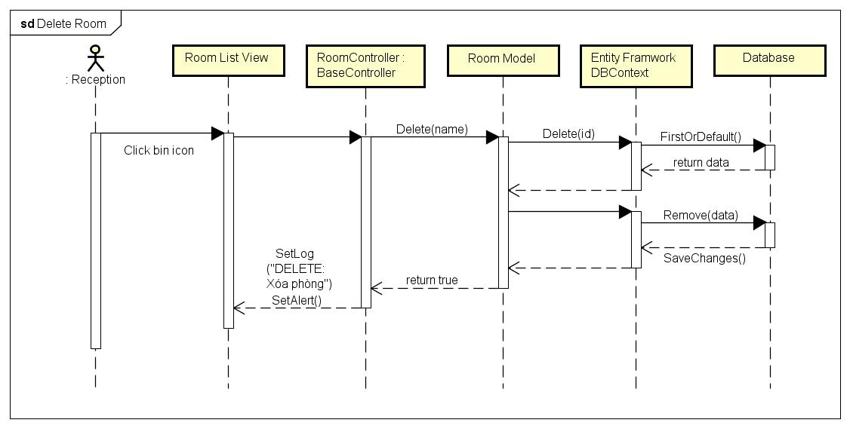

Figure 57: Delete Room Sequence Diagram

#### View Room

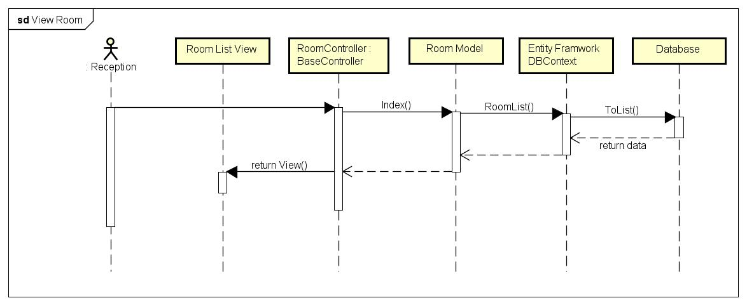

Figure 58: View Room Sequence Diagram

#### Create Staff Account

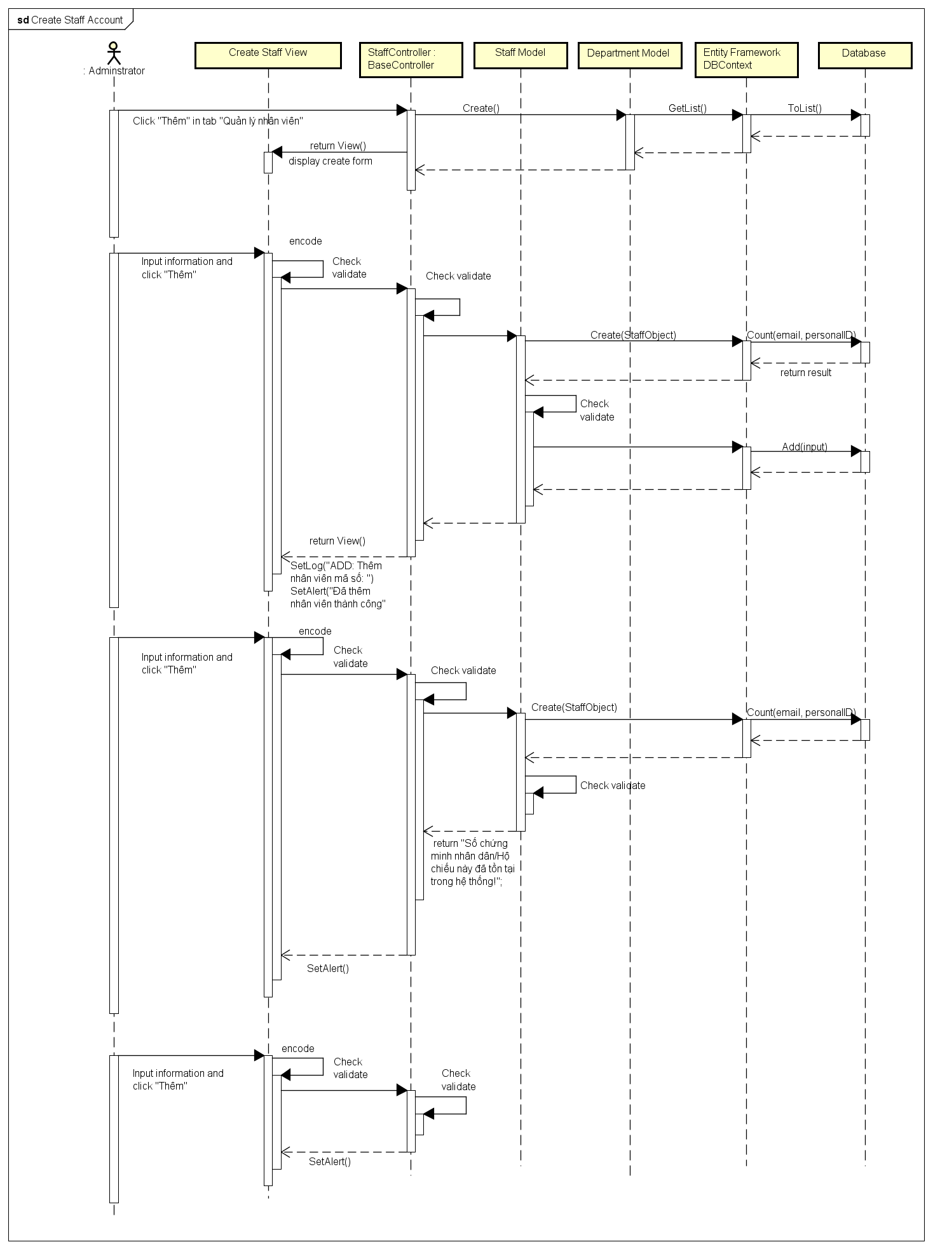

Figure 59: Create Staff Account Sequence Diagram

#### Delete Staff Account

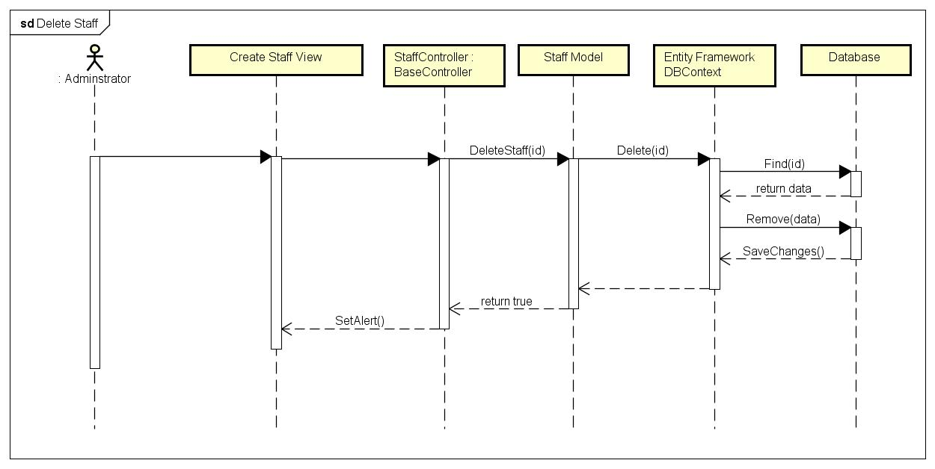

Figure 60: Delete Staff Account Sequence Diagram

#### View Staff Account

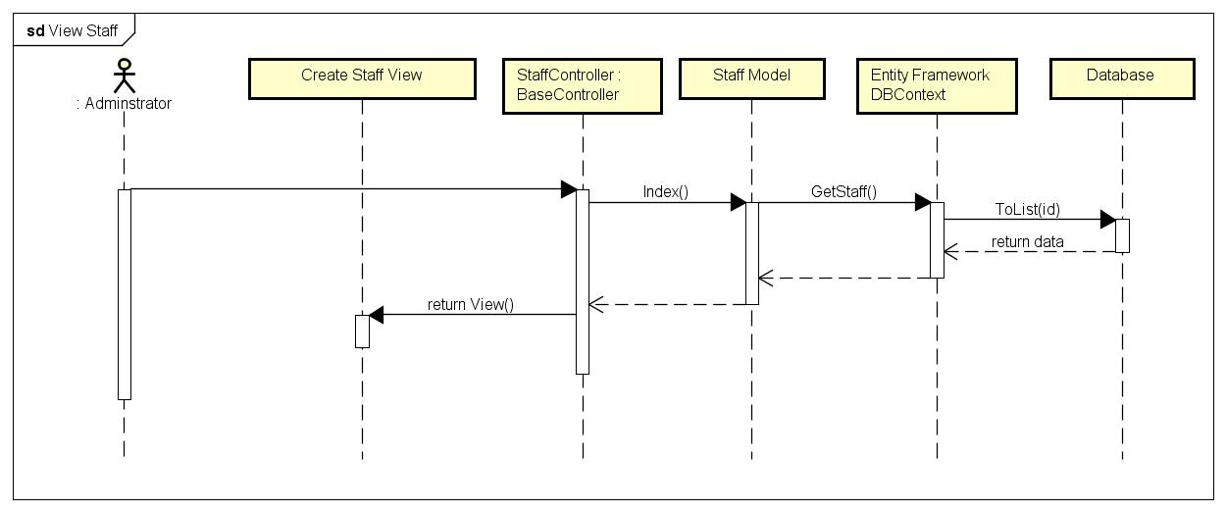

Figure 61: View Staff Account Sequence Diagram

#### View Action History

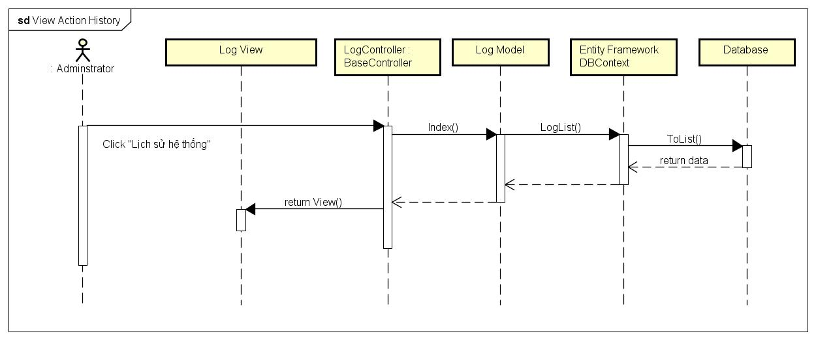

Figure 62: View Action Hitory Sequence Diagram

#### Clean Action History

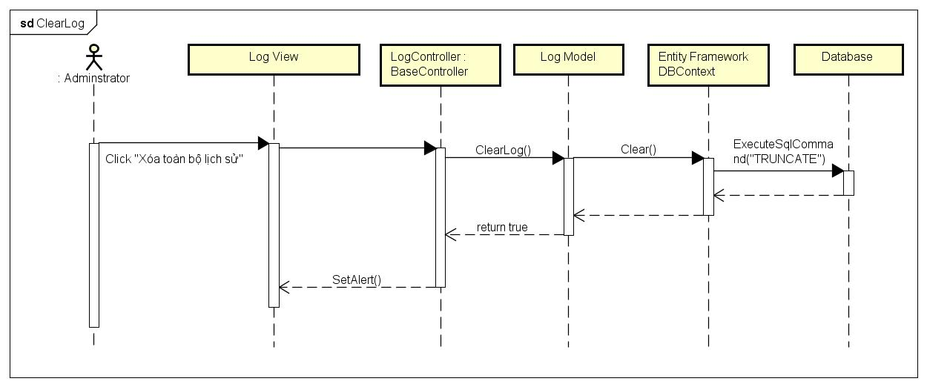

Figure 63: Clean Action Hitory Sequence Diagram

## CRC Cards and Class Diagram

### CRC Cards

| AdminAppointmentController | |
| --- | --- |
| Responsibilities | Collaborators |
| Get list of appointments | GetAppointmentList  Param  NormalRequest  GetAppointmentListRequestData  View |
| Get list of rooms | GetRoomList  Param  NormalRequest  GetRoomListRequestData  View |
| Get list of appointments by doctor | GetAppointmentListByDoctor  Param  NormalRequest  GetByIDRequestData  View |
| Update validate | UpdateValidate  Param  NormalRequest  UpdateValidateRequestData  Response |
| Cancel validate | CancelValidate  Param  NormalRequest  CancelValidateRequestData  Response |
| Update status of appointment | UpdateStatusOfAppointment  Param  NormalRequest  UpdateStatusRequestData  Response |
| Cancel appointment | CancelAppointmentByID  Param  NormalRequest  GetByIDRequestData  Reponse |
| Check in | CheckInById  Param  NormalRequest  GetByIDRequestData  Response |

|  |  |
| --- | --- |
| Absent | AbsentByID  Param  NormalRequest  GetByIDRequestData  Reponse |
| Create appointments | CreateAppointment  Param  NormalRequest |
| Create appointments | CreateAppointment  Param  NormalRequest  CreateAppointmentRequestData |
| Get staff by department id | GetStaffByDepartmentID  Param  NormalRequest  GetByIDRequestData  Response |
| Get schedule of doctor | GetScheduleByID  Param  NormalRequest  GetByID  Reponse |

| AdminGetAppointmentList | |
| --- | --- |
| Responsibilities | Collaborators |
| Authenticate user identity and authorize user privileges |  |
| Validate request data |  |
| Get list of appointments | AppointmentDAO |
| Return response | ResponseCode GetAppointmentListResponseData |

| AdminGetRoomList | |
| --- | --- |
| Responsibilities | Collaborators |
| Authenticate user identity and authorize user privileges |  |
| Validate request data |  |
| Get list of rooms | RoomDAO |
| Return response | ResponseCode GetRoomtListResponseData |

| AdminGetAppointmentListByDoctorID | |
| --- | --- |
| Responsibilities | Collaborators |
| Authenticate user identity and authorize user privileges |  |
| Validate request data |  |
| Get list of appointments by doctor | AppointmentDAO |
| Return response | ResponseCode GetAppointmentListByDoctorResponseData |

| AdminUpdate | |
| --- | --- |
| Responsibilities | Collaborators |
| Authenticate user identity and authorize user privileges |  |
| Validate request data |  |
| Update validate | AppointmentDAO |
| Return response | ResponseCode UpdateValidateResponseData |

| AdminCancel | |
| --- | --- |
| Responsibilities | Collaborators |
| Authenticate user identity and authorize user privileges |  |
| Validate request data |  |
| Cancel validate | AppointmentDAO |
| Return response | ResponseCode CancelValidateResponseData |

| AdminUpdateStatus | |
| --- | --- |
| Responsibilities | Collaborators |
| Authenticate user identity and authorize user privileges |  |
| Validate request data |  |
| Update status of appointments | ExaminationRecordDAO  AppointmentDAO |
| Return response | ResponseCode UpdateStatusResponseData |

| AdminCancelAppointment | |
| --- | --- |
| Responsibilities | Collaborators |
| Authenticate user identity and authorize user privileges |  |
| Validate request data |  |
| Cancel appointment | AppointmentDAO |
| Return response | ResponseCode CancelAppointmentResponseData |

| AdminCheckIn | |
| --- | --- |
| Responsibilities | Collaborators |
| Authenticate user identity and authorize user privileges |  |
| Validate request data |  |
| Check in | AppointmentDAO |
| Return response | ResponseCode CheckInResponseData |

| AdminAbsent | |
| --- | --- |
| Responsibilities | Collaborators |
| Authenticate user identity and authorize user privileges |  |
| Validate request data |  |
| Absent | AppointmentDAO |
| Return response | ResponseCode AbsentResponseData |

| AdminCreate | |
| --- | --- |
| Responsibilities | Collaborators |
| Authenticate user identity and authorize user privileges |  |
| Validate request data |  |
| Create | PatientDAO  DepartmentDAO |
| Return response | ResponseCode CreateResponseData |

| AdminCreateAppointment | |
| --- | --- |
| Responsibilities | Collaborators |
| Authenticate user identity and authorize user privileges |  |
| Validate request data |  |
| Create appointment | AppointmentDAO |
| Return response | ResponseCode CreateAppointmentResponseData |

| AdminGetDoctorByDepartmentID | |
| --- | --- |
| Responsibilities | Collaborators |
| Authenticate user identity and authorize user privileges |  |
| Validate request data |  |
| Get doctors by deparment id | StaffDAO |
| Return response | ResponseCode GetDoctorByDepartmentIDResponseData |

| AdminGetScheduleList | |
| --- | --- |
| Responsibilities | Collaborators |
| Authenticate user identity and authorize user privileges |  |
| Validate request data |  |
| Get schedule list | ScheduleDAO |
| Return response | ResponseCode GetScheduleResponseData |

| AdminDepartmentController | |
| --- | --- |
| Responsibilities | Collaborators |
| Get list of departments | GetDepartmentList Param NormalRequest GetDepartmentListRequestData View |
| Create | View |
| Create department | CreateDepartment  Param  NormalRequest  CreateDepartmentRequestData  View |
|  | ResponseCode CancelAppointmentResponseData |
| Edit department | ViewDepartment  Param  NormalRequest  ViewDepartmentRequestData  View |
| Edit department by id | CheckExist  Param  NormalRequest  UpdateDepartmentRequestData  Response |
| Delete department | DeleteDepartment  Param  NormalRequest  GetByIDRequesData  Reponse |

| AdminGetDepartmentList | |
| --- | --- |
| Responsibilities | Collaborators |
| Authenticate user identity and authorize user privileges |  |
| Validate request data |  |
| Get list of departments | DepartmentDAO |
| Return response | ResponseCode GetDepartmentListResponseData |

| AdminCreate | |
| --- | --- |
| Responsibilities | Collaborators |
| Authenticate user identity and authorize user privileges |  |
| Validate request data |  |
| Create |  |
| Return response | ResponseCode |

| AdminCreateDepartment | |
| --- | --- |
| Responsibilities | Collaborators |
| Authenticate user identity and authorize user privileges |  |
| Validate request data |  |
| Create department | DepartmentDAO |
| Return response | ResponseCode CreateDepartmentResponseData |

| AdminGetScheduleList | |
| --- | --- |
| Responsibilities | Collaborators |
| Authenticate user identity and authorize user privileges |  |
| Validate request data |  |
| Get schedule list | ScheduleDAO |
| Return response | ResponseCode GetScheduleResponseData |

| AdminEdit | |
| --- | --- |
| Responsibilities | Collaborators |
| Authenticate user identity and authorize user privileges |  |
| Validate request data |  |
| Get schedule list | DepartmentDAO |
| Return response | ResponseCode |

| AdminEditDepartment | |
| --- | --- |
| Responsibilities | Collaborators |
| Authenticate user identity and authorize user privileges |  |
| Validate request data |  |
| Check exist of department | DepartmentDAO |
| Return response | ResponseCode UpdateResponseData |

| AdminDeleteDepartment | |
| --- | --- |
| Responsibilities | Collaborators |
| Authenticate user identity and authorize user privileges |  |
| Validate request data |  |
| Delete department | DepartmentDAO |
| Return response | ResponseCode |

| AdminExaminationRecordController | |
| --- | --- |
| Responsibilities | Collaborators |
| Get list of patients | GetPatientList NormalRequest GetPatientListRequestData View |
| Update record | UpdateRecord  Param  NormalRequest  UpdateRecordRequestData  Response |
| Get record of examination | MedicineList  RoomList  GetAppointmentID  PatientID  Param  NormalRequest  GetExaminationRecordRequestData  View |

| AdminGetPatientList | |
| --- | --- |
| Responsibilities | Collaborators |
| Authenticate user identity and authorize user privileges |  |
| Validate request data |  |
| Get list of patient | PatientDAO |
| Return response | ResponseCode |

| AdminUpdateRecord | |
| --- | --- |
| Responsibilities | Collaborators |
| Authenticate user identity and authorize user privileges |  |
| Validate request data |  |
| Update record | BillDAO  ExaminationRecordDAO  PatientDAO  LogDAO |
| Return response | ResponseCode UpdateResponseData |

| AdminGetExaminationRecord | |
| --- | --- |
| Responsibilities | Collaborators |
| Authenticate user identity and authorize user privileges |  |
| Validate request data |  |
| Get list of patient | MedicineDAO  RoomDAO  AppointmentDAO  PatientDAO |
| Return response | ResponseCode |

| AdminLogController | |
| --- | --- |
| Responsibilities | Collaborators |
| Get list of logs | GetLogtList NormalRequest GetLogtListRequestData View |
| Log to reception | LogToReception  NormalRequest  LogToReceptionRequestData  View |
| Clear log | ClearLog  NormalRequest  ClearLogRequestData  Response |

| AdminGetLogList | |
| --- | --- |
| Responsibilities | Collaborators |
| Authenticate user identity and authorize user privileges |  |
| Validate request data |  |
| Update subject | LogDAO |
| Return response | ResponseCode |

| AdminLogToReception | |
| --- | --- |
| Responsibilities | Collaborators |
| Authenticate user identity and authorize user privileges |  |
| Validate request data |  |
| Update subject | LogDAO |
| Return response | ResponseCode |

| AdminClearLog | |
| --- | --- |
| Responsibilities | Collaborators |
| Authenticate user identity and authorize user privileges |  |
| Validate request data |  |
| Update subject | LogDAO |
| Return response | ResponseCode  ClearResponseData |

| AdminLoginController | |
| --- | --- |
| Responsibilities | Collaborators |
| Get session of patient | Login NormalRequest LoginRequestData  Request Response |
| Login | Login NormalRequest LoginRequestData  Request Response |
| Logout | LogoutS EmptyDataRequest Request Response |

| AdminLogin | |
| --- | --- |
| Responsibilities | Collaborators |
| Authenticate user identity and authorize user privileges | PrivilegeChecker |
| Validate request data | StaffDao  LogDAO |
| Login | Session  SesstionStore |
| Return response | ResponseCode  LoginResponseData |

| AdminLogout | |
| --- | --- |
| Responsibilities | Collaborators |
| Validate request data |  |
| Login | Session  SesstionStore |
| Return response | ResponseCode |

| AdminMedicineController | |
| --- | --- |
| Responsibilities | Collaborators |
| Get list of medicines | MedicineList NormalRequest MedicineListRequestData  View |
| Create | View |
| Create medicine | Create  Param  NormalRequest UpdateRequestData  Response |
| Edit medicine | Edit  Param  NormalRequest UpdateRequestData  Response |
| Delete medicine | Delete  Param  NormalRequest GetByIDRequestData  Response |

| AdminGetMedicineList | |
| --- | --- |
| Responsibilities | Collaborators |
| Authenticate user identity and authorize user privileges |  |
| Validate request data |  |
| Get list of medicine | MedicineDAO |
| Return response | ResponseCode |

| AdminCreate | |
| --- | --- |
| Responsibilities | Collaborators |
| Authenticate user identity and authorize user privileges |  |
| Validate request data |  |
| Delete medicine |  |
| Return response | ResponseCode |

| AdminCreateMedicine | |
| --- | --- |
| Responsibilities | Collaborators |
| Authenticate user identity and authorize user privileges |  |
| Validate request data |  |
| Delete medicine | MedicineDAO |
| Return response | ResponseCode UpdateMedicineResponseData |

| AdminEditMedicine | |
| --- | --- |
| Responsibilities | Collaborators |
| Authenticate user identity and authorize user privileges |  |
| Validate request data |  |
| Delete medicine | MedicineDAO |
| Return response | ResponseCode UpdateMedicineResponseData |

| AdminDeleteMedicine | |
| --- | --- |
| Responsibilities | Collaborators |
| Authenticate user identity and authorize user privileges |  |
| Validate request data |  |
| Delete medicine | MedicineDAO |
| Return response | ResponseCode UpdateResponseData |

| AdminPatientController | |
| --- | --- |
| Responsibilities | Collaborators |
| Get list of patients | PatientList NormalRequest PatientListRequestData  View |
| Delete account |  |
| Get detail of patients | DetailPatient  NormalRequest  DetailPatientRequestData  Response |
| Get record of examination | GetExaminationRecord  Param  NormalRequest  GetExaminationRecordRequestData  Response |
| Details | NormalRequest  View |
| Create | Param  NormalRequest  View |
| Create account of patient | Create  Param  NormalRequest  CreateRequestData  Response |
| Check personal id | IdIsValid  Param  NormalRequest  IdIsValidRequestData  Response |
| Check phone number | PhoneIsValid  Param  NormalRequest  PhoneIsValidRequestData  Response |
| Check mail | MailIsValid  Param  NormalRequest  MailIsValidRequestData  Response |
| Edit | NormalRequest  View |
| Edit account of patient | Update  Param  NormalRequest  UpdateRequestData  Response |
| Delete account of patient | Delete  Param  NormalRequest  DeleteRequestData  Response |
| Lock account of patient | Lock  Param  NormalRequest  LockRequestData  Response |
| Add account | AddAccount  Param  NormalRequest  AddAccountRequestData  Response |

| AdminGetPatientList | |
| --- | --- |
| Responsibilities | Collaborators |
| Authenticate user identity and authorize user privileges |  |
| Validate request data |  |
| Get list of patients | PatientDAO |
| Return response | ResponseCode |

| AdminDeleteAccount | |
| --- | --- |
| Responsibilities | Collaborators |
| Authenticate user identity and authorize user privileges |  |
| Validate request data |  |
| Get list of patients | PatientDAO |
| Return response | ResponseCode |

| AdminGetAccountDetail | |
| --- | --- |
| Responsibilities | Collaborators |
| Authenticate user identity and authorize user privileges |  |
| Validate request data |  |
| Get detail of account | PatientDAO |
| Return response | ResponseCode  AccountDetailResponseData |

| AdminGetExaminationRecord | |
| --- | --- |
| Responsibilities | Collaborators |
| Authenticate user identity and authorize user privileges |  |
| Validate request data |  |
| Get record of examination | ExaminationRecordDAO |
| Return response | ResponseCode  GetExaminationRecordResponseData |

| AdminDetail | |
| --- | --- |
| Responsibilities | Collaborators |
| Authenticate user identity and authorize user privileges |  |
| Validate request data |  |
| Detail |  |
| Return response | ResponseCode |

| AdminCreate | |
| --- | --- |
| Responsibilities | Collaborators |
| Authenticate user identity and authorize user privileges |  |
| Validate request data |  |
| Create |  |
| Return response | ResponseCode |

| AdminCreateAccount | |
| --- | --- |
| Responsibilities | Collaborators |
| Authenticate user identity and authorize user privileges |  |
| Validate request data |  |
| Create account | PatientDAO |
| Return response | ResponseCode CreateAccountResponseData |

| AdminCheckPersonalID | |
| --- | --- |
| Responsibilities | Collaborators |
| Authenticate user identity and authorize user privileges |  |
| Validate request data |  |
| Check personal id |  |
| Return response | ResponseCode |

| AdminCheckPhoneNumber | |
| --- | --- |
| Responsibilities | Collaborators |
| Authenticate user identity and authorize user privileges |  |
| Validate request data |  |
| Check phone number |  |
| Return response | ResponseCode |

| AdminMail | |
| --- | --- |
| Responsibilities | Collaborators |
| Authenticate user identity and authorize user privileges |  |
| Validate request data |  |
| Check mail |  |
| Return response | ResponseCode |

| AdminEdit | |
| --- | --- |
| Responsibilities | Collaborators |
| Authenticate user identity and authorize user privileges |  |
| Validate request data |  |
| Edit | PatientDAO |
| Return response | ResponseCode |

| AdminEditAccount | |
| --- | --- |
| Responsibilities | Collaborators |
| Authenticate user identity and authorize user privileges |  |
| Validate request data |  |
| Edit account | PatientDAO |
| Return response | ResponseCode EditAccountResponseData |

| AdminDeleteAccount | |
| --- | --- |
| Responsibilities | Collaborators |
| Authenticate user identity and authorize user privileges |  |
| Validate request data |  |
| Delete account | PatientDAO |
| Return response | ResponseCode DeleteAccountResponseData |

| AdminLockAccount | |
| --- | --- |
| Responsibilities | Collaborators |
| Authenticate user identity and authorize user privileges |  |
| Validate request data |  |
| Lock account | PatientDAO |
| Return response | ResponseCode LockAccountResponseData |

| AdminUnlockAccount | |
| --- | --- |
| Responsibilities | Collaborators |
| Authenticate user identity and authorize user privileges |  |
| Validate request data |  |
| Unlock account | PatientDAO |
| Return response | ResponseCode UnlockAccountResponseData |

| AdminProfileController | |
| --- | --- |
| Responsibilities | Collaborators |
| View | Normal request  View |
| Update profile | UpdateProfile  Param  NormalRequest  UpdateProfileRequestData  Response |
| Check phone number | PhoneIsValid  Param  NormalRequest  PhoneIsValidRequestData  Response |
| Check mail | MailIsValid  Param  NormalRequest  MailIsValidRequestData  Response |
| Update password | UpdatePassword  Param  NormalRequest  UpdatePasswordRequestData  Response |

| AdminView | |
| --- | --- |
| Responsibilities | Collaborators |
| Authenticate user identity and authorize user privileges |  |
| Validate request data |  |
| View |  |
| Return response | ResponseCode |

| AdminUpdateProfile | |
| --- | --- |
| Responsibilities | Collaborators |
| Authenticate user identity and authorize user privileges |  |
| Validate request data |  |
| Update profile | StaffDAO |
| Return response | ResponseCode UpdateProfileResponseData |

| AdminCheckPhoneNumber | |
| --- | --- |
| Responsibilities | Collaborators |
| Authenticate user identity and authorize user privileges |  |
| Validate request data |  |
| Check phone number |  |
| Return response | ResponseCode |

| AdminCheckMail | |
| --- | --- |
| Responsibilities | Collaborators |
| Authenticate user identity and authorize user privileges |  |
| Validate request data |  |
| Check mail |  |
| Return response | ResponseCode |

| AdminUpdatePassword | |
| --- | --- |
| Responsibilities | Collaborators |
| Authenticate user identity and authorize user privileges |  |
| Validate request data |  |
| Update password | StaffDAO |
| Return response | ResponseCode  UpdatePasswordResponseData |

| AdminReportController | |
| --- | --- |
| Responsibilities | Collaborators |
| Get report of departments | GetDepartmentReport  NormalRequest  GetDepartmenReportRequestData  View |
| Get report of beds by room | BedReport  NormalRequest  View |
| Get report of patients by department | NormalRequest  View |
| Get report of patients by doctor | DoctorAppointment  NormalRequest  DoctorAppointmentRequestData  View |

| AdminGetDepartmentReport | |
| --- | --- |
| Responsibilities | Collaborators |
| Authenticate user identity and authorize user privileges |  |
| Validate request data |  |
| Get report of department | DepartmentDAO |
| Return response | ResponseCode  GetListResponseData |

| AdminGetBedReport | |
| --- | --- |
| Responsibilities | Collaborators |
| Authenticate user identity and authorize user privileges |  |
| Validate request data |  |
| Get report of bed by room | RoomDAO |
| Return response | ResponseCode  GetRoomListResponseData |

| AdminGetPatientReportByDepartment | |
| --- | --- |
| Responsibilities | Collaborators |
| Authenticate user identity and authorize user privileges |  |
| Validate request data |  |
| Get report of patients by department |  |
| Return response | ResponseCode |

| AdminGetPatientReportByDoctor | |
| --- | --- |
| Responsibilities | Collaborators |
| Authenticate user identity and authorize user privileges |  |
| Validate request data |  |
| Get report of patients by dorctor | ReportDAO |
| Return response | ResponseCode  DoctorAppointmentResponseData |

| AdminRoomController | |
| --- | --- |
| Responsibilities | Collaborators |
| Get list of rooms | RoomList  NormalRequest  RoomListRequestData  View |
| Get information of rooms | RoomList  NormalRequest  RoomListRequestData  View |
| Create | Create  Param  NormalRequest  CreateRequestData  Response |
| Update | Update  Param  NormalRequest  UpdateRequestData  Response |
| Delete | Delete  Param  NormalRequest  GetByIDRequestData  Response |

| AppointmentController | |
| --- | --- |
| Responsibilities | Collaborators |
| Get all appointments | GetAppointmentListByPatient  NormalRequest  Param  GetAppointmentList  View |
| Get schedules by id | GetScheduleList  NormalRequest  Param  View |
| Get doctor by departmentID | Staffs  GetStaffByDepartmentID  DepartmentID  StaffID  Request |
| Get all customers | LoginSession  Parse  Request |
| Set a appointment | GetCusID  Date  RedirectToAction  Patient  Staff  Status  Validate  SetAppointment  Request |
| Delete appointment by id | Delete  RedirectToAction  Request |
| Update appointment by id | Appointment  Department  GetList  View |
| Update | GetCusID  AddDay  RedirectToAction  AppointmentID  Date  StaffID  Validate  Update |

| GetAllAppointments | |
| --- | --- |
| Responsibilities | Collaborators |
| Authenticate user identity and authorize user privileges |  |
| Validate request data |  |
| Get list departments | appointmentDAO |
| Get all appointments by patientID | GetAppointmentListByPatientID |
| Return response | ResponseCode  ResponseData |
|  |  |

| GetScheduleByID | |
| --- | --- |
| Responsibilities | Collaborators |
| Authenticate user identity and authorize user privileges |  |
| Validate request data |  |
| Get list schedule by id | appointmentDAO |
| Return response | ResponseCode  ResponseData |

| GetDoctorByDepartmentID | |
| --- | --- |
| Responsibilities | Collaborators |
| Authenticate user identity and authorize user privileges |  |
| Validate request data |  |
| Get doctors by department id | appointmentDAO |
| Return response | ResponseCode  ResponseData |

| GetAllCustomers | |
| --- | --- |
| Responsibilities | Collaborators |
| Authenticate user identity and authorize user privileges |  |
| Validate request data |  |
| Get all customers |  |
| Return response | ResponseCode  ResponseData |

| SetAppointment | |
| --- | --- |
| Responsibilities | Collaborators |
| Authenticate user identity and authorize user privileges |  |
| Validate request data |  |
| Set appointments | appointmentDAO |
| Return response | ResponseCode  ResponseData |

| DeleteAppointmentByID | |
| --- | --- |
| Responsibilities | Collaborators |
| Authenticate user identity and authorize user privileges |  |
| Validate request data |  |
| Delete appointment by id | appointmentDAO |
| Return response | ResponseCode  ResponseData |

| UpdateAppointmentByID | |
| --- | --- |
| Responsibilities | Collaborators |
| Authenticate user identity and authorize user privileges |  |
| Validate request data |  |
| Update appointment by id | appointmentDAO |
| Return response | ResponseCode  ResponseData |

| BaseController | |
| --- | --- |
| Responsibilities | Collaborators |
| Get session | Session  SessionStore  GetPatientID  Request |

| BController | |
| --- | --- |
| Responsibilities | Collaborators |
| Get session | Session  SessionStore  GetPatientID  Request |

| ContactController | |
| --- | --- |
| Responsibilities | Collaborators |
| Get contacts | Session  SessionStore  GetPatientID  Request  View |

| ExaminationController | |
| --- | --- |
| Responsibilities | Collaborators |
| Create examination records | addExaminationRecord  SaveChange |
| Get all examination records by patient id | patientIDParameter  getExaminationRecord |

| HomeController | |
| --- | --- |
| Responsibilities | Collaborators |
| Show home page | View |

| LoginController | |
| --- | --- |
| Responsibilities | Collaborators |
| Login | LoginService NormalRequest LoginRequestData  Request Response |
| Logout | LogoutService EmptyDataRequest Request Response |

| LoginService | |
| --- | --- |
| Responsibilities | Collaborators |
| Authenticate user identity and authorize user privileges | PrivilegeChecker |
| Validate request data | PatientDAO  StaffDAO |
| Login | Session  SesstionStore  Cookie  CookieStore |
| Return response | ResponseCode  ResponseData |

| LogoutService | |
| --- | --- |
| Responsibilities | Collaborators |
| Validate request data | PatientDAO  StaffDAO |
| Logout | Session  SesstionStore  Cookie  CookieStore |
| Return response | ResponseCode  ResponseData |

| NewsController | |
| --- | --- |
| Responsibilities | Collaborators |
| LoginService | Session  SessionStore  Cookie  CookieStore |
| Get news | GetPatientID  View |

| ProfileController | |
| --- | --- |
| Responsibilities | Collaborators |
| LoginService | Session  SessionStore  Cookie  CookieStore  GetPatientID |
| Update profile | SetAlert  Address  DOB  Email  Gender  Name  Password  Phone  UpdateProfile |
| UpdatePassword | AuthenticationPassword  CollectionPassword  SetAlert  UpdatePassword |

| RegisterController | |
| --- | --- |
| Responsibilities | Collaborators |
| Set alert | SetAlert |
| Register | ParseExactDOB  CheckExistEmail  CreateAccount  Request |

### Class Diagram

#### C:\Users\TuanAnhPh\AppData\Local\Microsoft\Windows\INetCache\Content.Word\Class Diagram0.png

Figure 64: Class Diagram

#### Register

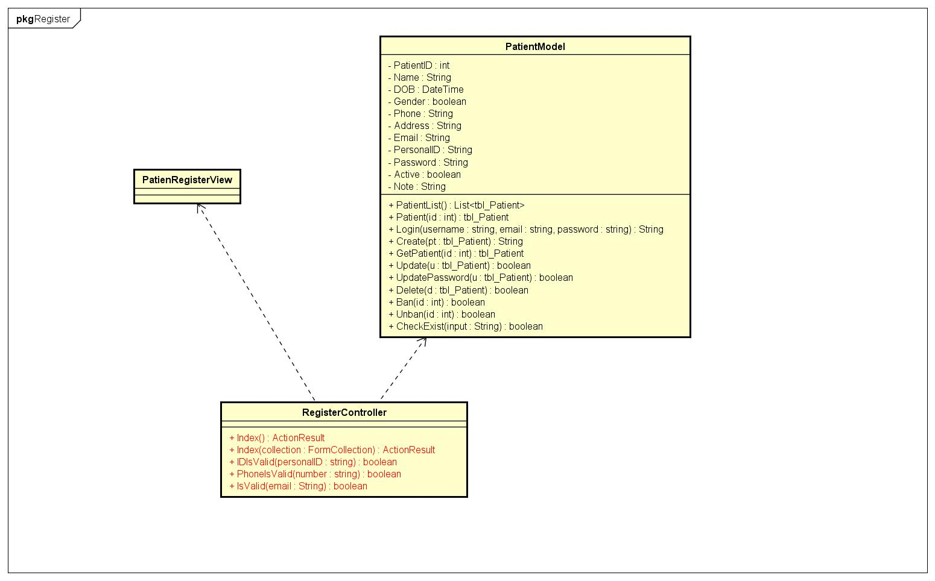

Figure 65: Register Class Diagram

#### Login

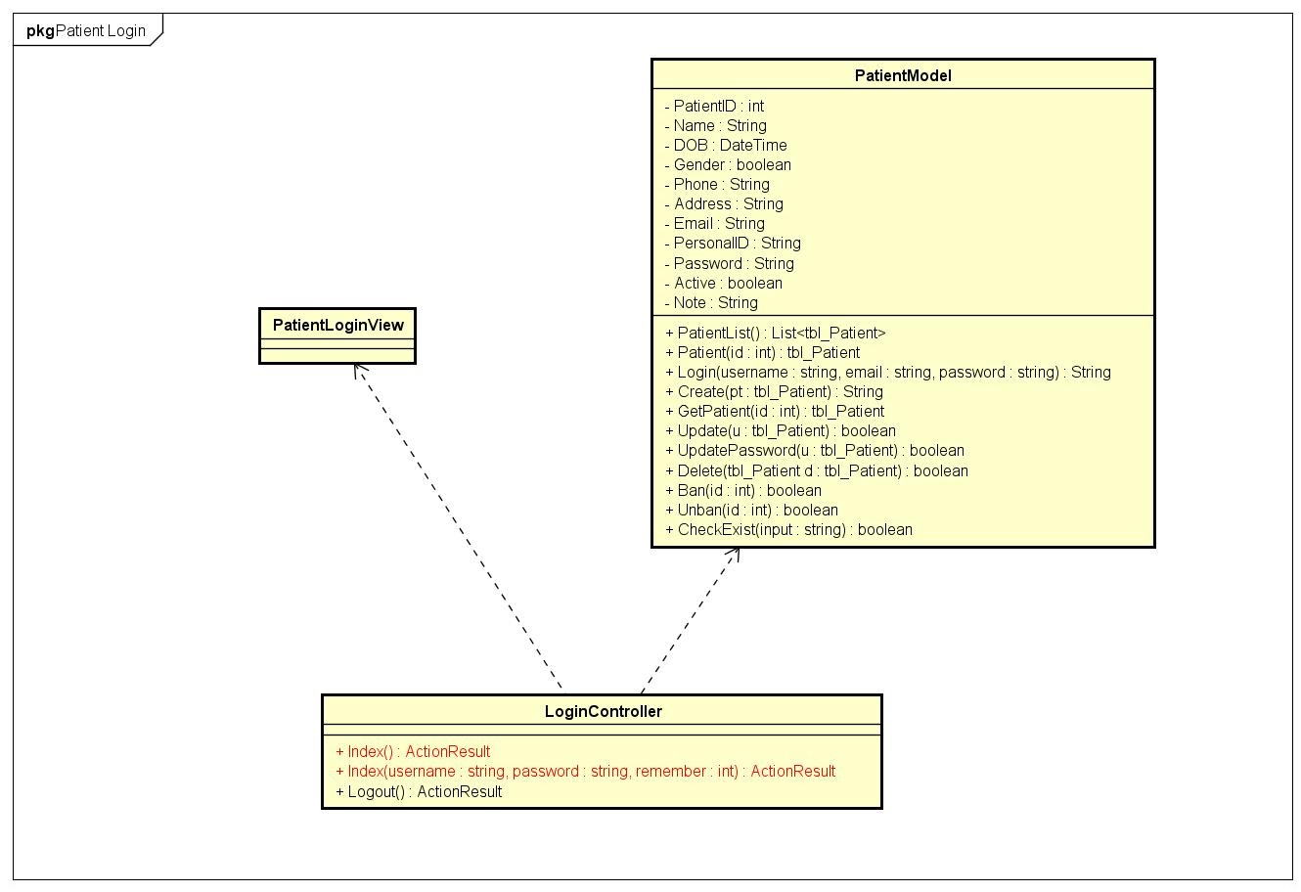

Figure 66: Patient Login Class Diagram

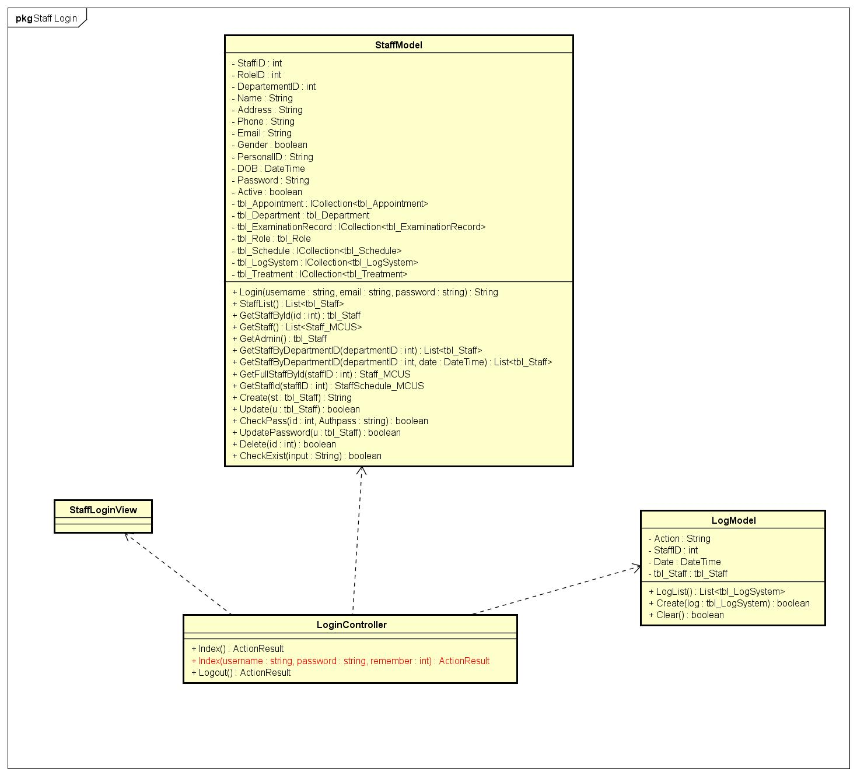

Figure 67 Staff Login Class Diagram

#### LogOut

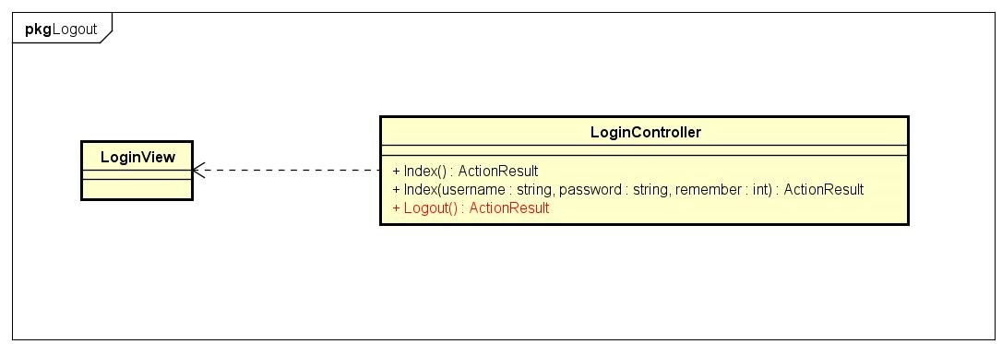

Figure 68: Log Out Class Diagram

#### Change password

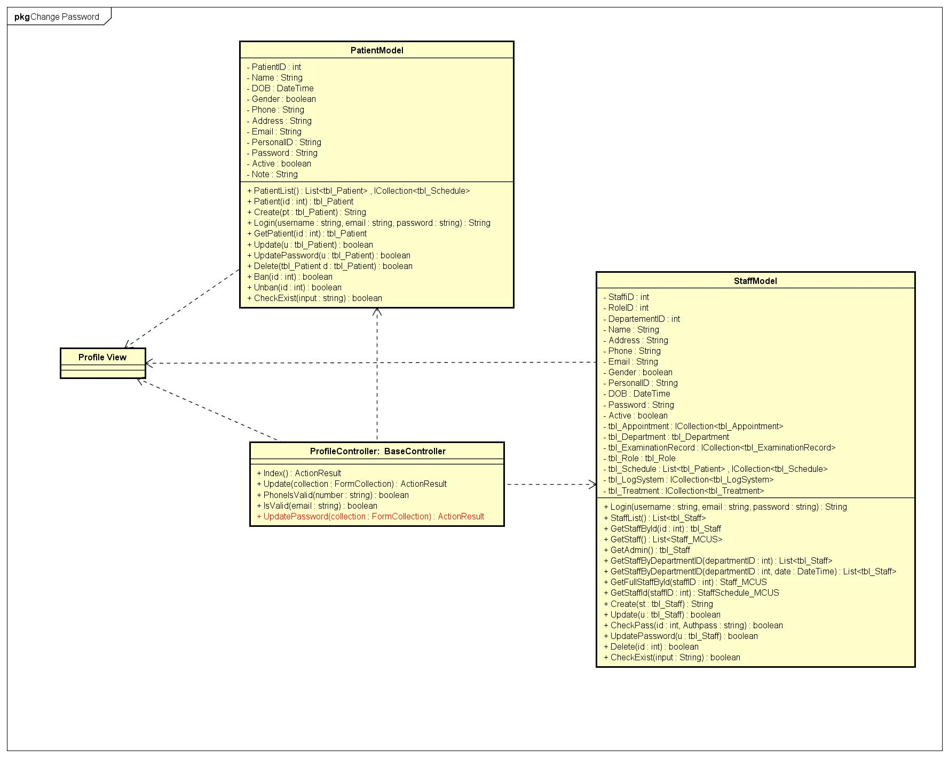

Figure 69: Change Password Class Diagram

#### View Profile

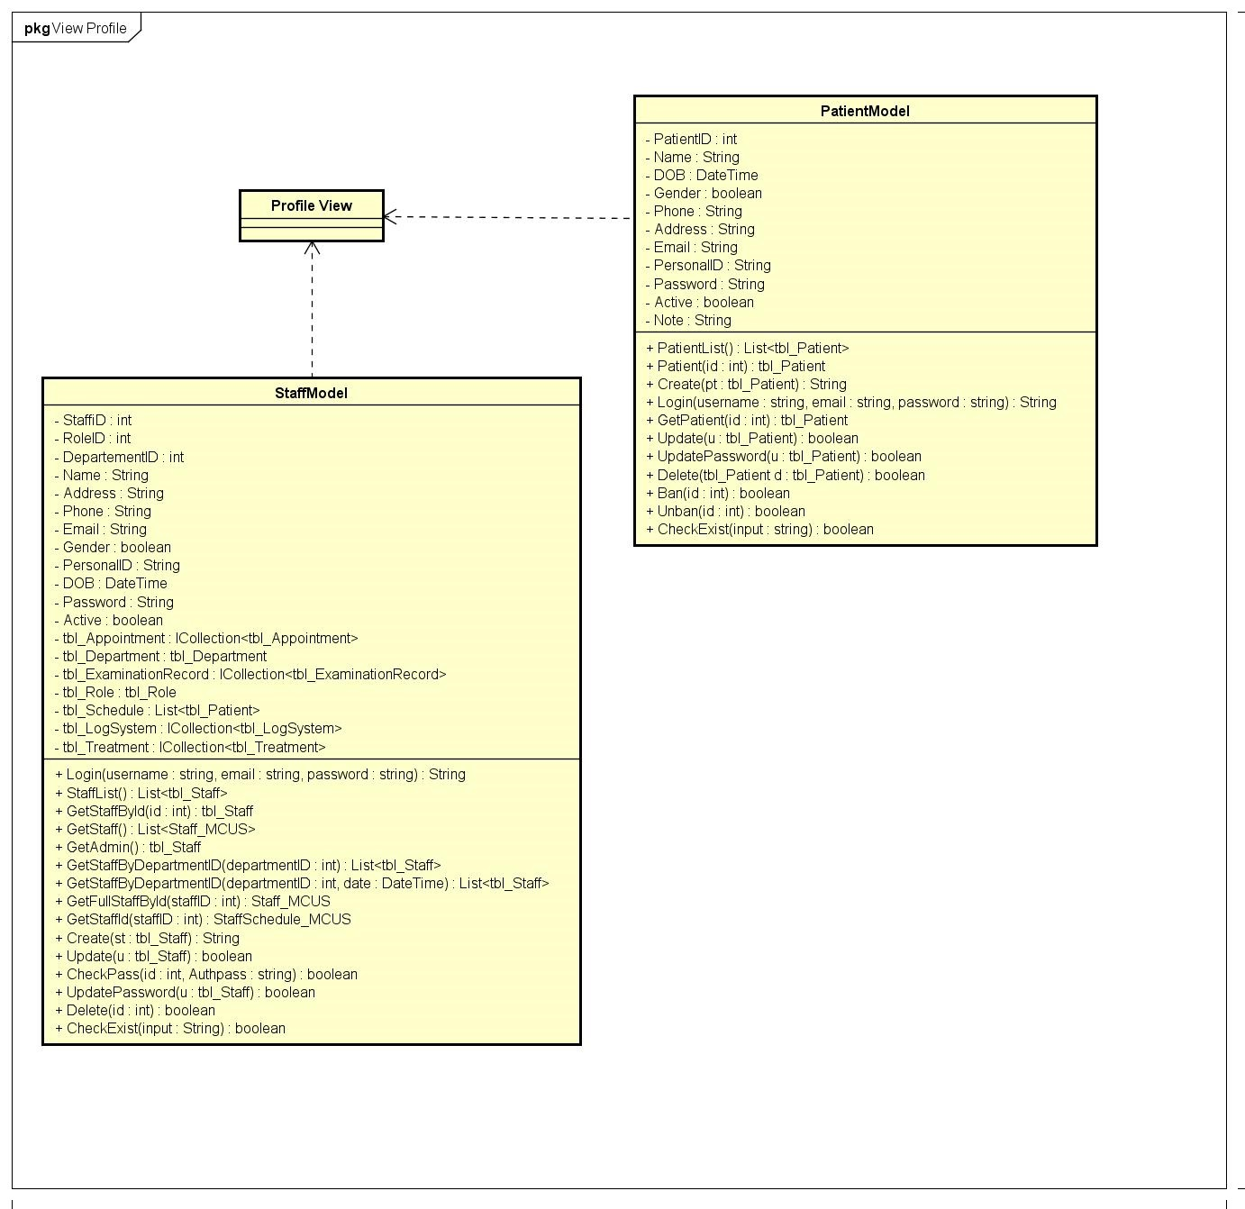

Figure 70:: View Profile Class Diagram

#### Edit Profile

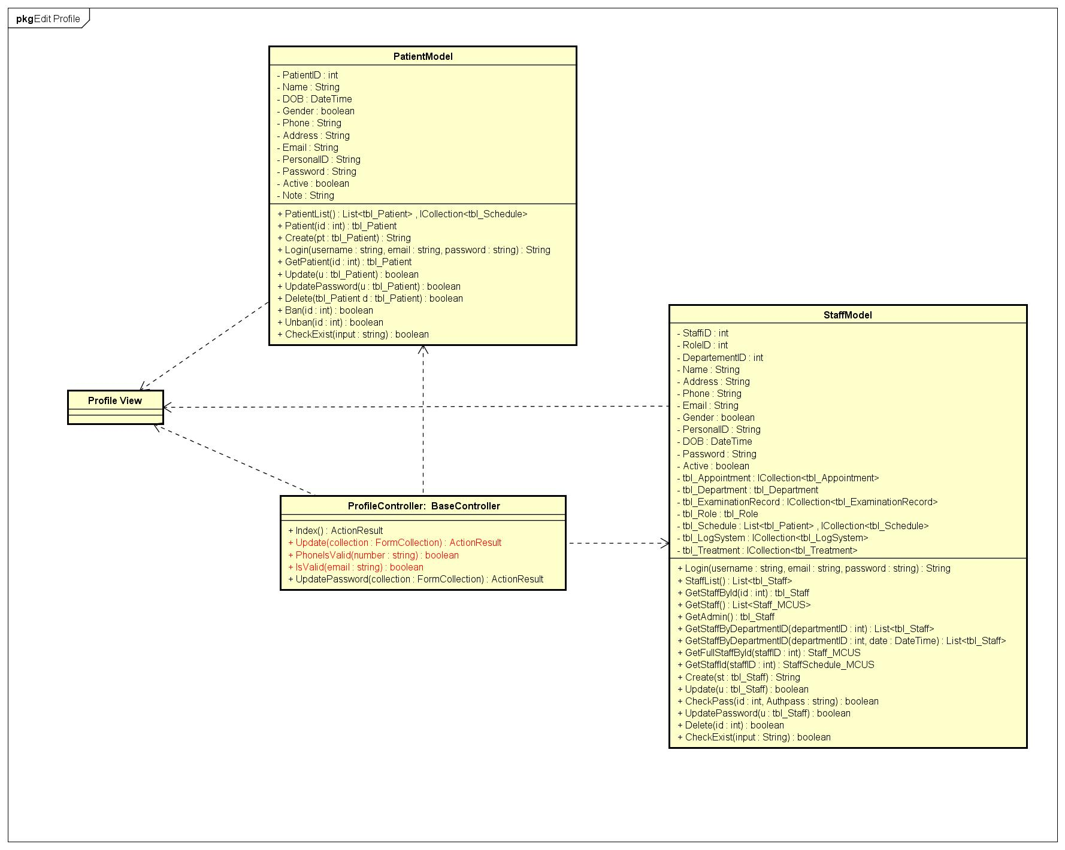

Figure 71: Ediit Profile Class Diagram

#### Create Appointment

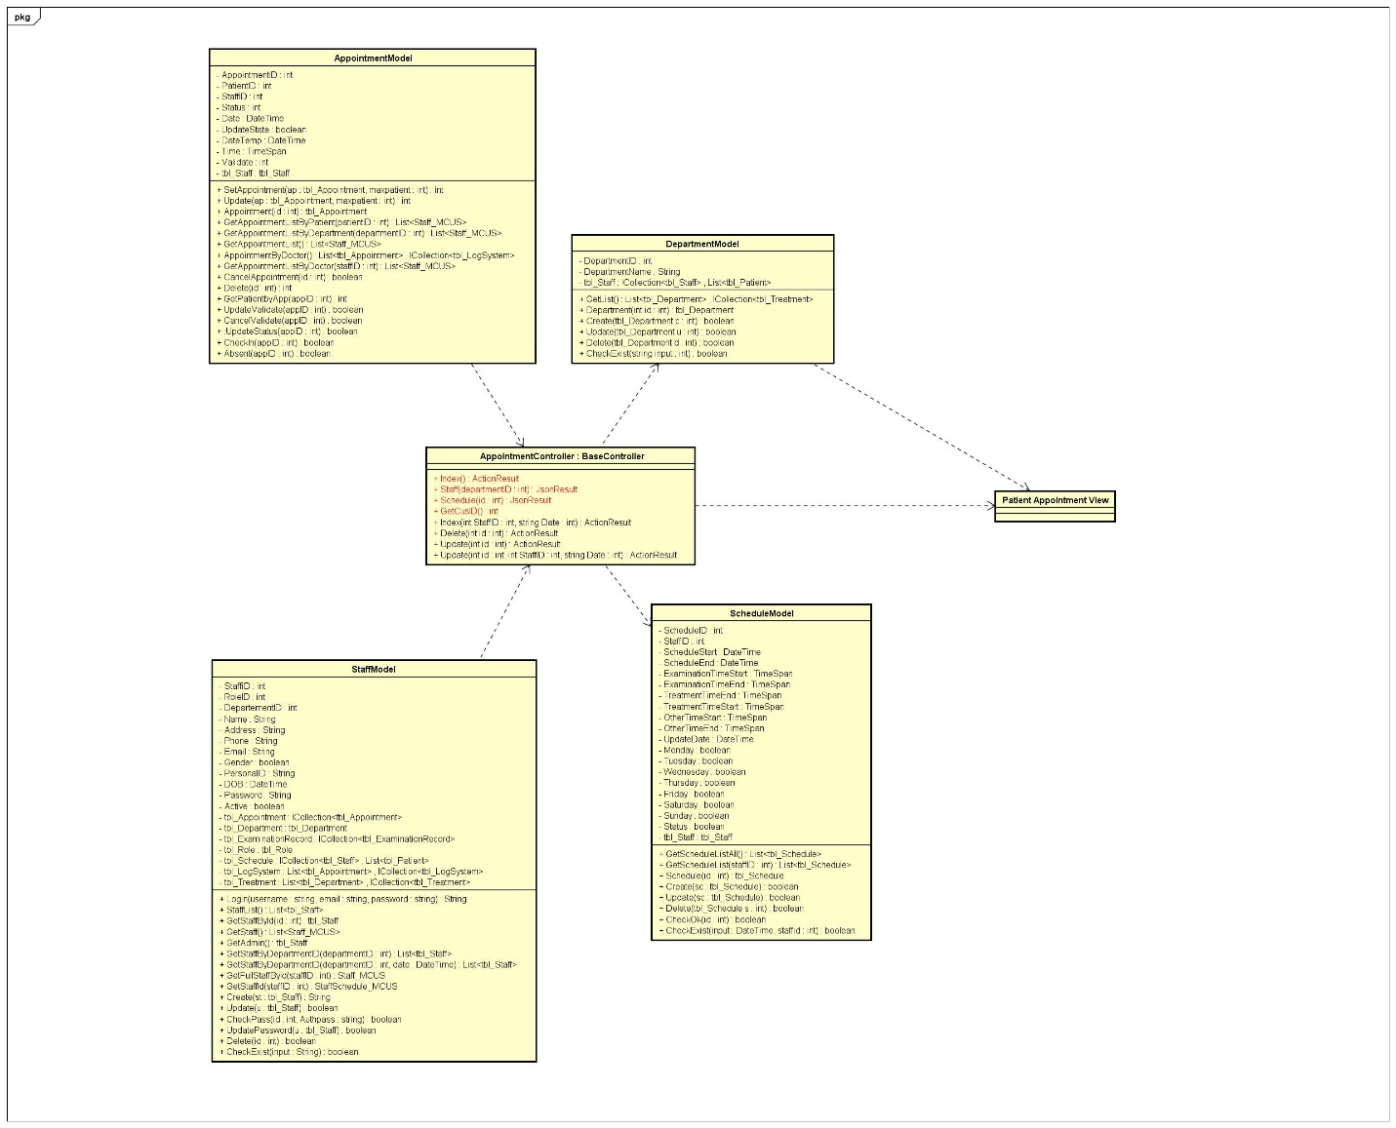

Figure 72: Create Appointment Class Diagram

#### View Appointment

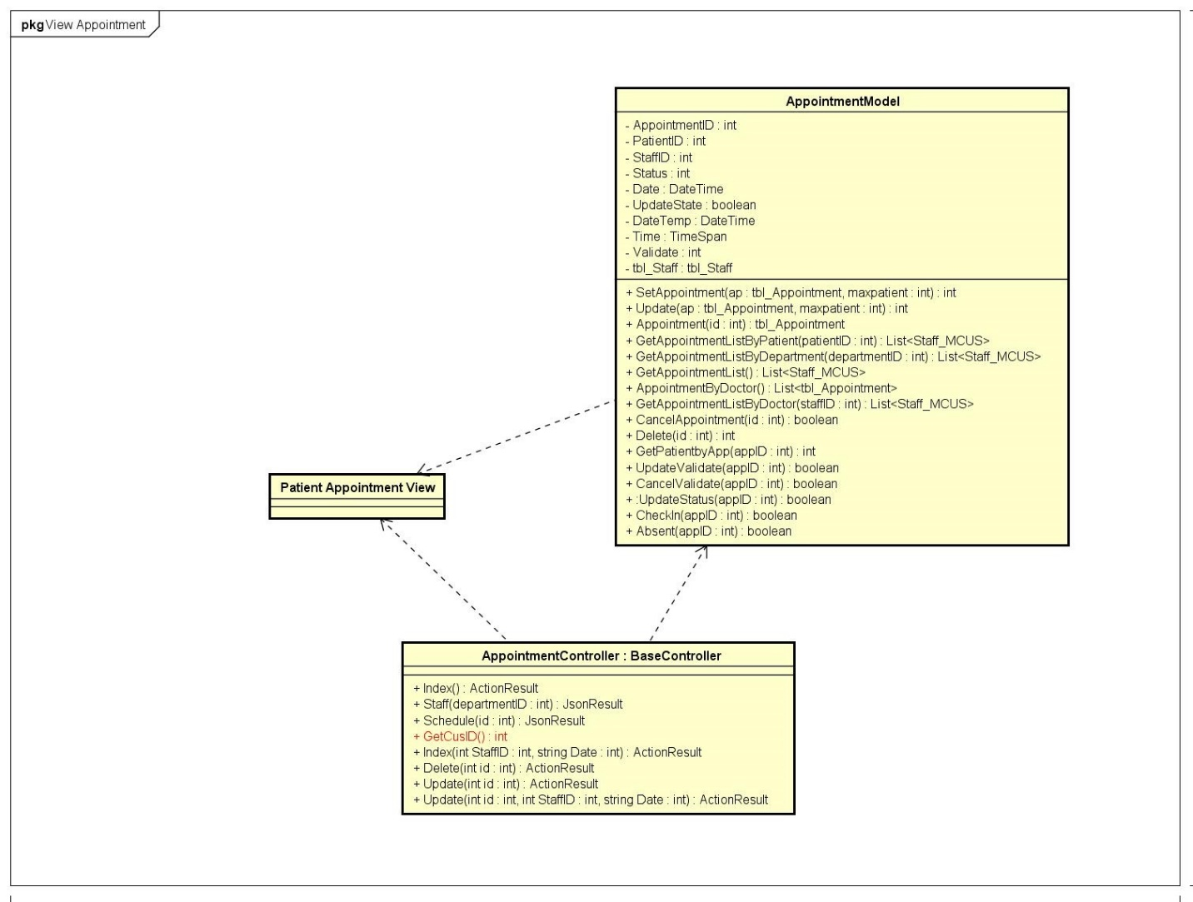

Figure 73: View Appointment Class Diagram

#### Edit Appointment

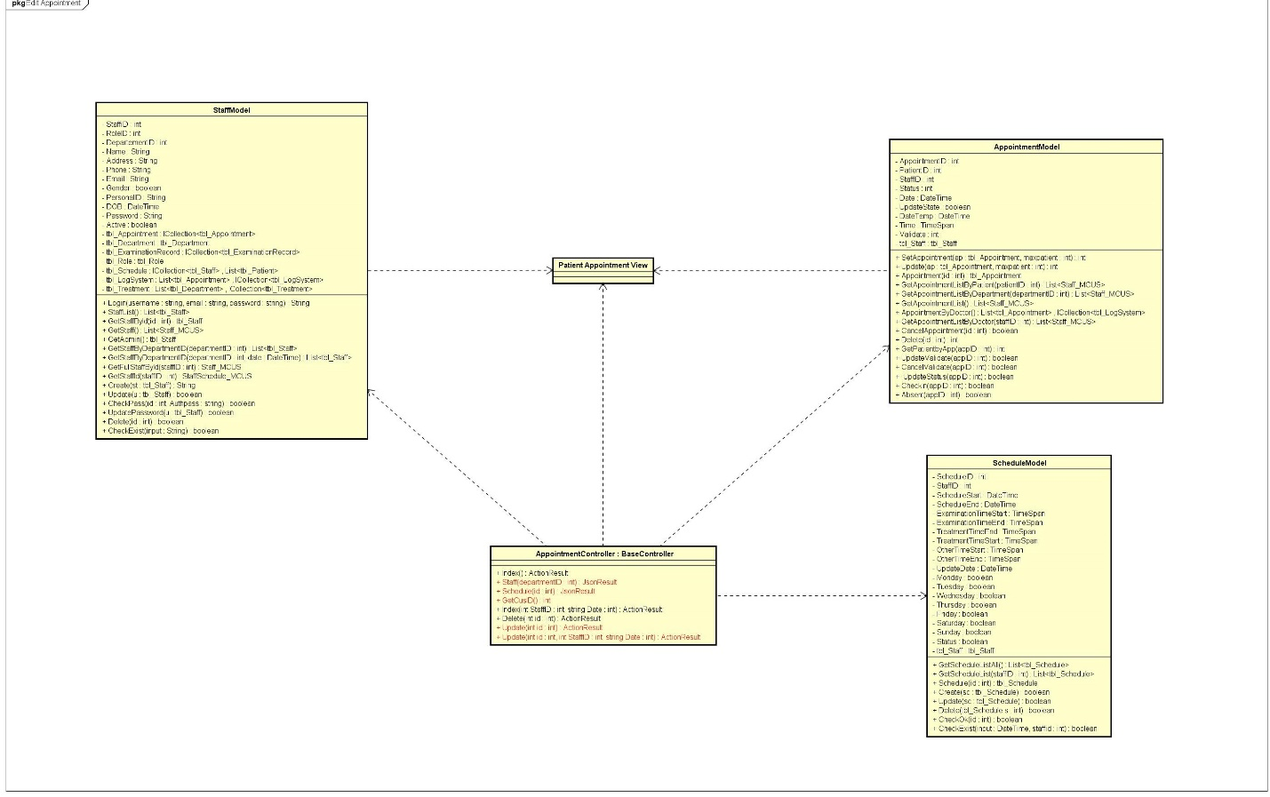

Figure 74: Edit appointment Class Diagram

#### Delete Appointment

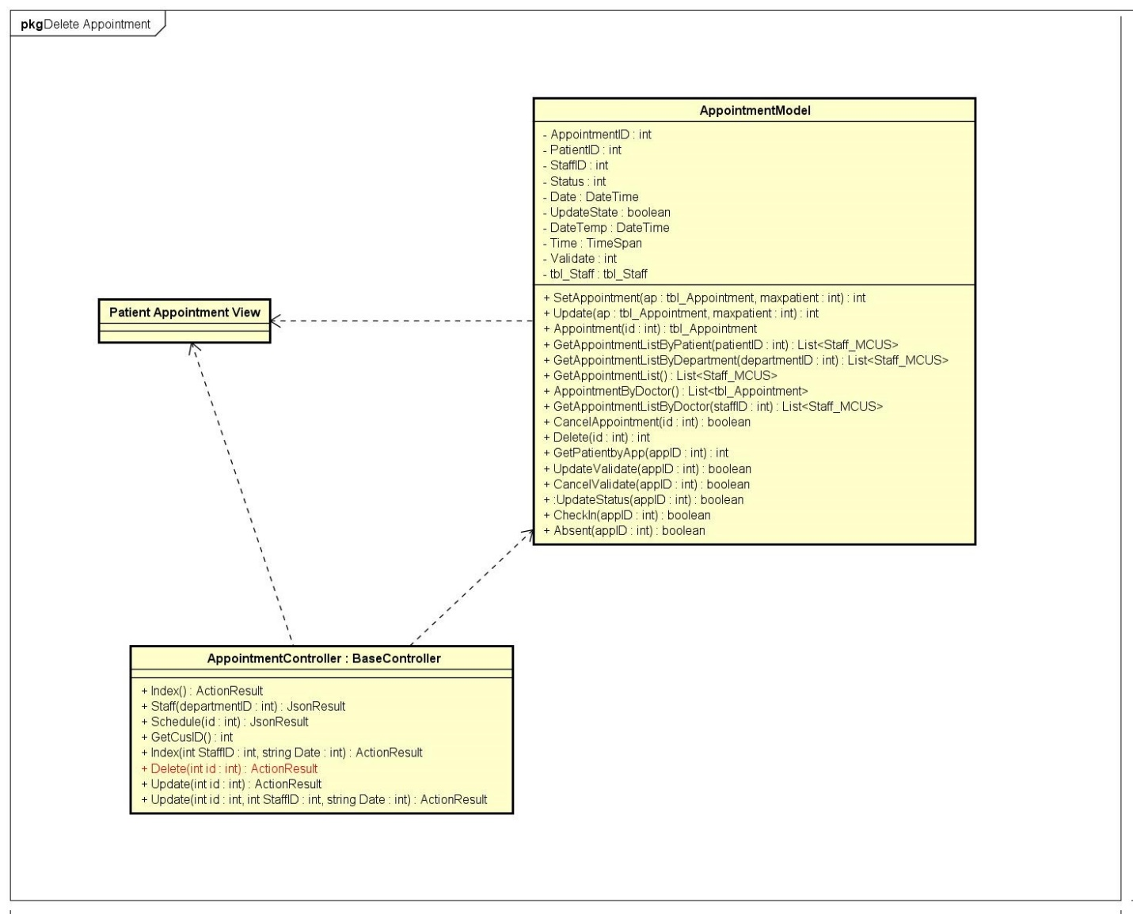

Figure 75: Delete Appointment Class Diagram

#### View Examination Record

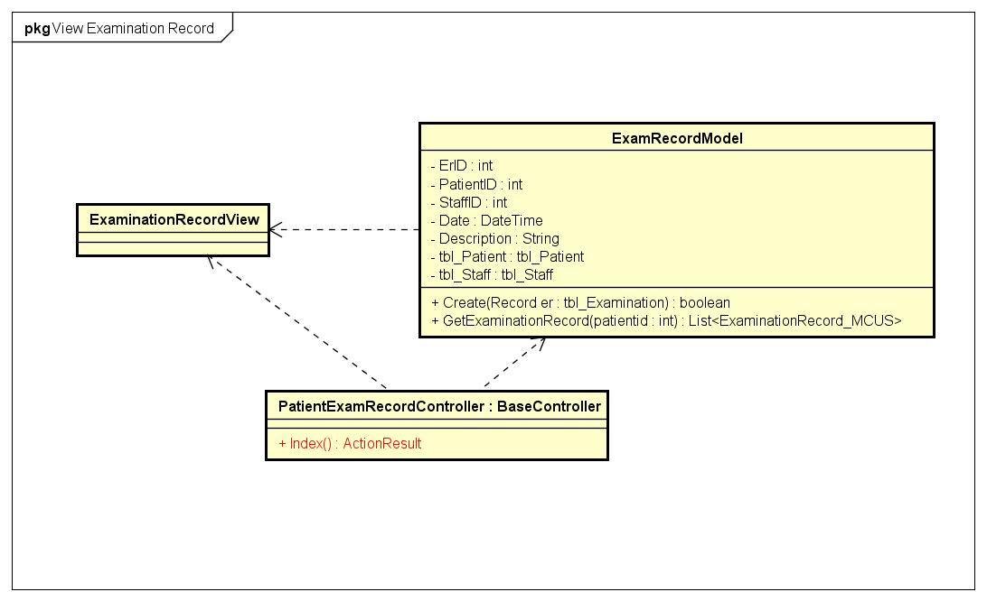

Figure 76: View Examination Class Diagram

#### Create Schedule

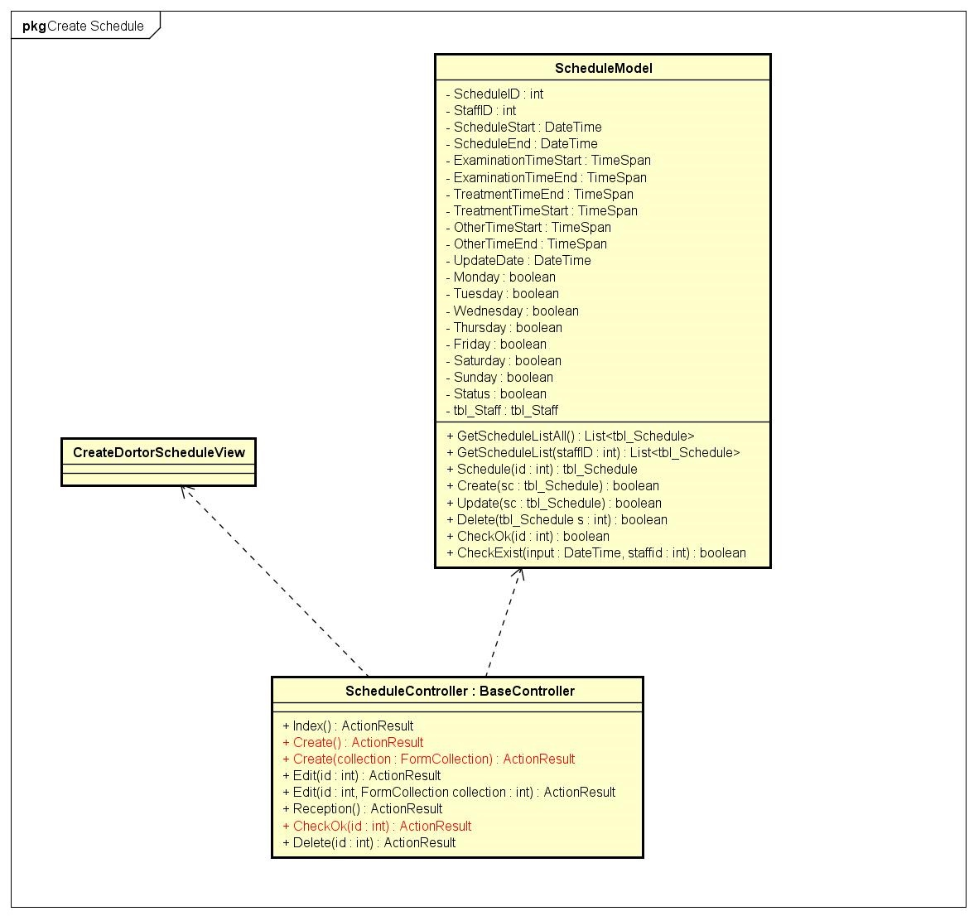

Figure 77: Create Schedule Class Diagram

#### View schedule

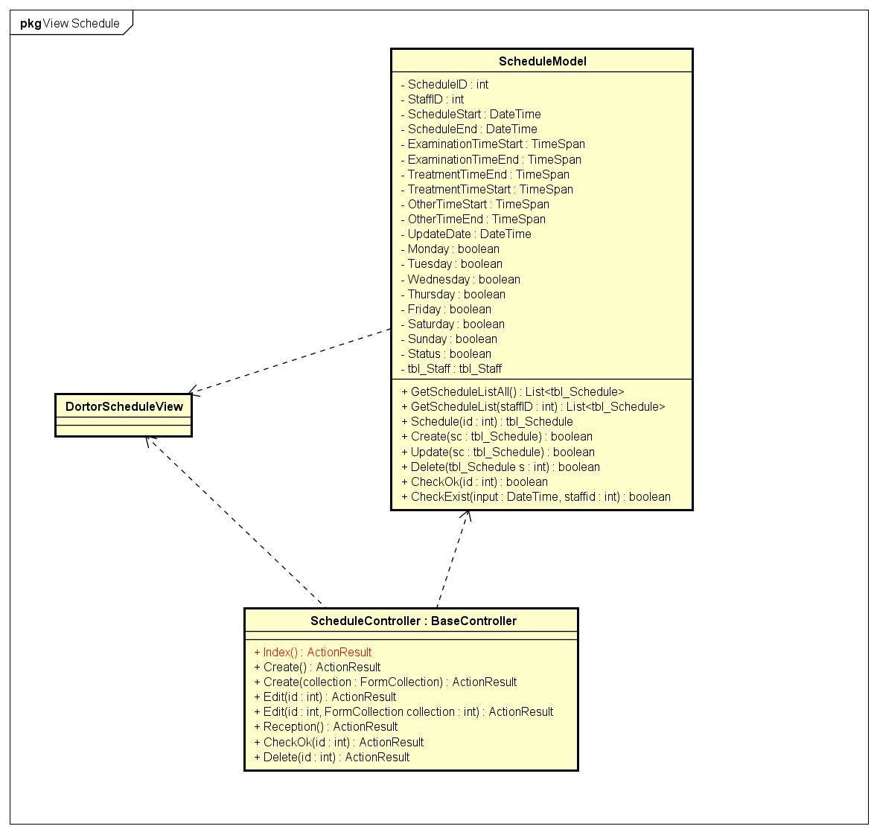

Figure 78: View Schedule Class Diagram

#### Edit Schedule

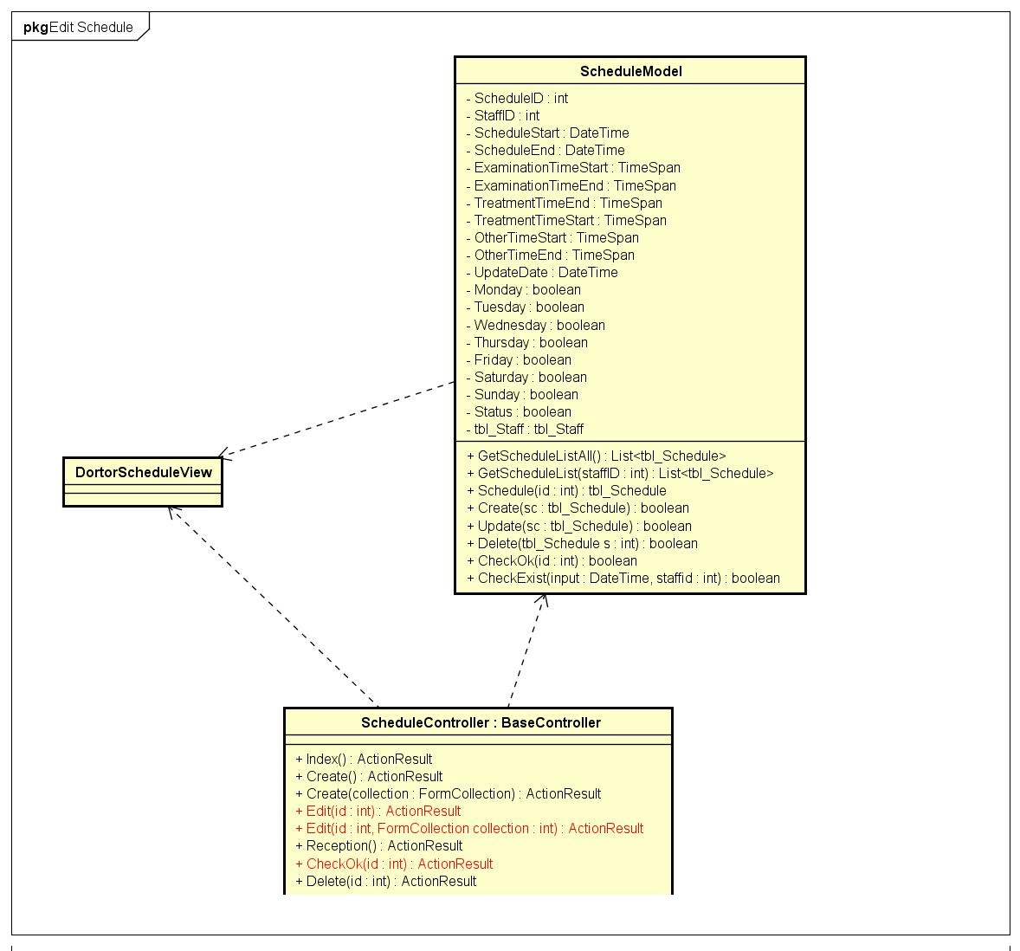

Figure 79: Edit Schedule Class Diagram

#### View Appointment

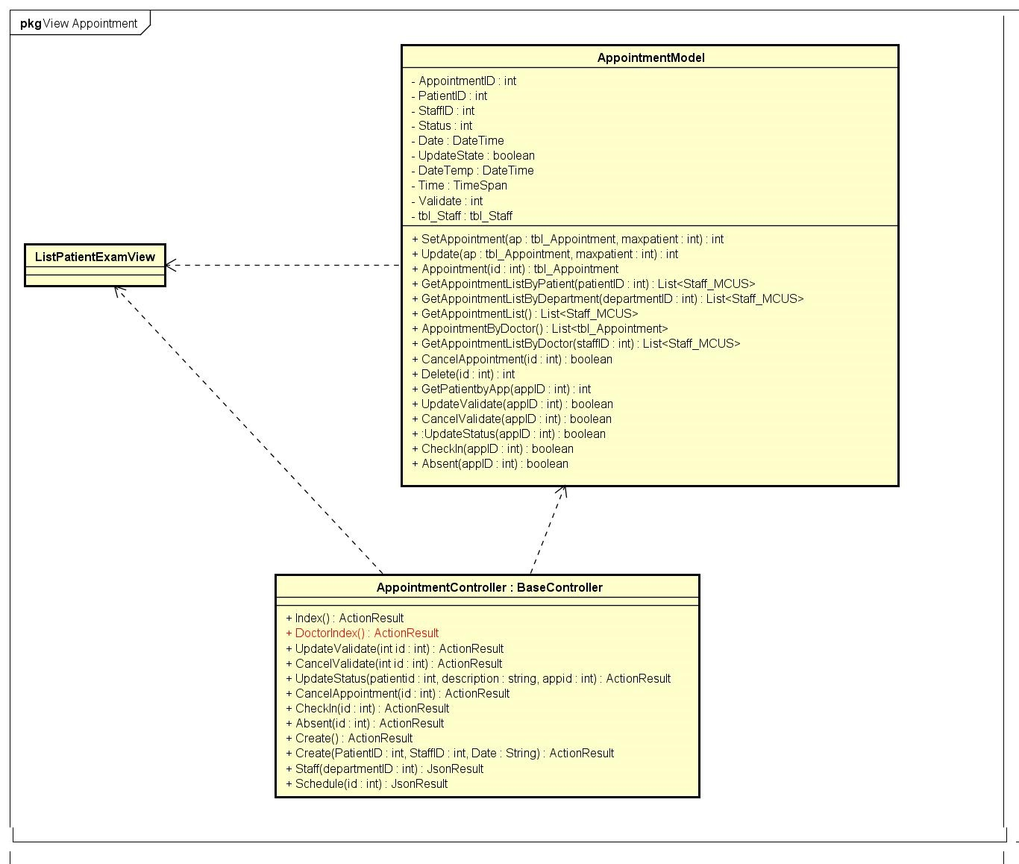

Figure 80: View Appointment Class Diagram

#### Create Examination Record

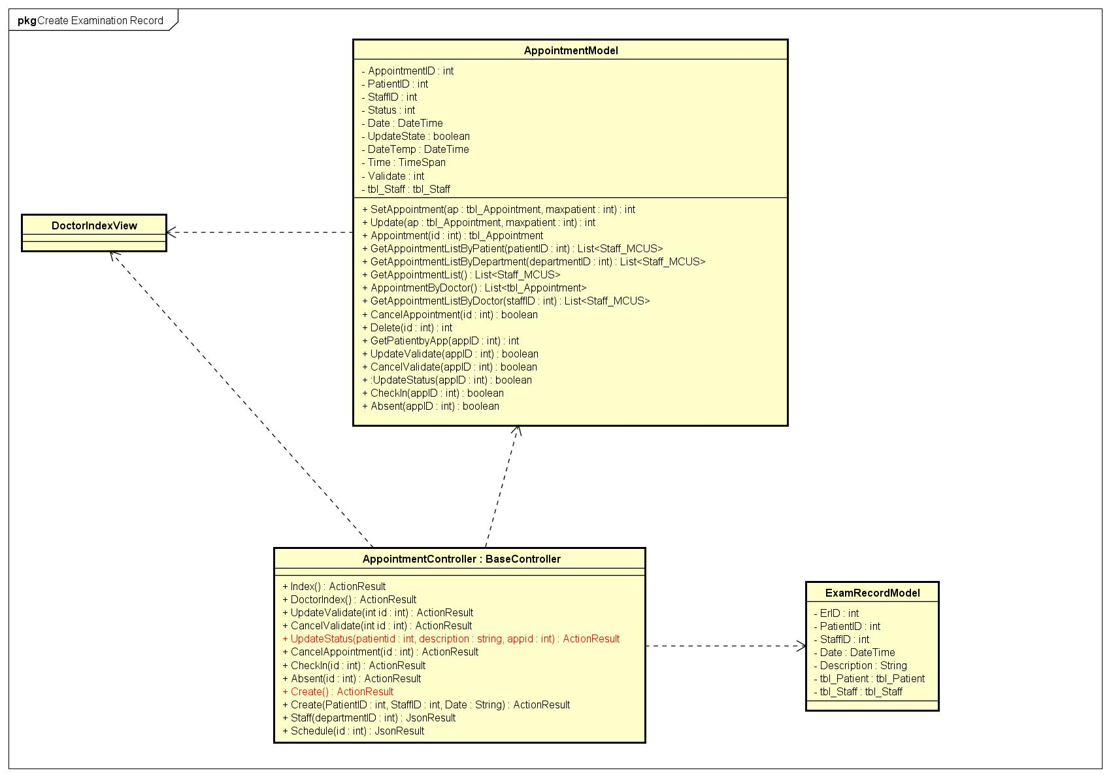

Figure 81: Create Examination Record Class Diagram

#### Create Direct Appointment

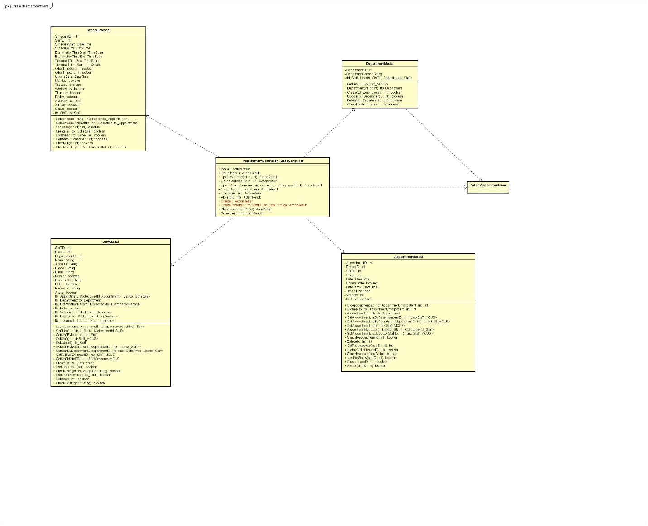

Figure 82: Create Direct Appointment Class Diagram

#### Accept Appointment

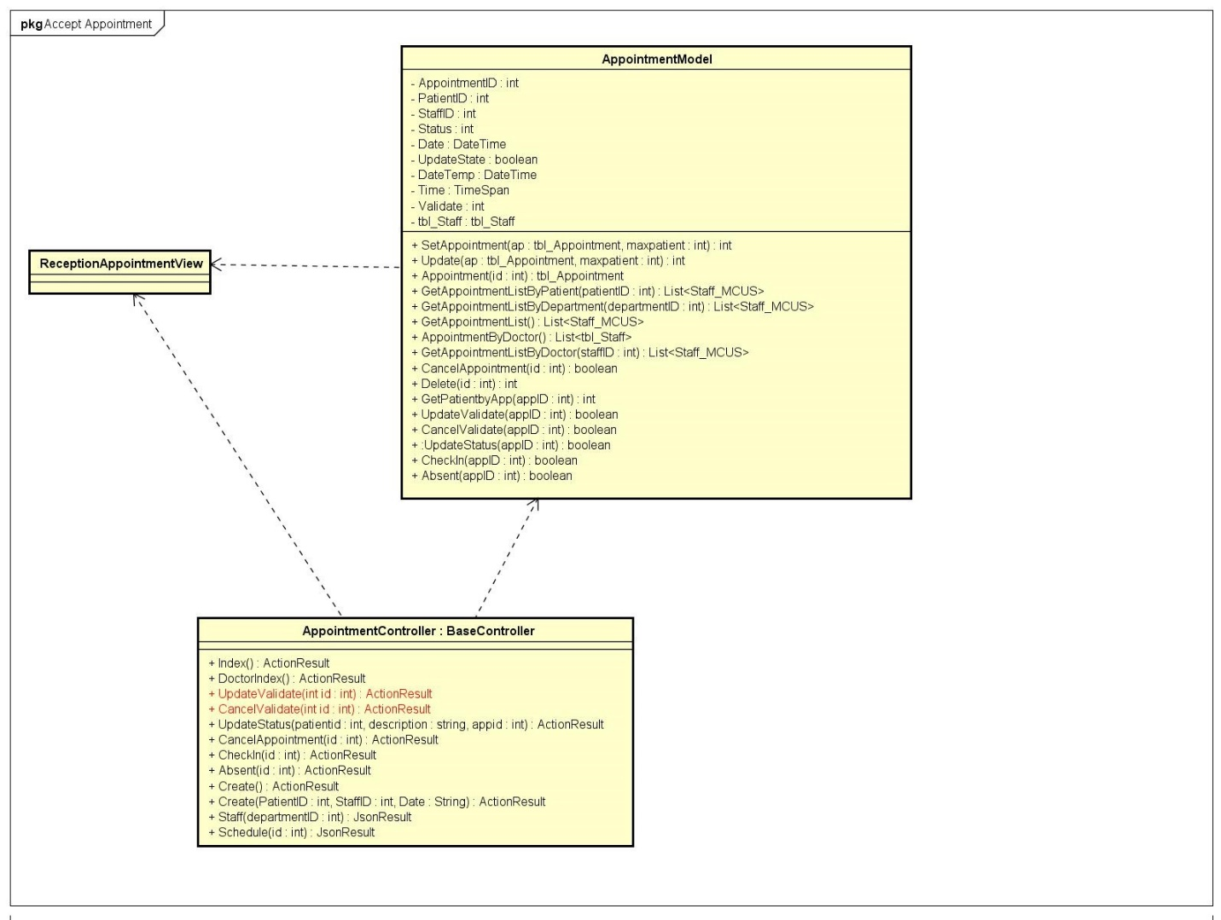

Figure 83: Accept Appointment Class Diagram

#### Delete Appointment

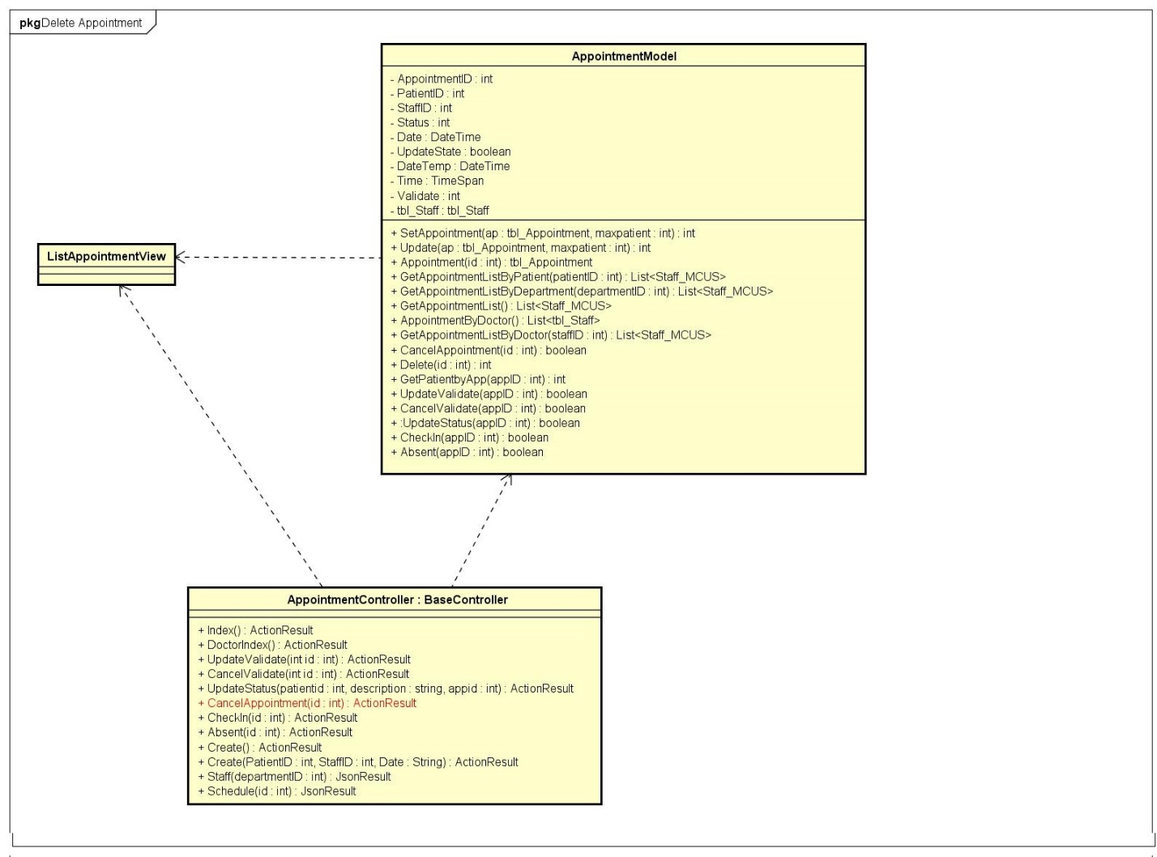

Figure 84: Delete Appointment Class Diagram

#### View Doctor Schedule

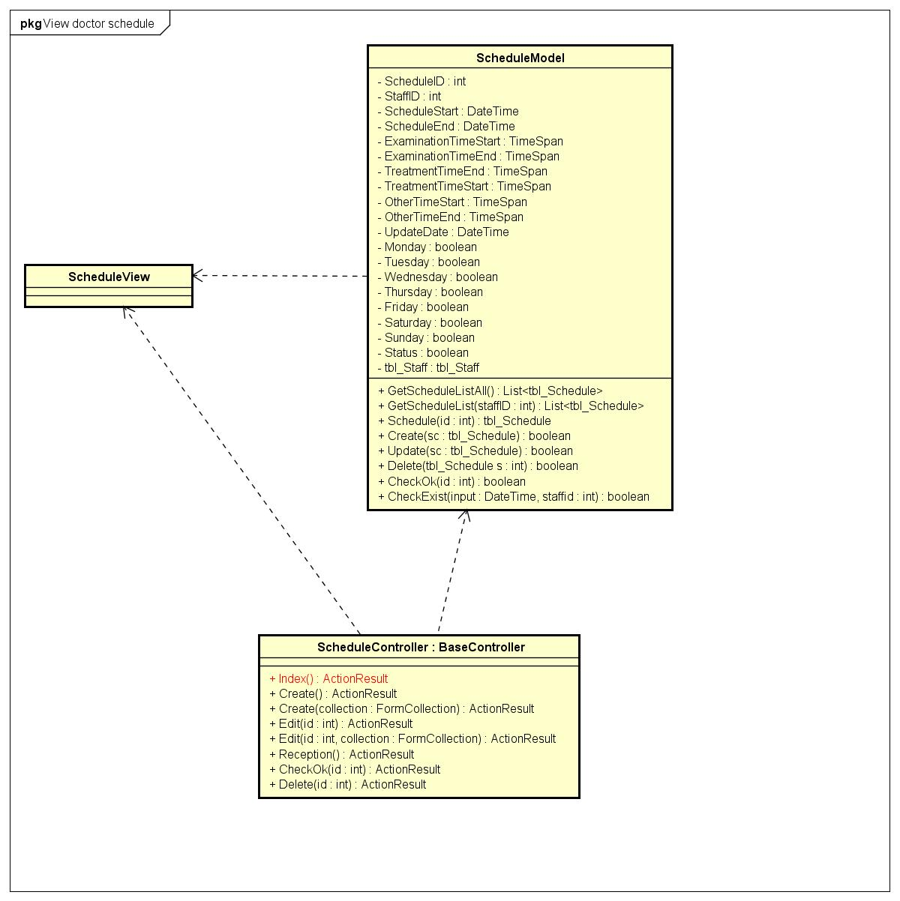

Figure 85: View Doctor Schedule Class Diagram

#### Accept Doctor Schedule

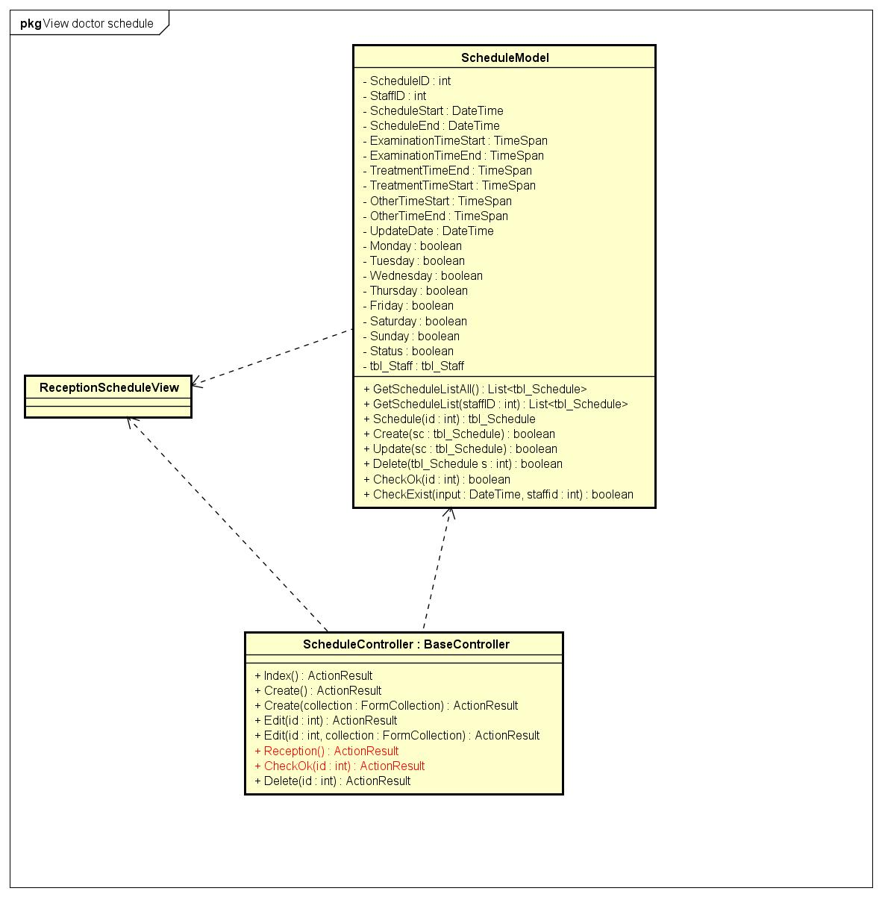

Figure 86: Accept Doctor Scheduler Class Diagram

#### View Examination Record

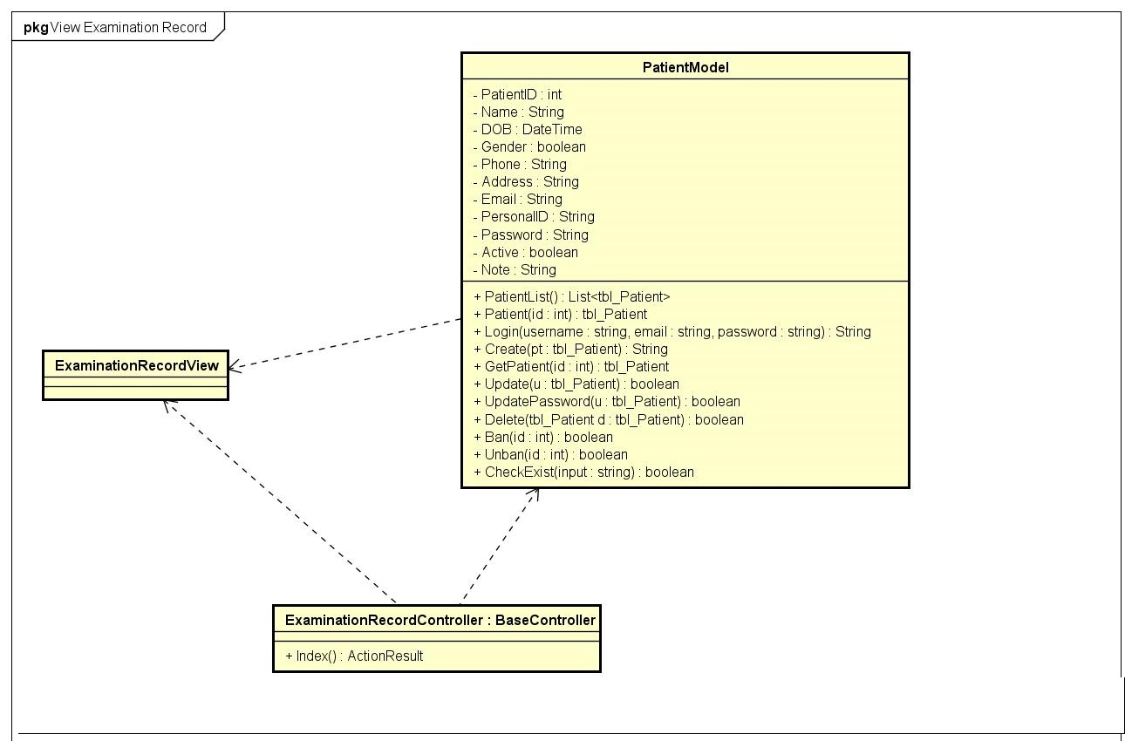

Figure 87: View Examination Record Class Diagram

#### Create Bill

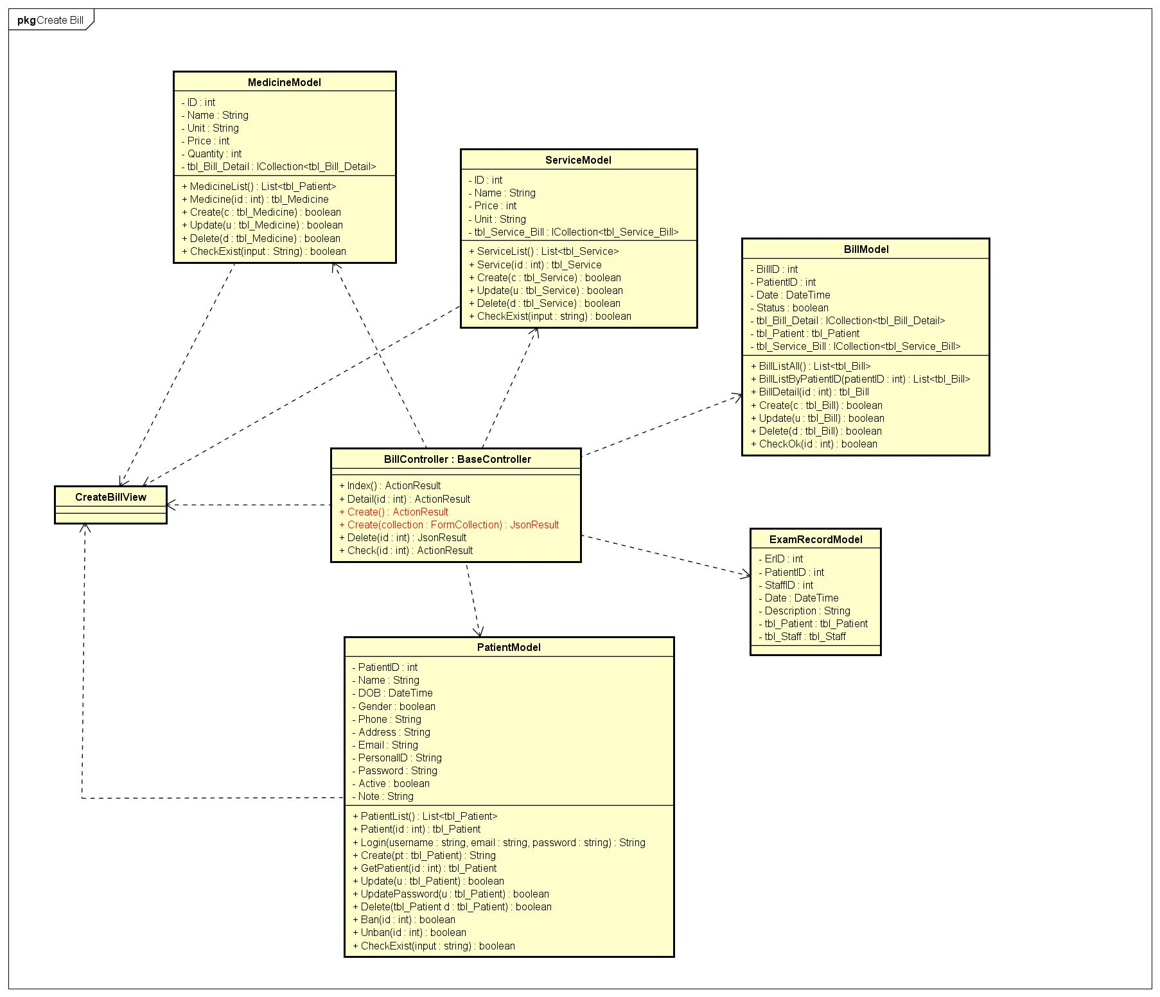

Figure 88: Create Bill Class Diagram

#### Finish Bill

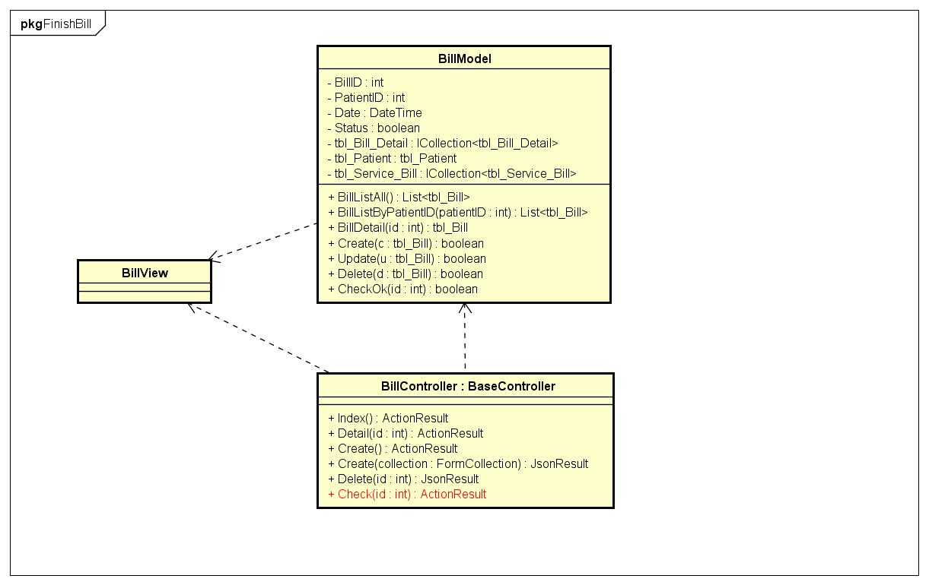

Figure 89: Finish Bill Class Diagram

#### Delete Bill

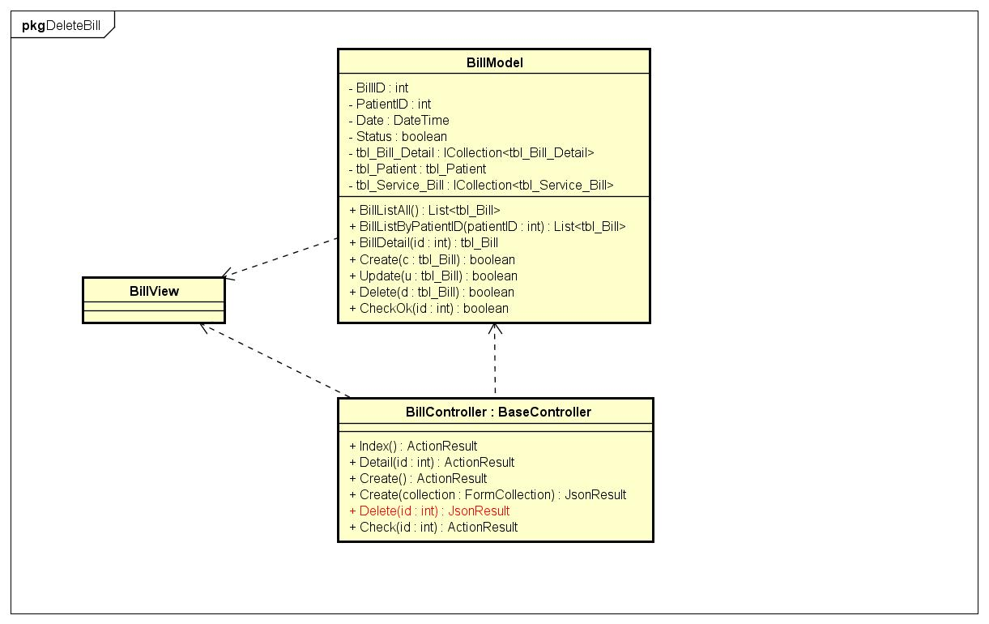

Figure 90: Delete Bill Class Diagram

#### View Bill

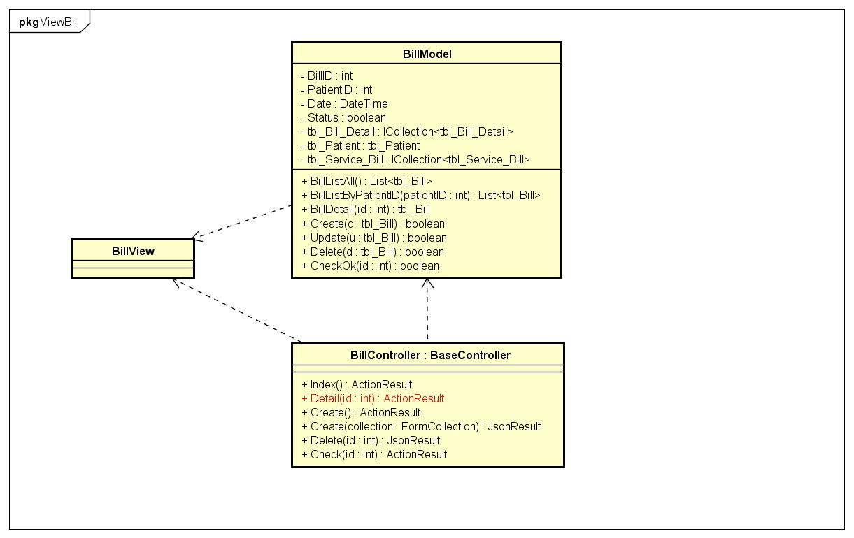

Figure 91: View Bill Class Diagram

#### Check-in To Exam

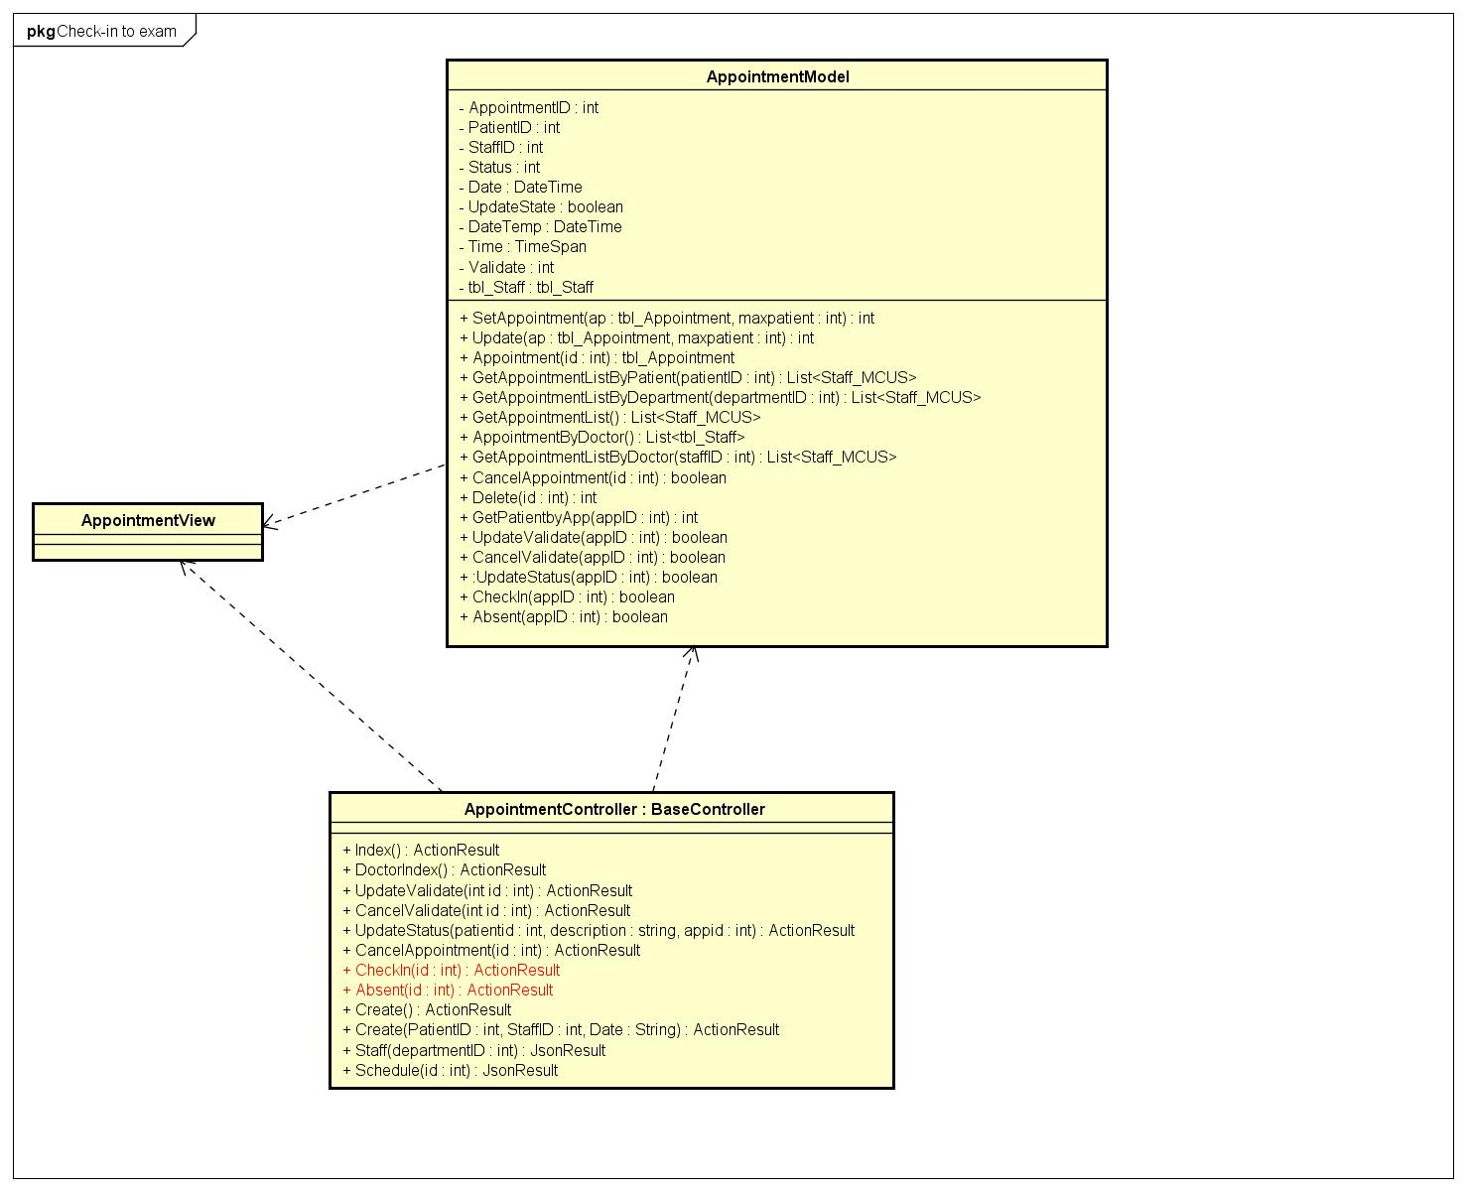

Figure 92: Check-in To Exam Class Diagram

#### Check-in bed

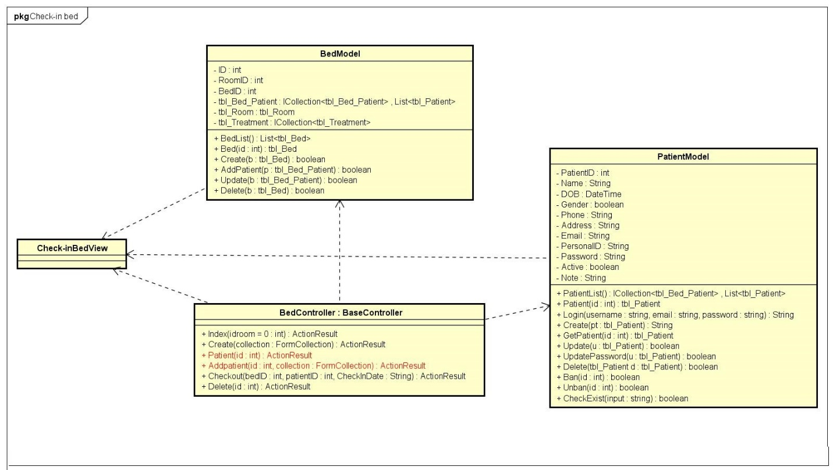

Figure 93: Check-in Bed Class Diagram

#### Check-out Bed

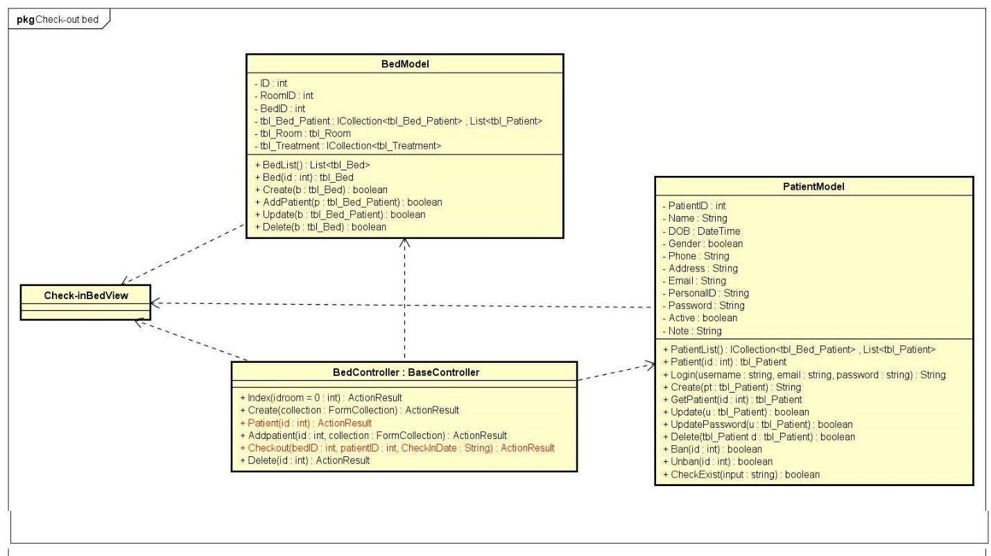

Figure 94: Check-out Bed Class Diagram

#### Ban Patient Account

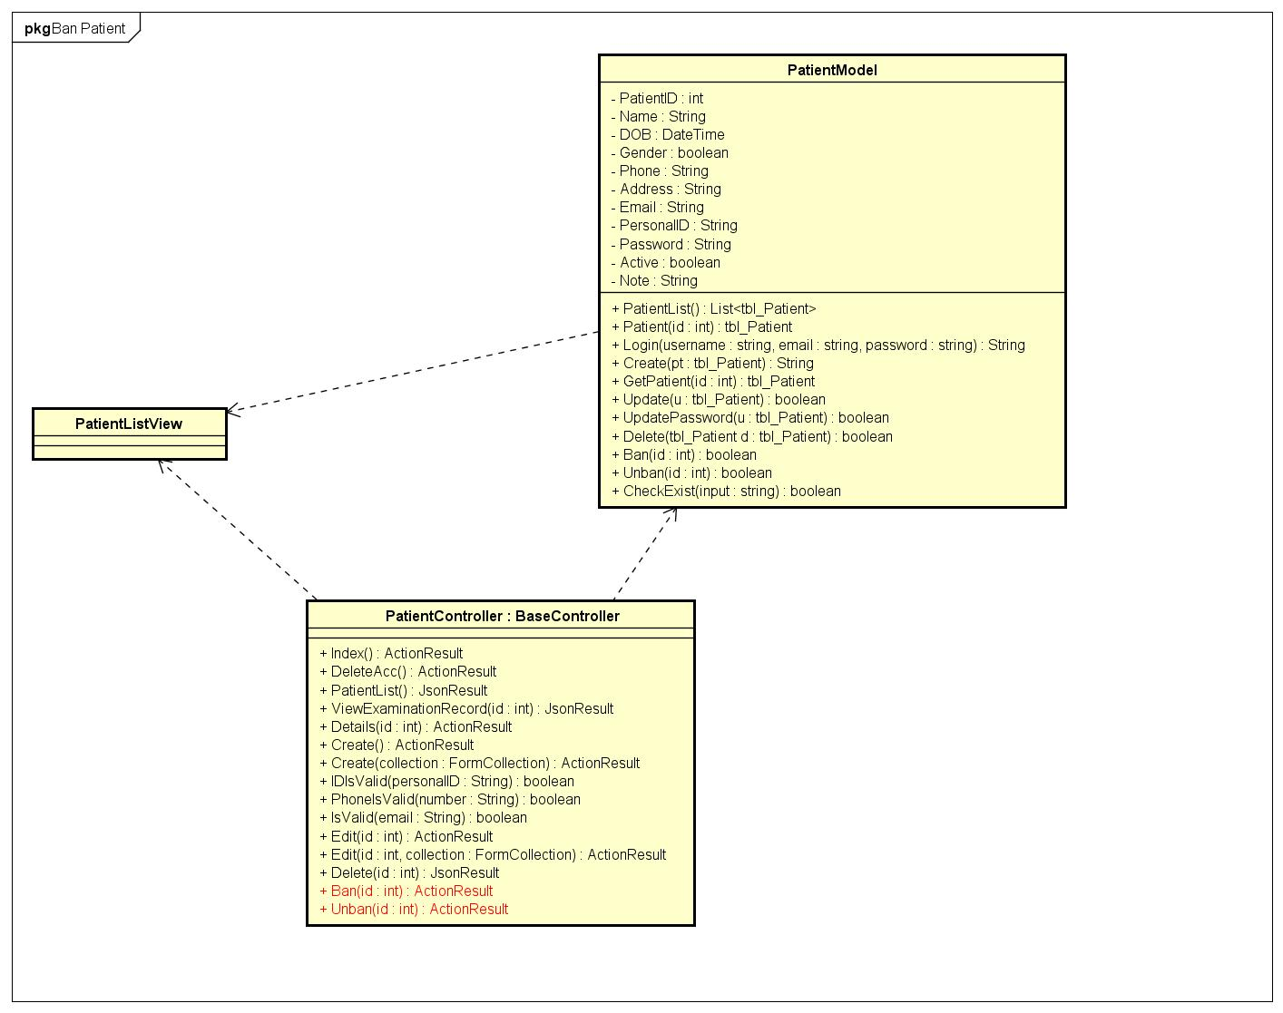

Figure 95: Ban Patient Account Class Diagram

#### View Patient Account

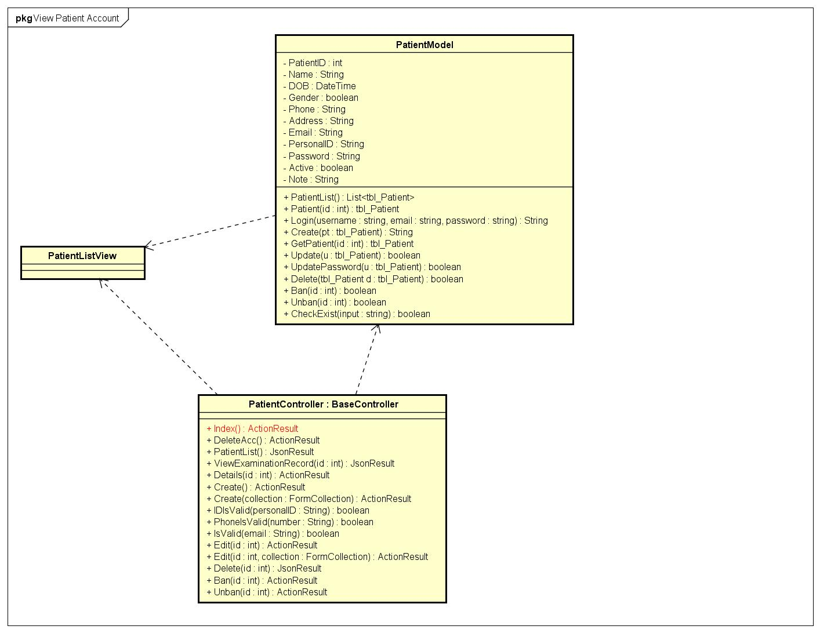

Figure 96: View Patient Account Class Diagram

#### Create Medicine

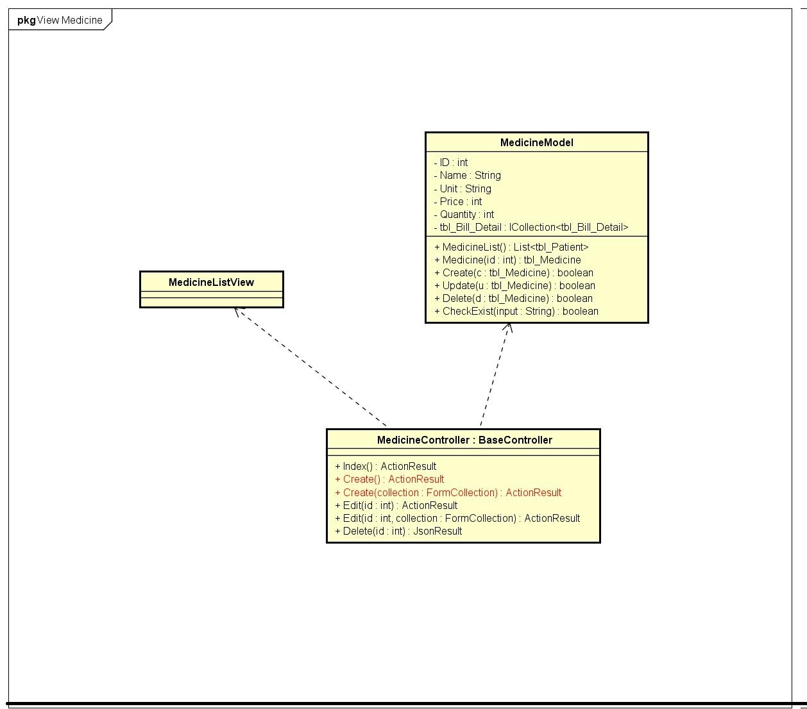

Figure 97: Creat Medicine Class Diagram

#### Delete Medicine

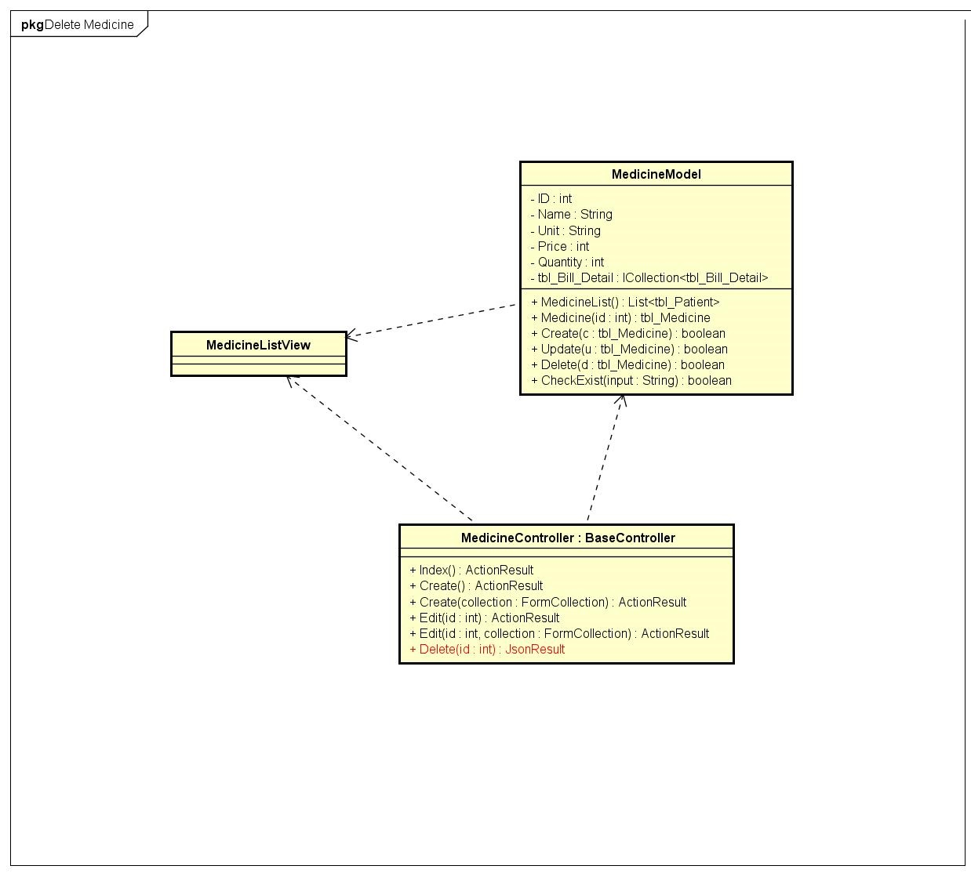

Figure 98: Delete Medicine Class Diagram

#### View Medicine

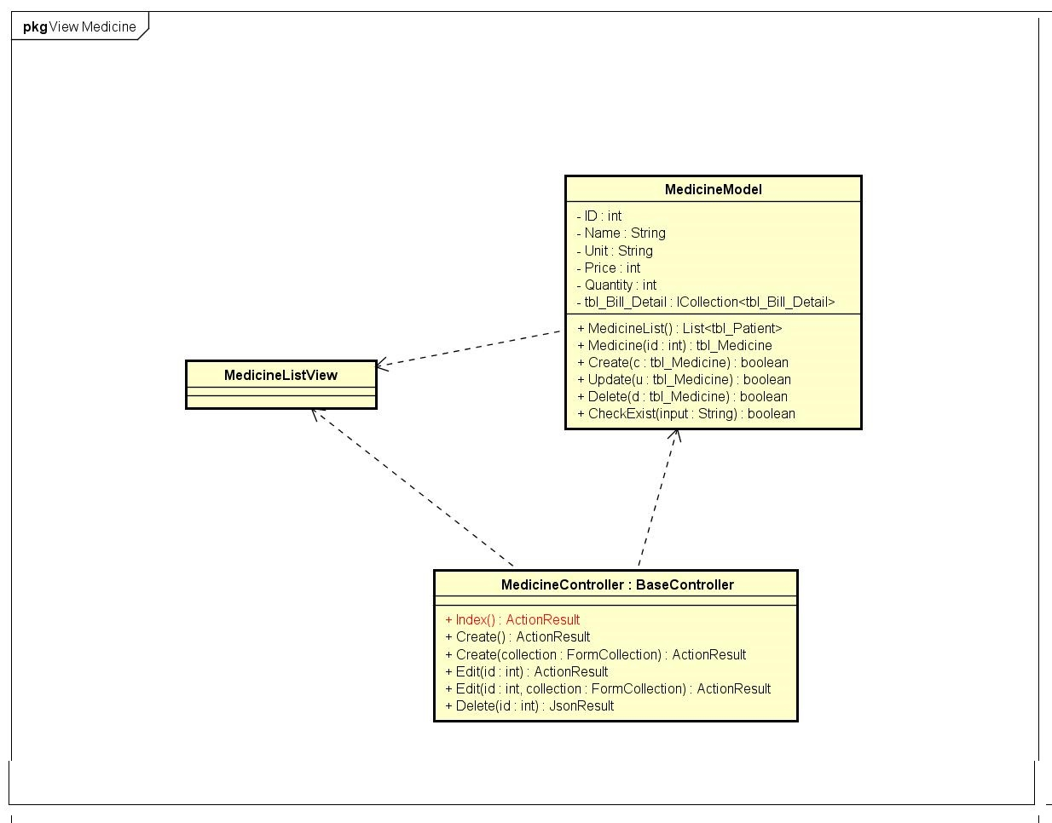

Figure 99: View Medicine Class Diagram

#### Create Room

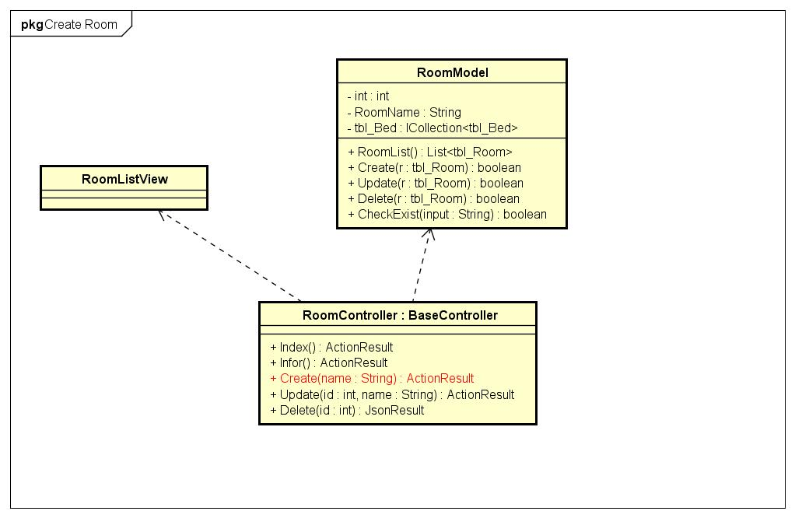

Figure 100: Create Room Class Diagram

#### Delete Room

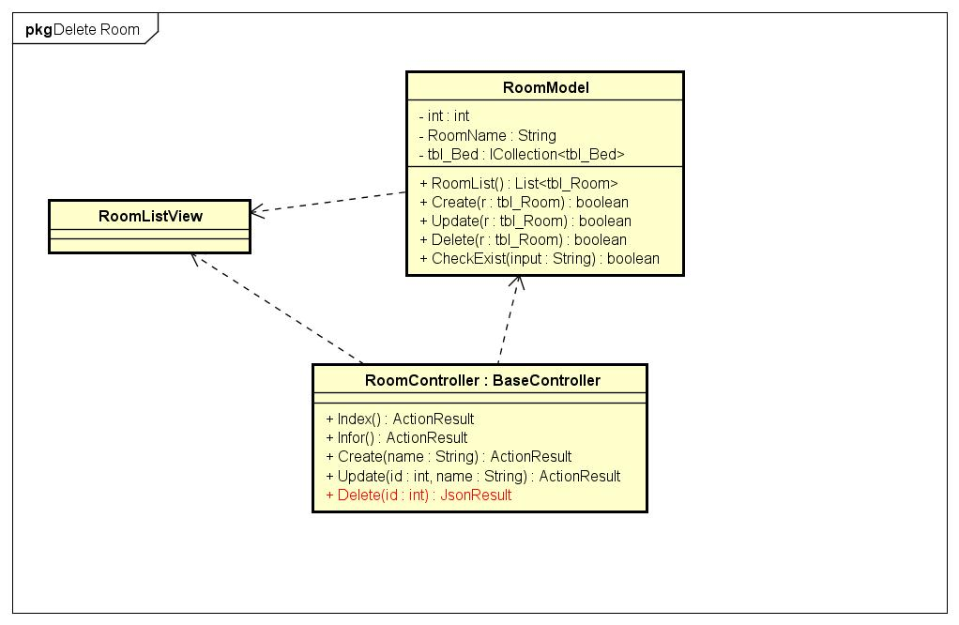

Figure 101: Delete Room Class Diagram

#### View Room

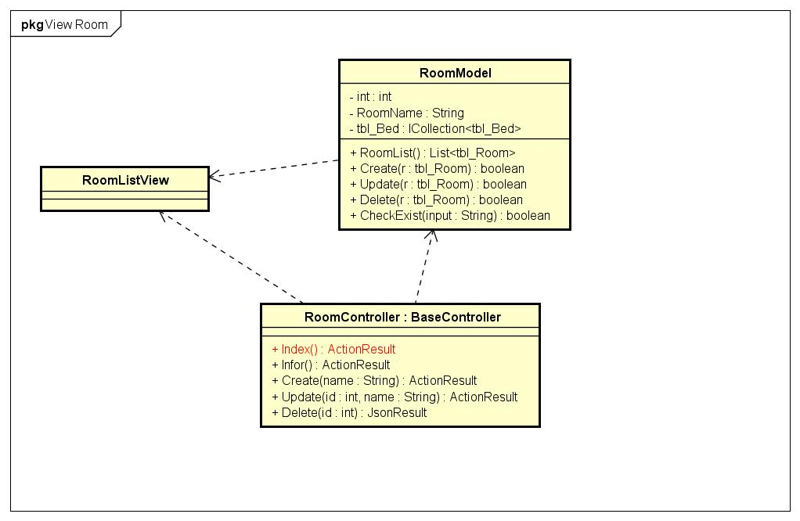

Figure 102: View Room Class Diagram

#### Create Staff Acount

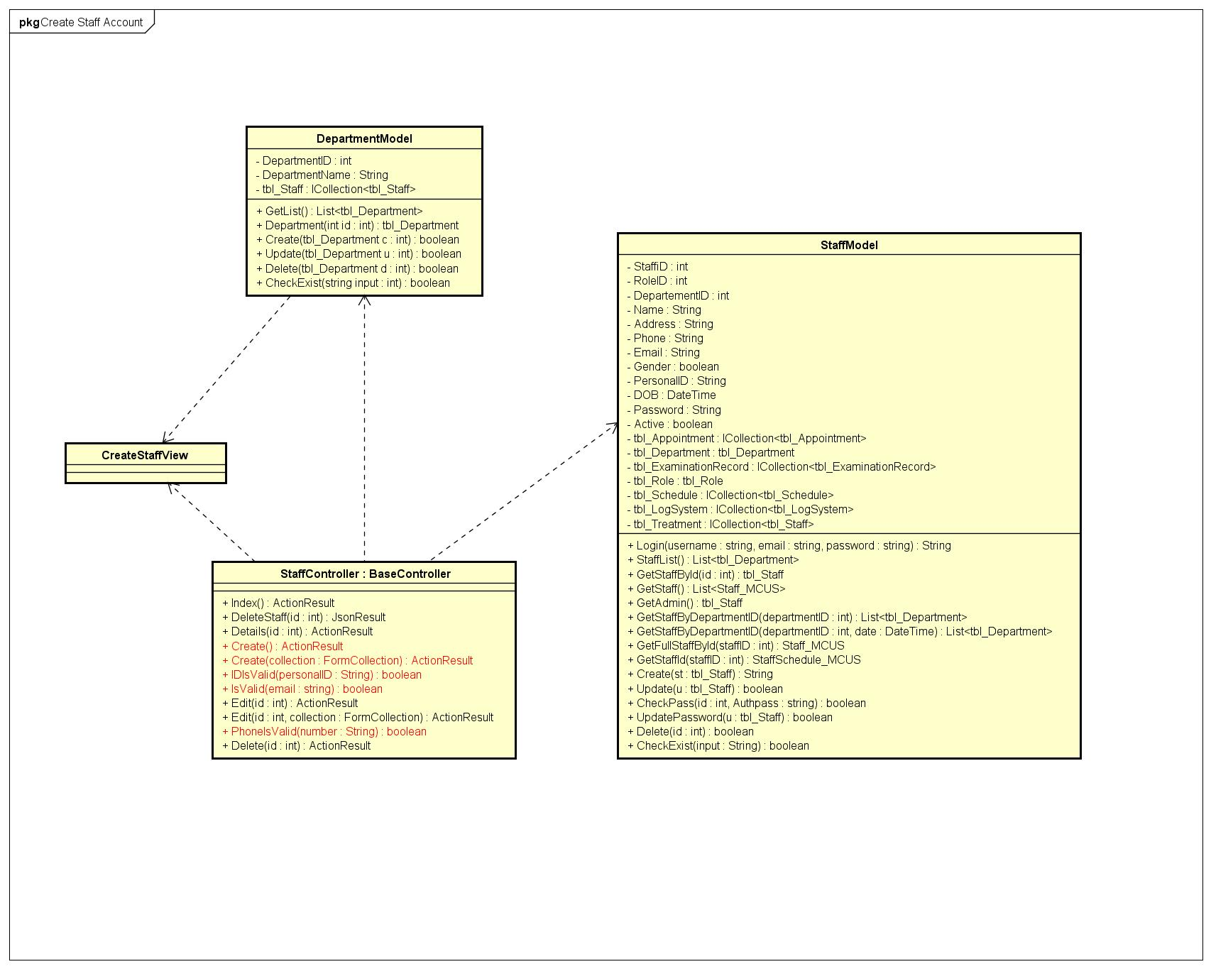

Figure 103: Create Staff Account Class Diagram

#### Delete Staff Account

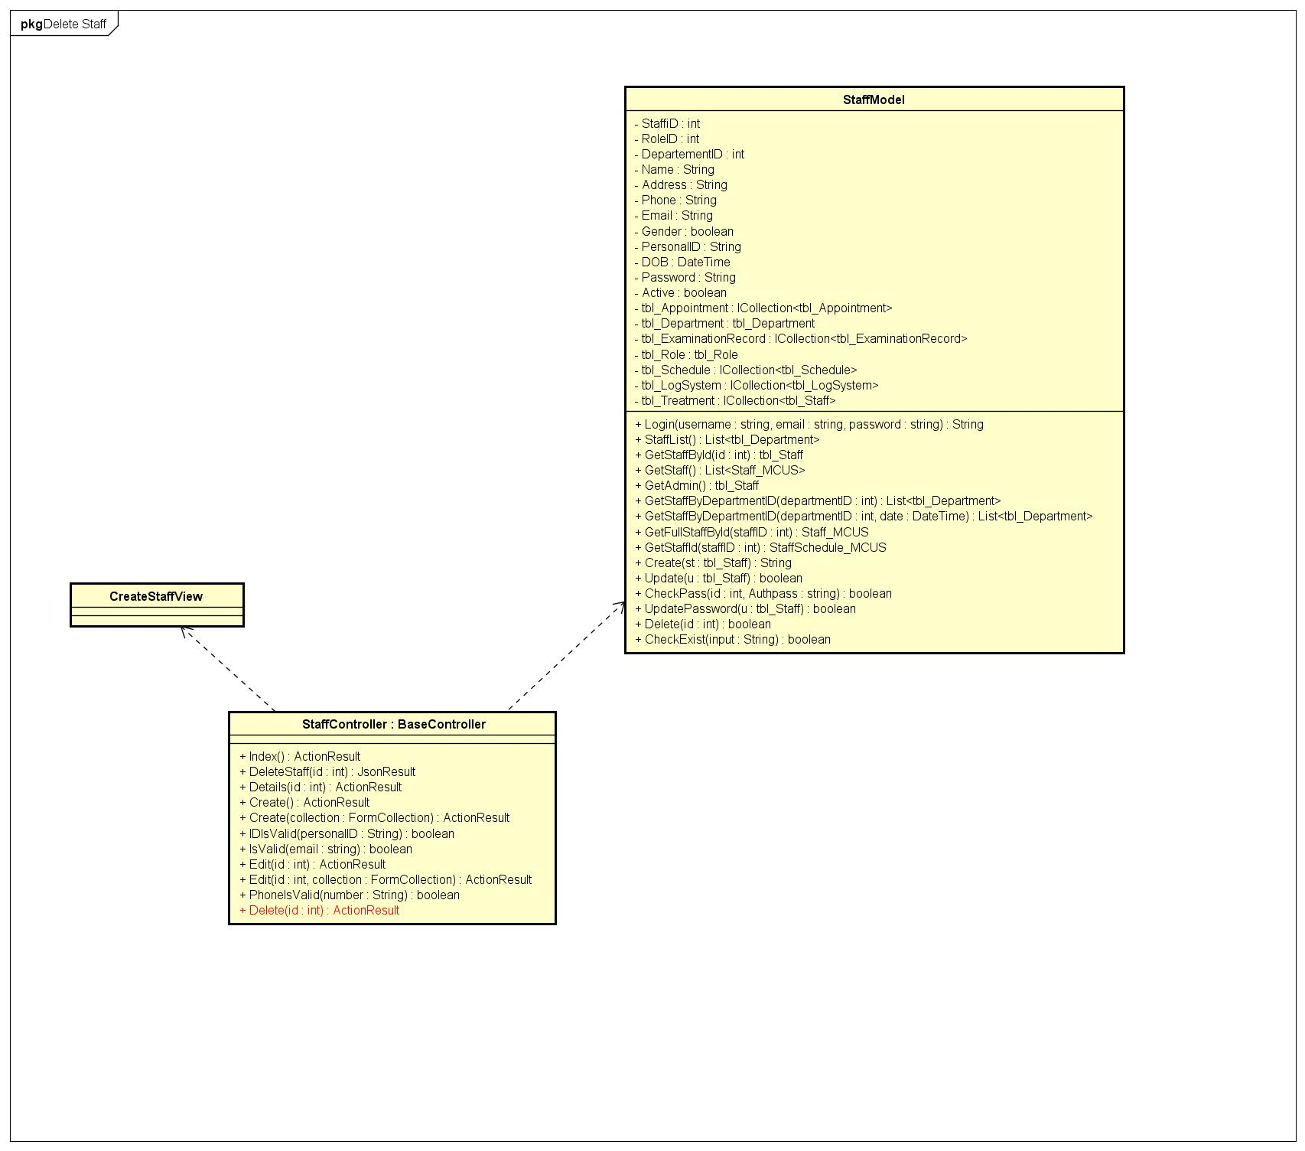

Figure 104: Delete Staff Account Class Diagram

#### View Staff Account

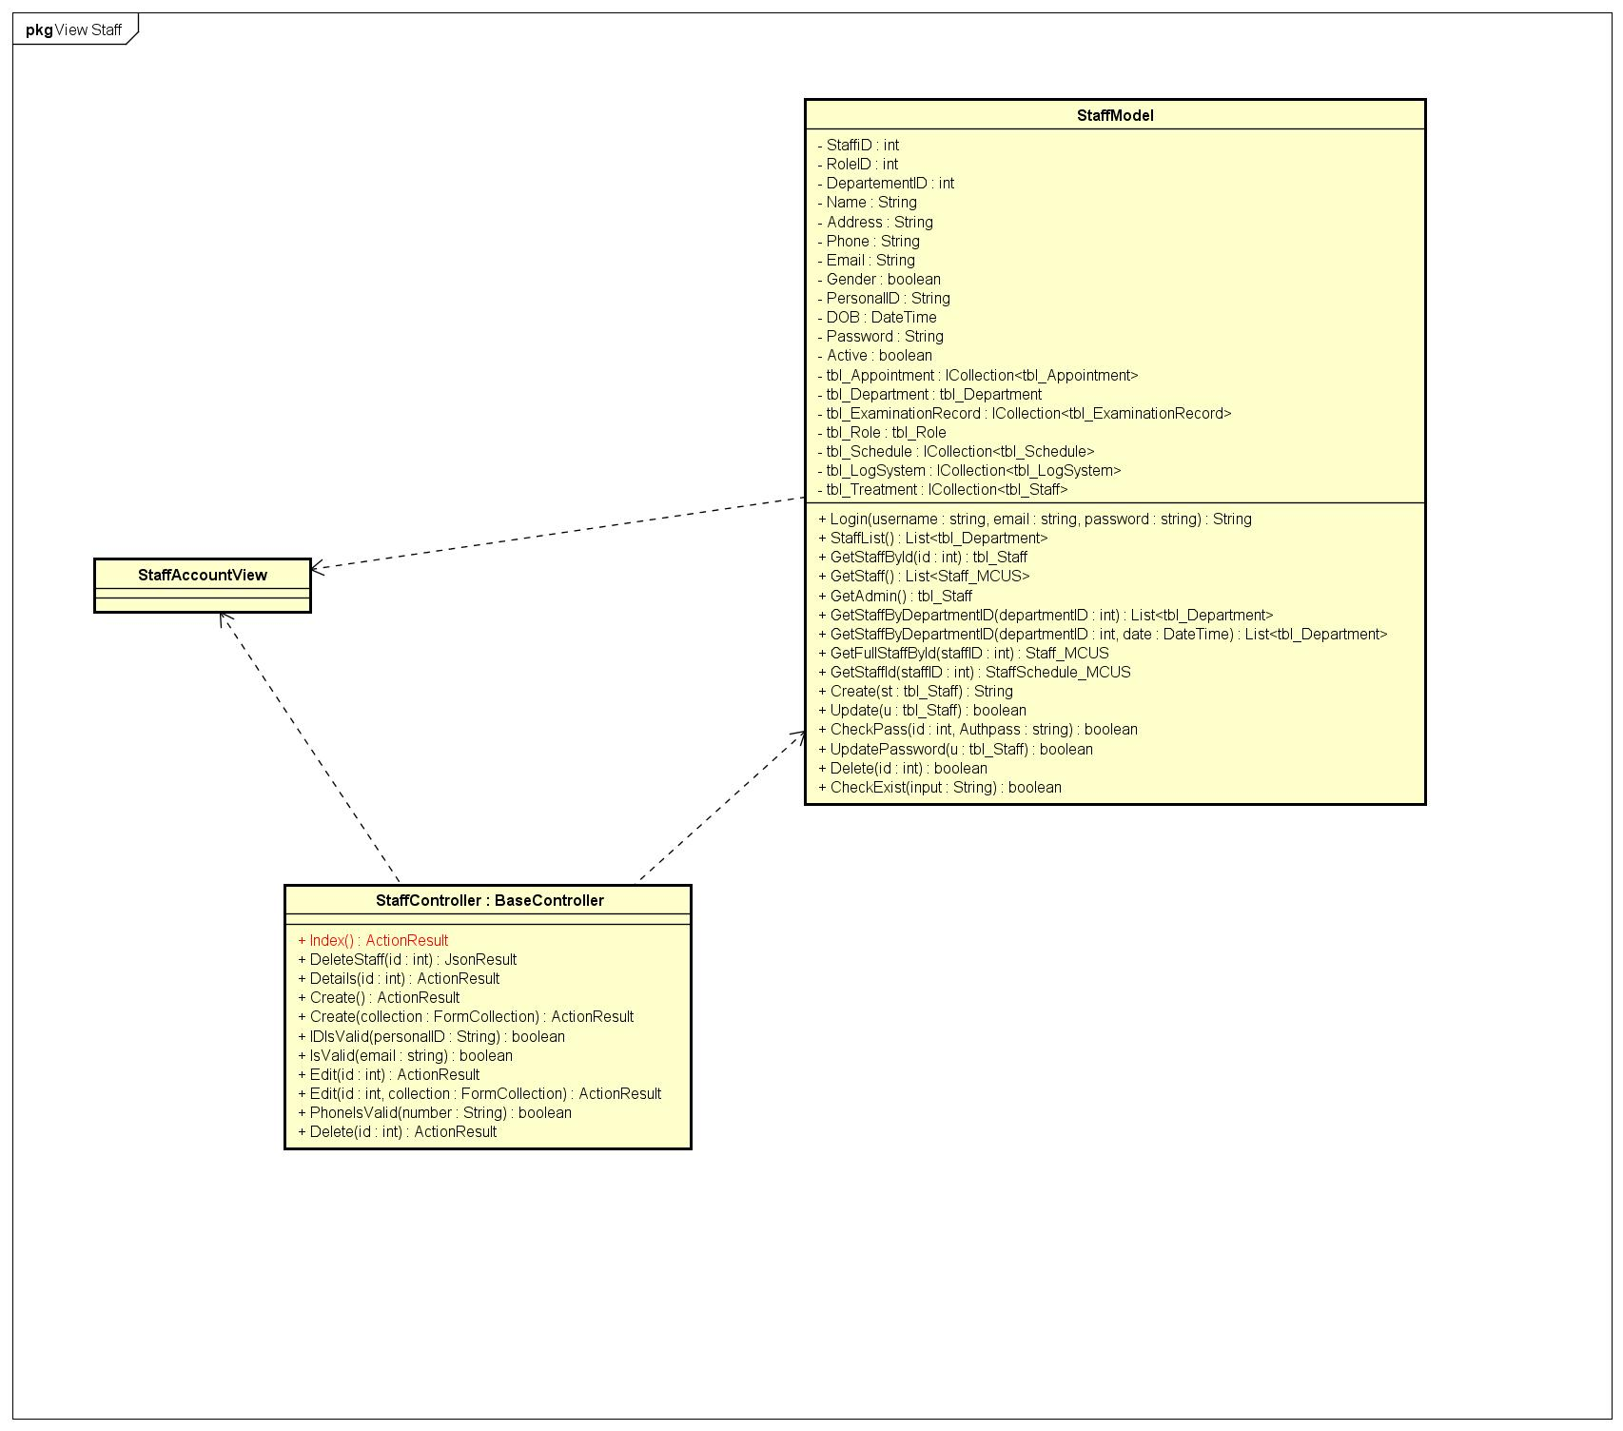

Figure 105: View Staff Account Class Diagram

#### View Action History

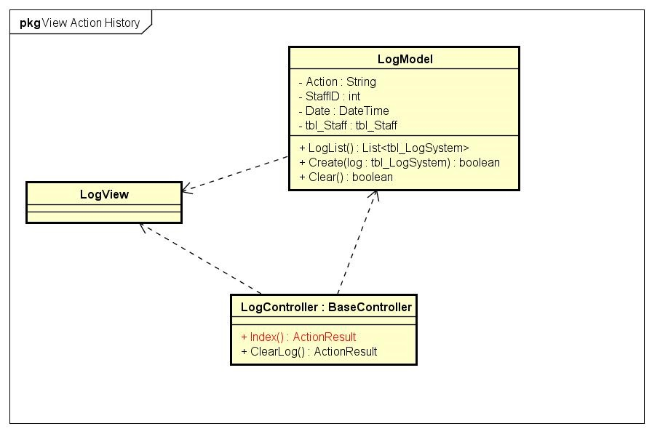

Figure 106: View Action Hitory Class Diagram

#### Clean Action History

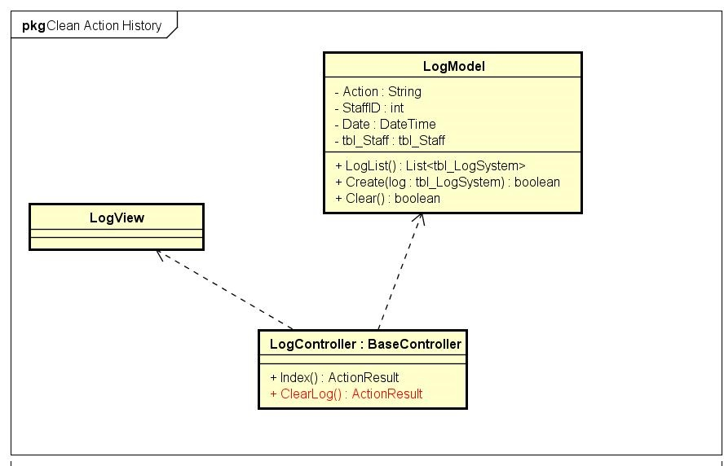

Figure 107: Clean Action Hitory Class Diagram

## Use Interface Design

### Register

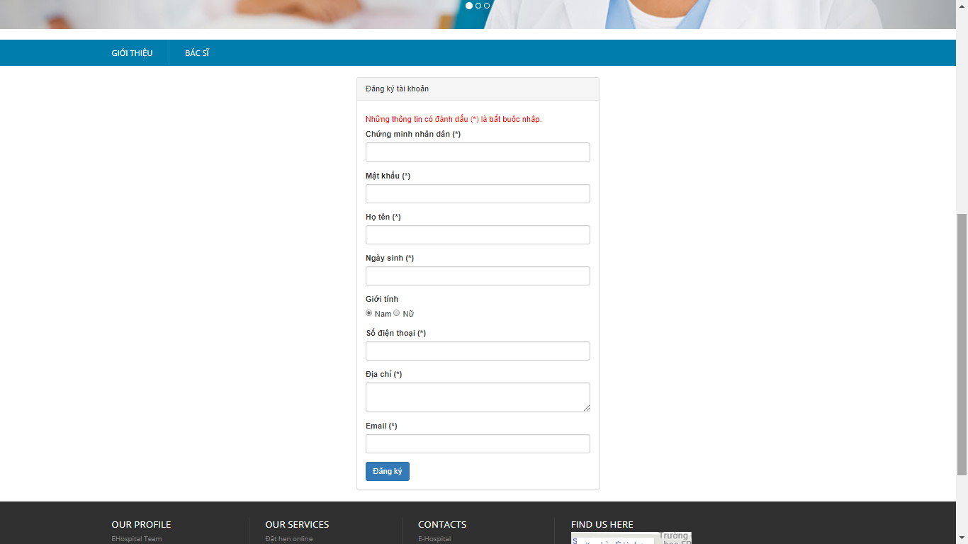

Figure 108: Register Screen

### View Profile

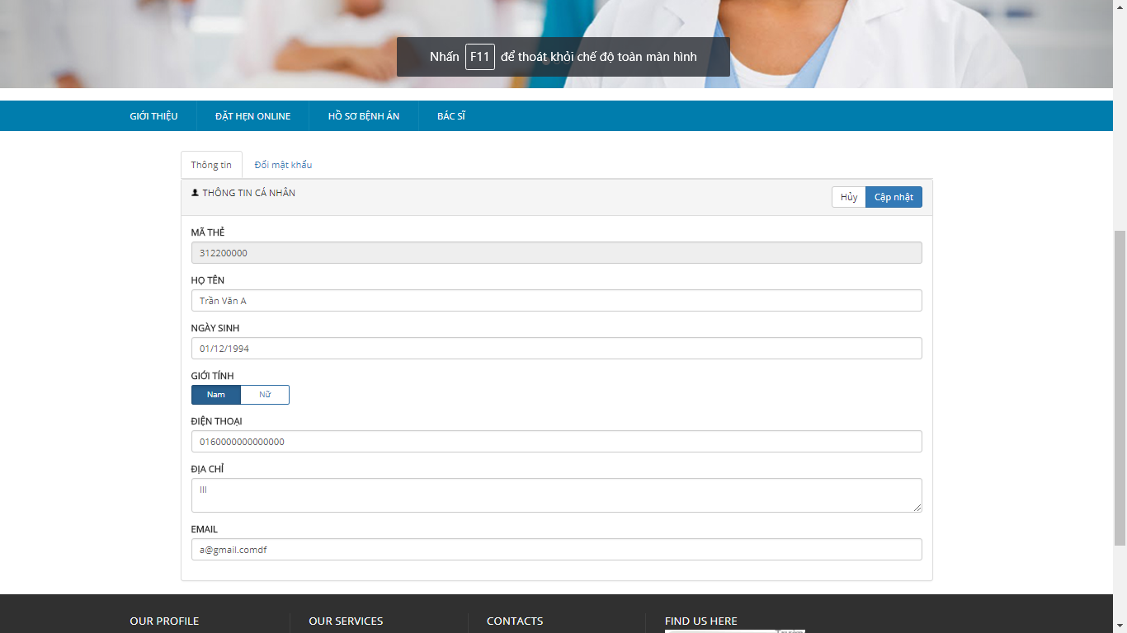

Figure 109: View Profile Screen

### Change Password

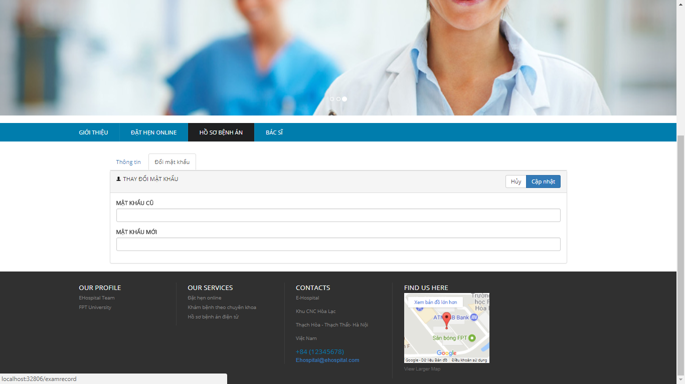

Figure 110: Change Password Screen

### Create Appointment

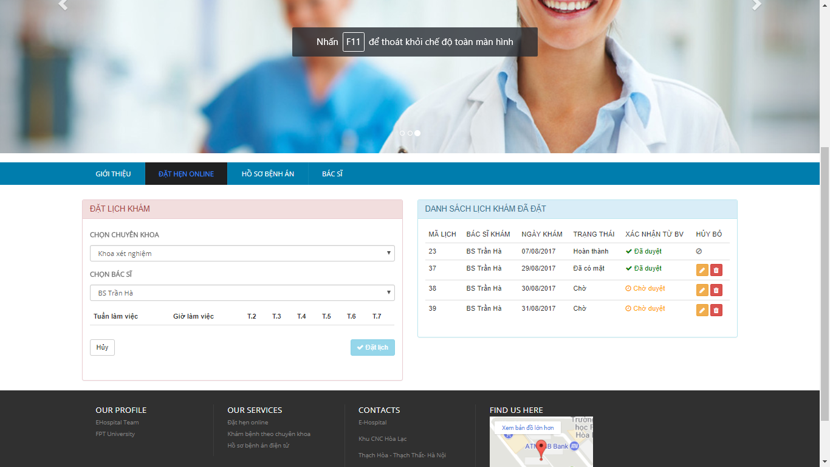

Figure 111: Create Appointment Screen

### View Examination Record

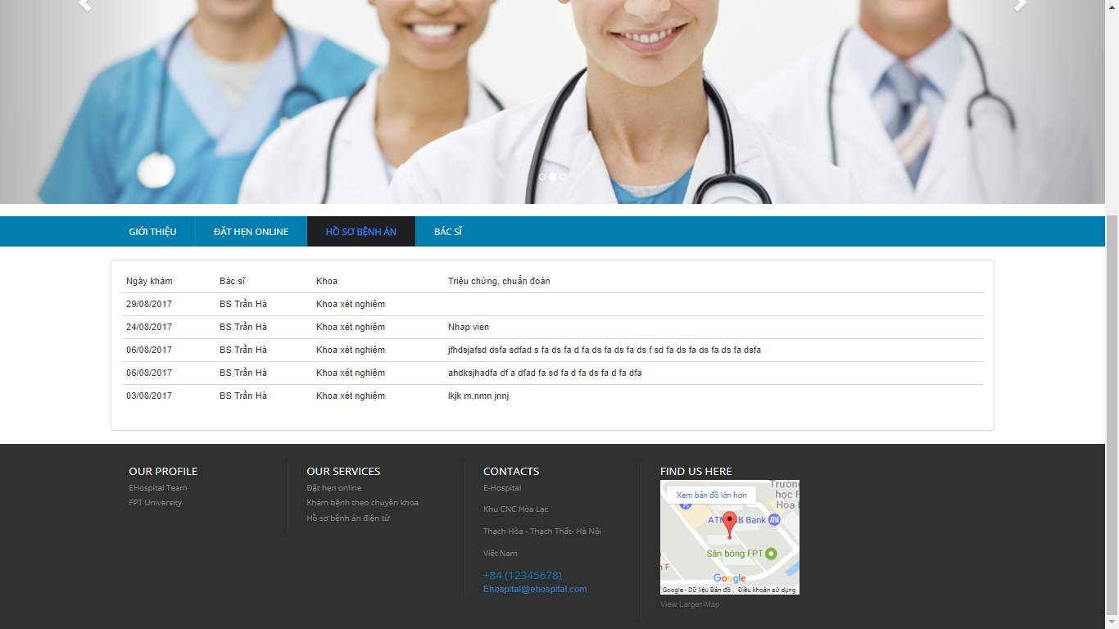

Figure 112: View Examination Screen

### Doctor Schedule Management

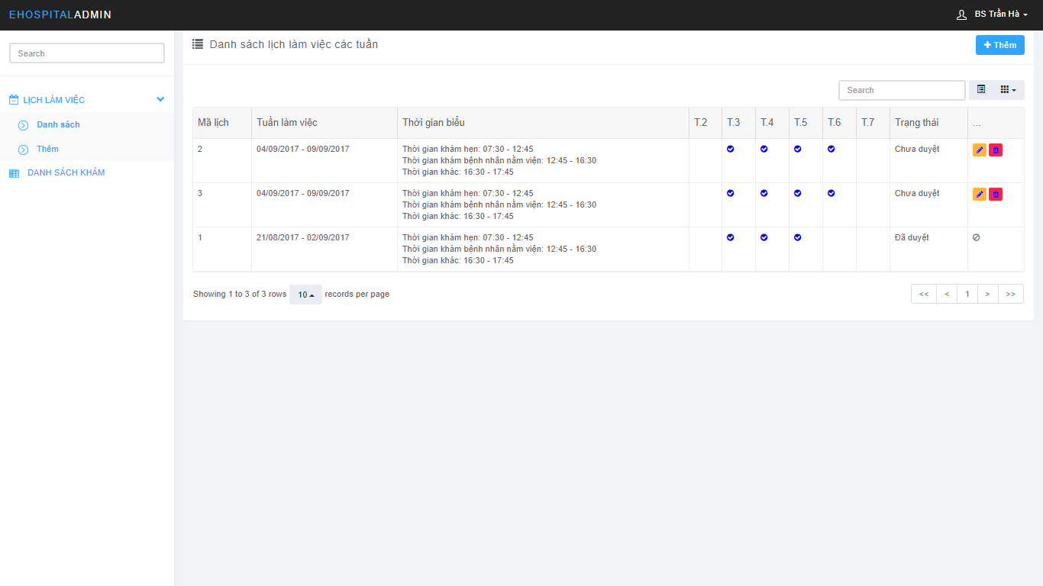

Figure 113: Doctor Schedule Management Screen

### View Appointment

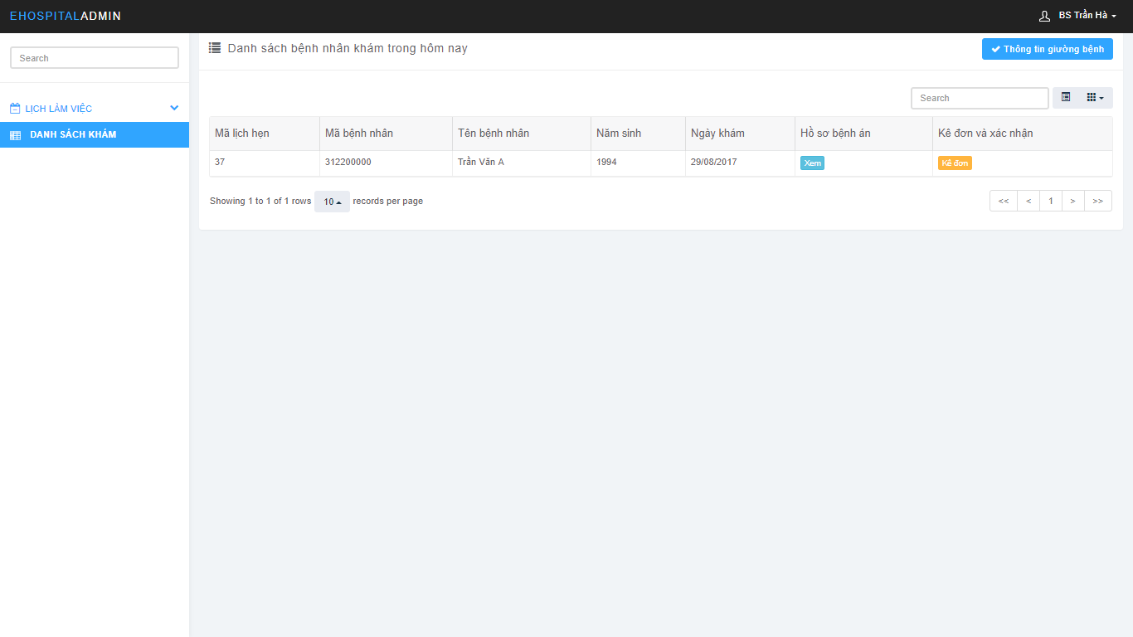

Figure 114: View Appointment Screen

### Patient Account Management (Reception)

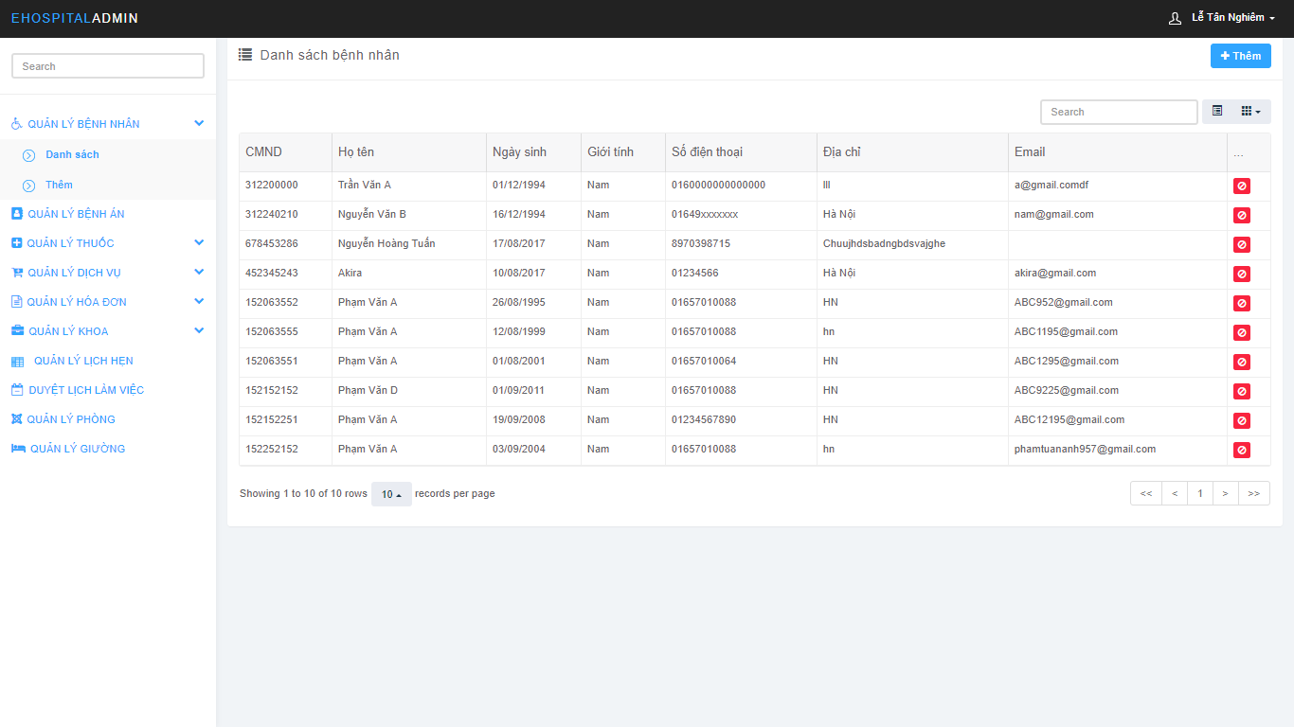

Figure 115: Patient Account Management Screen

### Medicine Management

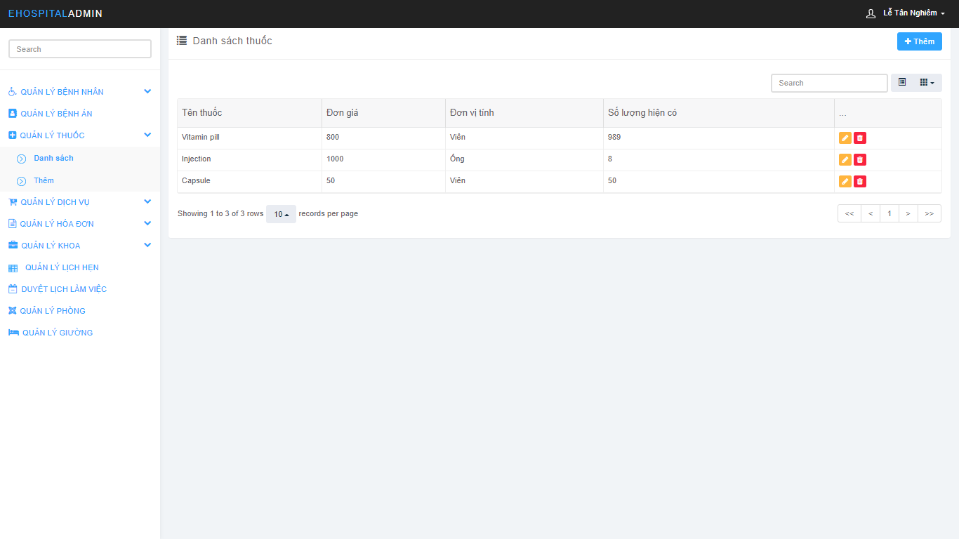

Figure 116: Profile Management Screen

### Service Management

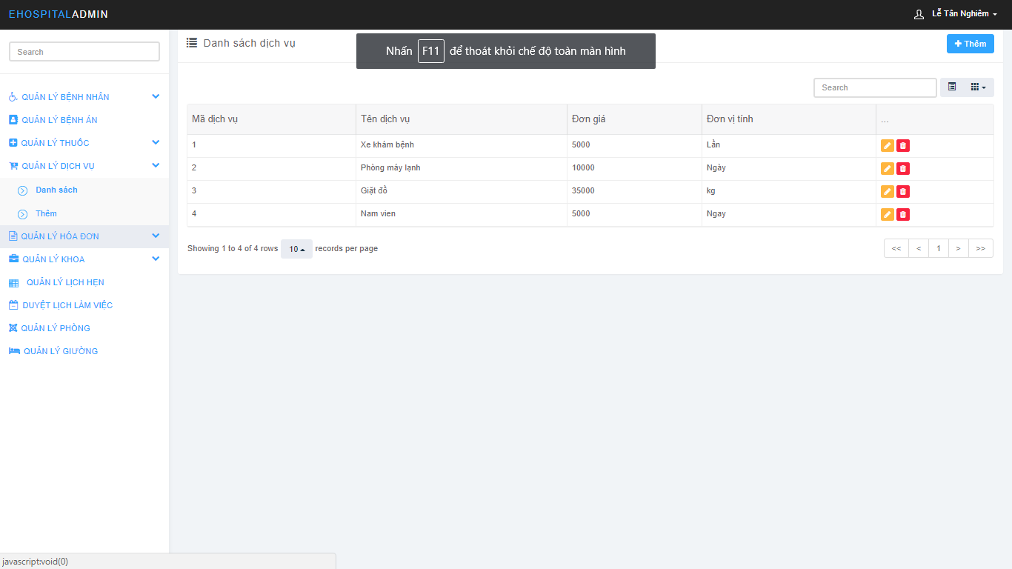

Figure 117: Service Managerment Screen

### Bill Management

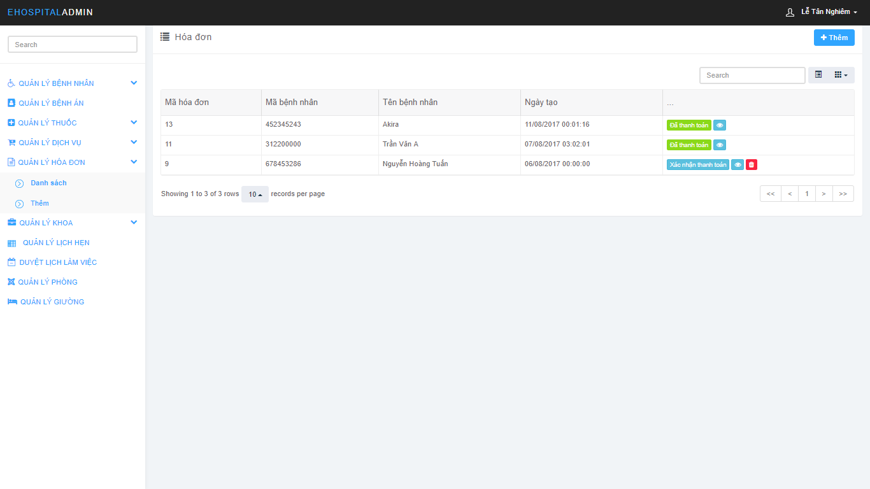

Figure 118: Bill Managerment Screen

### Department Management

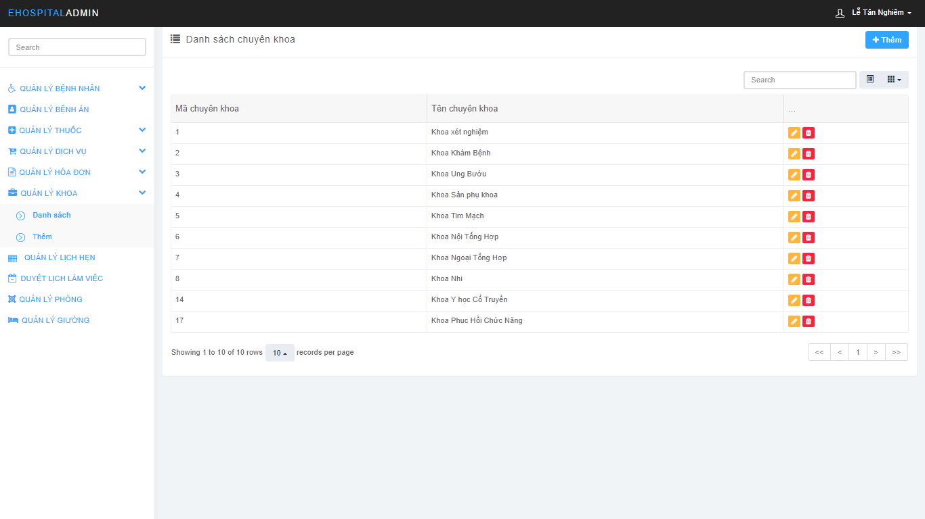

Figure 119: Department Managerment Screen

### Appointment Management

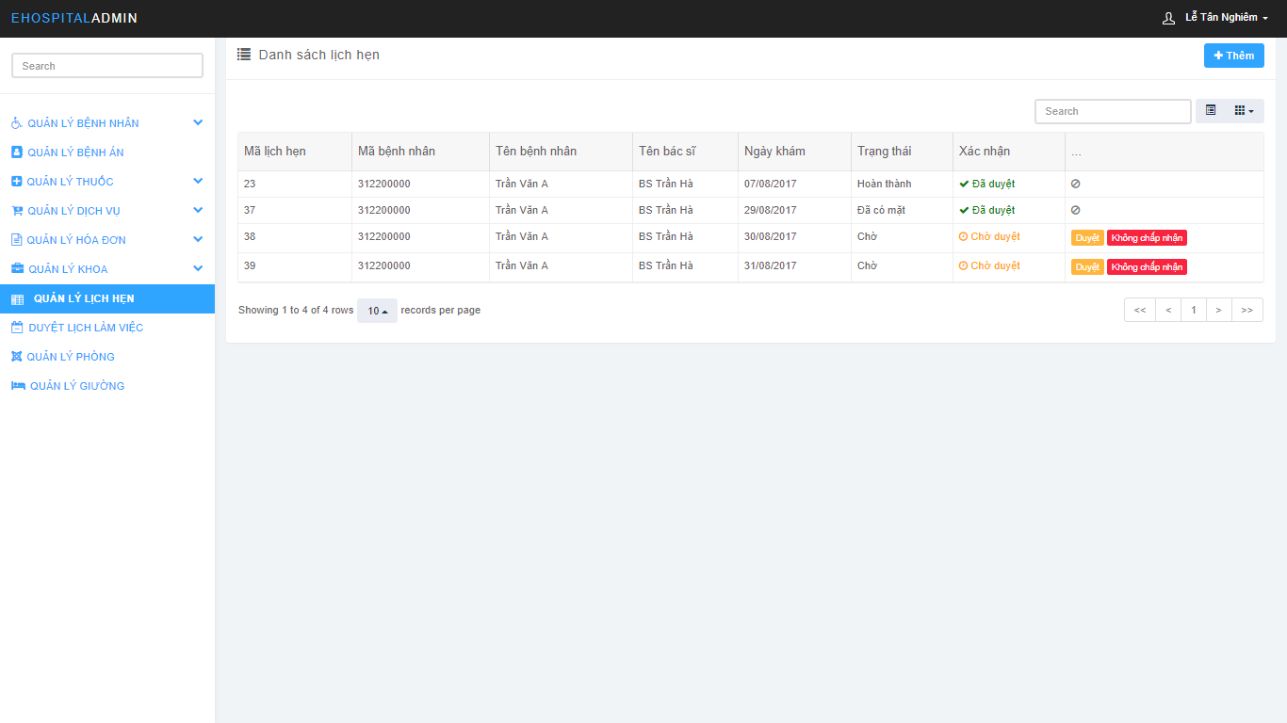

Figure 120: Appointment Managerment Screen

### Accept Doctor Schedule

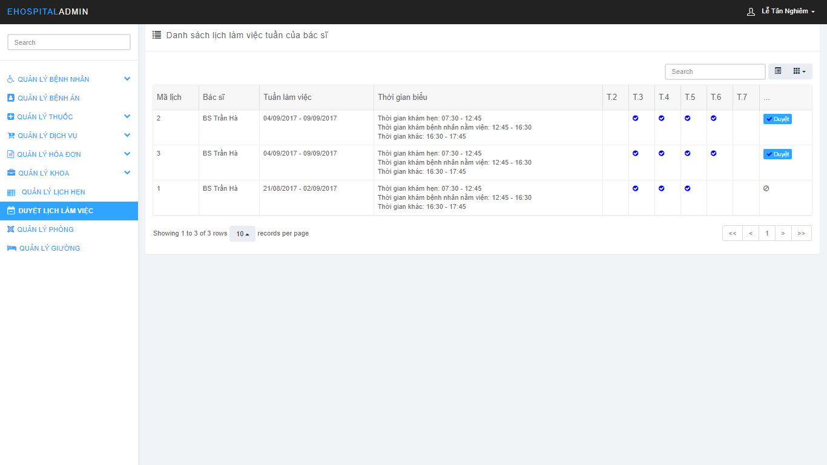

Figure 121: Accept Doctor Schedule Screen

### Room Management

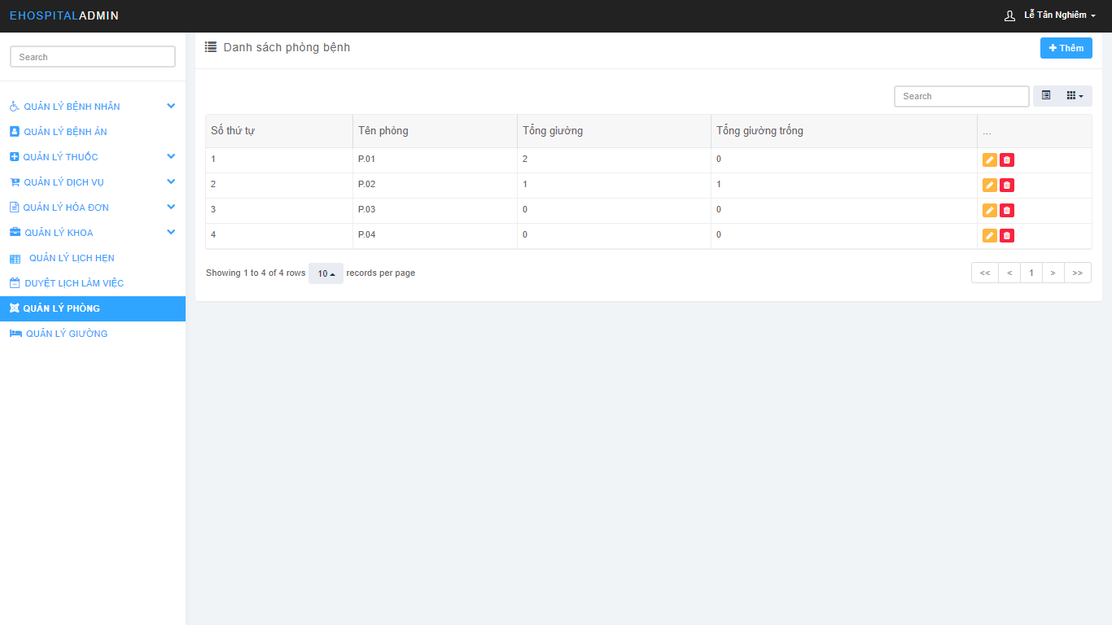

Figure 122: Room Managerment Screen

### Bed Management

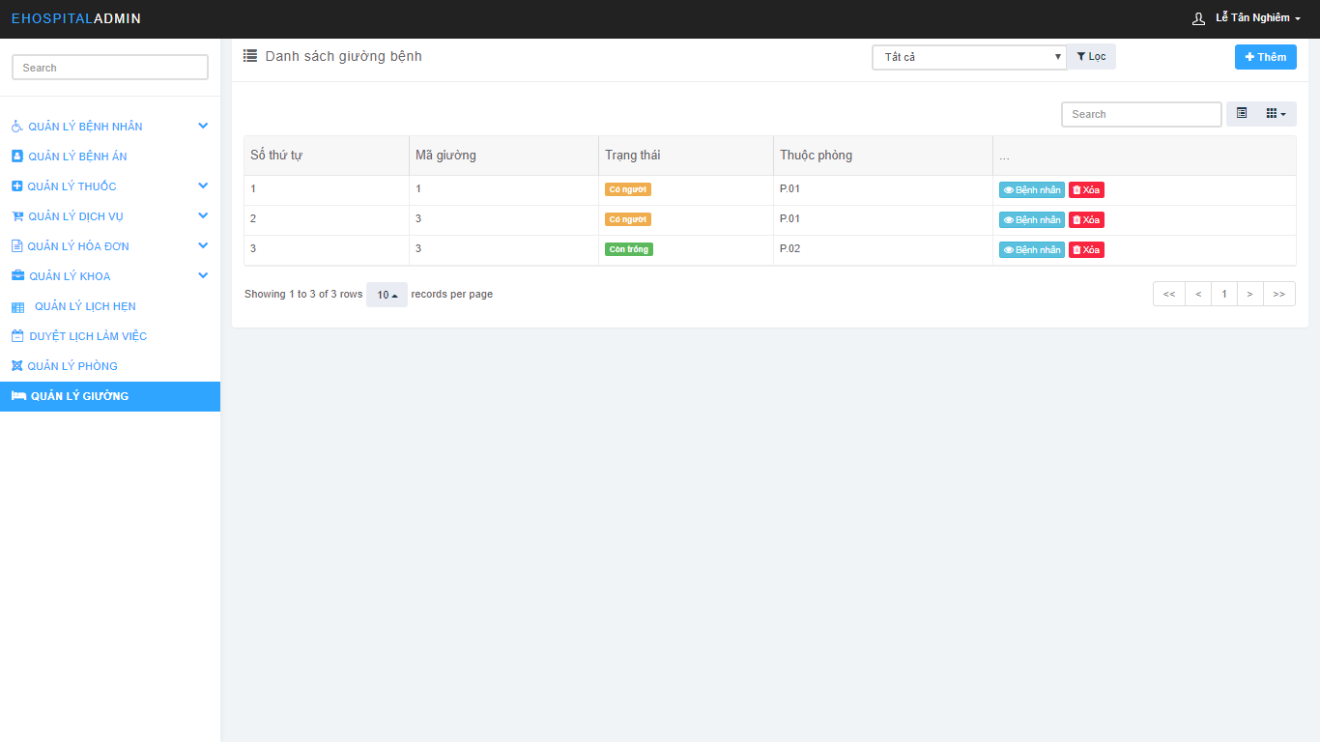

Figure 123: Bed Managerment Screen

### Staff Account Management

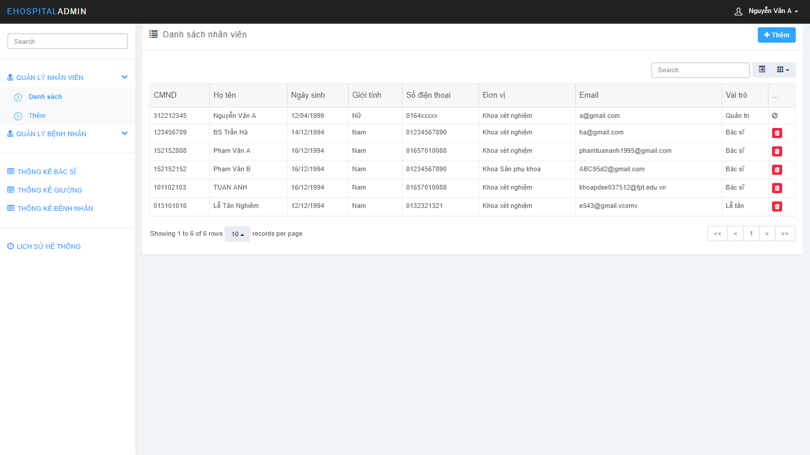

Figure 124: Staff Account Managerment Screen

### Patient Account Management (Admin)

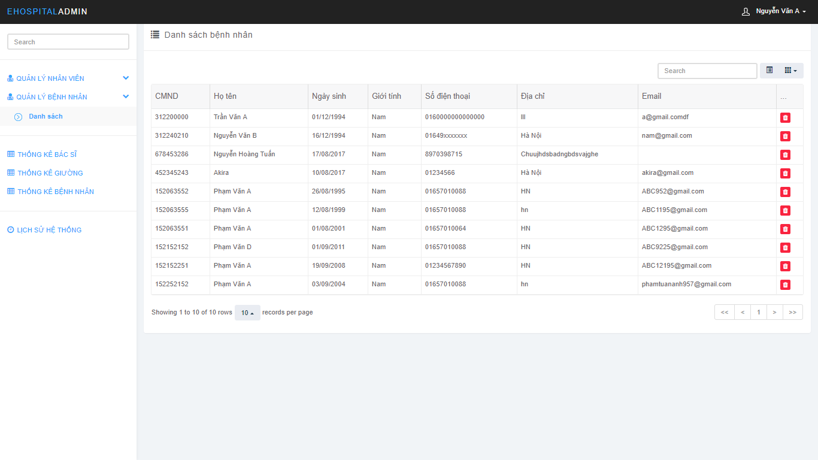

Figure 125: Patient Account Managerment Screen

### Action History Management

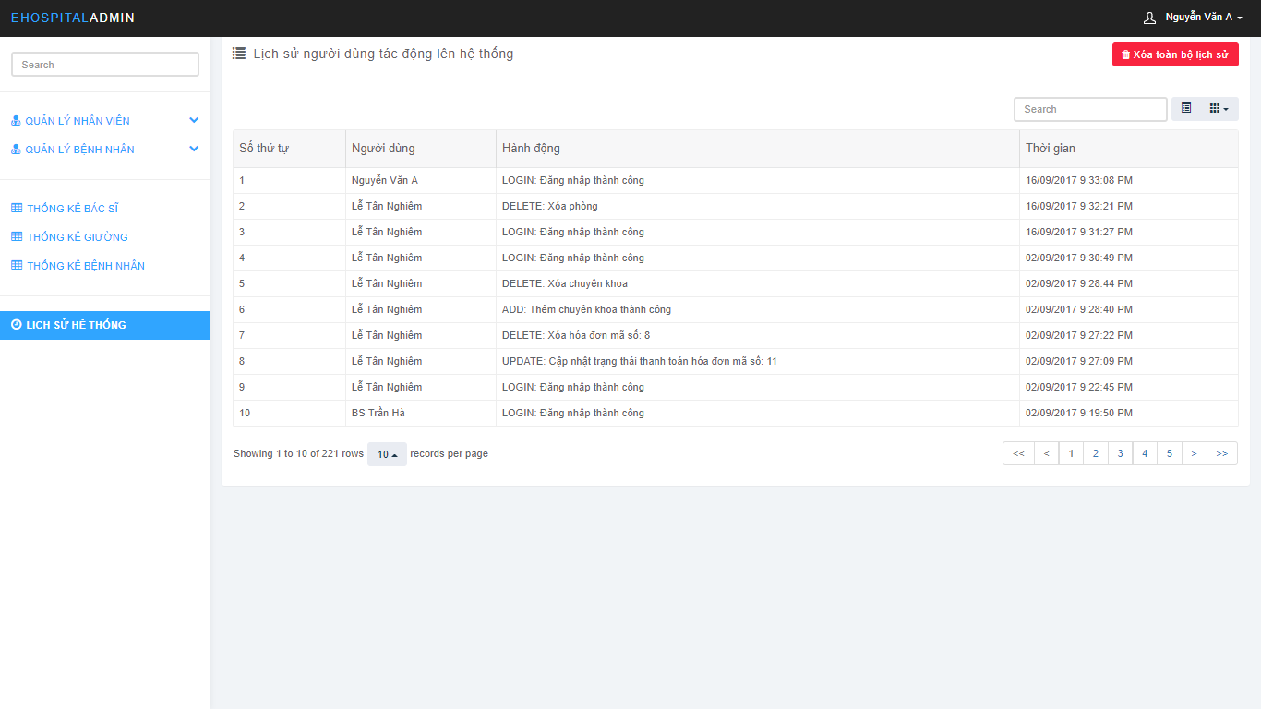

Figure 126: Action History Management Screen

## Database Design

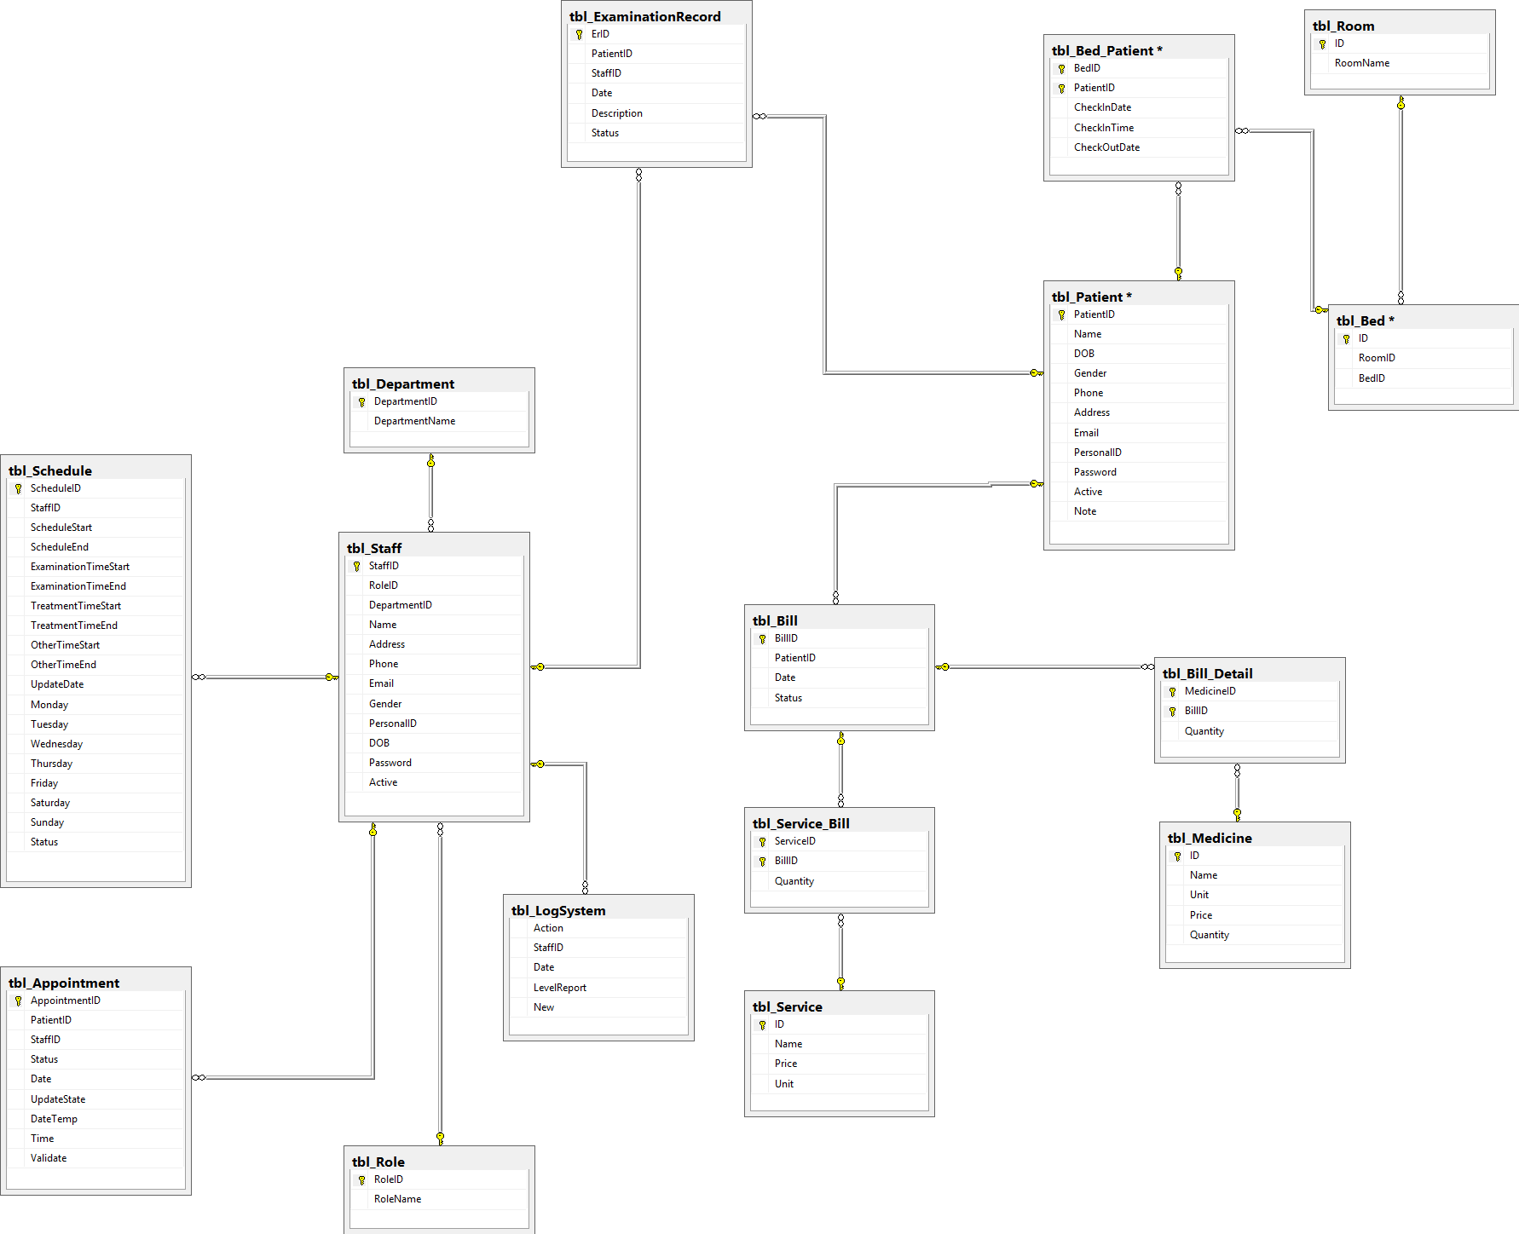

Figure 127: Database Design Screen

### Appointment table

Appointment table store appointment information.

|  |  |  |  |  |  |
| --- | --- | --- | --- | --- | --- |
| **No.** | **Field Name** | **Type** | **Size** | **Description** | **Not Null** |
| 1 | AppointmentID (Primary key) | int |  | The unique identity field for appointment | X |
| 2 | PatientID | int |  | The unique identity field for patient | X |
| 3 | StaffID | int |  | The unique identity field for staff | X |
| 4 | Status | int |  | Status of appointment | X |
| 5 | Date | date |  | Appointment creation date | X |
| 6 | Validate | int |  | Validate of hospital for appointment |  |

### Bed table

Bed table store hospital bed information.

|  |  |  |  |  |  |
| --- | --- | --- | --- | --- | --- |
| **No.** | **Field Name** | **Type** | **Size** | **Description** | **Not Null** |
| 1 | ID (Primary key) | int |  | The unique identity field for bed | X |
| 2 | RoomID | int |  | The unique identity field for room | X |
| 3 | BedID | int |  | The unique identity field for bed in using | X |

### Bed Patient table

Bed-Patient table store bed information for hospitalization patient.

|  |  |  |  |  |  |
| --- | --- | --- | --- | --- | --- |
| **No.** | **Field Name** | **Type** | **Size** | **Description** | **Not Null** |
| 1 | BedID (Primary key) | int |  | The unique identity field for bed-patient | X |
| 2 | PatientID  (Primary key) | int |  | The unique identity field for patient | X |
| 3 | CheckInDate | date |  | Check-in date of patient use this bed | X |
| 4 | CheckInTime | time | 7 | Check-in time of patient use this bed | X |
| 5 | CheckOutDate | date |  | Check-out date of patient use this bed |  |

### Bill table

Bill table store bill information.

|  |  |  |  |  |  |
| --- | --- | --- | --- | --- | --- |
| **No.** | **Field Name** | **Type** | **Size** | **Description** | **Not Null** |
| 1 | BillID (Primary key) | int |  | The unique identity field of bill | X |
| 2 | PatientID | int |  | The unique identity field of patient | X |
| 3 | Date | Datetime |  | Bill creation date | X |
| 4 | Status | bit |  | Status of bill | X |

### Bill Detail table

Bill Detail table store medicine information in a bill.

|  |  |  |  |  |  |
| --- | --- | --- | --- | --- | --- |
| **No.** | **Field Name** | **Type** | **Size** | **Description** | **Not Null** |
| 1 | MedicineID (Primary key) | int |  | The unique identity field of medicine | X |
| 2 | BillID  (Primary key) | int |  | The unique identity field of bill | X |
| 3 | Quantity | int |  | Quantity of medicine in this bill | X |

### Department table

Department table store department information.

|  |  |  |  |  |  |
| --- | --- | --- | --- | --- | --- |
| **No.** | **Field Name** | **Type** | **Size** | **Description** | **Not Null** |
| 1 | DepartmentID (Primary key) | int |  | The unique identity field of department | X |
| 2 | DepartmentName | nvarchar | 50 | Name of department | X |

### Examination Record table

Examination Record table store examination record of patient

|  |  |  |  |  |  |
| --- | --- | --- | --- | --- | --- |
| **No.** | **Field Name** | **Type** | **Size** | **Description** | **Not Null** |
| 1 | ErID (Primary key) | int |  | The unique identity field of examination record | X |
| 2 | PatientID | int |  | The unique identity field of patient | X |
| 3 | StaffID | int |  | The unique identity field of staff | X |
| 4 | Date | datetime |  | Examination Record creation date | X |
| 5 | Description | ntext |  | Description of examination record |  |
| 6 | Status | int |  | Status of examination record | X |

### Log System table

Log System table store action in system

|  |  |  |  |  |  |
| --- | --- | --- | --- | --- | --- |
| **No.** | **Field Name** | **Type** | **Size** | **Description** | **Not Null** |
| 1 | Action | nvarchar | 200 | Action description | X |
| 2 | StaffID | int |  | The unique identity field of staff | X |
| 3 | Date | datetime |  | Action date |  |
| 4 | LevelReport | int |  | Level of action | X |
| 5 | New | int |  | Condition of action | X |

### Medicine table

Medicine table store medicine information

|  |  |  |  |  |  |
| --- | --- | --- | --- | --- | --- |
| **No.** | **Field Name** | **Type** |  | **Description** | **Not Null** |
| 1 | ID (Primary key) | int |  | The unique identity field of medicine | X |
| 2 | Name | nvarchar | 100 | Name of medicine | X |
| 3 | Unit | nvarchar | 100 | Unit of medicine | X |
| 4 | Price | int |  | Price of medicine | X |
| 5 | Quantity | int |  | Quantity of medicine | X |

### Patient table

Patient table store patient information

|  |  |  |  |  |  |
| --- | --- | --- | --- | --- | --- |
| **No.** | **Field Name** | **Type** | **Size** | **Description** | **Not Null** |
| 1 | PatientID (Primary key) | int |  | The unique identity field of patient | X |
| 2 | Name | nvarchar | 80 | Name of patient | X |
| 3 | DOB | date |  | Date of birth of patient | X |
| 4 | Gender | bit |  | Gender of patient | X |
| 5 | Phone | nvarchar | 50 | Phone of patient | X |
| 6 | Address | nvarchar | 500 | Address of patient | X |
| 7 | Email | nvarchar | 80 | Email of patient | X |
| 8 | PersonalID | char | 8 | Personal identification number of patient | X |
| 9 | Password | nvarchar | 200 | Password of patient account | X |
| 10 | Active | bit |  | Condition of patient account | X |

### Role table

Role table store role information

|  |  |  |  |  |  |
| --- | --- | --- | --- | --- | --- |
| **No.** | **Field Name** | **Type** | **Size** | **Description** | **Not Null** |
| 1 | RoleID (Primary key) | int |  | The unique identity field of role | X |
| 2 | RoleName | nvarchar | 20 | Name of role | X |

### Room table

Room table store room information

|  |  |  |  |  |  |
| --- | --- | --- | --- | --- | --- |
| **No.** | **Field Name** | **Type** | **Size** | **Description** | **Not Null** |
| 1 | ID (Primary key) | int | 15 | The unique identity field of hospital room | X |
| 2 | DepartmentName | nvarchar | 50 | Name of department | X |

### Schedule table

Schedule table store schedule information

|  |  |  |  |  |  |
| --- | --- | --- | --- | --- | --- |
| **No.** | **Field Name** | **Type** | **Size** | **Description** | **Not Null** |
| 1 | ScheduleID (Primary key) | int |  | The unique identity field of schedule | X |
| 2 | StaffID | int |  | The unique identity field of staff | X |
| 3 | ScheduleStart | date |  | Starting schedule date | X |
| 4 | ScheduleEnd | date |  | Ending schedule date | X |
| 5 | ExaminationTimeStart | time | 7 | Starting examination time | X |
| 6 | ExaminationTimeEnd | time | 7 | Ending examination time | X |
| 7 | TreatmentTimeStart | time | 7 | Starting treatment time | X |
| 8 | TreatmentTimeEnd | time | 7 | Ending treatment time | X |
| 9 | OtherTimeStart | time | 7 | Starting other time | X |
| 10 | OtherTimeEnd | time | 7 | Ending other time | X |
| 11 | UpdateDate | datetime |  | Schedule creation date | X |
| 12 | Monday | bit |  | Schedule information on Monday | X |
| 13 | Tuesday | bit |  | Schedule information on Tuesday | X |
| 14 | Wednesday | bit |  | Schedule information on Wednesday | X |
| 15 | Thursday | bit |  | Schedule information on Thursday | X |
| 16 | Friday | bit |  | Schedule information on Friday | X |
| 17 | Saturday | bit |  | Schedule information on Saturday | X |
| 18 | Status | bit |  | Status of schedule | X |

### Service table

Service table store service information

|  |  |  |  |  |  |
| --- | --- | --- | --- | --- | --- |
| **No.** | **Field Name** | **Type** |  | **Description** | **Not Null** |
| 1 | ID (Primary key) | int |  | The unique identity field of service | X |
| 2 | Name | nvarchar | 100 | Name of service | X |
| 3 | Unit | nvarchar | 15 | Unit of service | X |
| 4 | Price | int |  | Price of service | X |

### Service Bill table

Service Bill table store service information in a bill.

|  |  |  |  |  |  |
| --- | --- | --- | --- | --- | --- |
| **No.** | **Field Name** | **Type** | **Size** | **Description** | **Not Null** |
| 1 | ServiceID (Primary key) | int |  | The unique identity field of service | X |
| 2 | BillID  (Primary key) | int |  | The unique identity field of bill | X |
| 3 | Quantity | int |  | Quantity of service in this bill | X |

### Staff table

Staff table store staff information

|  |  |  |  |  |  |
| --- | --- | --- | --- | --- | --- |
| **No.** | **Field Name** | **Type** | **Size** | **Description** | **Not Null** |
| 1 | StaffID (Primary key) | int |  | The unique identity field of staff | X |
| 2 | RoleID | int |  | The unique identity field of role | X |
| 3 | DepartmentID | int |  | The unique identity field of department |  |
| 4 | Name | nvarchar | 80 | Name of patient | X |
| 5 | DOB | date |  | Date of birth of patient | X |
| 6 | Gender | bit |  | Gender of patient | X |
| 7 | Phone | nvarchar | 50 | Phone of patient | X |
| 8 | Address | nvarchar | 500 | Address of patient | X |
| 9 | Email | nvarchar | 80 | Email of patient | X |
| 10 | PersonalID | char | 8 | Personal identification number of patient | X |
| 11 | Password | nvarchar | 200 | Password of patient account | X |
| 12 | Active | bit |  | Condition of patient account | X |

# CHAPTER 5: SOFTWARE TESTING DOCUMENT

## Introduction

### Purpose

This is comprehensive test plan of the eHospital project. The main purpose of this report is to detect and fix problems to ensure that our project is thoroughly tested and lead to the success of the project.

### Test Approach

E-Hospital follows V-Model process model:

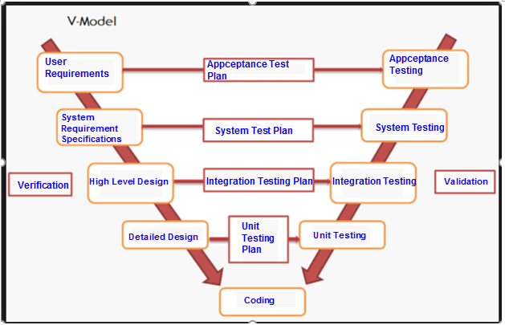

Figure 128: V-Model

There are three types of testing is conducted in E_Hospatal project:

**Unit testing**

* Unit Test is an important technique to improve software quality.
* Unit testing is done by developers

**Integration testing**

* Integration Testing is a test that integrates a group of individual modules together with individual unit tests in each module.
* A typical software project consists of several software modules, coded by different people. Integration testing focuses on testing the data transfer between modules.
* Integration test should be performed to ensure all components incorporate well.

**System testing**

* System testing is the testing process of a finished product and fully integrated. After Integration test and Unit test.
* Usually a software product is only tested on a demo environment, but the system test ensures that the system operates in a variety of environments and integrates with a variety of software and systems.
* System test is a type of black box testing. System involves the operation of the outside of the software from the user's point of view.
* Rule for filling test result:

|  |  |
| --- | --- |
| Test result pass | Pass |
|  |  |
| Test result fail | Fail |
|  |  |
| Do not test | Untested |
|  |  |
| Cannot test | N/A (Not available) |
|  |  |

**Appceptance Test**

* Acceptance testing is functional testing, which is done to check that the software meets the requirements of the customer.
* Acceptable testing is performed by the customer, the user and the parties involved.
* In acceptance testing will test the system to meet the business needs of the organization, the usability of the product.
* Software runs with realistic data.
* Acceptable testing is performed after system testing.

## Test Plan

### Test Process



Figure 129: Test Process

### Features to be tested

The testing is done for all functionalities:

|  |  |  |  |
| --- | --- | --- | --- |
| **No** | **Use case ID** | **Name** | **Primary Actor** |
|  | UC1.01 | Register | Guest |
|  | UC2.01 | Login | Patient, Reception, Doctor, Admin |
|  | UC2.02 | Logout | Patient, Reception, Doctor, Admin |
|  | UC2.03 | Change password | Patient, Reception, Doctor, Admin |
|  | UC2.04 | View profile | Patient, Reception, Doctor, Admin |
|  | UC2.05 | Edit profile | Patient, Reception, Doctor, Admin |
|  | UC2.06 | View doctor schedule | Patient |
|  | UC2.07 | Create appointment | Patient |
|  | UC2.08 | View appointment | Patient |
|  | UC2.09 | Edit appointment | Patient |
|  | UC2.10 | Delete appointment | Patient |
|  | UC2.11 | View examination record | Patient |
|  | UC3.01 | Create schedule | Doctor |
|  | UC3.02 | View schedule | Doctor |
|  | UC3.03 | Edit schedule | Doctor |
|  | UC3.04 | View appointment | Doctor |
|  | UC3.05 | Create examination record | Doctor |
|  | UC3.06 | Create daily record | Doctor |
|  | UC3.07 | View record | Doctor |
|  | UC5.01 | Create direct appointment | Reception |
|  | UC5.02 | Accept appointment | Reception |
|  | UC5.03 | Delete appointment | Reception |
|  | UC5.04 | View doctor schedule | Reception |
|  | UC5.05 | Accept doctor schedule | Reception |
|  | UC5.06 | View examination record | Reception |
|  | UC5.07 | Create bill | Reception |
|  | UC5.08 | Finish bill | Reception |
|  | UC5.09 | Delete bill | Reception |
|  | UC5.10 | View bill | Reception |
|  | UC5.11 | Check-in to exam | Reception |
|  | UC5.12 | Check-in bed | Reception |
|  | UC5.13 | Check-out bed | Reception |
|  | UC5.14 | Create patient account | Reception |
|  | UC5.15 | Ban patient account | Reception |
|  | UC5.16 | View patient account | Reception |
|  | UC5.17 | Create medicine | Reception |
|  | UC5.18 | Edit medicine | Reception |
|  | UC5.19 | Delete medicine | Reception |
|  | UC5.20 | View medicine | Reception |
|  | UC5.21 | Create service | Reception |
|  | UC5.22 | Edit service | Reception |
|  | UC5.23 | Delete service | Reception |
|  | UC5.24 | View service | Reception |
|  | UC5.25 | Create room | Reception |
|  | UC5.26 | Edit room | Reception |
|  | UC5.27 | Delete room | Reception |
|  | UC5.28 | View room | Reception |
|  | UC5.29 | Create bed | Reception |
|  | UC5.30 | Edit bed | Reception |
|  | UC5.31 | Delete bed | Reception |
|  | UC5.32 | View bed | Reception |
|  | UC5.33 | Create department | Reception |
|  | UC5.34 | Edit department | Reception |
|  | UC5.35 | Delete department | Reception |
|  | UC5.36 | View department | Reception |
|  | UC6.01 | Create staff account | Admin |
|  | UC6.02 | Delete staff account | Admin |
|  | UC6.03 | Delete patient account | Admin |
|  | UC6.04 | View staff account | Admin |
|  | UC6.05 | View patient account | Admin |
|  | UC6.06 | View action history | Admin |
|  | UC6.07 | Clean action history | Admin |
|  | UC6.08 | Analyze doctor working details | Admin |
|  | UC6.09 | Analyze bed | Admin |
|  | UC6.10 | Analyze patient examined | Admin |

### Features not to be tested

* + - Performance is not tested.

### Testing Tools and Environment

* + **Hardware**

The content of the Testing Environment is shown in the table below:

|  |  |
| --- | --- |
| Test tool | Hardware |
| Manual Testing | Laptop Asus X554L RAM 4G, Intel Core i5, 15.6 inch. |

* + **Software**
* Operating System: Windows 10
* Browser: Google Chrome , Mozilla Firefox

|  |  |  |
| --- | --- | --- |
| Software | Document | Purpose |
|  |  |  |
| Microsoft Word 2016 | Test Plan | Managing test |
|  |  |  |
| Microsoft Excel 2016 | Test case | Executing test |
|  |  |  |
| Microsoft Excel 2016 | Test report, Test checklist | Tracking test |
|  |  |  |

### Test phases

* **Unit Testing**: Individual components are tested to ensure that they operate correctly. Each component is tested independently without other system components.
* **Module Testing**: This involves the testing of independent components such as procedures and functions. A module encapsulates related components so it can be tested without other system modules.
* **Subsystem Testing**: This phase involves testing collections of modules which have been integrated into sub-systems. Sub-systems may be independently designed. The most common problems which arise in large software systems are sub-system interface mismatches. The sub-system test process should therefore concentrate on the detection of interface errors by rigorously exercising the interfaces.
* **System Testing**: Sub systems are integrated to make up the entire system. The testing process is concerned with finding errors that result from unanticipated interactions between sub-systems and system components. It is also concerned with validating that the system meets its functional and non-functional requirements.
* **Acceptance Testing**: This is the final stage in the testing process before the system is accepted for operational use. The system is tested with data supplied by the system procurer rather than simulated test data. Acceptance testing may reveal errors and omissions in the system requirements definition because the real data exercises the system in different ways from the test data. It may also reveal requirements problems where the system's facilities do not really meet the user's needs or the system's performance is not acceptable.

### Test schedule

|  |  |  |
| --- | --- | --- |
| Test Schedule | Start Date | End Date |
| *Phase 1: Main features* | **01/08/2017** | **15/08/2017** |
| User Interface Testing | 01/08/2017 | 08/08/2017 |
| Functional Testing | 08/08/2017 | 15/08/2017 |
| *Phase 2: Other features and improvements* | **16/08/2017** | **25/08/2017** |
| User Interface Testing | 16/08/2017 | 20/08/2017 |
| Functional Testing | 20/08/2017 | 25/08/2017 |
| Regression Tests | 25/08/2017 | 30/08/2017 |

### Deliverables

|  |  |  |
| --- | --- | --- |
| Deliverables | Responsibilities | Complete date |
| Test Plan | Tester | 01/08/2017 |
| Test Cases | Tester | 10/08/2017 |
| Test case review | Tester + PM | 11/08/2017 |
| Test Data | Tester | 15/08/2017 |
| Defect report | All members | 20/08/2017 |
| Final test summary report | PM | 21/08/2017 |

### Resources and responsibilities

|  |  |  |
| --- | --- | --- |
| ID | Resources | Responsibilities |
| 1 | Pham Duc Khoa (Project Manager) | * Review Test-case and report. |
| 2 | Nguyen Van Long,Chu Van Thang  (Tester) | * Preforming the actual system testing. * Manage test resource and assign test tasks. * Create Test Plan. * Create Test Cases. * Create Test Report. * Execute Test. * Test Log report. |
| 3 | Luong Tien Dung,Pham Tuan Anh,Pham Duc Khoa (Developer) | * Create Unit Test. * Fix bugs. |

## Test Case Sample

### Unit Test

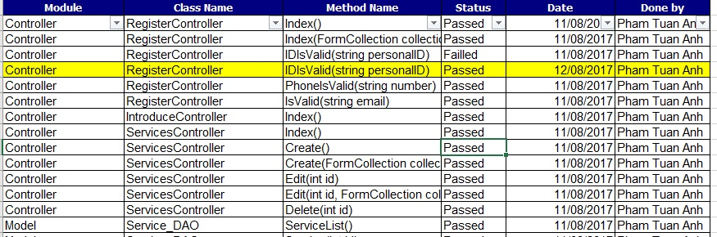

Figure 130: Unit Test Sample

### Integration Test

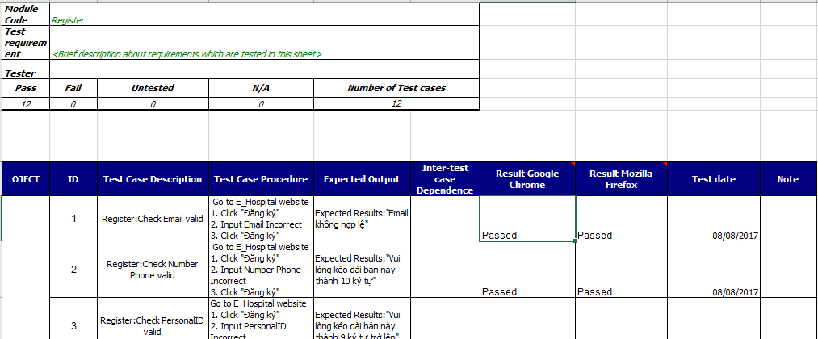

### System Test

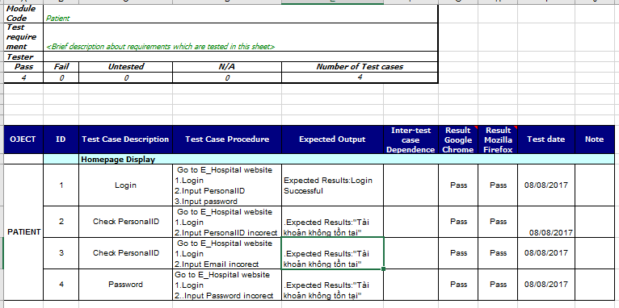

Figure 131: System Test Sample

### Acceptance Test

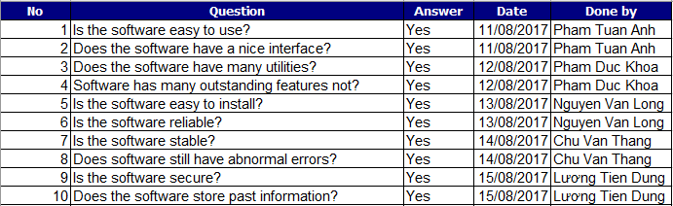

## Test Report Detail

### Unit Test

The first results:

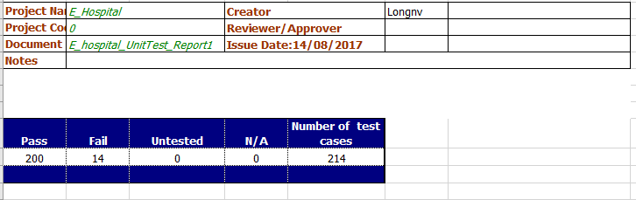

Figure 132: First Unit Test Report

The last results:

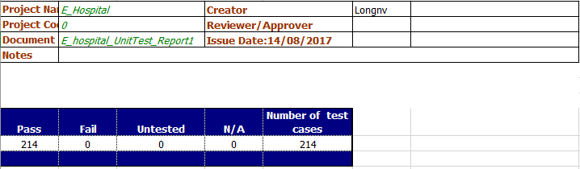

Figure 133: Last Unit Test Report

### Integration Test

The first results:

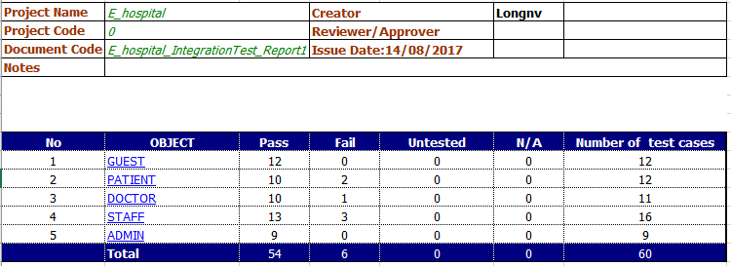

Figure 134: First Integration Test Report

The last results:

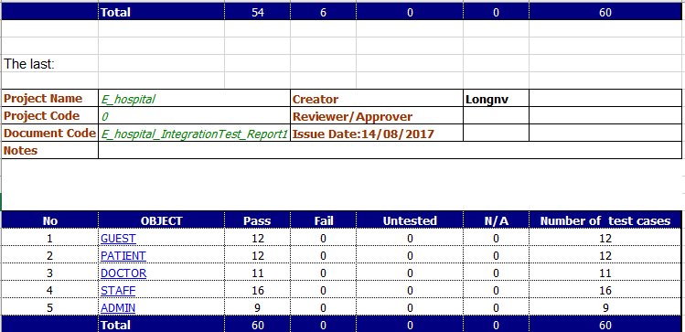

Figure 135: Last Integration Test Report

### System Test

The first results:

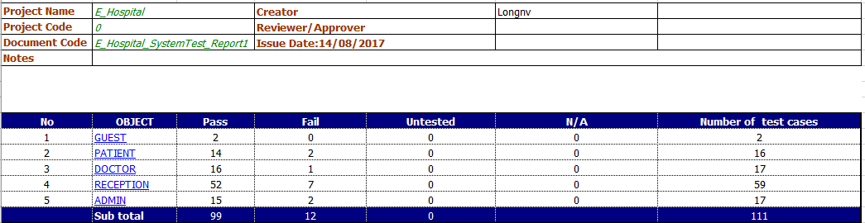

Figure 136: First System Test Report

The last results:

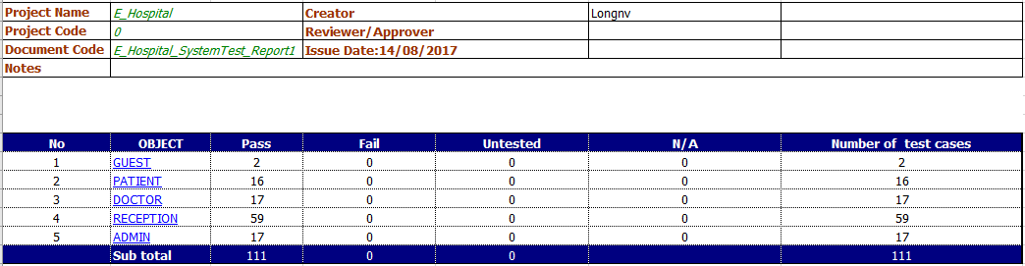

Figure 137: Last System Test Report

All test cases are described in **eHPT_TestCases.xlsx**

### Final Report

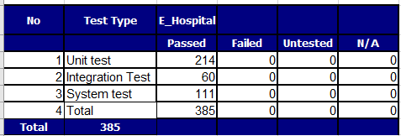

Figure 138: Final Report

## Checklist

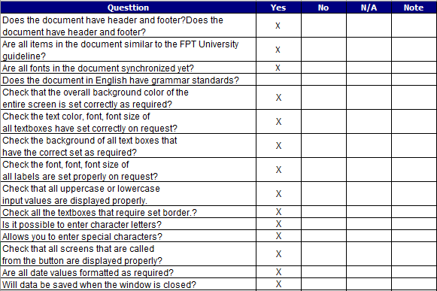

Figure 137: Check list

# CHAPTER 6: SOFTWARE USER’S MANUAL

## Deployment Guidelines

### Environment

Local Development Environment:

* Window 8.1,10.
* Processor: Intel® Core™ i7-4500U
* Memory: 4Gb.
* Disc space: HDD 1T.

### Register Microsoft Azure Account

* Create a Microsoft Account from : <https://signup.live.com/>
* Register Microsoft Azure Cloud from : [https://azure.microsoft.com/en-us/](https://azure.microsoft.com/en-us/%20)

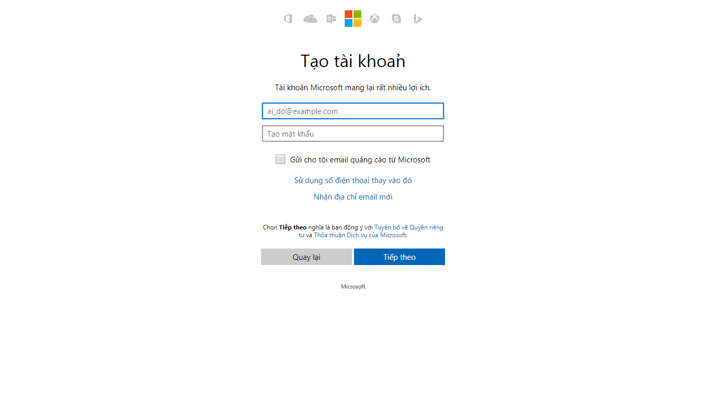

Figure 138: Register Microsoft Account

### **Update source code to cloud**

* Log into the administration interface link: <https://portal.azure.com/>

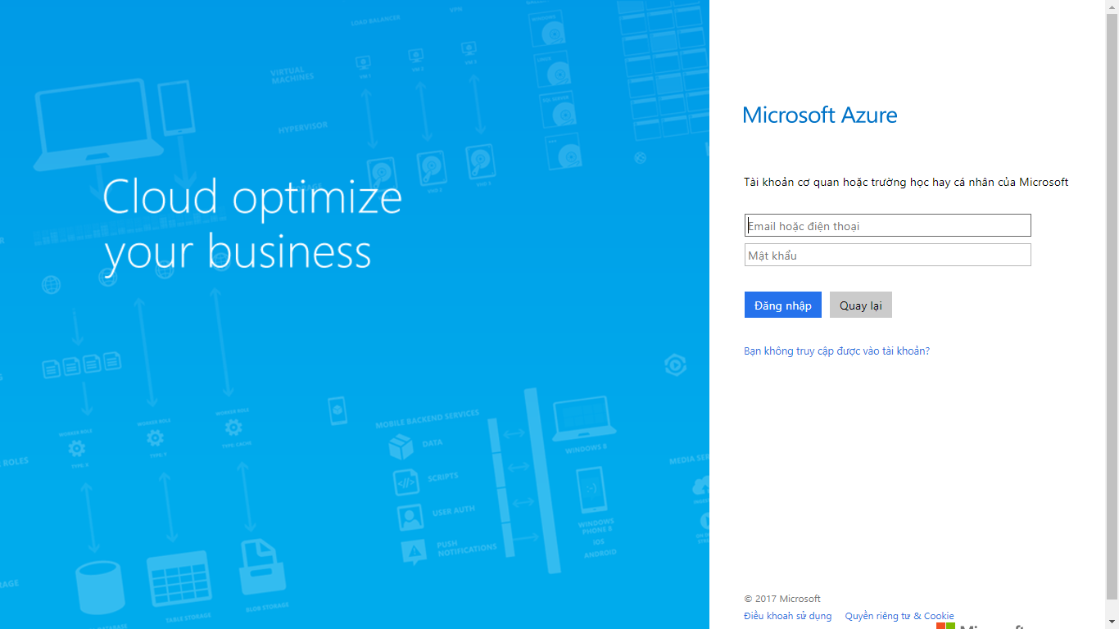

Figure 139: Update Source to cloud 1

* Create SQL Database

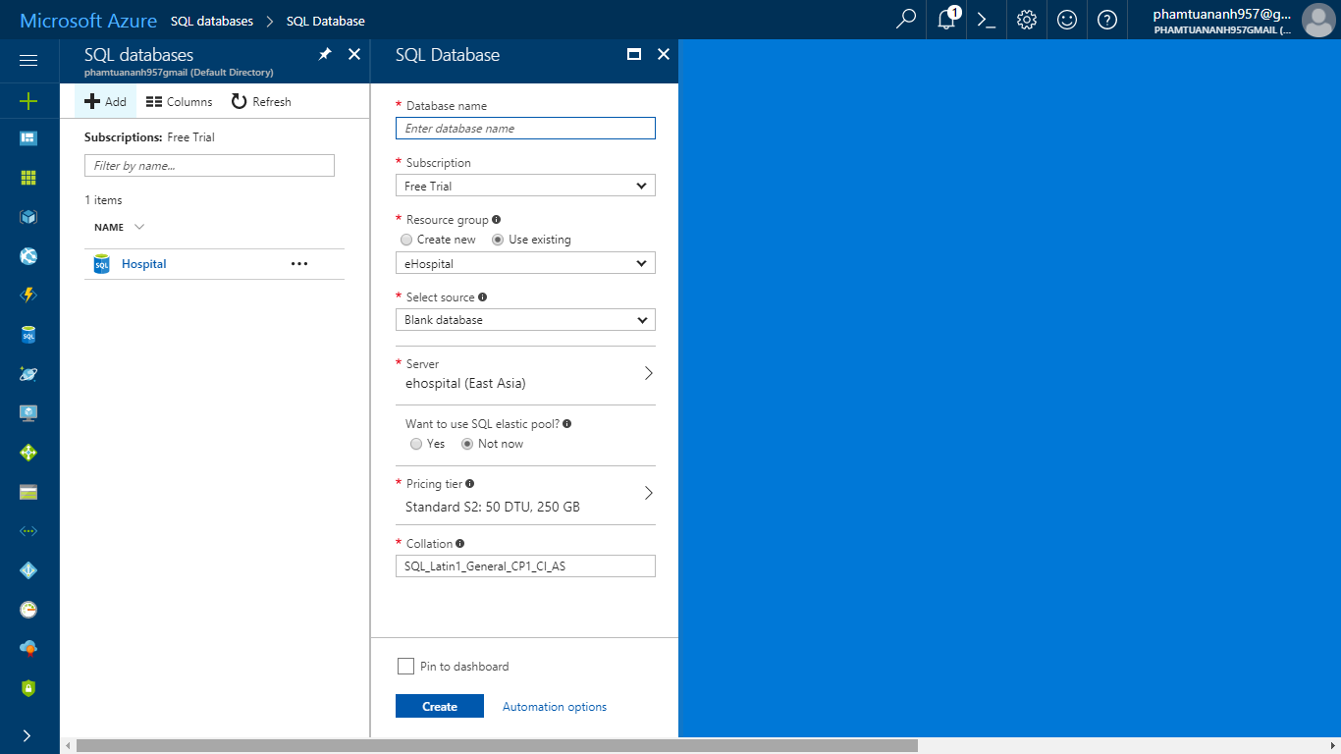

Figure 140: Update Source to cloud 2

* Get the connection string

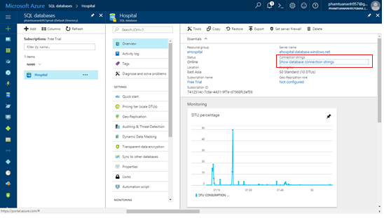

Figure 141: Update Source to cloud 3

* Create a web application

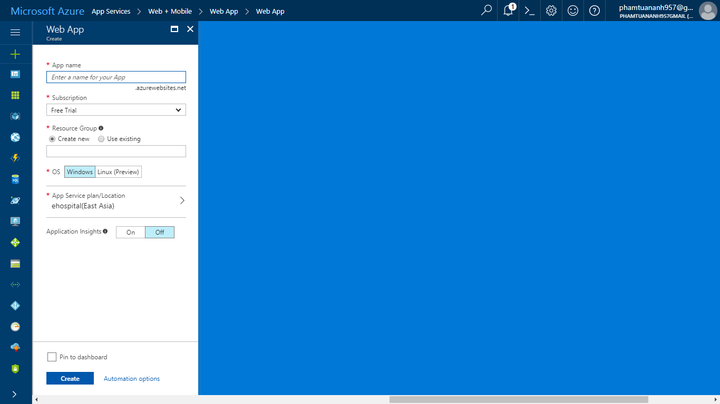

Figure 142: Update Source to cloud 4

* Get publish profile

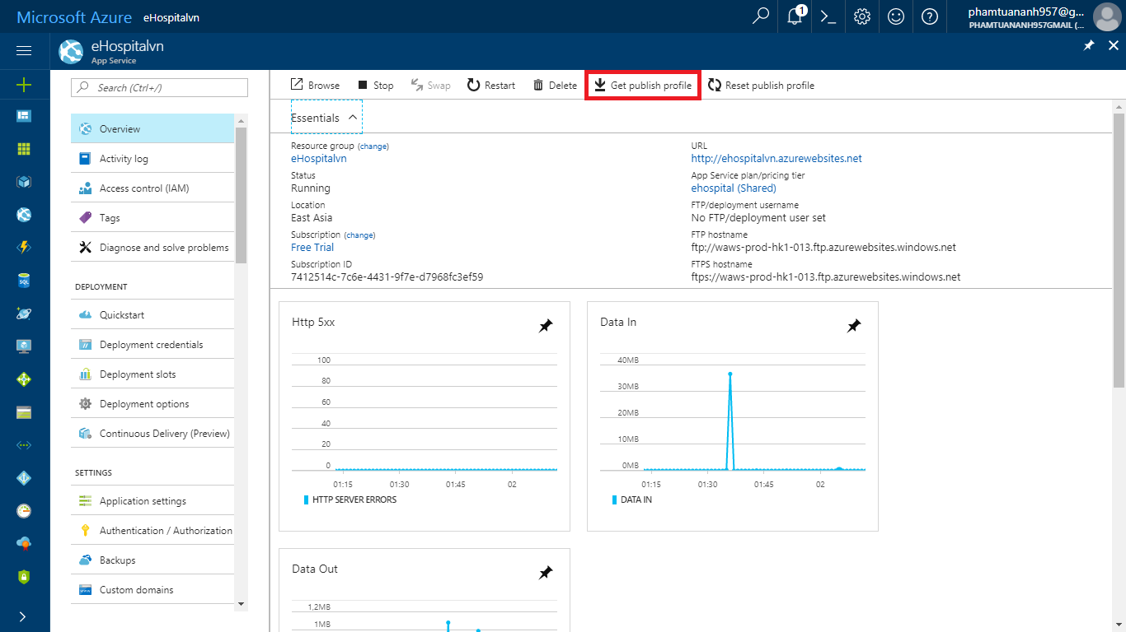

Figure 143: Update Source to cloud 5

* Publish web application to cloud by Visual Studio

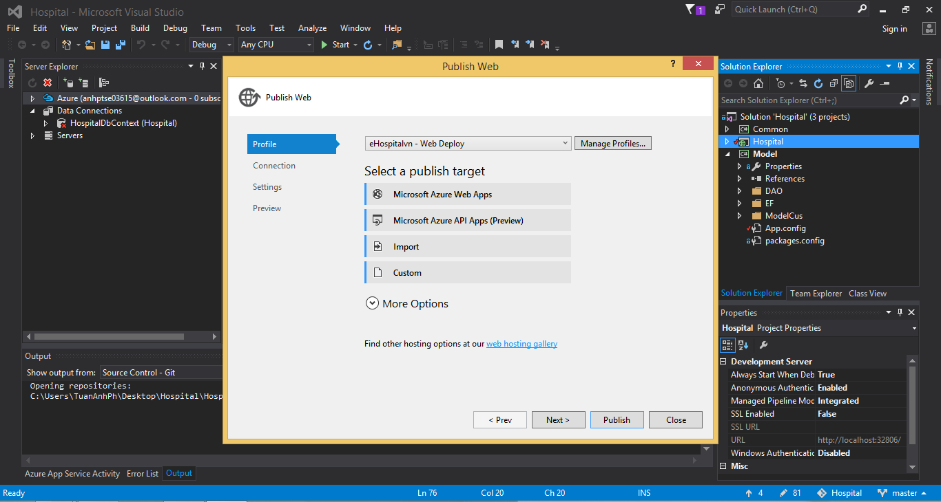

Figure 144: Update Source to cloud 6

## Guest’s Guide

### Register

* + - Step 1: Open browser and enter link <http://localhost:32806/login>
    - Step 2: Click on “Đăng ký”.
    - Step 3: Fill in the required information.
    - Step 4: Click on button “Đăng ký”.



Figure 145: Login screen



Figure 146: Register Screen



## Patient’s Guide

### Login

* Step 1: Open browser and enter link <http://localhost:32806/login>.
* Step 2: Input username and password.
* Step 3: Click on button “Đăng nhập”.

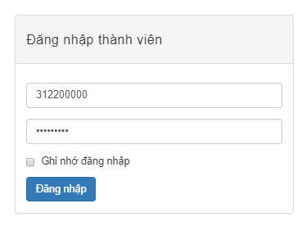

Figure 147: Login screen



### Logout

* Click on button “Đăng xuất”

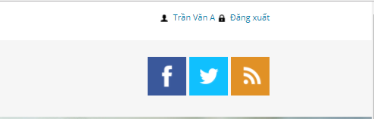

Figure 148: Logout button

### View Profile

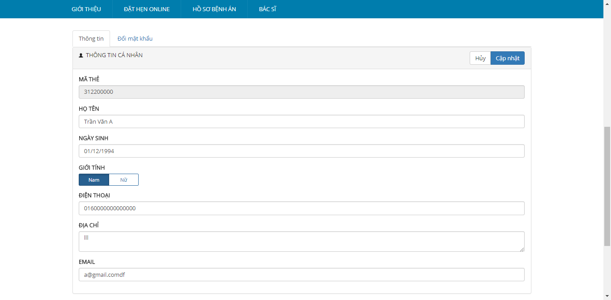

Figure 149: View Profile Screen

### Change Password

* Step 1: Click on tab “Change password”
* Step 2: Insert old password and new password (Old password different new password)
* Step 3: Click on button “Cập nhật”

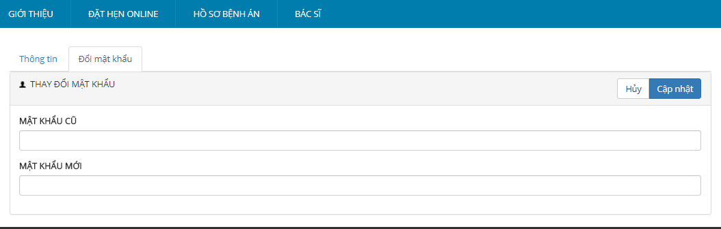

Figure 150: Change Password Screen

### Edit Profile

* Step 1: Change information.
* Step 2: Click on button “Cập nhật”.

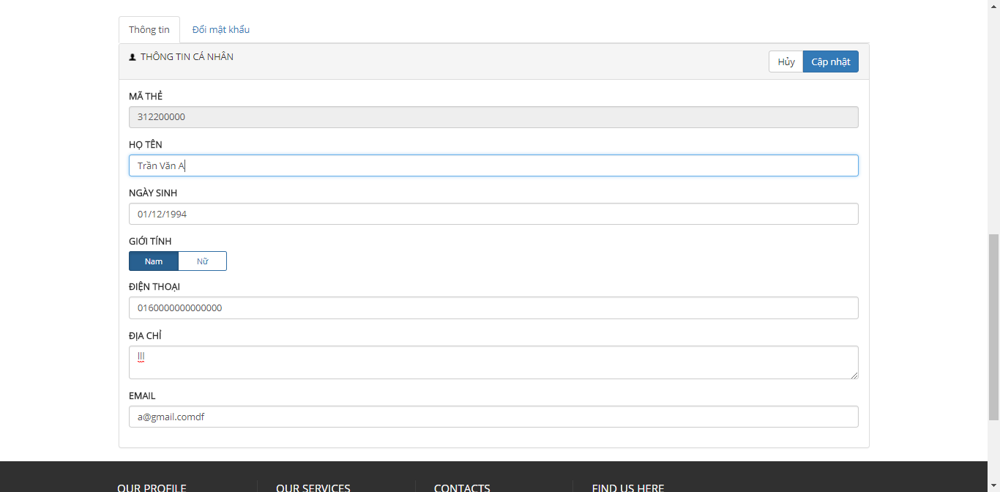

Figure 151: Edit Profile Screen

### View Doctor Schedule

* Step 1: Click on tab “ĐẶT HẸN ONLINE”
* Step 2: Choose department, doctor (System will auto show schedule of doctor)

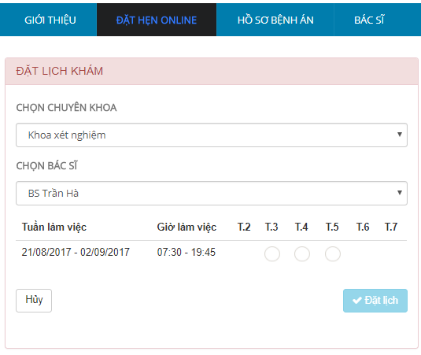

Figure 152: Doctor Schedule Screen

### Create Appointment

* Step 1: Click on tab “ĐẶT HẸN ONLINE”.
* Step 2: Choose department, doctor.
* Step 3: Click on button “Đặt lịch”.

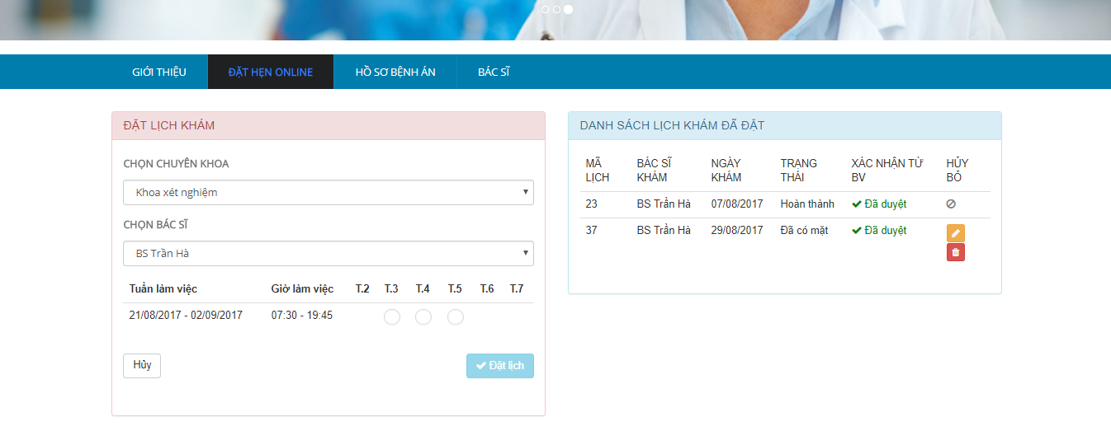

Figure 153: Create Appointment Screen

### View Appointment

* Click on tab “ĐẶT HẸN ONLINE”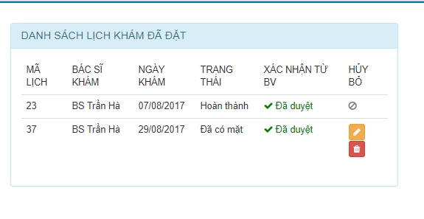

Figure 154: Appointment Screen

### Edit Appointment

* Step 1: Click on tab “ĐẶT HẸN ONLINE”.
* Step 2: Choose appointment need edit.
* Step 3: Click on icon “”
* Step 4: Fill new appointment information.
* Step 5: Click button ”Cập nhật”.



Figure 155: Appointment Screen

### Delete Appointment

* Step 1: Click on tab “ĐẶT HẸN ONLINE”.
* Step 2: Choose appointment need delete.
* Step 3: Click on icon “”.



Figure 156: Appointment Screen

### View Examination Record

* Click on tab” Hồ sơ bệnh án”

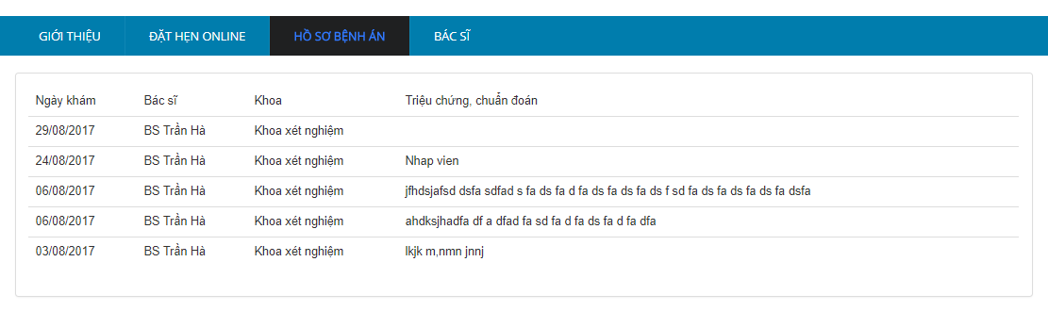 Figure 157: View Examination Record Screen

## Doctor’s Guide

### Login

* + - * Step 1: Open browser and enter link [http://ehospitalvn.azurewebsites.net/admin/login](http://localhost:32806/Admin/login)
      * Step 2: Input username and password.
      * Step 3: Click on button “Đăng nhập”

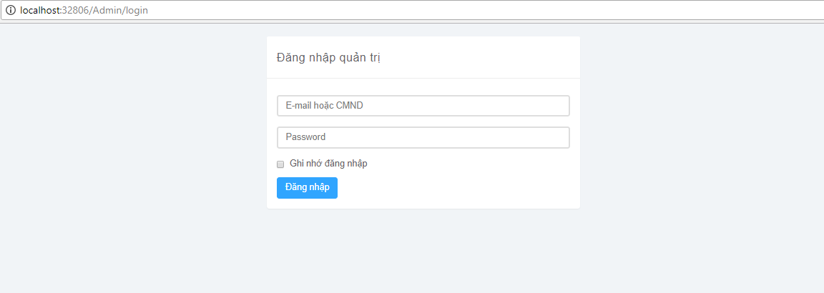

Figure 158: Logout Screen

### Create schedule

* + - * Step 1: Click on button “LỊCH LÀM VIỆC“.
      * Step 2: Click on button “Thêm” under button “LỊCH LÀM VIỆC”.
      * Step 3: Choose time and day doctor will do work.
      * Step 4: Click button “Thêm”.

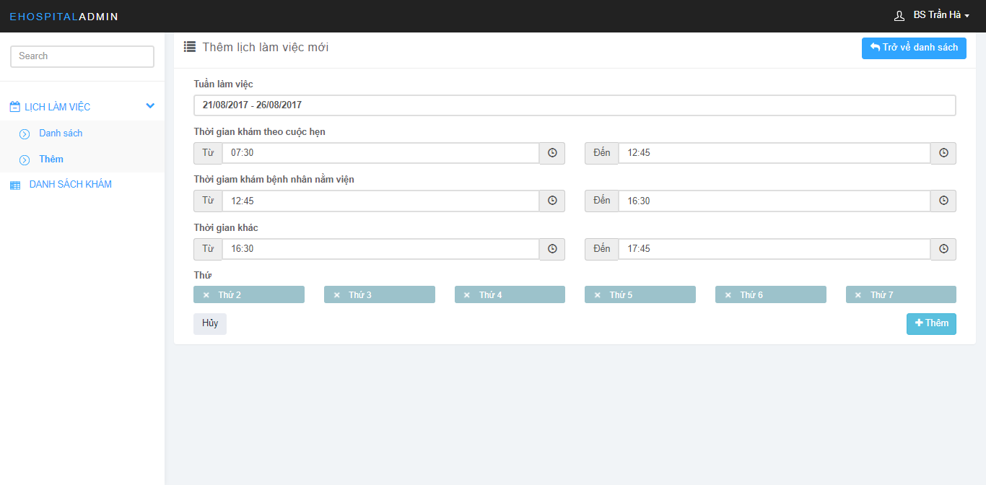

Figure 159: Doctor Schedule Screen

### View schedule

* + - * Step 1: Click on button “LỊCH LÀM VIỆC“
      * Step 2: Click on button “Danh sách” under button “LỊCH LÀM VIỆC”

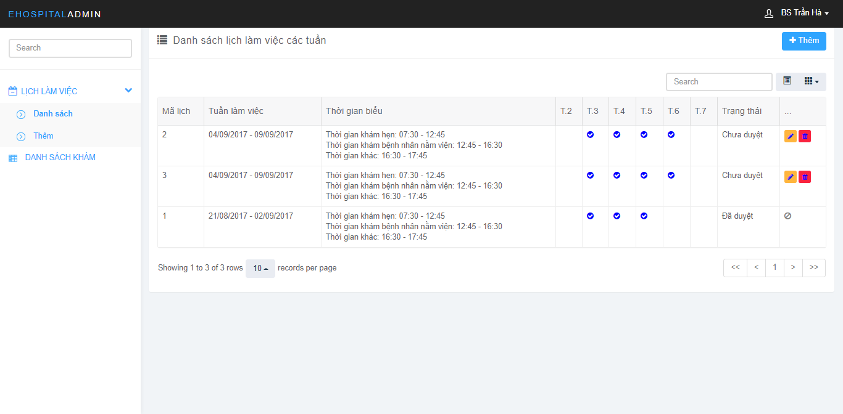

Figure 160: Doctor Schedule Screen

### Edit schedule

* + - * Step 1: Click on button “LỊCH LÀM VIỆC“
      * Step 2: Click on button “Danh sách” under button “LỊCH LÀM VIỆC”.
      * Step 3: Choose schedule need edit.
      * Step 4: Click on icon “”.
      * Step 5: Change schedule information.
      * Step 6: Click on button ”Cập nhật”.



Figure 161: Doctor Schedule Screen

## Reception’s Guide

### Login

* Step 1: Open browser and enter link [http://ehospitalvn.azurewebsites.net/admin/login](http://localhost:32806/Admin/login)
* Step 2: Input username and password.
* Step 3: Click on button “Đăng nhập”.



Figure 158: Logout Screen

### Create Direct Appointment

* Step 1: Click on button “QUẢN LÝ LỊCH HẸN”.
* Step 2: Click on “Thêm”.
* Step 3: Fill appointment information.
* Step 4: Click button “Đặt lịch”.

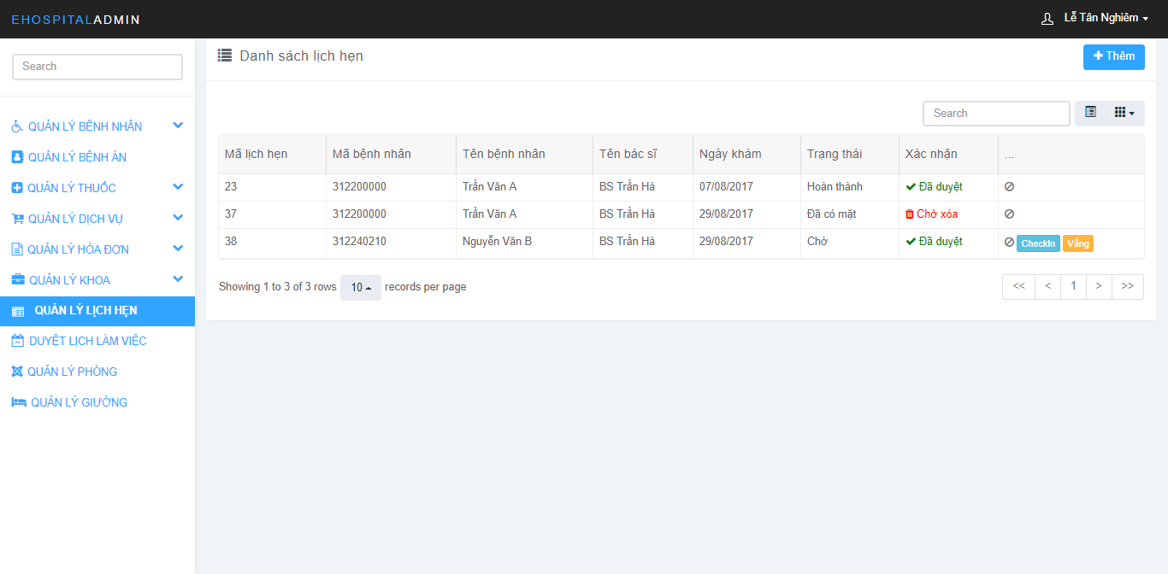

Figure 159: Create Direcet Appointment Screen

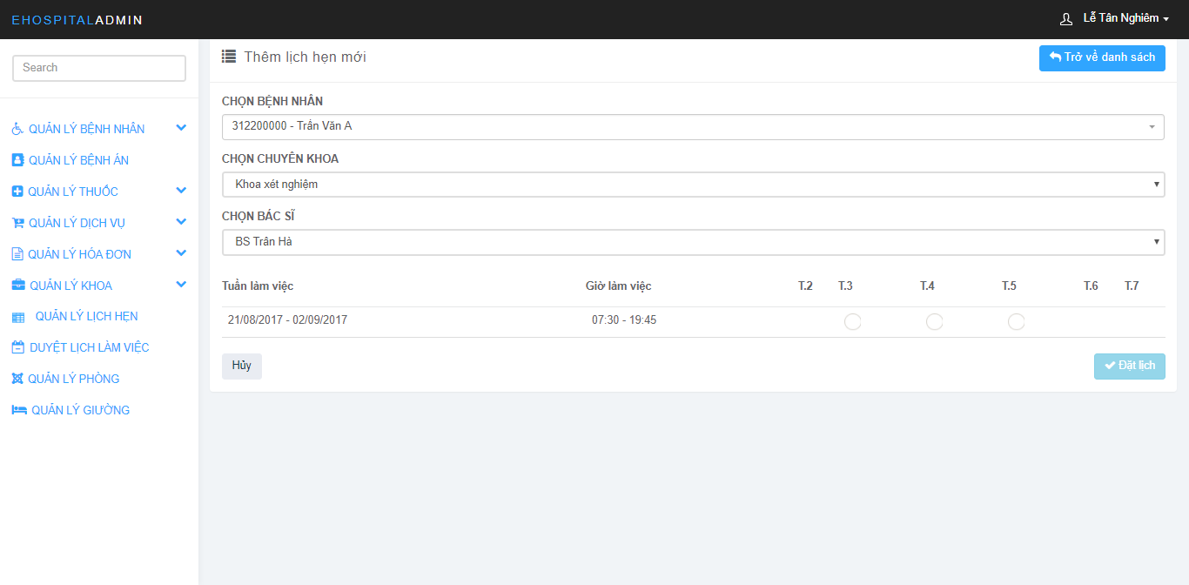

Figure 160: Create Direcet Appointment Screen

### Accept Appointment

* Step 1: Click on button “QUẢN LÝ LỊCH HẸN”.
* Step 2: Choose appointment need accept.
* Step 3: Click on button “Duyệt”

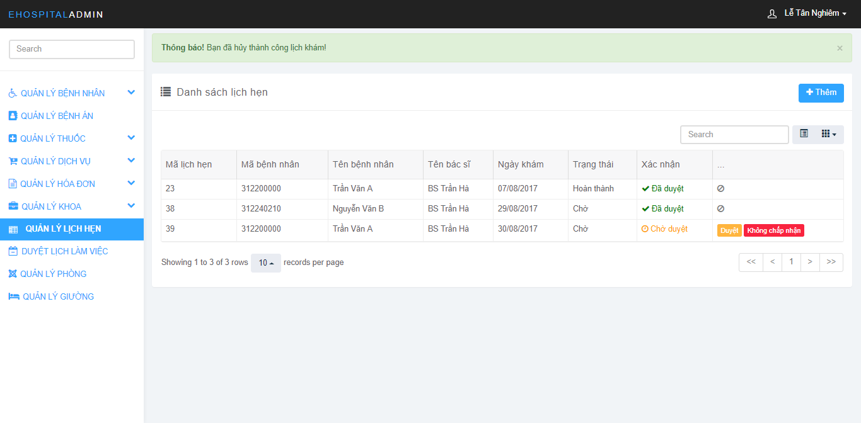

Figure 161: Appointment Management Screen

### Delete Appointment

* Step 1: Click on button “QUẢN LÝ LỊCH HẸN”.
* Step 2: Choose appointment need delete.
* Step 3: Click on button “Xóa”

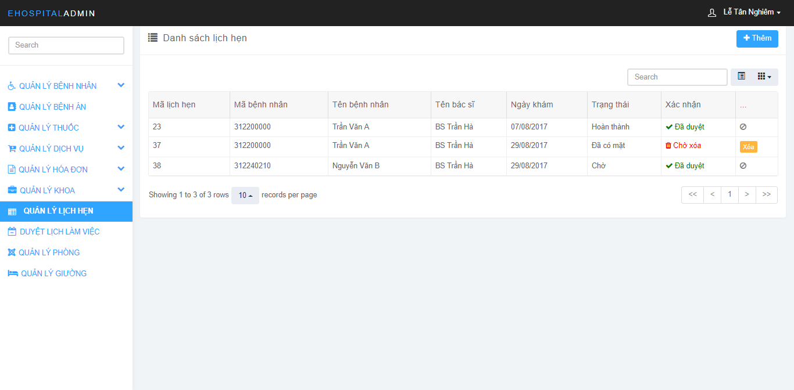

Figure 162: Appointment Management Screen

### View Doctor Schedule

* Click on button “DUYỆT LỊCH LÀM VIỆC”

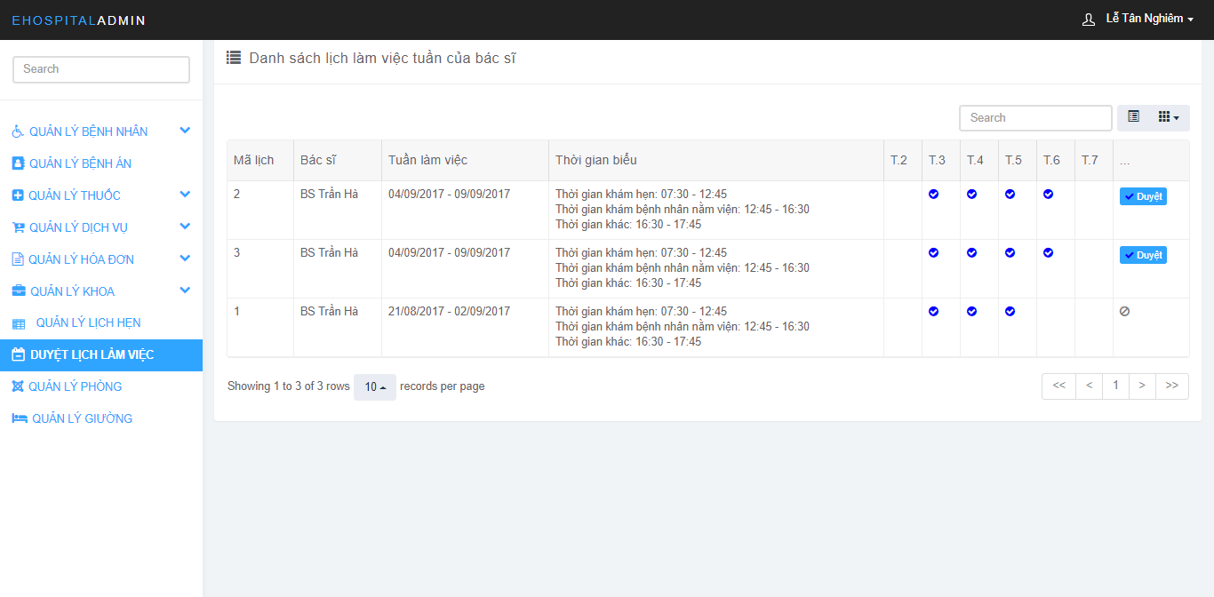

Figure 163: Doctor Schedule Management Screen

### Accept Doctor Schedule

* Step 1: Click on button “DUYỆT LỊCH LÀM VIỆC”.
* Step 2: Choose schedule need accept.
* Step 3: Click on button “Duyệt”.



Figure 164: Doctor Schedule Management Screen

### View Examination Record

* Step 1: Click on button “HỒ SƠ BỆNH ÁN”.
* Step 2: Click on button “Xem”.

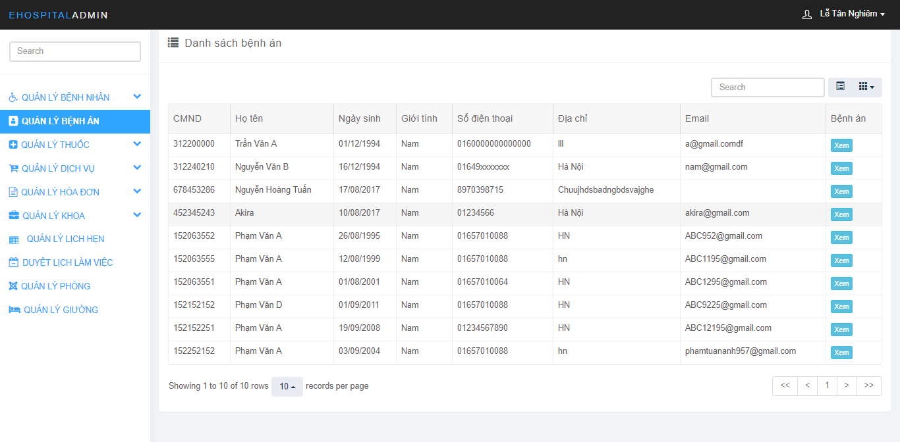

Figure 165: Examination Record Screen

### Create Bill

* Step 1: Click on “QUẢN LÝ HÓA ĐƠN”.
* Step 2: Click on button “Thêm” under button “QUẢN LÝ HÓA ĐƠN”.
* Step 3: Choose medicine and service patient have used.
* Step 4: Click button “Thêm”.
* Step 5: Click button “Tạo hóa đơn”.

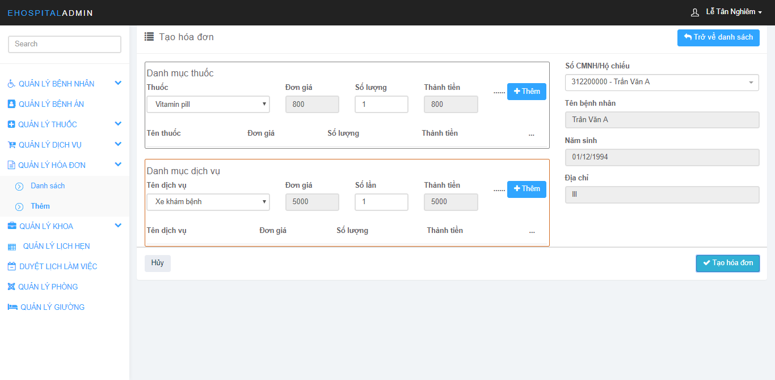

Figure 166: Bill Management Screen

### Finish bill

* Step 1: Click on “QUẢN LÝ HÓA ĐƠN”.
* Step 2: Click on button “Danh sách” under button “QUẢN LÝ HÓA ĐƠN”.
* Step 3: Choose bill need finish (When patient has paid).
* Step 4: Click on button” Đã thanh toán”

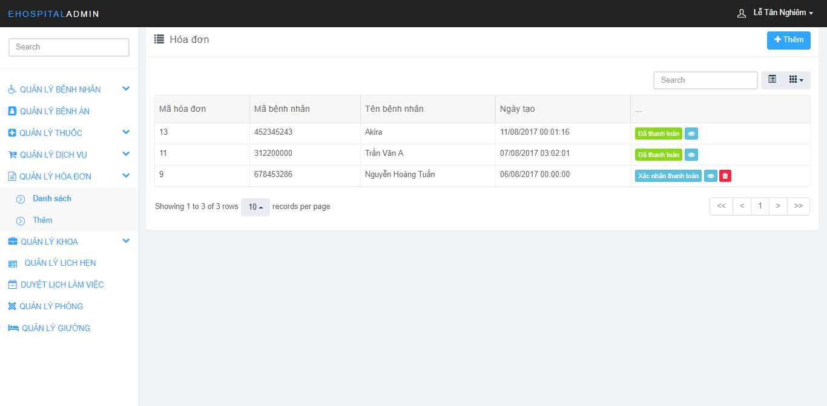

Figure 167: Bill Management Screen

### Delete bill

* Step 1: Click on “QUẢN LÝ HÓA ĐƠN”.
* Step 2: Click on button “Danh sách” under button “QUẢN LÝ HÓA ĐƠN”.
* Step 3: Choose bill need delete.
* Step 4: Click on icon “”



Figure 168: Bill Management Screen

### View bill

* Step 1: Click “QUẢN LÝ HÓA ĐƠN”.
* Step 2: Click button “Danh sách”.



Figure 169: Bill Management Screen

### Check-in to exam

* Step 1: Click on “QUẢN LÝ LỊCH HẸN”
* Step 2: Choose exam need check.
* Step 3: Check in to exam
* If patient has go to hospital and check in, click button “CheckIn”
* If patient don’t check in, click on button “Vắng”

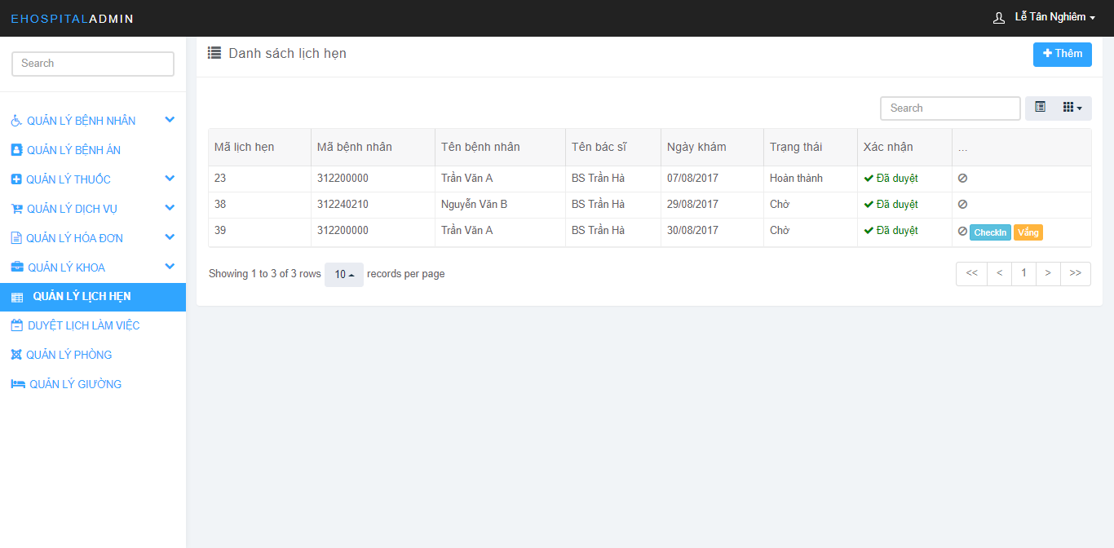

Figure 170: Appointment Management Screen

### Check-in bed

* Step 1: Click on “QUẢN LÝ GIƯỜNG”
* Step 2: Click on button “Bệnh nhân” (Provided the bed is empty)
* Step 3: Choose patient need hospitalization
* Step 4: Click button “Thêm”

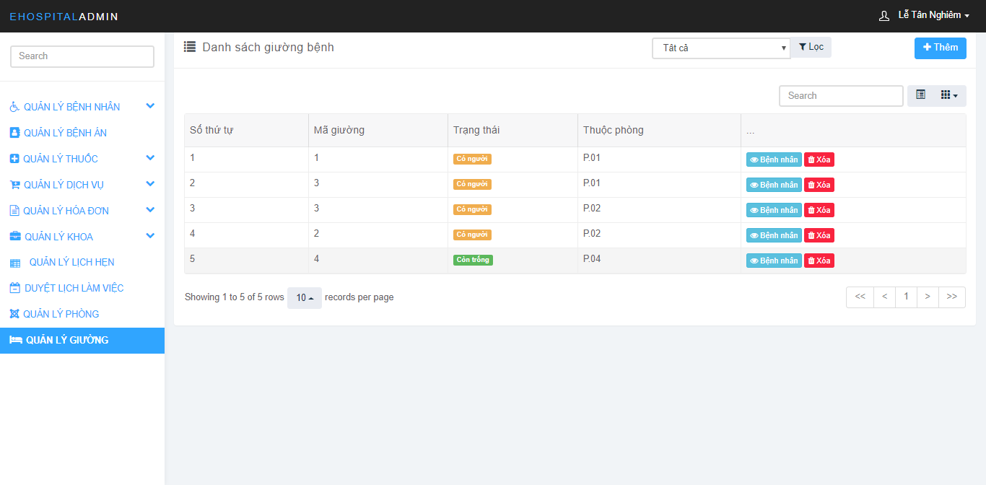

Figure 171: Bed Management Screen

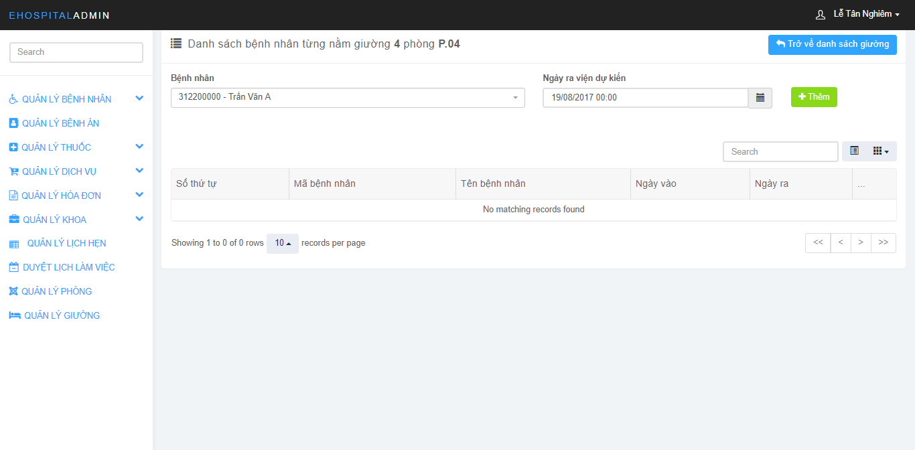

Figure 172: Bed Management Screen

### Check-out bed

* Step 1: Click on “QUẢN LÝ GIƯỜNG”
* Step 2: Click on button “Bệnh nhân”
* Step 3: Choose patient need check-out
* Step 4: Click button “Check out”

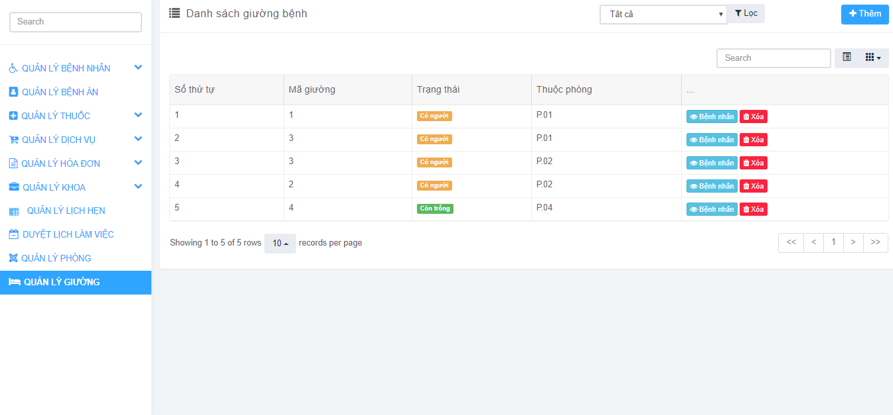

Figure 173: Bed Management Screen

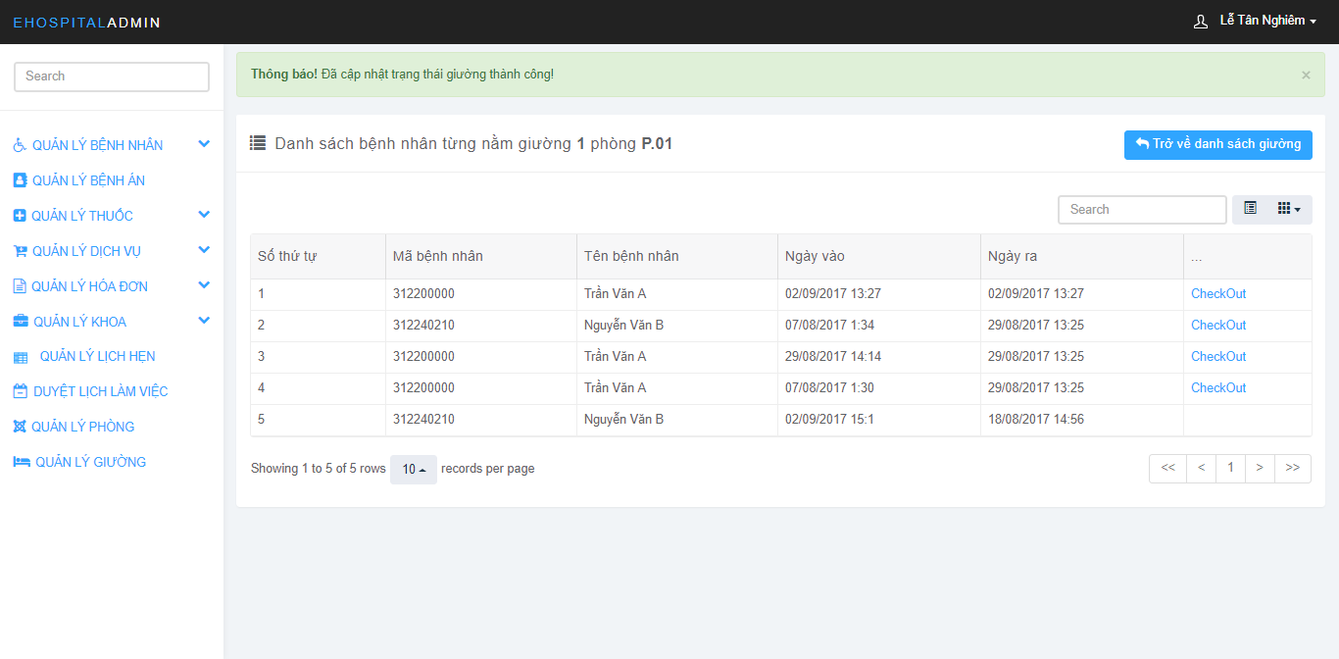

Figure 174: Bed Management Screen

### Create patient account

* Step 1: Click on “QUẢN LÝ BỆNH NHÂN”
* Step 2: Click on “Thêm” under “QUẢN LÝ BỆNH NHÂN”
* Step 3: Fill in the required information
* Step 4: Click on button “Thêm”

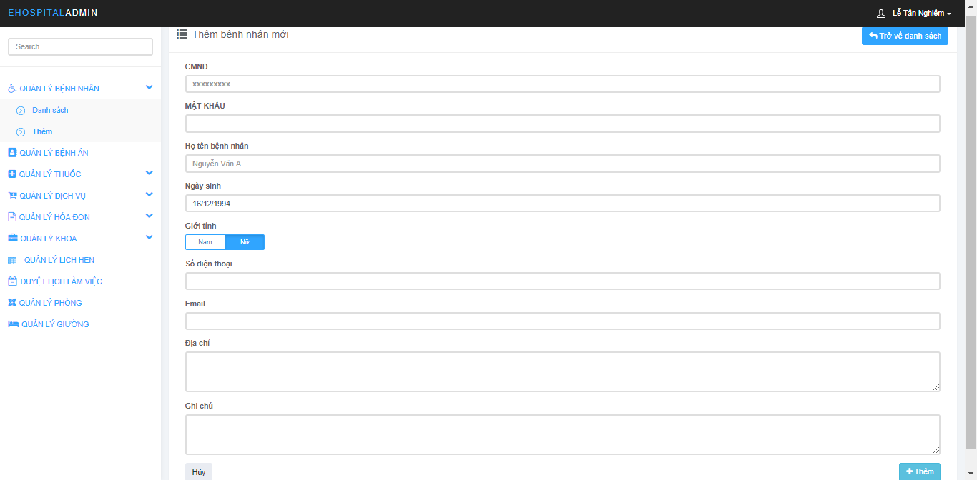

Figure 175: Patient Account Management Screen

### Ban patient account

* Step 1: Click on “QUẢN LÝ BỆNH NHÂN”
* Step 2: Click on “Danh sách” under “QUẢN LÝ BỆNH NHÂN”
* Step 3: Choose patient account need ban.
* Step 4: Click on icon” ”

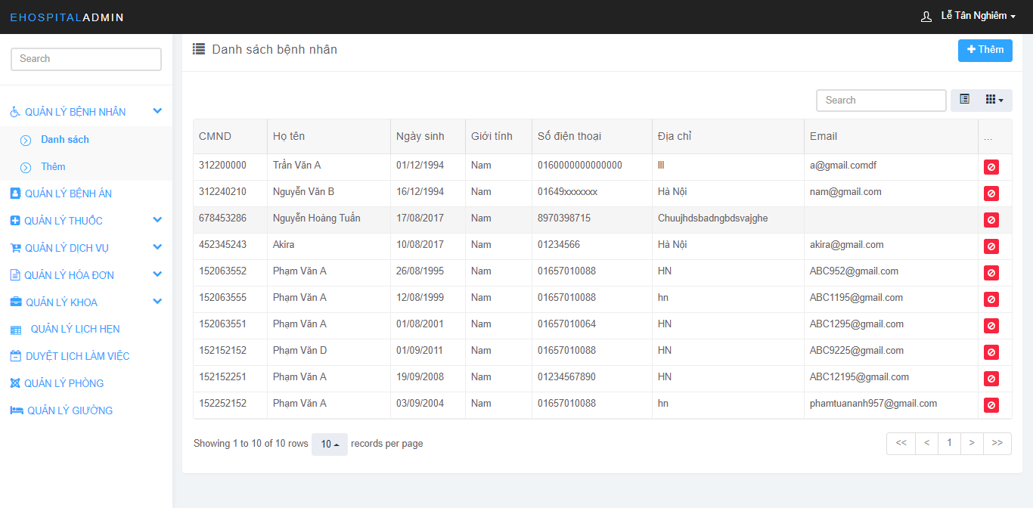

Figure 176: Patient Account Management Screen

### View patient account

* Step 1: Click on “QUẢN LÝ BỆNH NHÂN”
* Step 2: Click on “Danh sách” under “QUẢN LÝ BỆNH NHÂN”



Figure 177: Patient Account Management Screen

### Create medicine

* Step 1: Click on “QUẢN LÝ THUỐC”
* Step 2: Click on “Thêm” under “QUẢN LÝ THUỐC”
* Step 3: Fill in the information of the drug
* Step 4: Click on button “Thêm”

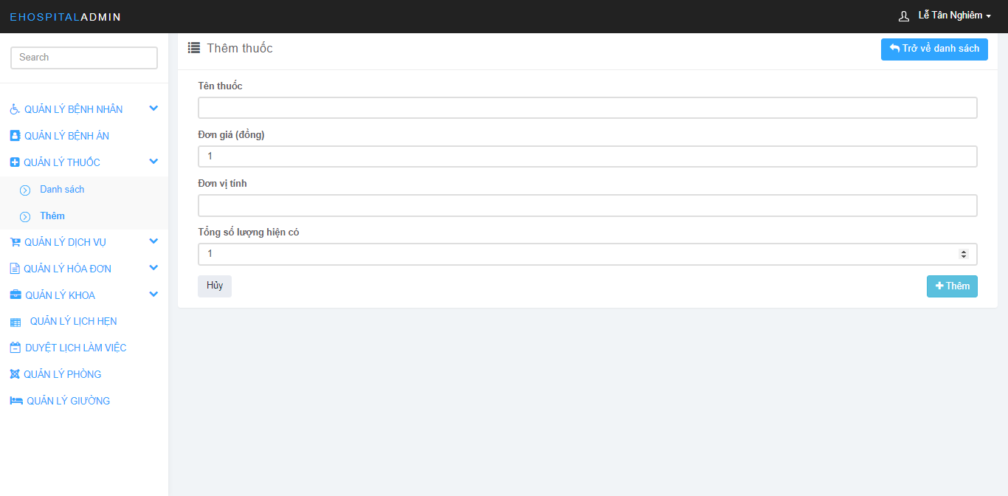

Figure 178: Medince Management Screen

### Edit medicine

* Step 1: Click on “QUẢN LÝ THUỐC”
* Step 2: Click on “Danh sách” under “QUẢN LÝ THUỐC”
* Step 3: Choose medicine need edit.
* Step 4: Click on icon “”
* Step 5: Change medicine information
* Step 6: Click on button “Cập nhật”

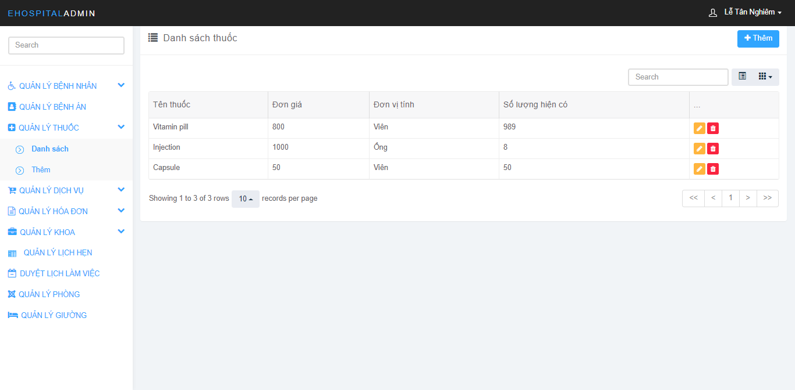

Figure 179: Medince Management Screen

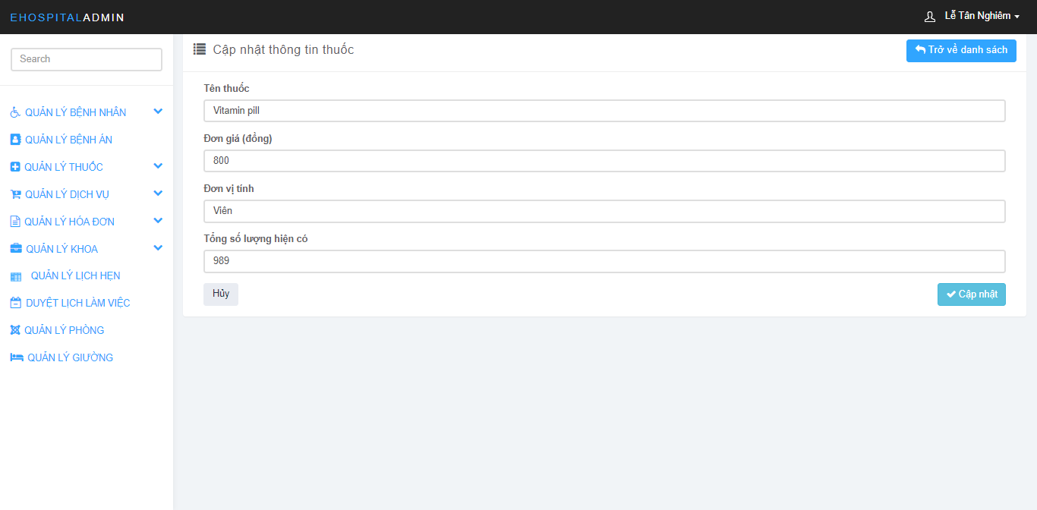

Figure 180: Medince Management Screen

### Delete medicine

* Step 1: Click on “QUẢN LÝ THUỐC”
* Step 2: Click on “Danh sách” under “QUẢN LÝ THUỐC”
* Step 3: Choose medicine need delete
* Step 4: Click on icon “”
* Step 5: Click on button “Xóa”

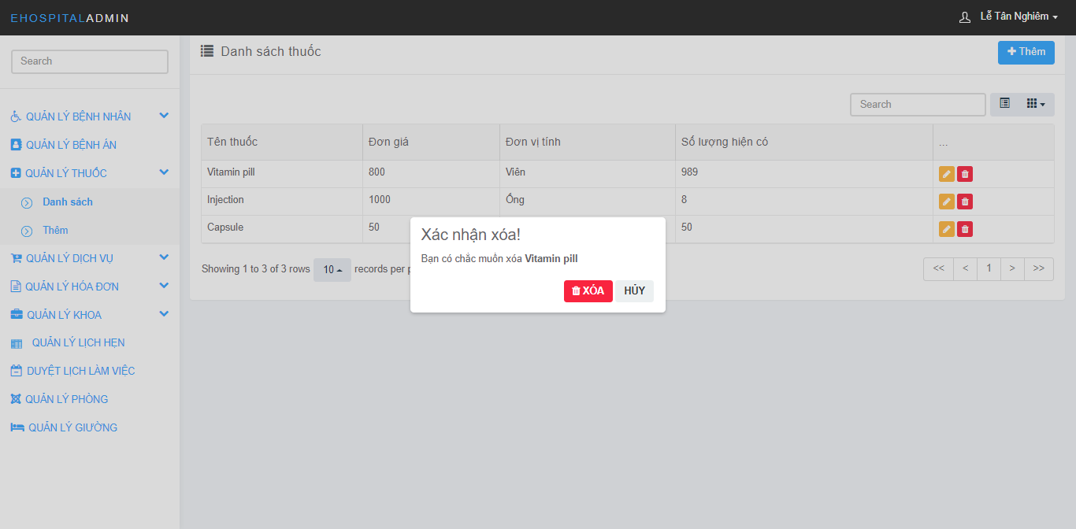

Figure 181: Medince Management Screen

### View medicine

* Step 1: Click on “QUẢN LÝ THUỐC”
* Step 2: Click on “Danh sách” under “QUẢN LÝ THUỐC”



Figure 182: Medince Management Screen

### Create service

* Step 1: Click on “QUẢN LÝ DỊCH VỤ”
* Step 2: Click on “Thêm” under “QUẢN LÝ DỊCH VỤ”
* Step 3: Fill in the information of the service
* Step 4: Click on button “Thêm”

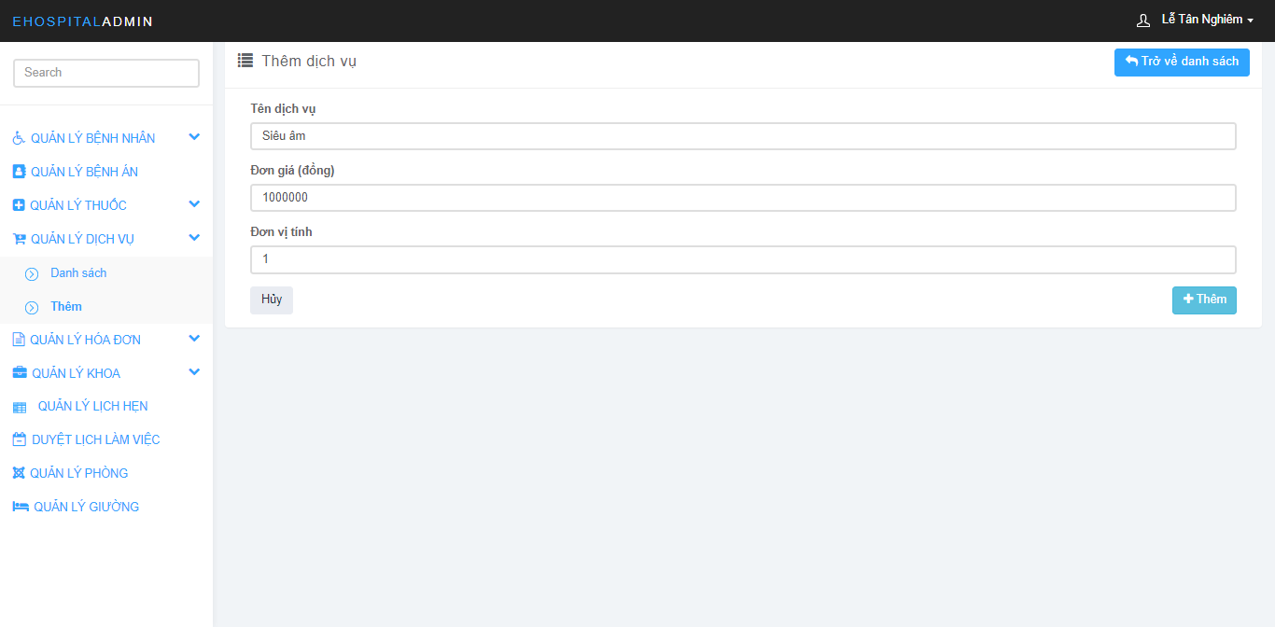

Figure 183: Service Manageent Screen

### Edit service

* Step 1: Click on “QUẢN LÝ DỊCH VỤ”
* Step 2: Click on “Danh sách” under “QUẢN LÝ DỊCH VỤ”
* Step 3: Choose service need edit
* Step 4: Click on icon “”
* Step 5: Change service information
* Step 6: Click on button “Cập nhật”

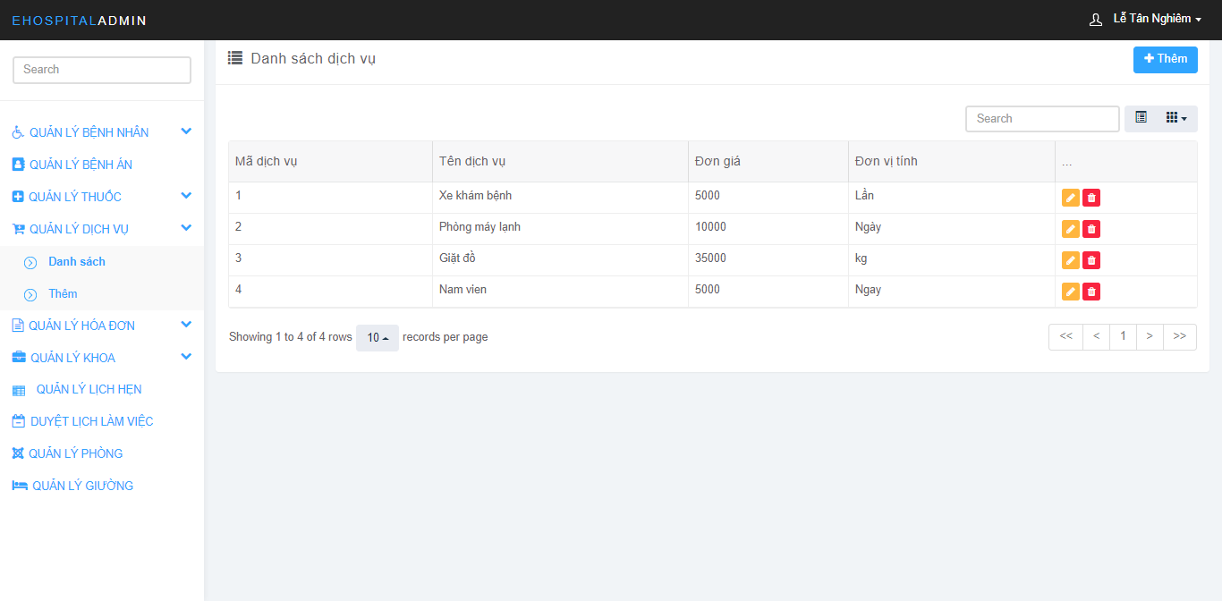

Figure 184: Service Manageent Screen

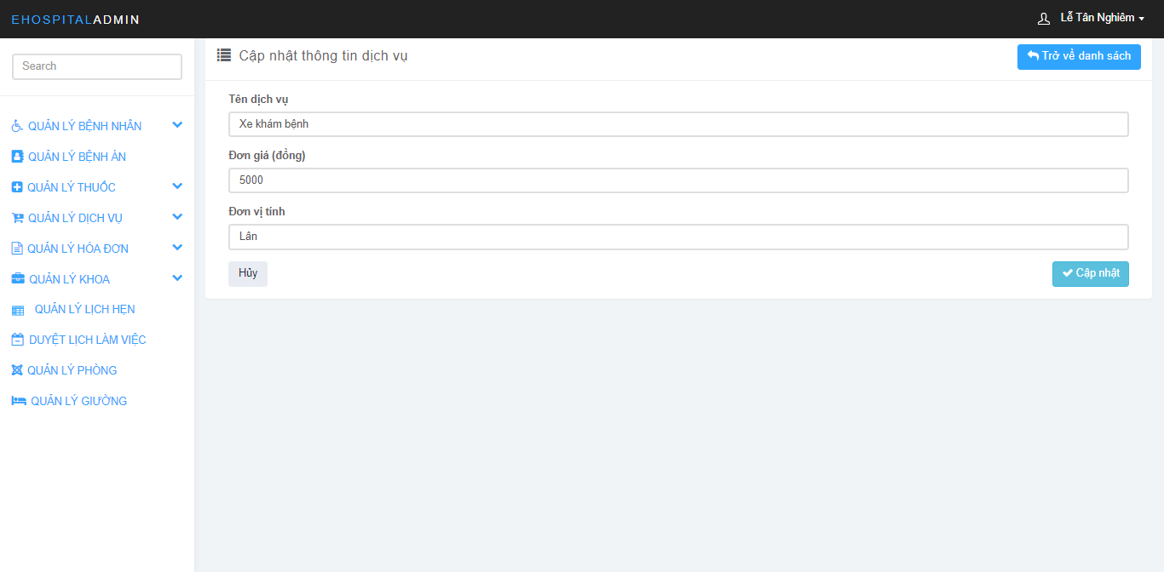

Figure 185: Service Manageent Screen

### Delete service

* Step 1: Click on “QUẢN LÝ DỊCH VỤ”
* Step 2: Click on “Danh sách” under “QUẢN LÝ DỊCH VỤ”
* Step 3: Choose service need delete
* Step 4: Click on icon “”
* Step 5: Click on button “Xóa”

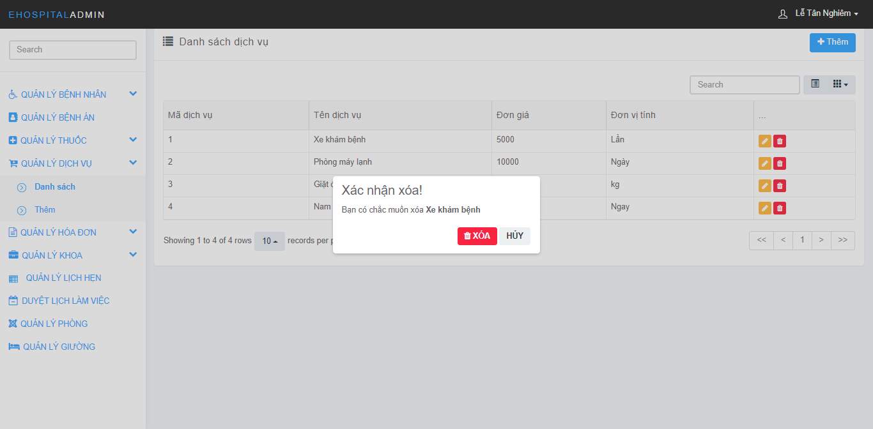

Figure 186: Service Manageent Screen

### View service

* Step 1: Click on “QUẢN LÝ DỊCH VỤ”
* Step 2: Click on “Danh sách” under “QUẢN LÝ DỊCH VỤ”



Figure 187: Service Manageent Screen

### Create room

* Step 1: Click on “QUẢN LÝ PHÒNG”
* Step 2: Click on button “Thêm”
* Step 3: Fill in the information of the room
* Step 4: Click on button “Ok”

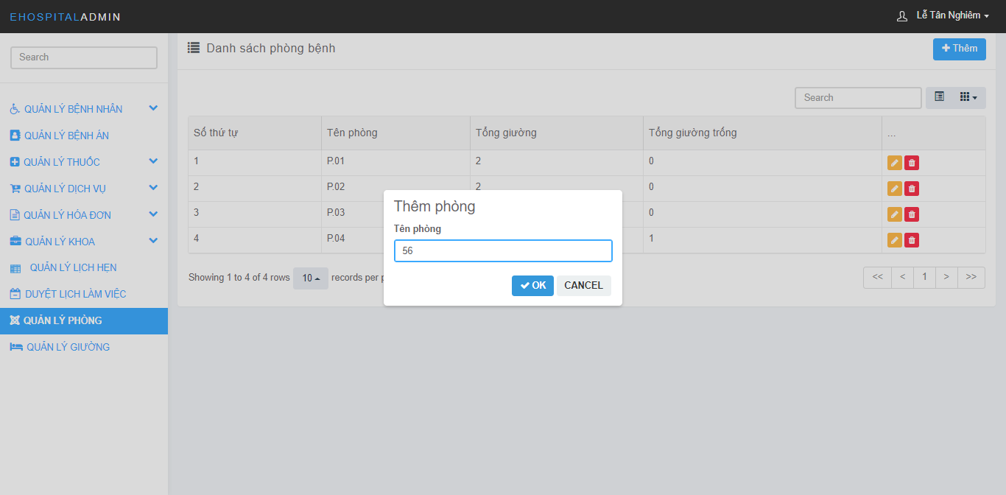

Figure 189: Room Management Screen

### Edit room

* Step 1: Click on “QUẢN LÝ PHÒNG”
* Step 2: Choose room need edit
* Step 3: Click on icon “”
* Step 4: Change room information
* Step 5: Click on button “Ok”

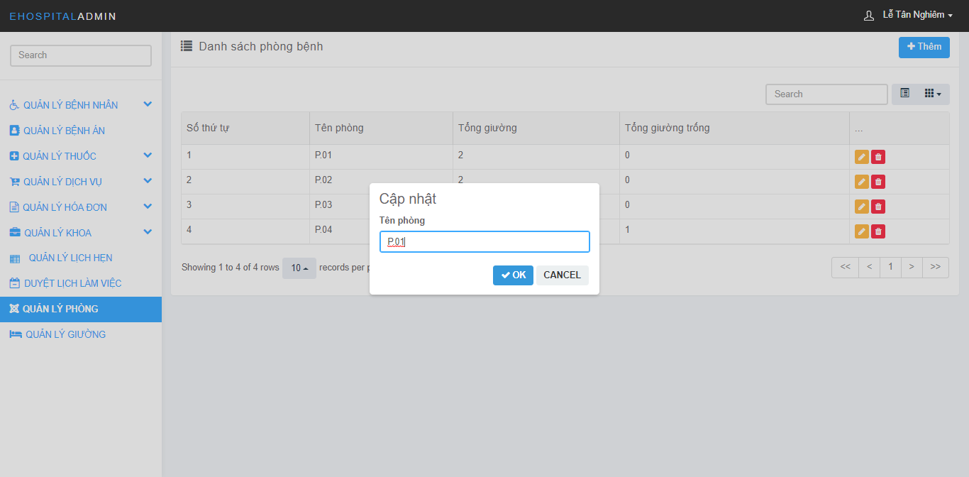

Figure 190: Room Management Screen

### Delete room

* Step 1: Click on “QUẢN LÝ PHÒNG”
* Step 2: Choose room need delete
* Step 3: Click on icon “”
* Step 5: Click on button “Xóa”

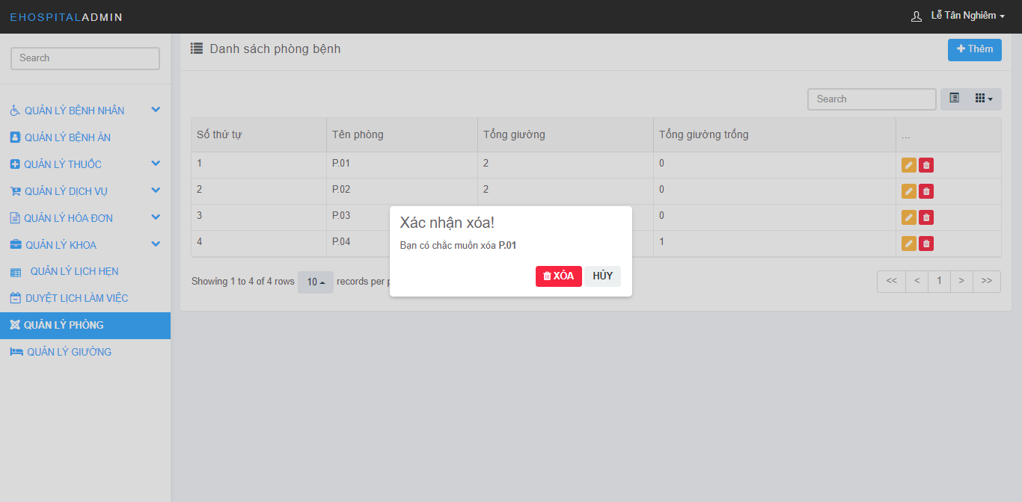

Figure 191: Room Management Screen

### View room

* Step 1: Click on “QUẢN LÝ PHÒNG”
* Step 2: View all rooms

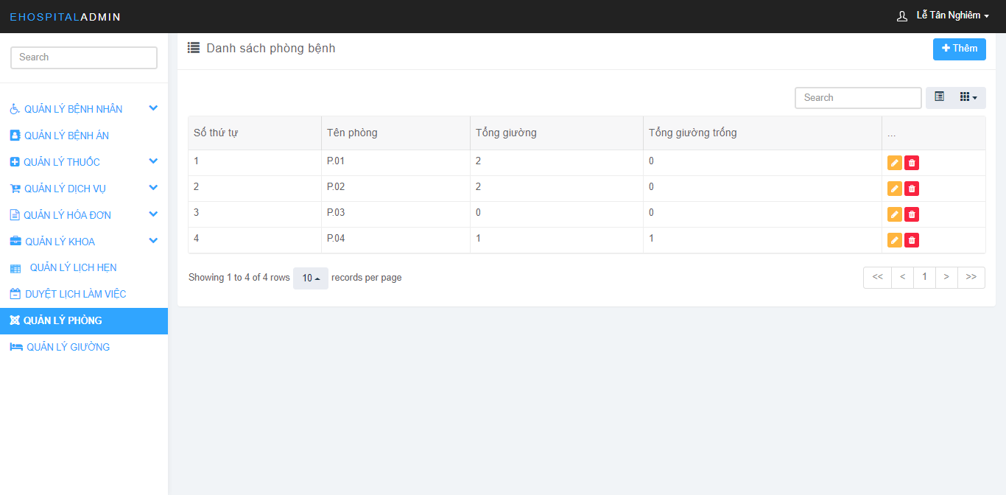

Figure 192: Room Management Screen

### Create bed

* Step 1: Click on “QUẢN LÝ GIƯỜNG”
* Step 2: Click on button “Thêm”
* Step 3: Fill in the information of the bed
* Step 4: Click on button “Ok”

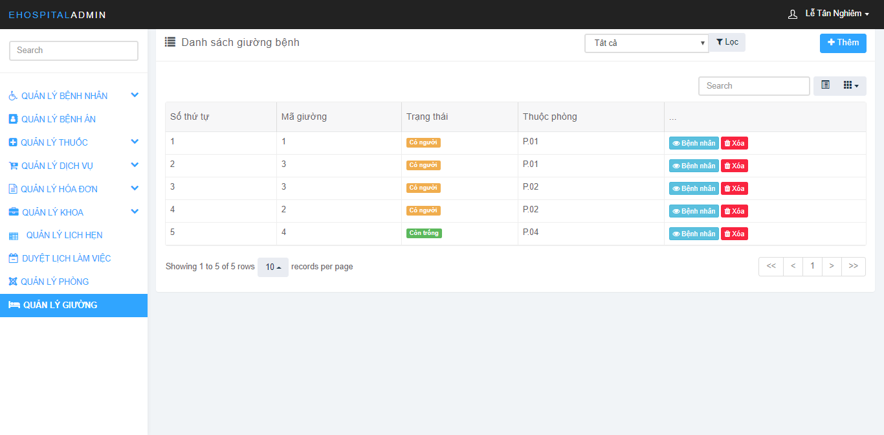

Figure 193: Bed Management Screen

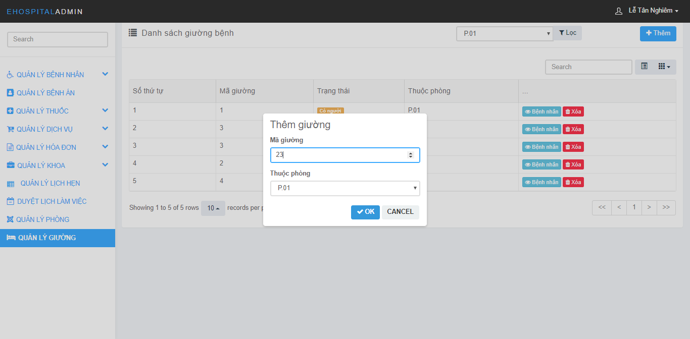

Figure 194: Bed Management Screen

### Delete bed

* Step 1: Click on “QUẢN LÝ GIƯỜNG”
* Step 2: Choose bed need delete
* Step 3: Click on icon “”
* Step 4: Click on button “Xóa”

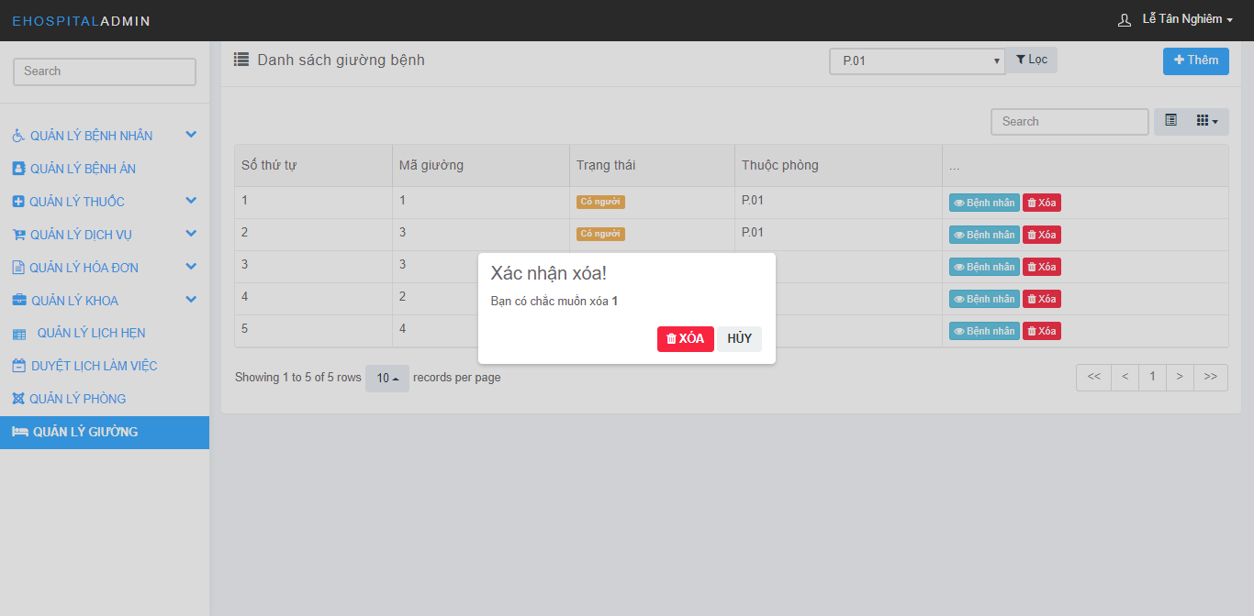

Figure 195: Bed Management Screen

### View bed

* Step 1: Click on “QUẢN LÝ GIƯỜNG”
* Step 2: View all beds



Figure 196: Bed Management Screen

### Create department

* Step 1: Click on “QUẢN LÝ KHOA”
* Step 2: Click on “Thêm” under “QUẢN LÝ KHOA”
* Step 3: Fill in the information of the department
* Step 4: Click on button “Thêm”

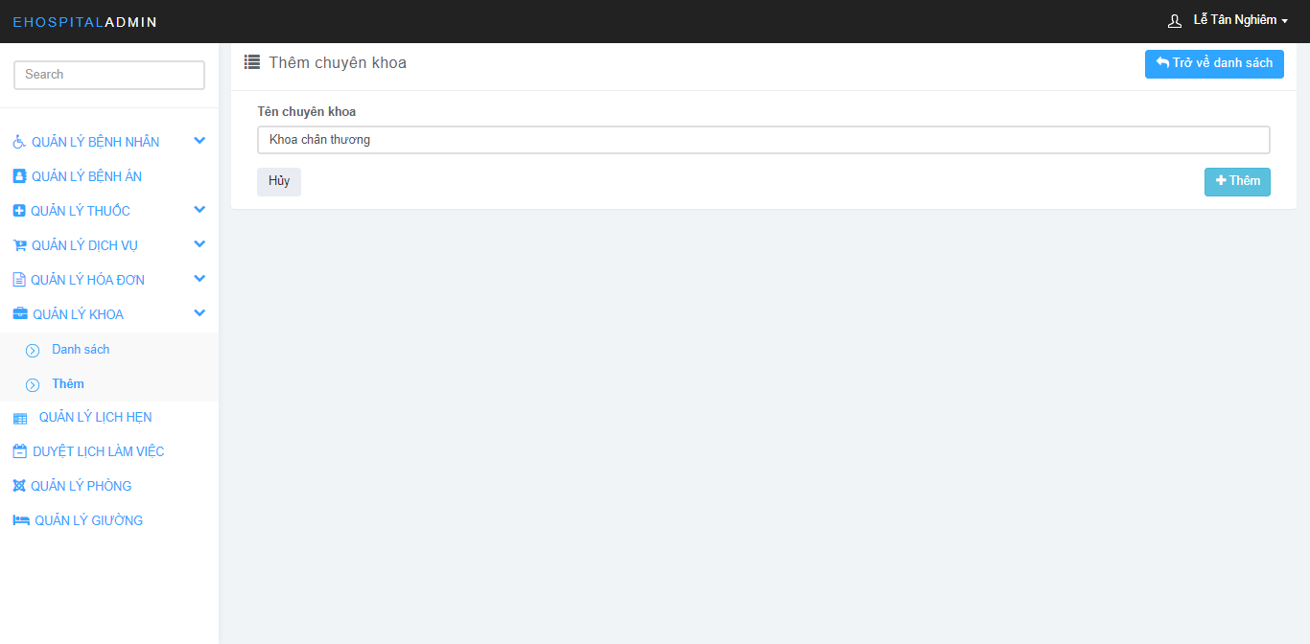

Figure 197 : Department Management Screen:

### Edit department

* Step 1: Click on “QUẢN LÝ KHOA”
* Step 2: Click on “Danh sách” under “QUẢN LÝ KHOA”
* Step 2: Choose department need edit
* Step 3: Click on icon “”
* Step 4: Change department information
* Step 5: Click on button “Ok”

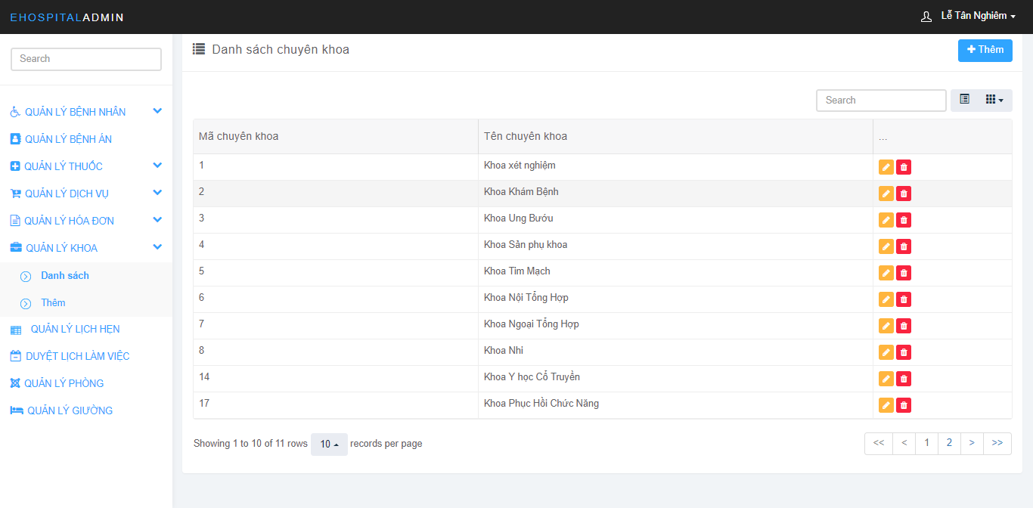

Figure 198: Department Management Screen:

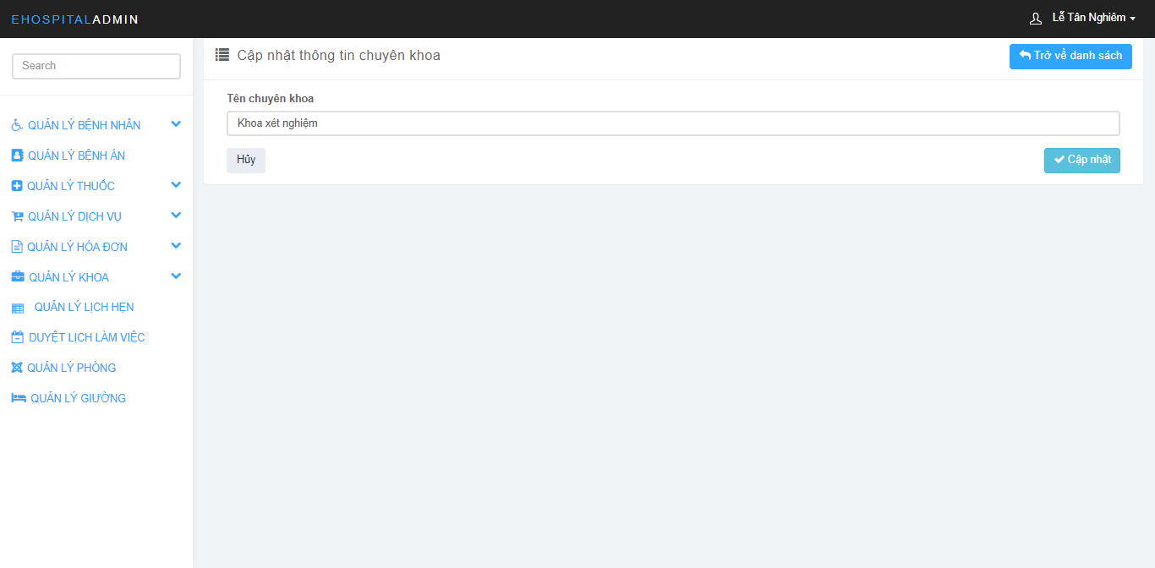

Figure 199: Department Management Screen:

### Delete department

* Step 1: Click on “QUẢN LÝ KHOA”
* Step 2: Click on “Danh sách” under “QUẢN LÝ KHOA”
* Step 3: Choose department need delete
* Step 4: Click on icon “”
* Step 5: Click on button “Xóa”

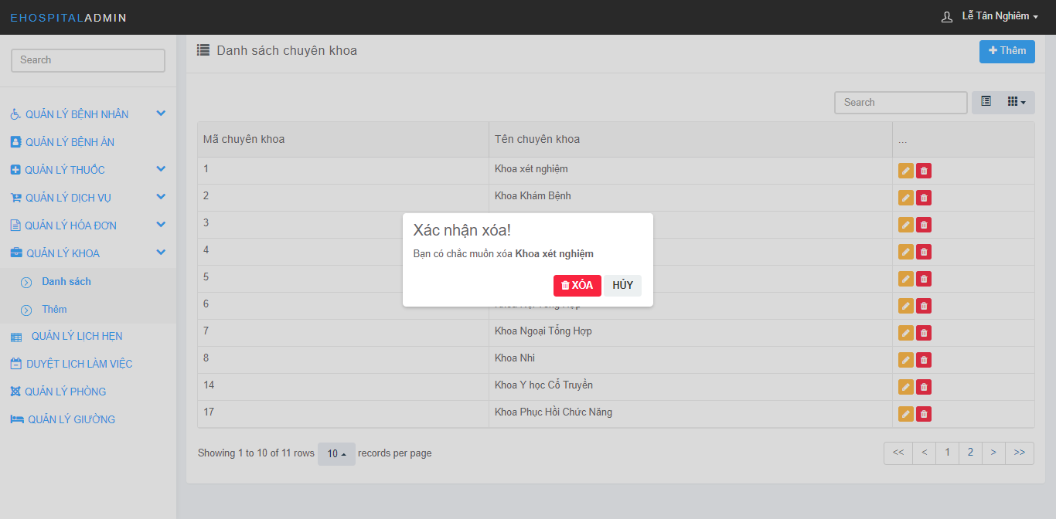

Figure 200: Department Management Screen:

### View department

* Step 1: Click on “QUẢN LÝ KHOA”
* Step 2: Click on “Danh sách” under “QUẢN LÝ KHOA”



Figure 201: Department Management Screen:

## Admin’s Guide

### Login

* Step 1: Open browser and enter link [http://ehospitalvn.azurewebsites.net/admin/login](http://localhost:32806/Admin/login)
* Step 2: Input username and password.
* Step 3: Click on button “Đăng nhập”.



Figure 202: Logout Screen

### Create Staff Account

* Step 1: Click on “QUẢN LÝ NHÂN VIÊN”
* Step 2: Click on “Thêm” under “QUẢN LÝ NHÂN VIÊN”
* Step 3: Fill in the required information
* Step 4: Click on button “Thêm”

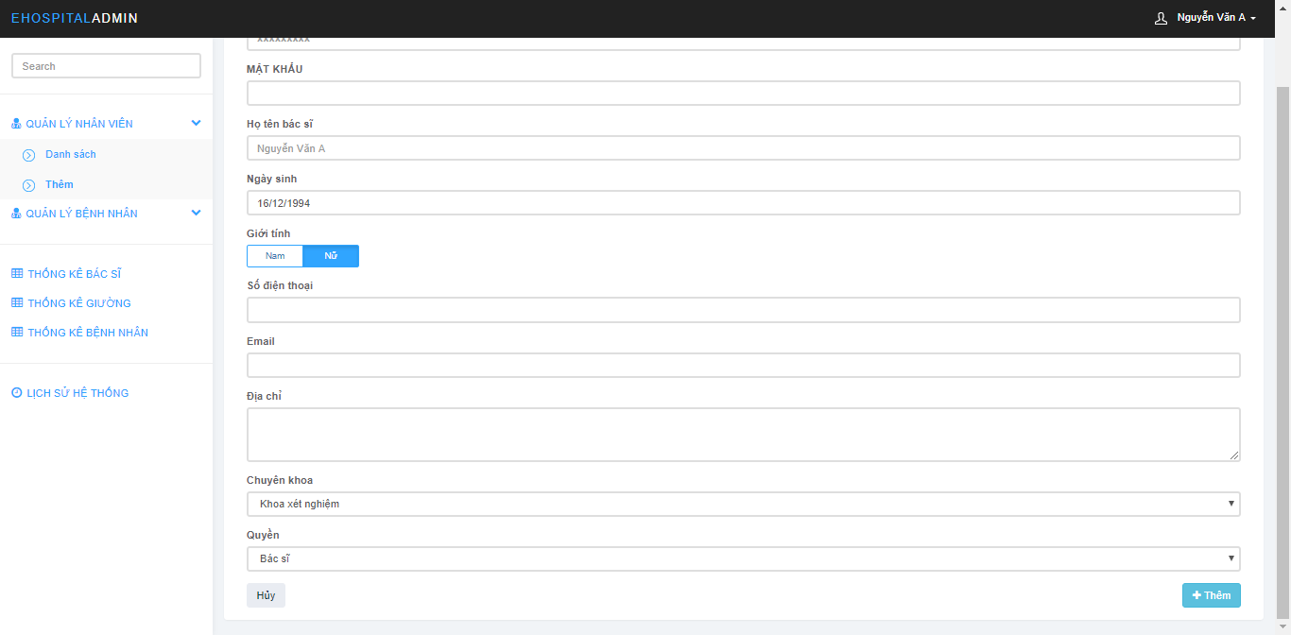

Figure 203: Staff Account Management Screen

### Delete Staff Account

* Step 1: Click on “QUẢN LÝ NHÂN VIÊN”
* Step 2: Click on “Danh sách” under “QUẢN LÝ NHÂN VIÊN”
* Step 3: Click on icon “”
* Step 4: Click on button “Ok”

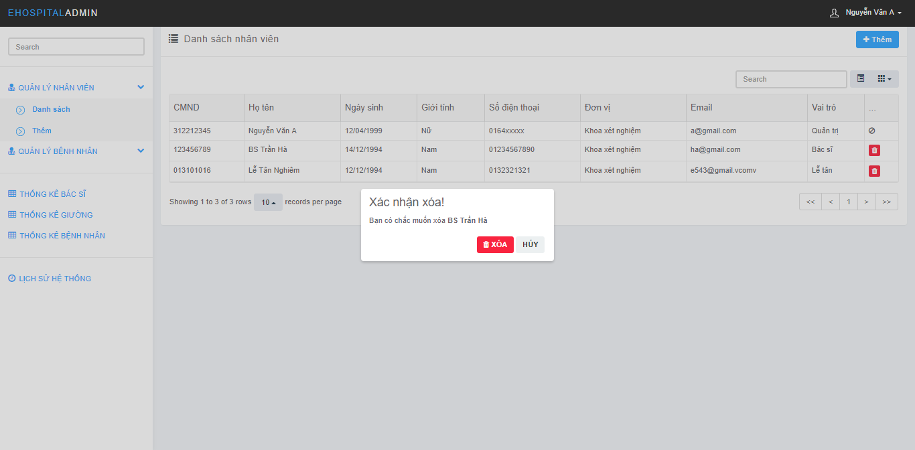

Figure 204: Staff Account Management Screen

### Delete Patient Account

Step 1: Click on “QUẢN LÝ BỆNH NHÂN”

Step 2: Click on “Danh sách” under “QUẢN LÝ BỆNH NHÂN”

Step 3: Click on icon “”

Step 4: Click on button “Ok”

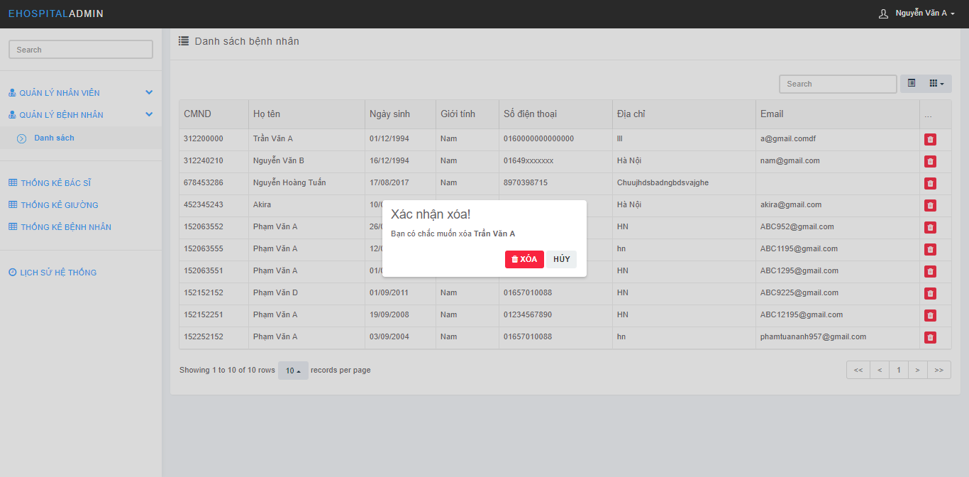

Figure 205: Delete Patient Account Screen

### View Staff Account

* Step 1: Click on “QUẢN LÝ NHÂN VIÊN”
* Step 2: Click on “Danh sách” under “QUẢN LÝ NHÂN VIÊN”

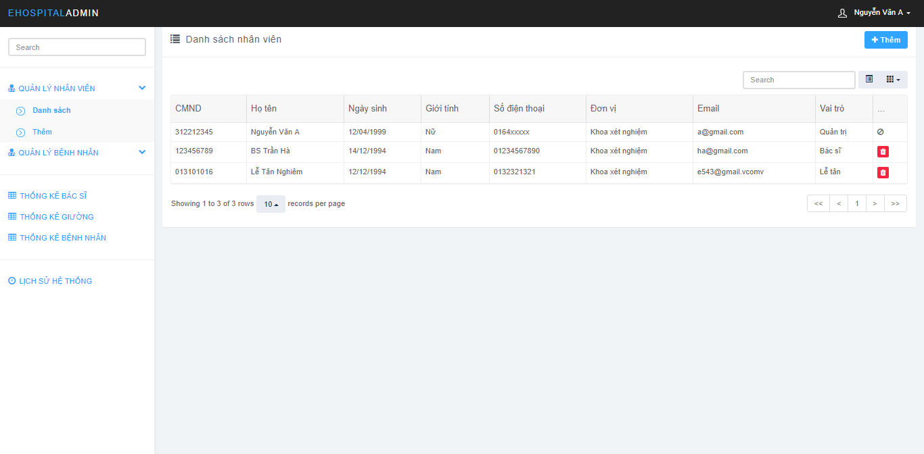

Figure 206: Staff Account Management Screen

### View Patient Account

* Step 1: Click on “QUẢN LÝ BỆNH NHÂN”
* Step 2: Click on “Danh sách” under “QUẢN LÝ BỆNH NHÂN”

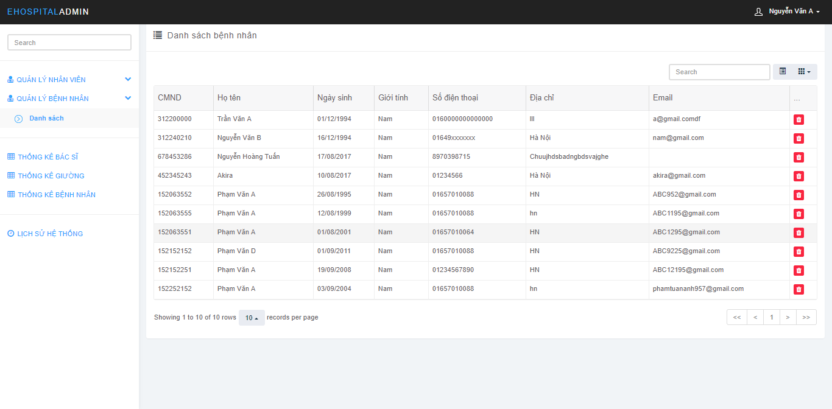

Figure 207: View Patient Account Screen

### View Action History

* Click on “LỊCH SỬ THỐNG KÊ”

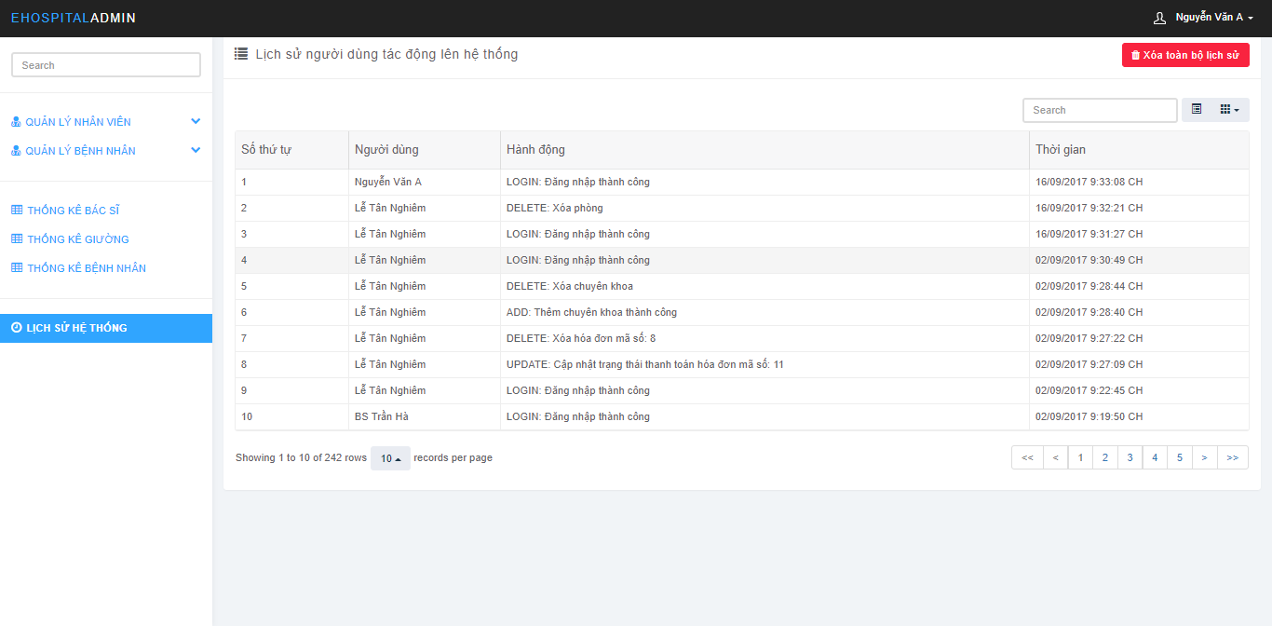

Figure 208: Action History Screen

### Analyze Doctor Working Detail

* Click on “THỐNG KÊ BÁC SĨ”

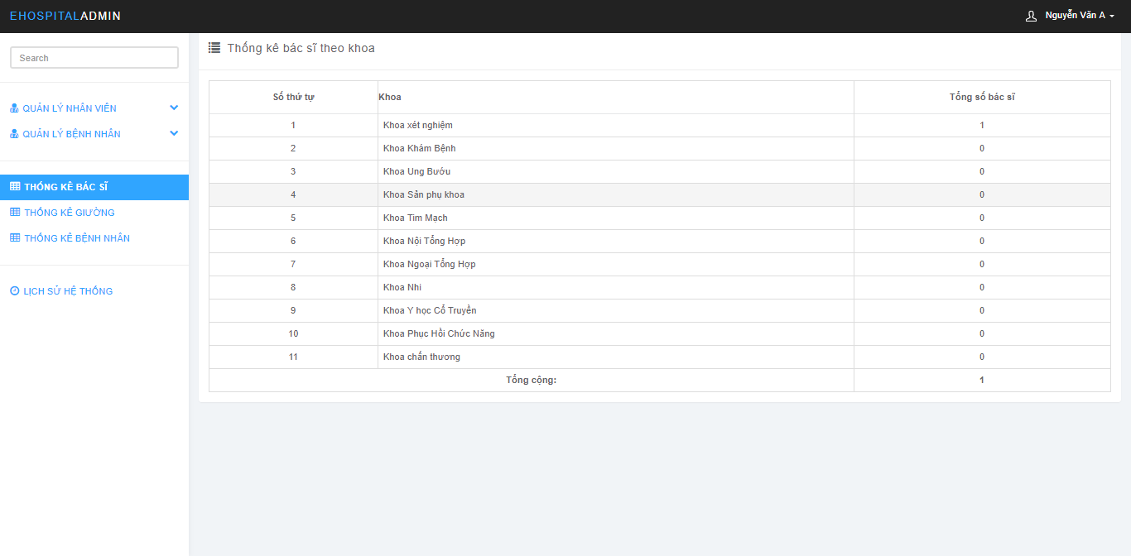

Figure 209: Analyze Screen

### Analyze Bed

* Click on “THỐNG KÊ GIƯỜNG”

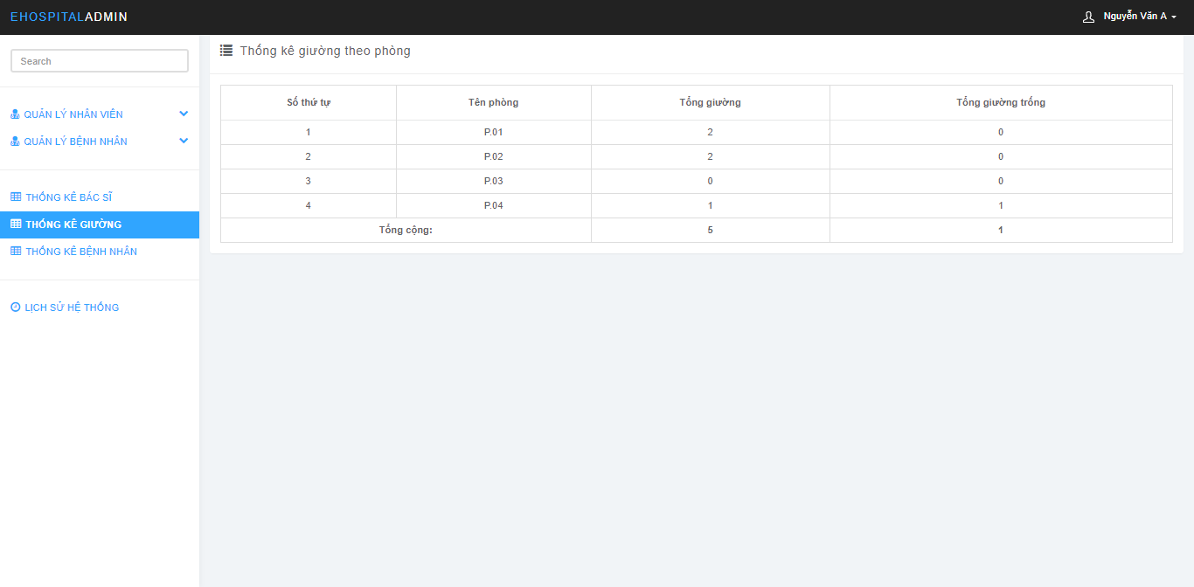

Figure 210: Analyze Screen

### Analyze Patient Examined

* Click on “THỐNG KÊ BỆNH NHÂN”

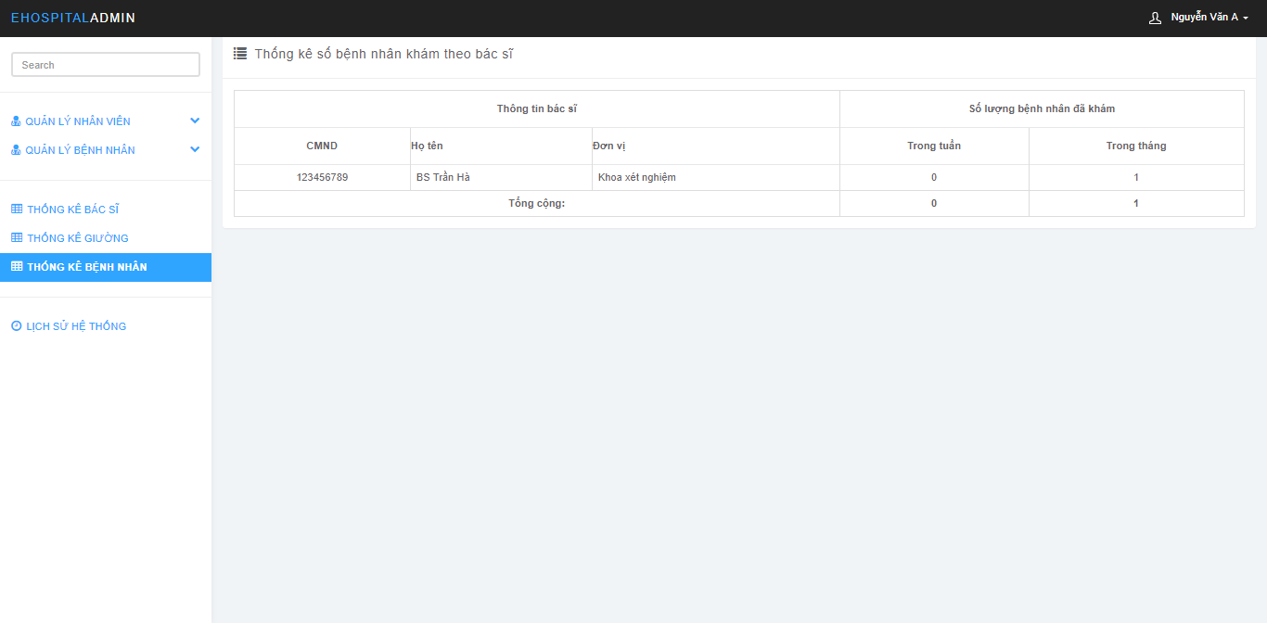

Figure 211: Analyze Screen